

**PSG COLLEGE OF TECHNOLOGY**

**DEPARTMENT OF PRODUCTION ENGINEERING**

**PRODUCTION ENGINEERING ASSOCIATION &**

**SOCIETY OF MAUFACTURING ENGINEERS- STUDENTS' CHAPTHER**

**REPORT ON LEAN-O-FLEX**

Event Name : Lean-O-Flex

Event date : 21/10/2024

Venue : Automation Lab, Manufacturing Lab, Metrology Lab

Number of Participants : 9 teams ( 3 per each team ) (27 students)

Description :

This event focuses on applying the 5S methodology (Sort, Set in Order, Shine, Standardize, Sustain) to improve machine efficiency in lean manufacturing. Participants will optimize machine organization, reduce waste, and enhance productivity through hands-on 5S implementation. The goal is to create a streamlined, cleaner, and more efficient work environment. Each team was tasked with implementing the 5S methodology in daily-used labs, such as automation, metallurgy, and mechanical. The teams were required to submit their ideas along with the budget needed for implementation. The 5S methodology, which stands for Sort, Set in Order, Shine, Standardize, and Sustain, aims to improve efficiency, organization, and cleanliness in workspaces, making the labs more streamlined and conducive to productive learning environments.

The teams' proposals were carefully evaluated based on their creativity, feasibility, and potential impact. The top three teams were selected, and appreciation prizes were awarded to acknowledge their hard work and innovative ideas. These successful proposals were then implemented in the corresponding labs, leading to tangible improvements in lab organization, safety, and overall functionality. Around six teams actively participated in the event, showcasing a diverse range of ideas and solutions. The event not only provided an opportunity for students to gain hands-on knowledge of the 5S methodology but also contributed to enhancing the labs' physical environment. It fostered teamwork, problem-solving, and leadership skills among participants, while encouraging a culture of continuous improvement and better learning spaces for everyone.

**IMPLEMENTATION OF 5S IN AUTOMATION LAB:**

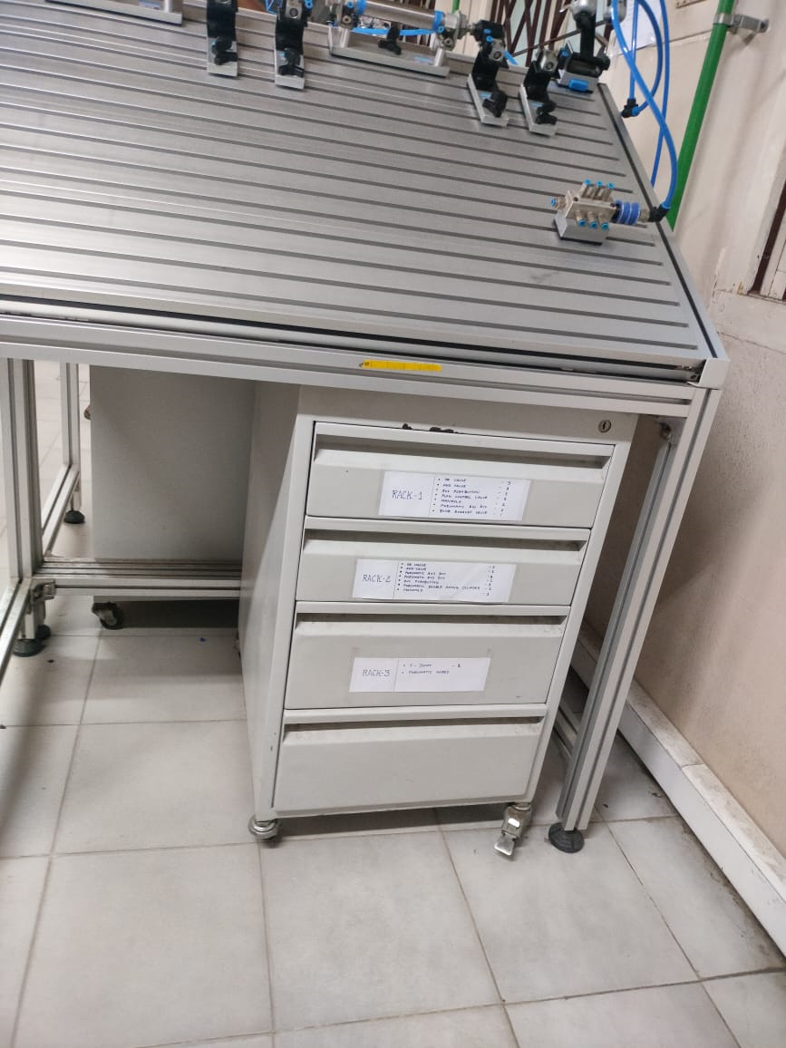 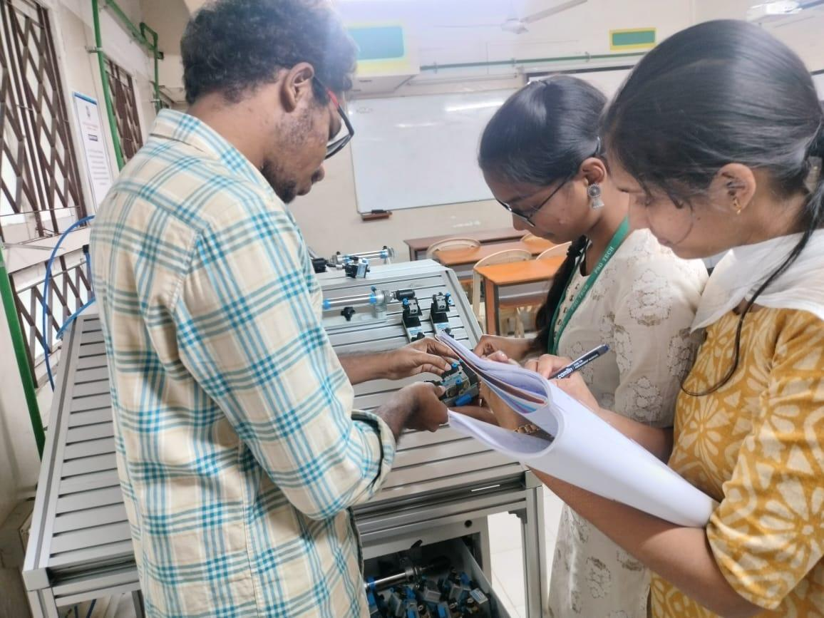

**IMPLEMENTATION OF 5S IN MANUFACTURING LAB:**

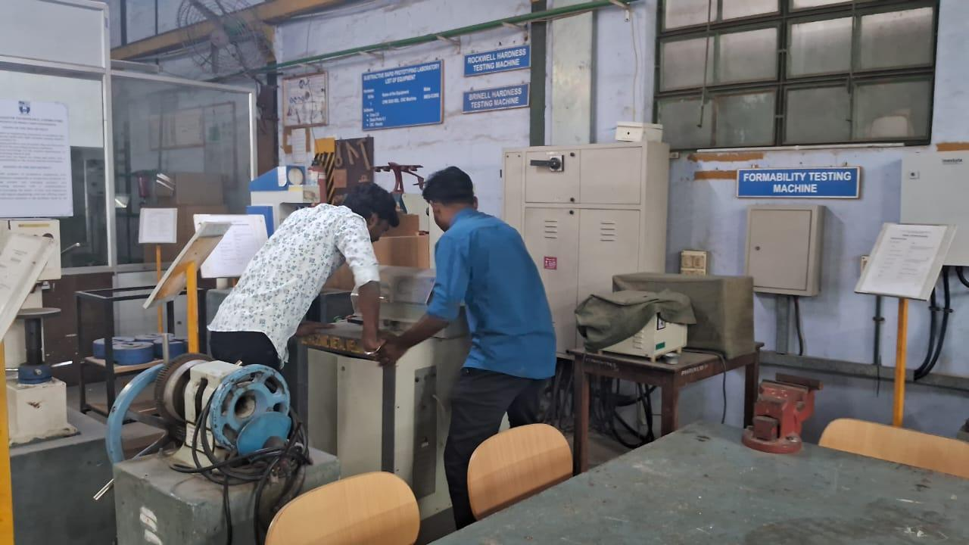 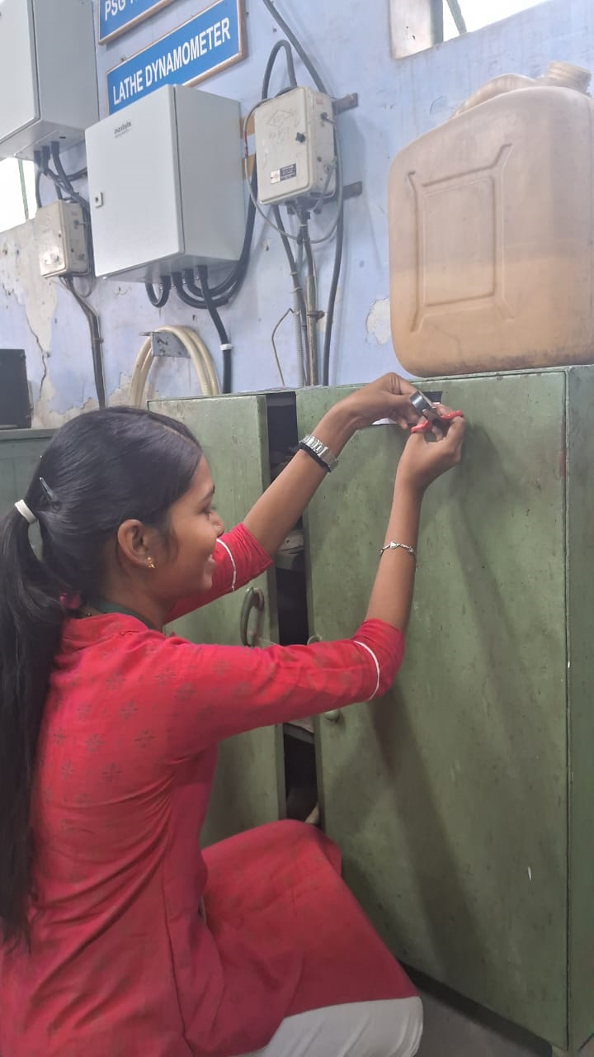

**IMPLEMENTATION OF 5S IN METROLOGY LAB:**

