

**GIT VERSION 2.32.0**

**What is Git?**

**Git** is an **open-source distributed version control system**. It is designed to handle minor to major projects with high speed and efficiency. It is developed to co-ordinate the work among the developers. The version control allows us to track and work together with our team members at the same workspace.

## Features of Git

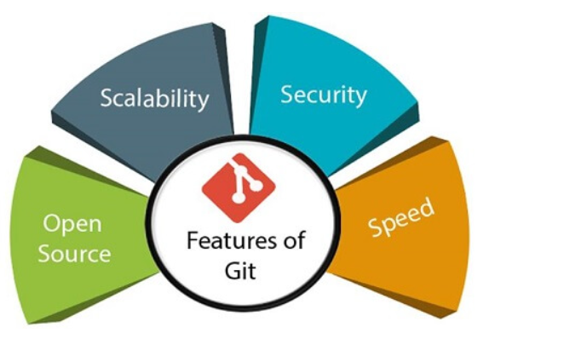

* **OpenSource**  
  Git is an **open-source tool**. It is released under the **GPL** (General Public License) license.
* **Scalable**  
  Git is **scalable**, which means when the number of users increases, the Git can easily handle such situations.
* **Distributed**  
  One of Git's great features is that it is **distributed**. Distributed means that instead of switching the project to another machine, we can create a "clone" of the entire repository.
* **Security**  
  Git is secure. It uses the **SHA1 (Secure Hash Function)** to name and identify objects within its repository. Files and commits are checked and retrieved by its checksum at the time of checkout. It stores its history in such a way that the ID of particular commits depends upon the complete development history leading up to that commit. Once it is published, one cannot make changes to its old version.
* **Speed**  
  Git is very **fast**, so it can complete all the tasks in a while. Most of the git operations are done on the local repository, so it provides a **huge speed**. Also, a centralized version control system continually communicates with a server somewhere.

# What is gitHub

GitHub is **a Git repository hosting service**, but it adds many of its own features. While Git is a command line tool, GitHub provides a Web-based graphical interface. It also provides access control and several collaboration features

**Features of gitHub**

* Using github the project managers can collaborate, review and guide the developers regarding any changes. This makes project management easy.
* The github repositories can be made public or private. Thus allowing safety to an organization in case of a project.
* GitHub has a feature of pull requests and issues in which all the developers can stay on the same page and organize.

# Version Control System

A version control system is a software that tracks changes to a file or set of files over time so that you can recall specific versions later. It also allows you to work together with other programmers.

The version control system is a collection of software tools that help a team to manage changes in a source code. It uses a special kind of database to keep track of every modification to the code.

Developers can compare earlier versions of the code with an older version to fix the mistakes.

# How to Install Git on Windows

To download the Git installer, visit the Git's official site and go to download page. The link for the download page is <https://git-scm.com/downloads>.

# Install Git on Ubuntu

**step1: Start the General OS and Package update**

First of all, we should start the general OS and package updates. To do so, run the below command:

1. $ apt-get update

Now we have started the general OS and package updates. After this, we will run the general updates on the server so that we can get started with installing Git. To do so, run the following commands:

**Step2: Install Git**

To install Git, run the below command:

1. $ apt-get install git-core

How to check the version of git

* + Git -–version

# Git Environment Setup

1. $ git config --global user.name "name"
2. git config --global user.email” [name@gmail.com](mailto:name@gmail.com)”

GIT LIFE CYCLE

* **Working Directory**
* **Staging Area**
* **Git Directory**

### *****Working Directory*****

Consider a project residing in your local system. This project may or may not be tracked by Git. In either case, this project directory is called your Working directory.

#### Staging Area

* When we make changes to the existing files in the working repo or if we add any folder of files and if we want these changes to need to be tracked and also need to be moved to the local repo for tracking then we need to move these changed files or newly added folder of file to the staging area. Git add is the basic command which will be used to move the modified files to the staged area.

#### GIT Directory

* When we have done the modifications or addition of files or folder and want them to be part of the repository they first we do is to move them to the staging area and they will commit ready. When we commit then provide the appropriate commit message and files will be committed and get updated in the working directory.

