# Kamazhi Account Software

## Description

This is the simple Double Entry system account software for both mobile and web environment.

Login Screen

1. As a user, I want x

## Entire Workflow

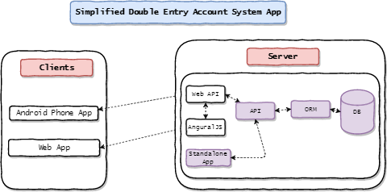

Database Diagram



## Database Design

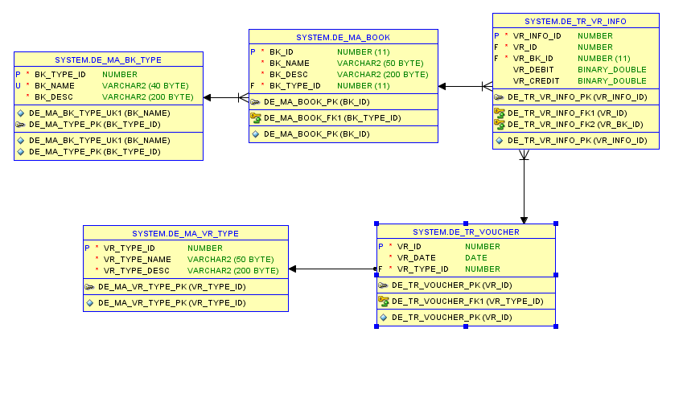

## Mobile App Sample Screen Shots

