**E-COMMERCE APPLICATION ON IBM CLOUD FOUNDRY**

**Team Member**

**SATHISH A - 310521104108**

**Phase 2 Document Submission**

**Innovation**

**Introduction :**

Enhancing user engagement and satisfaction is crucial for the success of any e-commerce application. By incorporating various features and strategies, you can create a more enjoyable and user-friendly shopping experience. This documentation outlines key features and strategies to boost user engagement and satisfaction on the e-commerce platform.

**1. Product Reviews:**



**Customer Feedback:**

Allow customers to leave reviews and ratings for products they have purchased. This helps other shoppers make informed decisions. Positive reviews build trust and credibility for your products and brand. Encourage users to engage with your platform by leaving reviews and sharing their experiences.

**2. Wishlists :**



**Save for Later:**

Wishlists allow users to save products they are interested in for future reference without committing to a purchase immediately. It will send email or app notifications when there are price drops or limited-time offers for items on a user's wishlist. Use wishlist data to personalize recommendations and marketing efforts.

**3. Personalized Recommendations:**



**Improved Shopping Experience:**

Utilize user browsing and purchase history to recommend products tailored to each individual's preferences and behavior.Suggest related or complementary products to increase the average order value. Keep users engaged by regularly updating recommendations on their homepage or via email notifications.

**4. Fast and Secure Checkout :**

**Multiple Payment Options :**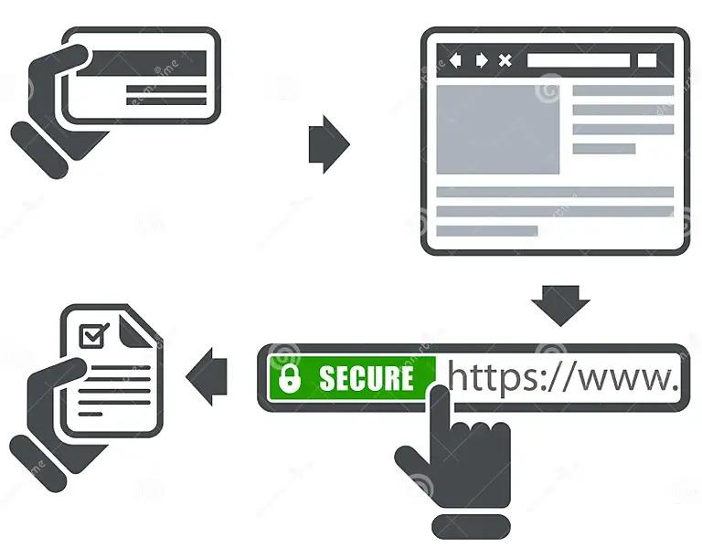

Offer various payment methods, including credit cards, digital wallets, and buy now, pay later. Allow guest checkout for users who prefer not to create an account.

**Secure Payment Processing :**

Ensure secure and reliable payment processing with encryption and fraud prevention. So that the Users can trust your Innovation.

**5. Social Media Integration :**



**Sharing Products :**

Enable users to share their favourite products on social media.

**Social Login :**

Allow users to sign in using their social media profiles for a seamless experience.

**User-Generated Content :**

Encourage users to post photos and reviews on social media, promoting your products.

**6. Seamless Navigation :**



**Intuitive UI/UX :**

Design an intuitive interface with clear navigation paths.



**Clear Categories and Filters :**

Organize products into categories and provide filtering options.

**Search Functionality :**

Implement a robust search feature with auto-suggestions and filters.

**7. Customer Support :**

**Live Chat :**

Provide real-time customer support through live chat for quick issue resolution.



**FAQs :**

Create a comprehensive FAQ section to address common user queries.

**Email and Phone Support :**

Offer email and phone support for more complex issues.

**9. Performance Optimization :**

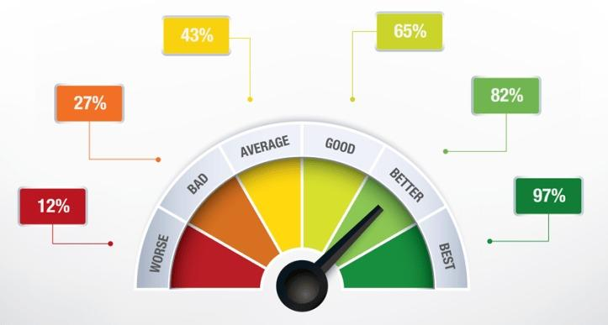

**Speed and Reliability :**

Optimize website and app performance for fast loading times and reliability.

**Mobile Data Optimization :**

Ensure that your platform is not data-intensive for users with limited data plans. Frequently update your application to fix bugs and introduce new features.

**Conclusion :**

By incorporating these features and strategies into an E-commerce application, we can enhance user engagement and satisfaction.