**E-COMMERCE APPLICATION ON IBM CLOUD FOUNDRY**

**Team Member**

**SATHISH A - 310521104108**

**Phase 4 Document Submission**

**Shopping Cart :**

The shopping cart, a fundamental component of the e-commerce experience, is the digital counterpart to the traditional shopping basket or trolley found in physical stores. It plays a pivotal role in the world of online retail, serving as the digital vessel that holds the hopes, dreams, and purchases of countless consumers worldwide.

In its most basic form, a shopping cart is a virtual container, represented by an icon or symbol, prominently displayed on an e-commerce website. It is the receptacle where customers gather their desired products, much like they would in a physical store as they stroll down aisles, selecting items to buy. With just a click or tap, users can effortlessly add products to their digital cart, and the cart dynamically updates to display the accumulated items, their quantities, and the total cost. This real-time feedback empowers shoppers to make informed decisions as they explore the vast array of products available online.

Yet, the modern e-commerce shopping cart is more than just a passive holder of goods. It's a sophisticated tool that streamlines the entire shopping process. Shoppers can easily edit their selections, adjust quantities, or even remove items, providing the flexibility and control needed to create a personalized shopping experience. The cart often features a summary section, displaying the subtotal, taxes, shipping costs, and the grand total, offering a transparent view of the financial aspect of the purchase. As customers proceed through the checkout process, the shopping cart also manages critical data, such as shipping and billing information, to ensure a seamless transaction.

Furthermore, the shopping cart is not confined to a single visit. In the digital realm, it can remember the items selected by the user even if they leave the website and return later. This feature, known as "persistent shopping cart," enhances user convenience, as it allows for a more extended consideration period and encourages return visits.

The e-commerce shopping cart is a pivotal element in the online retail experience, a pivotal piece in the intricate puzzle of converting website visitors into satisfied customers. It blends simplicity and sophistication, making the shopping process intuitive and efficient, while simultaneously tracking and managing vital information. In doing so, the digital shopping cart has become an indispensable tool for e-commerce businesses, enriching the lives of online shoppers and enabling the growth and success of countless online retailers.

**CODE :**



**OUTPUT :** 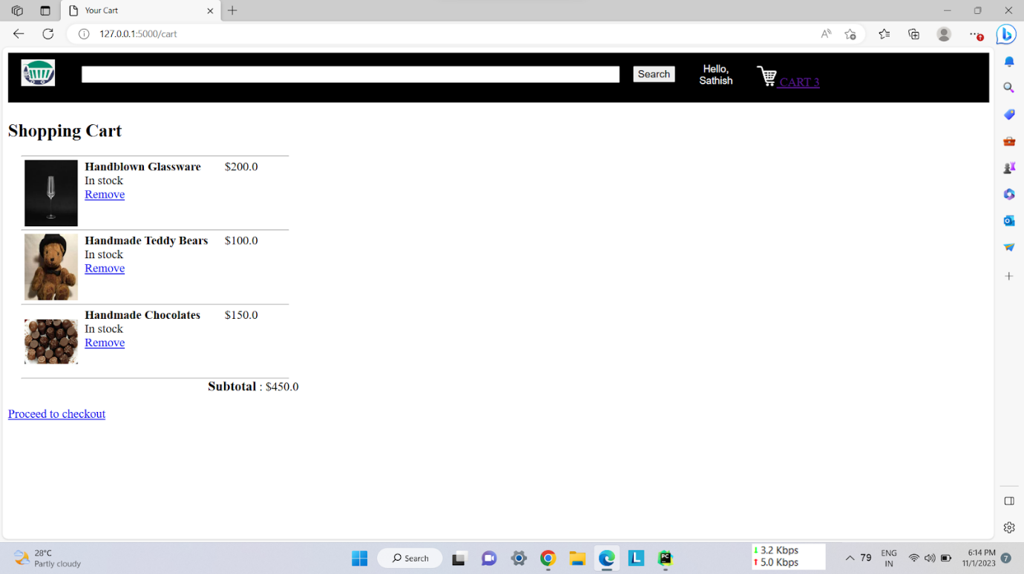

**USER AUTHENTICATION :**

User authentication is a fundamental concept in the realm of cybersecurity and digital identity, serving as the cornerstone for safeguarding sensitive information and ensuring the integrity of online interactions. In essence, it is the process of verifying the identity of a user, typically requiring them to provide specific credentials, such as a username and password, a fingerprint, a smart card, or a one-time code. The primary objective of user authentication is to grant access only to individuals who possess the appropriate credentials, thereby preventing unauthorized users from gaining entry to a system or service.

Authentication methods have evolved over the years, progressing from traditional password-based approaches to more sophisticated and secure techniques. While passwords remain prevalent, they are susceptible to various security risks, including brute force attacks and password reuse. Consequently, multi-factor authentication (MFA) has gained widespread adoption, incorporating a combination of something the user knows (password), something the user has (a smartphone or token), and something the user is (biometric data like fingerprints or facial recognition). MFA significantly bolsters security by creating multiple layers of defense against unauthorized access.

User authentication is indispensable in a wide range of applications, from logging into email accounts and social media platforms to accessing financial services and healthcare records. As our digital lives expand, the importance of robust and user-friendly authentication mechanisms becomes increasingly apparent. However, balancing security with user convenience is an ongoing challenge, as overly complex authentication processes can lead to user frustration and potential workarounds. Striking this balance is critical to providing a seamless and secure digital experience for users while safeguarding their data from malicious actors.

In conclusion, user authentication is a vital aspect of modern digital life, enabling secure access to a multitude of online services and resources. It is a continuously evolving field, adapting to emerging threats and technologies. Striving for both enhanced security and a user-friendly experience, it remains an essential component of our interconnected world, helping to protect our personal information and maintain the integrity of our digital interactions.

**USER REGISTRATION :**

User registration is a fundamental aspect of any e-commerce platform, serving as the gateway for customers to access a world of online shopping convenience. It is a process that not only provides access to a plethora of products and services but also enables businesses to establish a direct and personalized relationship with their customers. When a user embarks on the journey of registration, they are essentially creating a digital identity, which is pivotal for a seamless and secure online shopping experience.

The user registration process typically commences with the customer providing basic information such as their name, email address, and a secure password. This information serves as the foundation of their profile, ensuring that their interactions with the platform are uniquely tailored to their preferences. Additionally, this data acts as a means of communication between the customer and the e-commerce site, enabling order updates, transaction receipts, and personalized recommendations.

In today's digital age, user registration is not solely about creating an account but also about establishing trust and security. To this end, e-commerce platforms often employ robust security measures to safeguard user data, such as encryption and multi-factor authentication, assuring customers that their personal information is kept safe. This sense of security is crucial in persuading users to share their financial information, like credit card details, for transactions.

Furthermore, the registration process can be enhanced with optional features like social media login integration, simplifying the process and enhancing the user experience. It can also include opt-in choices for newsletters, notifications, and personalized offers, making the registration process more engaging and customer-centric.

In conclusion, user registration in the realm of e-commerce serves as the gateway to a world of convenience and personalization. It is a pivotal step that not only enables customers to access an array of products and services but also allows businesses to build trust, enhance security, and establish lasting relationships with their clientele. As technology evolves, the user registration process will continue to adapt and improve, ensuring that the world of online shopping remains a dynamic and customer-focused domain.

**CODE :**

**OUTPUT :** 

**LOGIN PAGE :**

