Gopalakrishnan Manickam 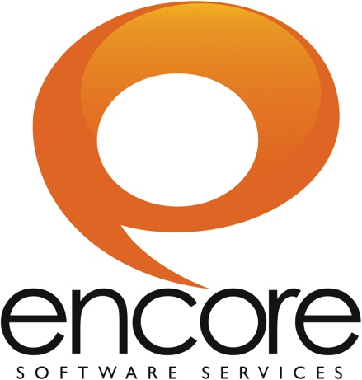
gmanickam@encoress.com
Mobile: 91-9715716791

EXPERIENCE SUMMARY
- Working as a Software Engineer with Encore Software Solutions Pvt. Ltd, Chennai from July 2012 to till date.

- Effective team member, comfortable with leading or collaborating.
- A highly motivated, quick-learner, and adaptable person proficient in technical skills.

ACADEMIC PROFILE
Course | Institution | Board/University | Year of passing | Percentage
B.E  (Computer Science & Engineering) | M.Kumarasamy College Of Engineering,  Karur | Anna  University Of Technology  (Coimbatore) | 2011 | 8.00*
HSC | P.A.Vidhya Bhavan Higher Secondary School,  Karur | State  Board | 2007 | 83.8
SSLC | Government Higher Secondary School,  Karur | State  Board | 2005 | 78.8
*CGPA

SKILLS
- Programming Languages : JAVA, .NET
- Java Framework : Play Framework
- Operating System : Windows XP,Windows 7
- DBMS : MySQL
- IDE : Eclipse, Visual Studio 2010
- Packages : MS Office, Jasper Reports, POI
- Other Basic Skills : HTML, CSS, JavaScript, Jquery, PHP

Project Profile
For Encore: (Oct-2011 to till date)

Project Title: CLIQ Ads Manager

Technologies used: PHP, JQuery , JQuery MX , CSS, HTML.

Roles and responsibilities:
• Understanding client requirements in terms of user requirements, functional specifications and technical requirements.
• Worked as a UI developer and integrated the APIs using the Jquery MX framework.
• Used CSS and HTML to manage the look and feel of the application.

Project Description:

It is a facebook advertising platform that makes targeted, scalable Facebook ad campaigns easy to execute, manage and measure for agencies and brands. Ads Manager goes beyond other social media advertising tools and APIs by enabling to precisely target the audience and execute the campaigns more intelligently and efficiently, all while gaining deep insights into fans and prospective customers.

ACHEIVEMENTS:
- Got cash award for First rank in 8th standard
- Won Second prize in Tamil Elocution competition in my school level
PROJECTS:
- The project done by final year titled as “Fourth Generation Desktop and Mobile Application Control” -This project used to done all process of computer through mobile with help of GPRS and STATIC IP. To work with mobile in front of computer, the computer display viewed on mobile.
EXTRA CURRICULAR ACTIVITIES:
- Participated in March Past event during college sports day
- Participated in NSS training and camp during college days
- Acted as a class committee member during 3rd semester

CO CURRICULAR ACTIVITIES:
- Presented a paper on IMAGE PROCESSING in Selvam College of Technology, Namakkal
- Exhibited a project on VOICE OPERATED FM in M.Kumarasamy College of Engineering,Karur
- Exhibited a project on BURNING MONEY in M.Kumarasamy College of Engineering,Karur

PERSONAL DETAILS:
Father’s Name : Mr.S.Manickam
Mother’s Name : Mrs.AmaravatiManickam
Date of Birth : 11.07.1990
Languages : English & Tamil
Nationality : Indian
Gender : Male

Place :
Date : (M.GOPALAKRISHNAN)

