Gopalakrishnan Manickam 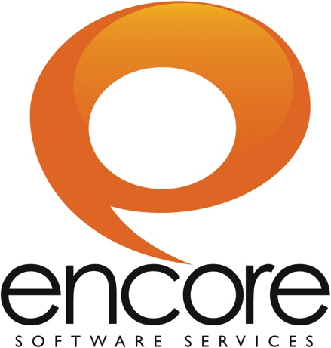
gmanickam@encoress.com
Mobile: 91-9715716791

EXPERIENCE SUMMARY
- Working as a Software Engineer with Encore Software Solutions Pvt. Ltd, Chennai from July 2012 to till date.

- Effective team member, comfortable with leading or collaborating.
- A highly motivated, quick-learner, and adaptable person proficient in technical skills.

ACADEMIC PROFILE
Course | Institution | Board/University | Year of passing | Percentage
B.E  (Computer Science & Engineering) | M.Kumarasamy College Of Engineering,  Karur | Anna  University Of Technology  (Coimbatore) | 2011 | 8.00*
HSC | P.A.Vidhya Bhavan Higher Secondary School,  Karur | State  Board | 2007 | 83.8
SSLC | Government Higher Secondary School,  Karur | State  Board | 2005 | 78.8
*CGPA

SKILLS
- Programming Languages : JAVA, PHP
- Other Basics Languages : .NET
- Java Framework : Play Framework
- Operating System : Windows XP,Windows 7
- Packages : MySQL, MS Office, Jasper Reports
- Server : Amazon EC2
- Other Basic Skills : HTML, CSS, JavaScript, JQuery, AJAX

PROJECT PROFILE
For Encore Software Services: (Sep-2011 to till date)
PROFESSIONAL WORK

Project Name : CLIQ (Compass Labs Intelligence Quotient)
Technologies used : Java 1.6, Play 1.2.3, MySql, JSON, Amazon EC2, Amazon S3.
Company : Encore IT Services Solution Pvt Ltd
Client : CompassLabs, USA
Role : Junior Software Developer

DESCRIPTION

CLIQ Ads Manager is a Facebook advertising platform that makes targeted, scalable Facebook ad campaigns easy to execute, manage and measure for agencies and brands. Ads Manager goes beyond other social media advertising tools and APIs by enabling you to precisely target your audience and execute your campaigns more intelligently and efficiently, all while gaining deep insights into your fans and prospective customers.
CLIQ Ads Manager uses sophisticated natural language processing, predictive analytics and artificial intelligence technologies to parse the vast flood of user status updates, mentions, check-ins, offer claims and other forms of actions and expressions to deliver the right audience. Ads Manager’s exclusive Interest Cluster generator turns public social chatter into targetable audience segments, deriving precise user interests from real-time status updates, allowing you to target your audience far beyond basic keyword and category targeting.

ROLES AND RESPONSIBILITES

- Understand the project requirements and design.
- Fix bugs in CompassLabs API (CLAPI) and track it on Bugzilla
- Deployment on DEV and Staging environment
- Handle the CLRS (Compass Labs Reporting System)
CLRS DESCRIPTION

Technologies used: Java 1.6, Play 1.2.3, MySQL, JSON, IReport (Jasper Reports).
CLRS is Compass Labs Reporting System to generate the Reports for different formats. It generates HTML, XLS, PPT, PDF formats using Jasper Reports and POI.

CLRS ROLES AND RESPONSIBILITES:

- Understand the project requirements and design.
- Create new type reports based on client request.
- Deployment on Staging and PROD environment.
- Create and config crontab services in Java

INTERNAL APPLICATION
ENCORE TOURNAMENT DETAILS
- Technologies Used: .NET (C# and ASP), MySQL
- We used this application, if any tournament contains in the company.
ENCORE ASSET MANAGEMENT SYSTEM:
- Technologies Used: PHP, MySQL.
- We used this application, company asset related.
ENCORE EXPENSES PROJECT:
- Technologies Used: PHP(CakePHP Framework), MySQL.
- We used this application, if employee did any expenses work.

