Agile Methodology Metrics:
Common metrics used for gauging overall progress are as below:
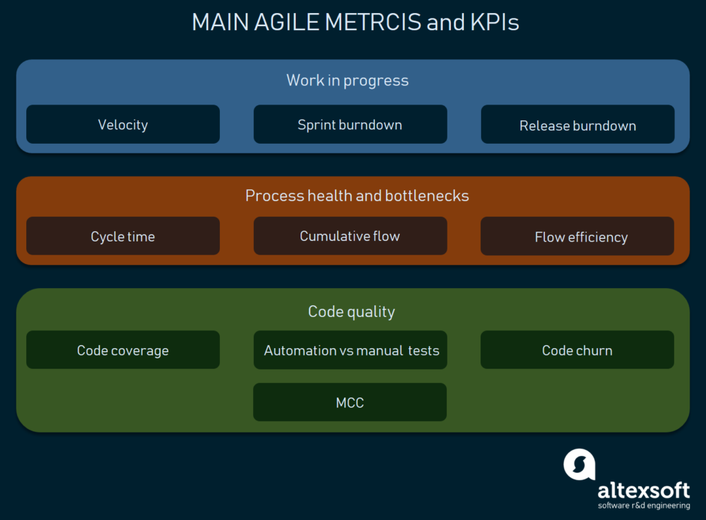

Work in Progress Metrics
Velocity: Average amount of work (or, story points) that the team can accomplish in a sprint. This is different for each team, and it gives a metric to PO as to how many story points a team can take in a sprint. This can vary in each sprint for a team. The longer the sprints, the more accurate it is.
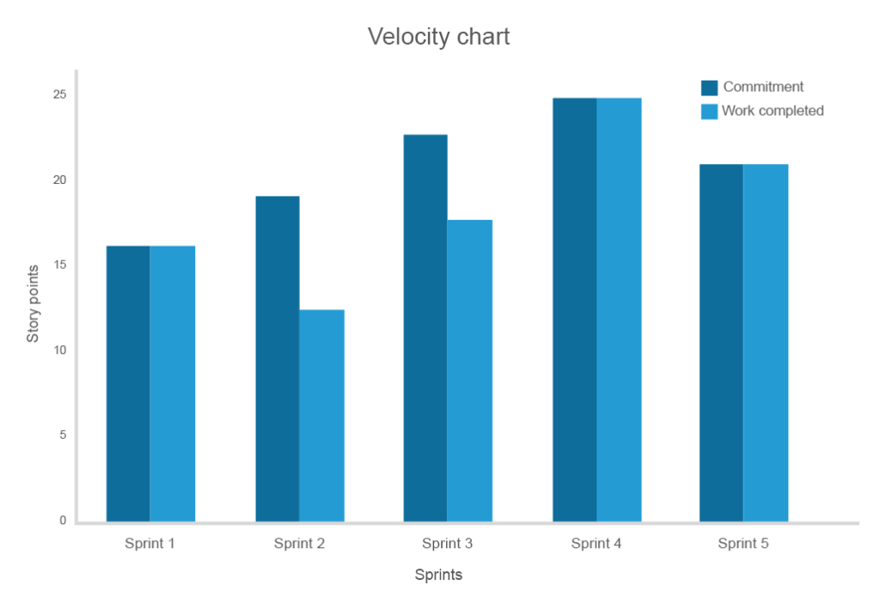
Sprint Burndown Chart: It gives a graphical representation of amount of work (or, story points) that are remaining to be done in a sprint. Sometimes, unplanned tasks, or other blocking dependencies are encountered, which can be captured here.
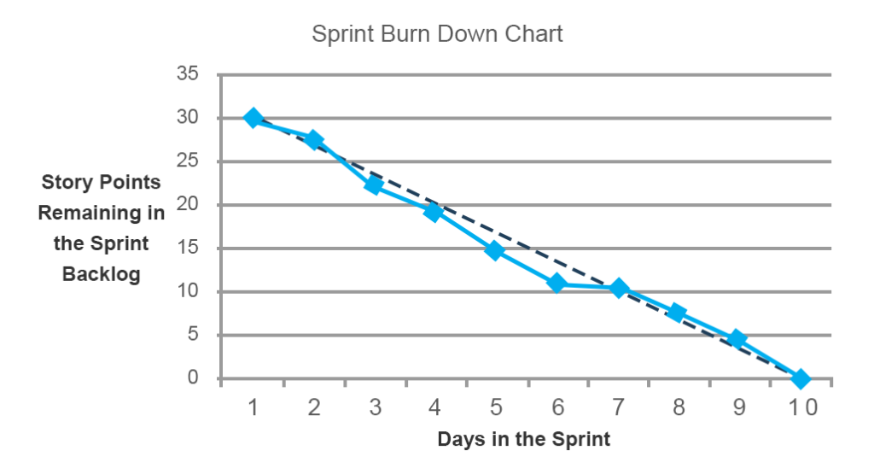

Release Burndown Chart: It gives a graphical representation of amount of pending work (or, story points) left to be done before a software can be deployed by the release date.

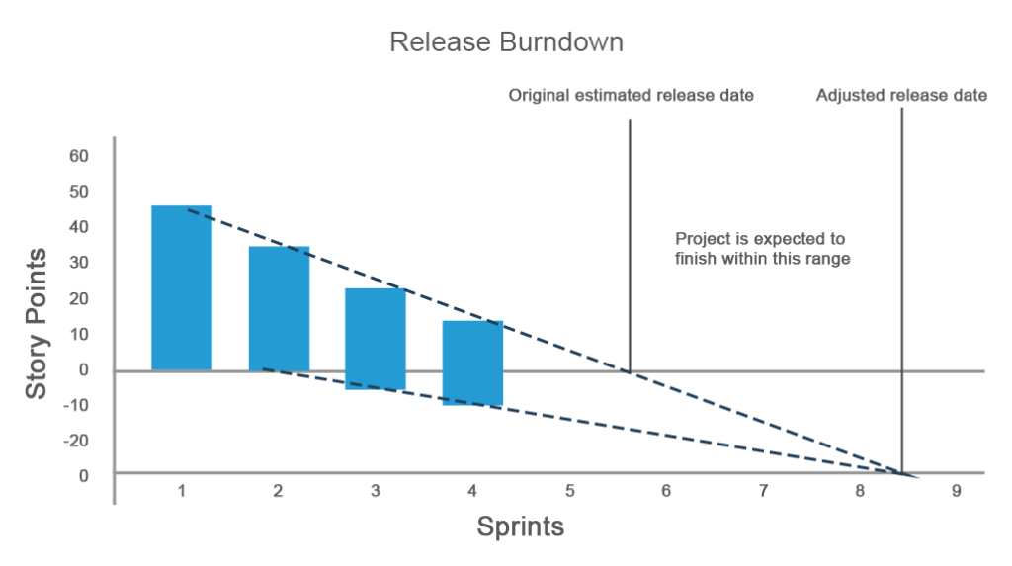
Process Health and Bottleneck Metrics
Cycle Time: It measures how much time was spent on the task, including, opening it and completing it each time.
Cumulative Flow Chart: It gives representation of different types of tasks at each stage of a project.
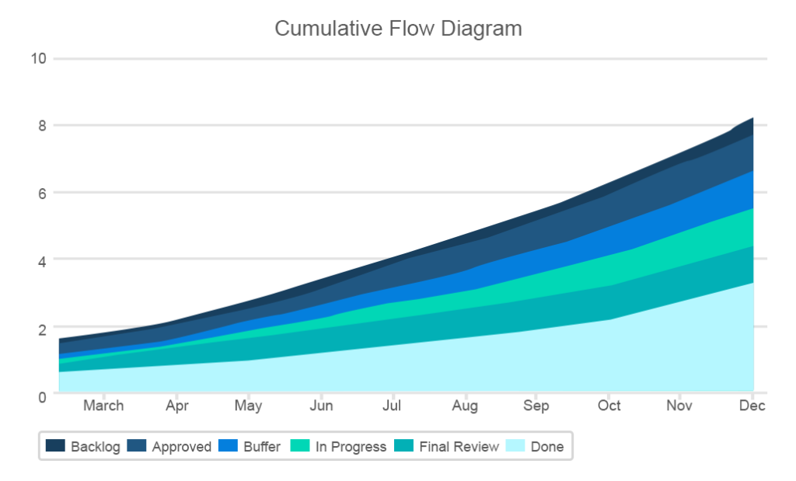
Flow Efficiency: It gives a metric of how much wait time is occurring because of other dependencies.
Code Coverage: It represents how many lines of code (or, blocks of code) are executed while performing automated tests.

