Location vs Price for 2

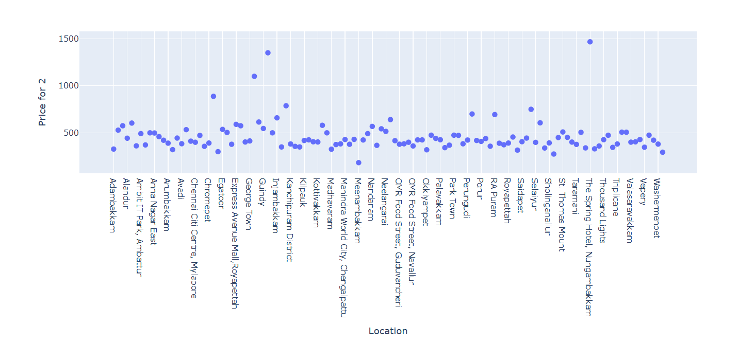

The above plot shows that the Price for 2 will be huge for Nungambakkam, Guindy, and Injambakkam.

Lower is Meenambakkam. And average price is around 500.

Price for 2 Vs Dining Rating

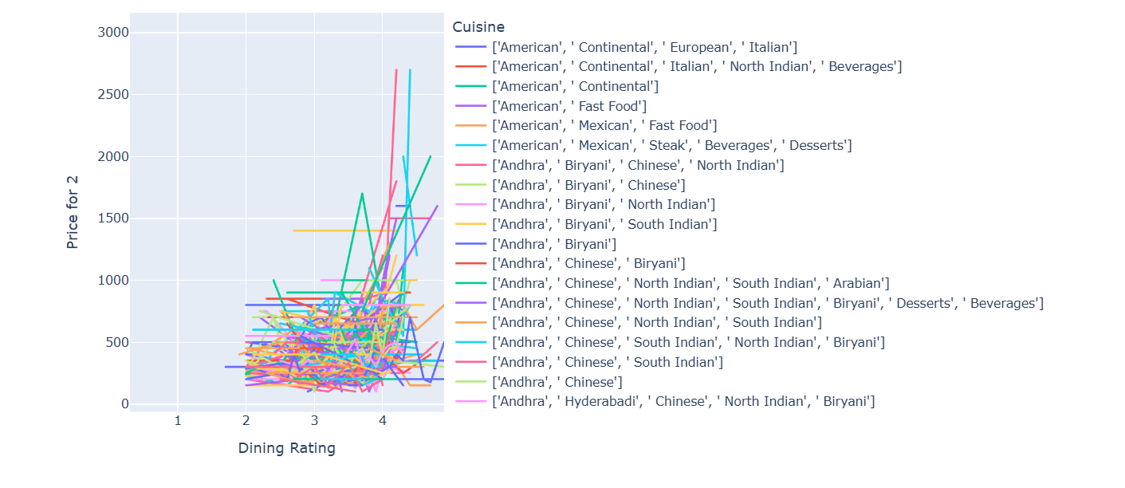

High Rating 🡪 American, Continent, European, North Indain

* American, Continent, Italian

Lower 🡪 Andra, Chinese,

Average 🡪 Most of the Andra, North indian, south Indian

Location Vs Count of Restaurants

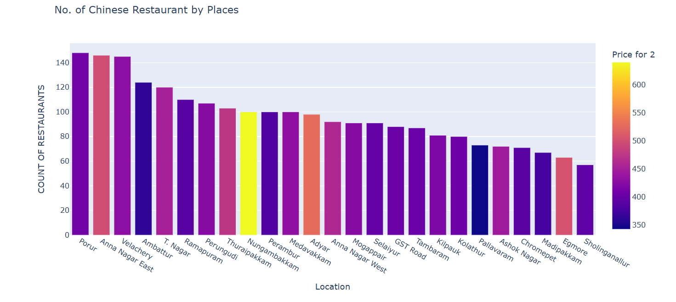

Porur has more restaurants in count and less in sholinganllur

Average price distribution:

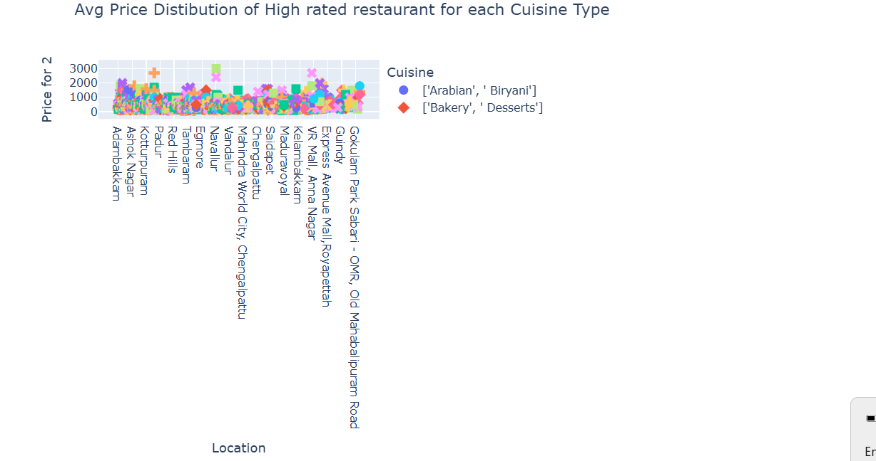

Cuisine based restaurants

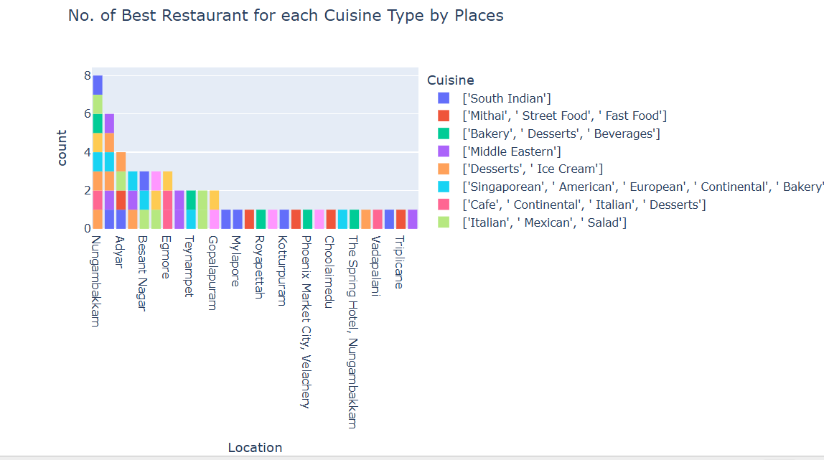

Restaurants percentage based on the rating

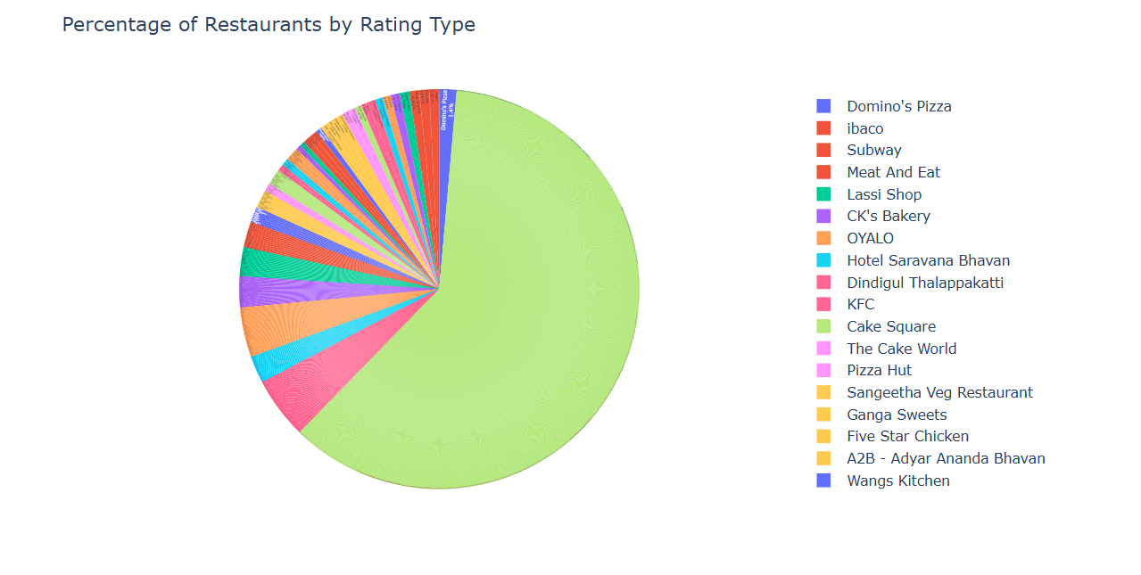

No of Restaurants based on the cuisine

Biriyani, south Indian restaurants have occupied more counts ..

