**What is intergroup behaviour?**

* **Intergroup behaviour** is any perception, cognition, or behaviour that is influenced by people’s recognition that they and others are members of distinct social groups.
* International and intra-national conflicts, political confrontations, revolutions, interethnic relations, negotiations between unions and management, and competitive team sports are all examples of intergroup behaviour.
* Intergroup behaviour is usually competitive and ethnocentric, with people favouring their own group over outgroups, and sometimes it can become hostile and highly destructive.
* In understanding intergroup behaviour, we are also trying to understand the conditions under which such behaviour can be shifted away from destructive hostility toward harmless competition or constructive cooperation

[**Intergroup Theories (Integrated Threat, Social Identity, and Social Dominance)**](https://wikispaces.psu.edu/pages/viewpage.action?pageId=41095610)

**Integrated Threat Theory**

* The main concept of Integrated Threat Theory is that people recognize changes in the environment by observing how other people are using material and psychological resources which then either motivates them to react or not.
* The theory was originally introduced by Walter G. Stephan in 2000, and is structurally modeled after Thomas F. Pettigrew’s Intergroup Contact Theory of 1998, which focused on the conditions that foster intergroup contact and lead to changes in intergroup relations.
* Similarly, Integrated Threat Theory focuses on the conditions that lead to perceptions of threat, which in turn have an impact on attitudes and behavior (Wagner, 2008).

1. **Personal Threat**

* Personal threat is when an individual believes his or her own resources or identity are under attack or risk and feel the need to protect. A personal threat can be triggered by something as simple as being categorized into a group. This type of threat is sometimes called "self-directed threat."
* For example, a person who received a negative review at work may quit as a way of protecting their personal identity from being attacked. Another example is when someone in a relationship does something wrong and decides to end the relationship in order to "save face" and protect their personal identity.

1. **Intergroup Threat**

* Intergroup threat is similar to personal threat but in case of intergroup threat the whole group is impacted rather than the individual. As a general definition, intergroup threat occurs when one group's actions, beliefs, or characteristics challenge the goal attainment or well-being of another group" (**Riek, Mania, &** Gaertner**, 2006**).
* Intergroup threat has traditionally been depicted as competition for resources or status, but also occurs under conditions of social comparison (Brown, 1978; Shipley, 2008).
* The general idea is that members of one group perceive that another group will use up resources, and they will no longer be able to access those resources for themselves. These resources may be tangible, like money or material things or intangible like power or knowledge (Reik, Mania, & Gaertner, 2006).
* When resources are scarce, the group that feels threatened by the lack of resources finds itself motivated to compete for the resources in order to maintain its identity or to achieve its goals (Riek, Mania, & Gaertner, 2006). This competition promotes negative attitudes towards those in the group utilizing the resources (Aberson & Gaffney, 2008).

1. **No** **Threat – Group Affirmation**

* The absences of threat show that an individual does not see any aspect of a situation as negative and does not react or act (Redmond, 2012). Without threat, individuals are not motivated to protect their resources. Instead they are motivated to engage in cooperative behaviors like gaining judgments that are more accurate of their group and contributing more efficient decision-making abilities (Redmond, 2012). These behaviors can be described as self-affirmation and group affirmation (Derks, Van Laar, & Ellemers, 2009).
* Self-affirmation is when the individual focuses on themselves rather than the group. Group affirmation is when the focus is on the group as a whole. Individuals from western cultures are more likely to engage in self-affirmation because in general, western cultures are more individualistic. Western cultures are more likely to focus on their personal identities rather than social identities (Redmond, 2012).

## **Integrated Threat Theory Components**

There are several types of threats, which cause conflict between groups, including realistic threats, symbolic threats, intergroup anxiety and negative stereotyping. According to the Stephans, the Realistic and Symbolic threats both deal with threats to the interests of the group and "the degree [to which] you think your group's interests are being threatened, you will be prejudiced toward the other group" (Kendall, 1998). This differs from Intergroup Anxiety and Negative Stereotypes, which enhance perceived threats by cultivating negative expectations and opinions of other groups (Redmond, 2012).

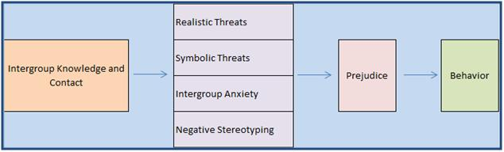

Source: Securitization: What Makes Something a Security Threat? (Adapted for formatting purposes).

### Realistic Threats

These types of threats result from the perceptions held by the in-group, that the out-group "poses a risk to their safety, economy, politics, health or well-being" (Kendall, 1998). For example, when two groups within an organization are competing for the rights to complete a project for the president of the organization, and one group has more material resources than the other, the group with fewer resources will feel threatened because it feels there are barriers (the material resources), which will inhibit their ability to compete for the project.

Three studies were conducted to measure the antecedents of women's attitudes toward men using the integrated threat model. Four types of threats were hypothesized to produce negative attitudes toward men: (1) realistic threat based on threats to women's political and economic power, (2) symbolic threat based on value differences, (3) intergroup anxiety experienced during social interaction with out-group members, and (4) negative stereotypes of men. Negative contact was hypothesized to increase the perception of all four threats as well as to affect attitudes directly. The findings suggest that symbolic threat, intergroup anxiety, and negative contact are the strongest predictors of negative attitudes toward men. Contrary to expectation, realistic threat may not be important to women's attitudes toward men.

The following graphic depicts the types of realistic threats as detailed by Kendall (1998).

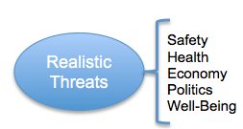

### Symbolic Threats

Symbolic threats refer to the beliefs and values of the group, which may be at risk. They primarily involve "perceived group differences in morals, values, standards, beliefs, and attitudes." (Oskamp, 2000, p.42) These threats affect the in-group paradigm, in that they affect the manner in which the group understands and interprets the world. The symbolic "threats arise, in part, because the in-group believes in the moral rightness of its system of values" (Oskamp, 2000, p.41). For example, if an in-group values a more protected approach to business, it might employ labor and materials purchased from its country of origin. As a result, a symbolic threat would involve competing firms that adopt a more global approach to business, especially if the costs of going global are substantially lower. This type of threat is found in many aspects of our lives; however, politics is the one that can be used to illustrate this threat the best. The different parties represent the different groups, and typically the major platforms the politicians run on are based on the morals, values and beliefs of that particular group.

The following graphic depicts the types of symbolic threats are detailed by Oskamp (2000, p.42)

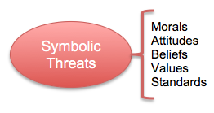

##### 

## **The Consequences of Threats**

Intergroup threats contribute to conflict because they influence behaviors, perceptions, and emotions. An appraisal of threat can evoke strong negative emotions, including that of fear, rage, anger, resentment, frustration, contempt and insecurity. In addition, perceptions of threat reduce emotional empathy for members of an out-group. The cognitive demands of dealing with threats causes a person to be in a sense preoccupied, in turn leading to poor decision-making. Intergroup threats can also influence the in-group’s perception of themselves in comparison to the out-group. This perception can lead to believing that the once "powerful" in-group has now become vulnerable. Negative intergroup perceptions and emotional biases contribute to the response in behavior towards a threat. The level of the behavioral response depends solely on the power of the threatened group. Higher power groups are not used to being threatened as their power generally isolates them from threat. Negative behavioral effects associated with these threats can impede peace and prolong reconciliation. When working in a group and threats and conflicts arise, communication comes to a screeching halt, and the group begins to lose focus of the goals that were initially set which can be detrimental. Communication is the key to all groups succeeding.

### Intergroup Anxiety

Intergroup anxiety refers to the "uneasiness and awkwardness in the presence of out-group members because of uncertainty about how to behave towards them" (Riek, Mania, & Gaertner, 2006, p. 341). This component of Integrated Threat Theory can be considered the strongest threat, as it deals with high emotions between groups. "People feel personally threatened in intergroup interactions because they are concerned about negative outcomes for the self, such as being embarrassed, rejected, or ridiculed" (Oskamp, 2000, p.40). The more anxiety the in-group feels towards the out-group, the more the in-group will anticipate a negative reaction from the out-group. The emotional anxiety can even occur in circumstances when the in-group incorrectly predicts the out-groups response to in-group values. The increased expectation of a negative reaction leads to a higher degree of prejudice and bias between members of the conflicting groups (Riek, Mania, & Gaertner, 2006). Incidents that reinforce the negative feelings between groups can prolong and exacerbate the anxiety felt by both groups.

### Negative Stereotyping

In the last component of Integrated Threat Theory, the in-group develops negative stereotypes about the out-group. Negative Stereotyping occurs when an individual’s “beliefs about the characteristics of groups and the traits of group members” create “expectancies about the type of interactions that can be anticipated with out-group members” (Fiske, Gilbert, & Lindzey 2010). These stereotypes, like any other stereotypes, are based upon attributes the in-group believes the out-group to have (Kendall, 1998). These negative stereotypes towards the out-group are further enhanced as the degree of negative attitudes the in-group has towards the out-group increases (Reik, Mania, & Gaertner, 2006). Two reviews (Nguyen & Ryan, 2008; Walton & Cohen, 2003) concluded that people in the absence of threat make less stereotypical decisions and react in less biased ways in line with Ellemers et al.'s (2002) accuracy prediction.

The theory of accuracy in the absence of threat is supported by the theory of stereotype lift/boost. Stereotype lift/boost occurs when individuals perform better when they are reminded of a positive stereotype about themselves and their group membership (Walton & Cohen, 2003; Wraga, Duncan, Jacobs, Helt, & Church, 2006). When the performance threat is removed because the person is reminded of their stereotypical abilities, they perform at a higher level than when the stereotype is absent. An example of this is described as an Asian student performing well on a math exam compared to others when reminded of their ethnicity before taking the exam (Redmond, 2010).

## **Research Support on Integrated Threat Theory**

Integrated threat theory is fairly new, and therefore does not have the extensive research that other motivational theories have. However, the field of research is growing, and of particular interest is its relevance to present societal issues. The research is valuable as it helps us understand the cognitive processes behind people’s attitudes, beliefs, and behaviors. Some of the research topics the theory can be applied to include:

* Religious intolerance
* Public attitudes toward immigration
* Racial profiling and stereotyping
* Public attitudes toward same gender relationships
* Support for feminist movements
* Diversity and a “national identity”
* Different motives in the workplace

Integrated Threat research has also shown its relevance with issues important to students. For example, one study looked at the cultural adjustment process required of students studying abroad (Fritz, M. V. et all 2008). This study examined the acculturation process of students living abroad and the effects of learning a new language, being separated from family and friends, and managing financial problems. The researchers looked at how Integrated Threat Theory addresses the issue of intergroup anxiety, where a student living abroad may experience feelings of being part of the “out” group.

Based on the study’s findings, the researchers were able to recommend specific program elements that would help foreign students adjust better to a new culture. More importantly, the study found that cultural sensitivity is the most important part of a successful program. A program designed to help Europeans adjust to studying in the U.S. would not be as helpful for a program designed for Asian students for example. Therefore, instead of grouping all foreign students together in a program to help them adjust, programs should be designed for specific cultural groups to help them adjust to their new environment.

One way to improve relations within a group experiencing conflict is to apply the Intergroup Contact Hypothesis, which was first proposed by Gordon Allport in 1954. His hypothesis suggests that under certain circumstances, having contact with members of different groups can reduce prejudice and intergroup conflict. However, the contact situation must include four major conditions in order to see positive effects. These conditions include equal status, intergroup cooperation, common goals, and support by social and institutional authorities. Research conducted in 1961, 1984, 19787, and 2007 has found positive contact has reduced prejudice against blacks, gays, the elderly, and the disabled. (The Inquisitive Mind, 2013).

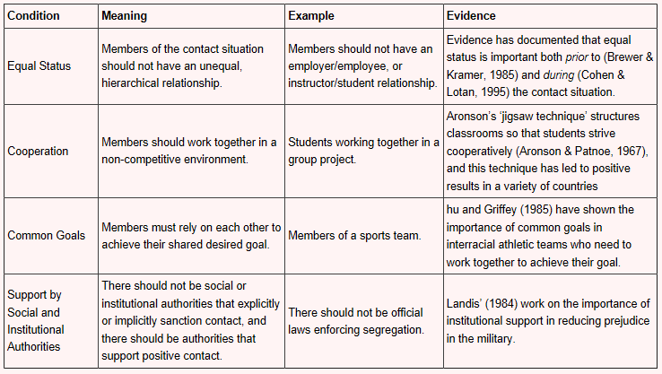

## **Strengths and Weaknesses of Integrated Threat Theory**

The student abroad study mentioned above is one example of Integrated Threat Theory’s application to individual, but most research findings have focused on intergroup relationships and have found analyzing group conflict to be the theory’s main strength. The original theory was found to have some weaknesses over the course of many studies and meta-analysis. First, there were problems in conceptualizing the types of threat and second, the number of antecedents and consequences was too limited.

To address these weaknesses the theory was revised in 2002 (Stephan & Renfro, 2002). The new theory now makes a distinction between threats to the in-group as a whole, and threats to individual members of the in-group, known as personal threats. In addition to this distinction, the antecedents of the theory were expanded upon. In the original theory there were four antecedents of threat; which included strong identification with the in-group, negative personal contact with the out-group, a history of conflict between the groups, and substantial disparities in status between groups.

In the revised theory, the following antecedents were added to the list: relations between groups, which factor in the size of the out-group relative to the in-group within the society, difference variable, including social dominance orientation and self esteem for factoring, cultural dimensions as this is a new domain of variables that can influence perceived threats and includes concepts like, individualism / collectivism, power distance, and uncertainty avoidance, and situational factors, which are variables that affect perceptions of threat like the setting, whether or not and how much the group interaction is structured or planned, and the nature of the interaction (cooperative vs. competitive).

The revised theory provides a much more comprehensive range of applications, but also requires more research to test and validate its concepts.

## **Application of Integrated Threat Theory in the Workplace**

Within an organization at any given time, many groups exist and may be in conflict with each other. An example of groups in conflict can include managers' priorities differing from employees' priorities. There will always be threats in workplaces because people will always have differing motives, needs, and ideas.

Organizational knowledge of Integrated Threat Theory and its implications on group interaction can be essential in preventing or minimizing group conflict. When managers and employees have differing priorities, knowledge of the integrated threats and understanding why groups feel threatened, will allow organizational leaders to recognize the conflict and then work with the two groups to set common goals and priorities to eliminate the competing priorities.

# Social Identity Theory Overview

Social Identity Theory focuses on the relationship between self-concept and group behavior (Hogg & Terry, 2001). This theory explains that different aspects of individuals' personalities motivate them at different times, and that motivation from identity will be decided by the certain situation that the individual is in by relying on personal or social identity (PSU World Campus, L.8, 2012, p.5). Henri Tajfel proposed the Social Identity Theory as a result of work he had conducted in the 1970's concerning "categorization and social perception, intergroup behavior, and the pursuit of social psychological understanding of the causes of prejudice and intergroup conflict" (Abrams & Hogg, 1999). Tajfel et al (1971) attempted to identify the minimalconditions that would lead members of one group to discriminate in favor of the in-group to which they belonged and against another out-group.

Tajfel believed individuals were inconsistent when it came to how they behaved when they related to others in an intergroup setting, opposed to an interpersonal setting and sought to explain the behavior of people in-group situations (Abrams & Terry, 2001). Tajfel identified three components of social identity: self-conceptualization, group self-esteem, and commitment to the group, which when met, led a person to feel connected to their in-group. As a result, all other groups become out-groups and are rivals for status and resources as well as a source for comparison. This can lead to discrimination in favor of the in-group or against other out-groups, as well as stereotyping and prejudice when a perceived threat occurs (Redmond, 2009).

### **In-Group Favoritism**

An in-group can be described as the group of people with whom an individual categorizes himself/herself. From a biological perspective, this behavior is inherent which means that people tend to help members from their own group rather than those from another. People can and will interact with out-groups, but use different strategies with both. Members of an in-group feel a sense of commitment to the group and gain greater esteem from their sense of belonging to the group (Redmond, 2012). In-group favoritism primarily exists to protect the group as individuals and as a group. By giving special treatment to group members, resources may be unavailable to other groups, and that group can maintain a higher status. Typically the larger the in-group, the more power they can impose on others. The overall idea is that members of the in-group stick together and give each other preferential treatment on professionally, financially, or socially.

In-group favoritism can be explained through the average sports fan.  Posten says "sports can work to increase self-esteem for a person by association and affiliation” (Posten, 1998, p.1). As a sports fan, you are extremely happy and proud after your team wins, as if you played the game yourself.  Social Identity Theory also tells us that when our team loses, we will view that defeat positively so as to not defuse our self-esteem, since we have already identified with “our team” (Posten, 1998).

The graphic below illustrates the in-group and the out-group concept:

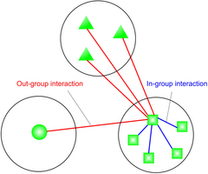

### **Out-Group Derogation**

An out-group can be described as any group outside of an individual's in-group and a group that can be a potential rival/competitor for resources (Redmond, 2012). Individuals in the out-group may be motivated to try and enter the in-group to gain access to limited or previously unavailable resources. Although once groups are formed, it can be hard to move to a new group and the person trying may face resentment from both groups. Members that are in the in-group can attempt to make members of the out-group look bad as to enhance their image and status.

Social Identity Theory explains that every group has some type of social status that goes with its membership. This social status gives it value for the individuals that are members. Individual group members use the status from their membership in the group to gain and maintain self-esteem. The motivations to enhance self-esteem and gain status cause individuals to behave in ways that maintain the group and their memberships in the group. The better one's own group looks in comparison to other groups, the more status the group gains, and the more self-esteem it can provide for its members.

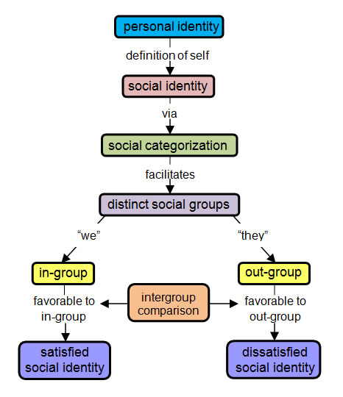

## **Social Identity Theory Components**

According to Social Identity Theory, "social identity and intergroup behavior is guided by the pursuit of evaluative positive social identity through positive intergroup distinctiveness, which in turn is motivated by the need for positive self-esteem" (Hogg & Terry, 2001). In other words, their positive association with their in-group will affect a person’s behavior when that association elevates their self-esteem and/or status. Furthermore, according to Michael Hogg (2006), social identity is motivated by self-enhancement and uncertainty reduction, which causes groups to "strive to be both better than and distinct from other groups" (pg. 120). Central to this theory are three components identified by Tajfel: self-categorization, group self-esteem, and group commitment.

### **Personal Identity**

Mayer, Greenbaum, Kuenzi, and Shteynberg (2009) state "personal identityconsists of moral sensibility and conscience, and also a desire for achievement, mastery, and competence." Personal identity is the "combination of objective biosocial markers such as age, race, sex, and so on, and the personal life history of the individual" (Brewer & Gardner, 1996; Weigert et al., 1986). Personal identity is the aspects of one's self that make them unique and help define that individual (Brewer & Gardner, 1996). Individuals tend to be inconsistent when it comes to behavior in an social setting versus an individual setting. Social identity contrasts with personal identity because individuals will act differently in social settings based on their perceived status within the group.

### **Self-Categorization**

Social Identity Theory demonstrates that "the self is reflexive in that it can take itself as an object, and can categorize, classify, or name itself in particular ways in relation to other social categories or classifications" (Stets & Burke, 2000). This Identification process is known as self-categorization and refers to a person's belief that they belong to a group. A person must categorize or identify him or herself as a member of a group in order to have their self-esteem elevated through association with the group. According to this theory, categorization "sharpens intergroup boundaries by producing group-distinctive stereotypical and normative perceptions and actions and assigns people, including self, to the contextually relevant category" (Hogg & Terry, 2001). In addition, self-categorization can reduce "uncertainty about themselves and others and about how they and others may or ought to behave in specific social contexts" (Hogg & Terry, 2001). In other words, we are able to find out specifics about ourselves and others as well as the appropriate behaviors associated with the group(s) in which we belong. "The core of an identity is the categorization of the self as the occupant of a role" (Stets & Burke, 2000). By assigning roles to individuals that are self-categorized as being part of a group, individuals can derive meanings and expectations associated with their roles, and as a result, are able to create value-based standards that motivate and guide what is perceived to be appropriate behavior.

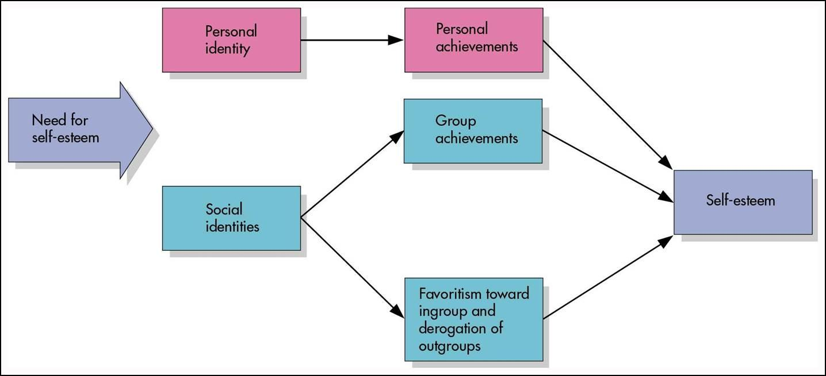

### Group Self-Esteem

Group self-esteem refers to the positive self-esteem or self-identity gained through membership in a group. "The relationship between intergroup differentiation and self-esteem should be assessed by using a measure of esteem at the level of the group or collective, rather than by using measures that address personal self-esteem" (De Cremer, Van Vugt, & Sharp,1999). In order to categorize one's self as a member of a group, membership in the group must hold some value for the person such as improvement in their status or positive personal identity through the association with the group. An example of this would be how memberships in sororities and fraternities constitute high social status among peers, and lifelong association with these groups produces additional personal identity benefits, including self-esteem.

The theory suggests that people have a need to "see themselves in a positive light in relation to relevant others" (Hogg & Terry, 2001) and that this can be achieved in a group context through "making comparisons between in-group and relevant out-groups in ways that favor the in-group" (Hogg & Terry, 2001). "The better one's group looks in comparison to other groups, the more status the group gains, and the more self-esteem it can provide for its members" (Morton, Postmes, Haslam, & Hornsey, 2009; Tajifel & Turner, 1979, 1986). "Self esteem and status are the main reasons that social identity is proposed to motivate individuals. But also remember that a person must also first describe him or herself as part of the group (self-categorization) and want to be part of the group (commitment)" (Redmond, 2010).

### Group Commitment

Group commitment refers to the strength of the commitment a person feels to their in-group. This is important because if an individual believes they can move into a higher status group, this person will be "unlikely to show much solidarity or engage in much direct intergroup competition" and will instead attempt to "un-identify and gain psychological entry to the dominant group" (Hogg & Terry, 2001).

When a person identifies with a group, he or she gains positive self-esteem through the group, and feels committed to the group; the person will be motivated to "maintain the group and their memberships in the group" (Redmond, 2009). A 16-item scale was developed in an effort to measure the level of self-esteem that can be derived from being a member of a group. A study was conducted, incorporating the scale, and found that "people high in collective self-esteem, engaged in indirect enhancement of the in-group" (De Cremer, Van Vugt, & Sharp,1999).

There can also be adverse consequences; however, when an individual over-identifies with a group. When a person becomes too attached to a group, it can lead to stereotyping and the degradation of out-groups as well as over-dependent, antisocial behavior, decreased creativity, and a decreased sense of self for the individual (Hogg & Terry, 2001). As a result of being too attached, the lines that once separated the individual identity from that of the group may become blurred. If this loss of individuality takes place, it may result in a decreased ability to create an independent self-concept apart from the group. This can be a potentially harmful situation if taken to extremes. An example of this would be The Jonestown Massacre. Orchestrated by Jim Jones, The Jonestown Massacre showed the extremes people will go to in order to identify themselves with a group (Information Please, 2007). Charles Manson and his followers are examples of extreme group behavior in which the lines became blurred (Rosenberg, J., About.com Guide).

**Research on Social Identity Theory**

A vast amount of research has shown support for the Social Identity Theory, both in labs and in organizations (Redmond, 2009). The research has been conducted through experiments, self-report measures, and observations and has largely "focused on intergroup relations, prejudice, discrimination, stereotyping, collective action, and other such behaviors" (Hogg & Terry, 2001). (Social Identity theory has generated a vast amount of empirical research. It has stimulated a plethora of different analysis and hypothesis in a wide range of areas associated with the theory. Perhaps most importantly the theory and its research has provided new ways of thinking about major social-psychological phenomena, in particular, the individual-group relationship and group processes, prejudice and inter-group relations, social stereotyping, and the self-concept and personality (Ellemers, 1999). The perspective represents an approach in social psychology that is unique in that it embodies a general meta-theory, social interactionism.

In recent years as technology has become more prevalent, there has been research done on how groups are affected when members of the group only communicate via telephone or computer and not face-to-face in a co-located environment. This research has found that when the "dispersed workforce" feels psychologically connected to the organization, the goals of the group and the organization converge and this "allows its members to act as a coordinated unit" (Hogg & Terry, 2001).  Research concerning gender discrimination has also been a focus in recent years as more and more women are entering fields typically dominated by men. These studies show that in certain situations women do experience discrimination by men as well as other women, which can lead to less job satisfaction, lower organizational commitment, turnover, absenteeism, and lower job performance (Hogg & Terry, 2001). This research is useful for organizations to be able to understand social identity and to initiate interventions such as intergroup contact, which has been shown to promote for positive intergroup attitudes (Hogg & Terry, 2001).

**Current Research**

Trepte and Kramer (2006) measured social identity theory in media in two experiments. Their results were mixed, finding that men did prefer television with male protagonists while women did not show a significant bias. Also, a strong bias for nationality was not found in U.S. or German subjects, although this bias was stronger in subjects from Great Britain.

Reicher & Haslam (2006) took their own turn on the infamous Stanford Prison Experiment. Prisoners were given the opportunity to be promoted to guards, who were the superior group in this study. The guards bonded much more closely and exhibited in-group favoritism to a large degree.

Chow & Crawford (2004) surveyed a relatively small (approximately 2000 employees) United Kingdom company. Men outnumbered women 3:1, and minorities comprised 20% of the workforce. 150 employees were surveyed, and the survey received a 70% response rate, with the proportion of genders and ethnicities replying being roughly equal to the overall company demographics. In decision-making meetings, 10% of whites reported their views were "always accepted," while no minorities reported this. No white employees reported having their view rejected at these meetings, 41.2% of black employees reported just that. Females were 200% more likely than males to have their views rejected. Minorities and women reported sometimes preferring to be silent in these meetings because they didn't feel they were respected. 20% of males described co-workers as very supportive, while no women reported this. Approximately 63% of females and 75% of minorities described co-workers as largely unsupportive. Clearly, the perception at this company was that the in-group – older white males – displayed significant in-group favoritism.

Madera, King and Hebl (2012) conducted a study of 211 working adults via an online survey to discover whether displaying or suppressing an identity such as ethnicity, religion, sexual orientation, or disability in the workplace is related to perceived discrimination, job satisfaction, and turnover intentions. The results of the survey indicated that efforts to suppress a group identity had a negative effect on the individual causing a negative workplace experience. However, individuals that manifest their identities in the in-group and manage identity in the out-group have a more positive reported work experience. These results suggest that employees using these identity management strategies in the work place have significant positive consequences.

**Research of the 90s**

Nass, Fogg, & Moon (1995) conducted another study asking the question “how powerful is social identity?” They used a computer in place of a participant in a group interaction. They aimed to investigate two key questions, “(1) Can researchers manipulate affiliation (create a sense of teamwork or groupfulness) between humans and computers, and (2) will the effects of human-computer affiliation be similar to documented effects of human-human affiliation?” (Nass, Fogg, & Moon, 1995).

Nass, Fogg, & Moon (1995) used twenty-eight volunteer college students, with equal numbers of men and women in each condition and all with similar levels of computer experience. The two between-subject conditions were, team and individual, identifying two key factors, group identity and interdependence. In order to create a feeling of “teamness," or the presence of affiliation, participants in this group were told they were part of the “blue team” and that they were to interact with a teammate called the “blue computer." Interdependence was manipulated by telling each participant, "he or she would be evaluated as a team with the computer.” In order to create “individualness” of absence of group affiliation, the participants in this group were told that even though they were working with the computer, they were working as an individual, a “blue individual” working with a “green computer."

Prior to performing the experiment, participants were told that they would be working on a task called “The Desert Survival Problem." The subjects read a short description of the problem, and then they were asked to complete a questionnaire in which they ranked the importance of twelve items needed for desert survival. When they were escorted into the computer lab, participants entered their own data into the computer. The computers contained a ranking of the items that was different from the participants. The participants then carried out a virtual chat with the computer about the “Desert Survival Problem.” After the interaction, participants were given the questionnaire again to determine if their answers would become similar to those provided by the computer. Nass, Fogg, & Moon (1995) determined “the data shows that the experiment successfully manipulated the subject's perceptions of social identity.” The members of the “team” condition perceived themselves as being affiliated with the computer more than those that were part of the “individual." The data also shows significant behavioral conformity in the “team” condition with the computer (Nass, Fogg, & Moon, 1995).

Wilder (1990) tested in-group and out-group social identity when he had subjects wear badges with their group's name and put subjects in rooms labeled with groups' names. Subjects were more influenced by messages written by in-group members even when messages were entirely identical.

Lalonde (1992) studied a hockey team, which was performing rather poorly. Lalonde questioned the players, and the team responded that their poor performance was due to other teams playing dirty. Observation, however, indicated that other teams were not playing dirty, and the poorly performing team was merely exhibiting in-group bias.

**Research of the 70s and 80s**

Mackie (1986) studied group interdependence and manipulated intergroup competition by telling subjects they could win money by following specific rules. All the subjects listened to a tape of a discussion of supposed group members, but those in the intergroup competition thought the group norms were more extreme and were more polarized in their attitudes.

Breakwell (1978) studied teens who identified themselves as soccer fans. Some of the teens went to games while others did not. Breakwell found that those who did not go to games were the most vociferous in claiming themselves as fans and showed the most in-group bias. Breakwell concluded that these fans felt a greater need to prove themselves as fans because they didn't attend games.

# ****Strengths and Weaknesses of Social Identity Theory****

Originally founded by Henri Tajfel and John C. Turner, research on Social Identity Theory has been conducted since approximately 1970. Within this theory there have been discoveries of various strengths and weaknesses of this theory. The weaknesses focus on elusive characteristics of an individual to justify their motivational reasoning for ones actions. Based on the situation a person may choose their personal identity or their social identity.

There are several strengths within this theory; the first is that this theory has a surplus of empirical evidence to support it both in the lab and organizations (PSU, 2011). Second, it comprises societal and personal features along with explaining the motivational reasoning for the behavior. Due to the fact that an individual’s identity is not just limited to their personal identity, this theory incorporates the motivational reasoning for both the personal and social characteristic of an individual. “Another strength is that it includes social and personal aspects in addition to describing how the situation adds to behavior” (PSU, 2011).

Social Identity’s “main weakness is that it relies heavily on an intangible aspect (identity) to explain why people are motivated to behave the way that they do” (PSU, 2011). For instance, it has been shown that when a person feels that they are exposed to an evaluated ranking threat, one's personal identity will emerge and motivate that person’s behavior. On the other hand, when ones group has been threatened, that person’s social identity determines one’s motivational behavior. An individual’s personality can obstruct or support the motivational behavior of a group. Some people "are primarily individual-oriented, gaining their self-esteem from their own personal accomplishments", while others in low status groups may not perceive any value from belonging to their group (Stangor, 2004). Another weakness for this theory is "the fact that while there are several valid measures of identity, none has become widely accepted among organizational psychologists as of yet" (PSU, 2011). A further weakness is that one's behavior is not likely to be determined fully by one's group membership and will also not be completely independent of it (Batalha, 2008). There is evidence that shows that the self and in-groups are linked together (Smith & Henry, 1996), making the case that the two are linked, and that one's social behavior expresses both their individuality and group membership.

### **Application of Social Identity Theory in the Workplace**

Social Identity Theory can be a useful tool in understanding organizational behavior as well as to boost self-confidence and improve attitudes of employees. Studies suggest individual employees may exert increased effort and experience greater motivation if working on tasks for their collective group rather than in working for his or herself (Haslam, 2003). In addition, because of the tendency to form groups in the workplace, employers are able to choose rival organizations to use as a comparison in order to set "benchmarks" for their own employees. This rival organization will be seen as an out-group, which "threatens the group's prestige" and motivates the in-group to become more competitive (Hogg & Terry, 2001).

Awareness of Social Identity Theory can be beneficial for any company. Social Identity theory posits that individuals identify themselves based on characteristics like age, gender, or race. They identify more with similar people (in-group) than with those who are less similar (out-group). Due to things like in-group favoritism and negative stereotyping, minorities are often excluded from group membership and decision-making activities. This, in turn, reduces opportunities for career advancement and results in a perception of unfair treatment, resulting in a negative work environment for everyone. An understanding Social Identity Theory by key management personnel can ensure that minority groups are included in functional groups and the decision-making process, providing a better work environment for all employees (Crawford, 2004).

Workplace interventions can also be useful to reduce conflict between rival groups within the same organization. When employers have people from two different out-groups work together, this interaction between the two can lead to "attitude and stereotype change that is extended from the particular interaction partner to other members of his or her group" (Hogg & Terry, 2001). In a situation where an organization is merging with another company, each organization has a strong identity. The leadership within the organization will put up some resistance to the merger, as neither organization will give up their social identity. To make the merger easier, the organizations will make the merger slower and create a shared identity before the official merger occurs (PSU, 2011). In many situations, the organization will also change their name to create a new combined organization. Through understanding the Social Identity Theory, interventions such as this can play a vital role in organizations to limit harmful stereotypes, prejudices, and discrimination in the workplace as well as to ensure employees feel connected to their respective groups as "organizations can suffer from individual members who are psychologically alienated" (Hogg & Terry, 2001).

# *****Social Dominance Theory Overview*****

Social dominance theory was developed to examine the process of social structure in human societies. Social dominance theory states that all people belong to groups.  The membership to these groups is important to them because the groups provides support and protection for them(PSU WC L.8, 2016).  The theory helps us understand how individual groups members behave to maintain them. Social dominance Theory also helps to explain how groups form into hierarchies.  Group members are motivated to behave in ways that maintain these hierarchies.  The few dominant groups at the top of the hierarchy possess the most power and resources (PSU WC L.8, 2016).  Group members that are lower in the hierarchy behave in ways that maintain it in an attempt to move up.  When looking to bring in new members from out-groups members will look for people who most resemble those in the in-group, not necessarily those who will be the most valuable.  This type of motivation can help us to understand how prejudicial behavior, stereotypes and discrimination are produced and maintained. The theory allows the many levels of society to be examined using this model (Pratto &Sidanius, 2006).

### Positive Social Value

Positive social value is what motivates high status group members to maintain the hierarchy (Sidanius & Pratto, 1999). Members of the high status group maintain hierarchy by keeping in-group favoritism and out-group derogation practices. This helps uphold the high-status group's status, power, and resources so that they alone can continue to benefit. Subordinate group members on the other hand help keep the status quo by not being able to challenge a dominant group, although they strive to work their way upward, hoping that they will eventually join or become the dominant group so that they can have access to the positive social value (Pratto et al., 2006; Sidanius & Pratto, 1999).

### Negative Social Value

Negative social value is what motivates low-status group members to join high-status group members (Sidanius & Pratto, 1999). If and when membership is presented by the high-status group, group conflict between the group with high-status or positive social value and the group with the negative social value is likely (Pratto et al., 2006; Sidanius & Pratto, 1999).

### **Behavioral Asymmetry**

The difference in these motivations between dominant groups and subordinate groups has been labeled behavioral asymmetry (Pratto et al., 2006; Sidanius & Pratto, 1999). The Social Dominance Theory states that many subordinate groups will work to maintain the social hierarchy even if they are put at a disadvantage, because the existence of the subordinate group gives an opportunity to join a high-status group. This is an overlapping concept known as legitimizing myths (Sidanius & Pratto, 1999).

Social Dominance Theory originated in an attempt to coalesce the more classical theories of social behavior such as Marxism and more contemporary theories such as Social Identity Theory into a unified behavioral model to explain bias in group behavior (Sidanius & Pratto, 1999). Social Dominance Theory is based on the idea that in virtually all societies, group-based hierarchies are formed in which both dominant and subordinate groups co-exist.  As is naturally the case, the dominant group(s), referred to as having "positive social value" in the group structure; has access to rights and privileges that are denied to subordinate group(s) because their (negative) social value and ability to bring to bear power and resources are limited (Sidanius & Pratto, 1999). As we will see below, this theory has significant practical, yet profound implications on behavior across all modes of group-based social interactions including race, gender, age and even organizational lines.

## **Social Dominance Theory Components**

A principle distinction between Social Dominance Theory and similar group-based social theories, such as Social Identity Theory, is that group members are not only motivated to protect the group to preserve their social status, but feel compelled to justify their group behavior (dominant or subordinate) through a hierarchical system represented through the following components: Legitimizing Myths, Trimorphic Structure, and Social Dominance Orientation (Redmond, 2009).

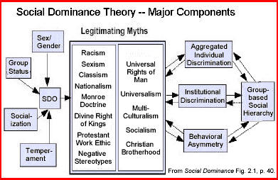

### Legitimizing Myths

Social systems engage in certain types of social practice. Social practices are responsible for distributing social value in social systems. Legitimizing myths make up the attitude and values that fuel moral and cognitive justification for the social practices. Legitimizing myths are a way in which group based social hierarchies are produced and maintained (Sidanius&Pratto 1999). “Legitimizing myths consist of attitudes, values, beliefs stereotypes, and ideologies that provide moral and intellectual justification for the social practices that distribute social value within the social system” (Sidanius & Pratto, 1999, p. 45). Legitimizing myths can be broken down into two distinct groups: hierarchy-enhancing legitimizing myths (HELM) and hierarchy-attenuating legitimizing myths (HALM).

### **Hierarchy-Enhancing Myths**

HELM's not only organize individual, group, and institutional behavior in ways that sustain dominance, they also justify the social structure of the hierarchy.  This can often lead subordinates to collaborate with dominants in the maintenance of oppression (Pratto, Sidaneous, Levin, 2006, p. 275). A contemporary example of a HELM is the absence of a female candidate for US presidency. In 2008, the Democratic Party chose Hilary Clinton as their candidate for vice-president; this is proof of a fading, but resilient HELM. Voting rights for women is another example in US history; this extended from policy to citizen beliefs.

### **Hierarchy-Attenuating Myths**

On the other hand, HALM’s act as a counterweight and attempt to provide a more symmetric playing field for inferior groups.  They bring equality within groups (PSU WC L.8, 2016).  Examples of HALM's are political doctrines such as social democracy, socialism, and communism, religious doctrines such as the preferential option for the poor or inclusive and egalitarian themes in the New Testament, and humanist doctrines such as the universal rights of man, feminism, and human rights (Pratto, Sidaneous, Levin, 2006; p. 275).

|  |  |  |
| --- | --- | --- |
|  | Legitimizing Myths |  |
|  | Hierarchy-Enhancing (HELM) | Hierarchy-Attenuating (HALM) |
|  | Literature, written policy, attitudes, values, beliefs, stereotypes, and ideologies that provide moral and intellectual justification for the dominant group to have access to vast resources and remain in power. | Literature, written policy, attitudes, values, beliefs, stereotypes, and ideologies that provide moral and intellectual justification for the inferior group to progress through the ranks and have more access to resources and equality. |

These concepts can both be thought of as discriminatory; it will depend on which group (dominant or inferior) views the actions, behavior, beliefs, etc. Both hierarchy-enhancing and hierarchy-attenuating myths are tied to the cosmologies, patterns of behavior, and relations that constitute culture (Pratto, Sidaneous, Levin, 2006, p. 275).

Dambrun, et al. (2009) upholds Sidanius and Pratto's contention that both dominant and subordinate groups strive to sustain group-based hierarchies "…by the development of opposing ideologies that promote, or attenuate group inequality and domination;" otherwise referred to as "legitimizing myths."  In other words, social groups play off each other through "social policies" to maintain the group hierarchy but are motivated to do so for different reasons. The differences between these reasons are referred to as "behavioral asymmetry" (Redmond, 2009).

Asymmetry occurs when the dominant group wishes to maintain their positive social status, yet the subordinate group wishes to climb the proverbial ladder and participate in the myriad advantages of the dominant social group.  As selfish as we are, social groups are not fully inclusive.  These groups seek to maintain their social status by justifying behaviors through mitigating perceived gaps in social status.  This is accomplished through legitimizing myths - in the form of perceived negative stereotypes, values and beliefs against the opposing groups.  For example, in an Eibach & Ehrlinger (2006) study, "White Americans perceive that more progress towards racial equality has been made than Black Americans do."  Legitimizing myths serve to reinforce the inverse perception that perceived differences between dominant social groups are less than the perceptions of subordinate status groups.

## **Trimorphic Structure of Group-Based Hierarchies**

There are three group-based social hierarchies recognized in the Social Dominance Theory. This trimorphic structure of human society is universal.   The three hierarchy systems are an age system, a gender system and an arbitrary-set system. The age system is one in which adults have more power over children. In the gender system, men have more power over women in areas such as politics and military. The arbitrary-set system is based on what the society, in which the group is based, finds or holds socially distinct in terms of power.  Examples of arbitrary-set are class, ethnicity and nationality (Pratto &Sidanius, 2006).  Unlike the age and gender systems, the arbitrary system has a very high degree of alterability in terms of which distinction in the group become socially significant. There is also a higher degree of violence in arbitrary set groups. It is thought that arbitrary-set hierarchy focuses mostly on the control of subordinate males by coalitions of dominant males (Pratto &Sidanius, 2006).

Our predisposition to join groups is an essential element of Social Dominance Theory that assumes a trimorphic structure of group-based social hierarchy in which members are stratified into social groups based on characteristics related to the following three structures (Sidanius & Prato, 1999).

1. Age System - Older individuals have a higher positive social value and are motivated to maintain their social stature (PSU, 2014).
2. Gender System - Males hold a higher positive social value than women and are motivated to maintain the status quo (PSU, 2014). This system was reinforced through a study by Huang & Liu in which they demonstrated that men have a higher social dominance orientation score than women (2005). A high social dominance score is a feature of those with a strong disposition towards the gender system status quo.
3. Arbitrary Set system - This system is made up of multiple ordered factors of human belief categories such as religion, organizational values, and statutory authority (PSU, 2014). These unique categories influence status and value within groups.  When deciding which side of an argument is correct support can be made for both sides as far as which one has the higher positive social value (PSU WC L.8, 2016).

The inclusion (or exclusion) of membership within the arbitrary set system however, is dependent upon the factor(s) applied to the group.  For example, a social group based on ethnicity or religion will include a very specific subset of participants to the exclusion of all others.

For these reasons, the arbitrary set system represents the most dynamic group-based social hierarchy.  This system has the potential to be the most inclusive (and positive) in terms of being socially constructive, as well as the most exclusive, or socially destructive.  For example, a social group based on politically conservative, older white males is likely to wield disproportionate power as a dominant group over most other subordinate groups seeking to achieve higher status.

## **Social Dominance Orientation (SDO)**

SDO is defined as "...the degree to which individuals desire and support group-based hierarchy and the domination of 'inferior' groups by 'superior' groups" (Sidanius & Pratto 1999, p. 48).  An individual with high SDO, will behave in ways that support group-based hierarchies and discriminates against subordinate groups.  For example, a person with high SDO will most likely select a job candidate that is in a high-status group despite another candidate from a lower-status group being more qualified for the job.  Even if the individual with high SDO belongs to a low-status group, they are more likely to favor someone from a 'superior' group and discriminate against individuals from 'inferior' groups.  Individuals use legitimizing myths in order to justify and support why their group is superior to another.  In-group favoritism is more likely for members of high-status groups, for example, Whites and men, and less likely for low-status groups such as Blacks, Latinos, and women (Umphress, et. al, 2008).  In research studies, an individual's SDO has been measured by utilizing a series of statements to which participants must indicate their agreement.

## **Assess Your Social Dominance Orientation**

#### **Social Dominance Orientation Scale (n.d.)**

Indicate your agreement with the following statements. Use the following scale to respond to each statement. It might be easier to cut and paste this into a Word document and fill in your answers.

7 - strongly agree     6 - agree    5 - somewhat agree   4 - neither agree nor disagree   3 - somewhat disagree   2 - disagree   1 - strongly disagree

______ 1.  Some groups of people are simply inferior to other groups.

______ 2.  In getting what you want, it is sometimes necessary to use force against other groups

______ 3.  It’s OK if some groups have more of a chance in life than others.

______ 4.  To get ahead in life, it is sometimes necessary to step on other groups.

______ 5.  If certain groups stayed in their place, we would have fewer problems.

______ 6.  It’s probably a good thing that certain groups are at the top and other groups are at the bottom

______ 7.  Inferior groups should stay in their place.

______ 8.  Sometimes other groups must be kept in their place.

______ 9.  It would be good if groups could be equal.

______ 10. Group equality should be our ideal.

______ 11. All groups should be given an equal chance in life.

______ 12. We should do what we can to equalize conditions for different groups.

______ 13. Increased social equality is beneficial to society.

______ 14. We would have fewer problems if we treated people more equally.

______ 15. We should strive to make incomes as equal as possible.

______ 16. No group should dominate in society.

**Scoring**

For items 1 thru 8, sum the numbers to get the subscore for those items           Score  __________

For items 9 thru 16, scoring is reversed. Use the below conversion.                   Score  __________

7 converts to 1, 6 converts to 2, 5 converts to 3, 4 converts to 4, 3 converts to 5, 2 converts to 6, 1 converts to 7

**Your total score is the sum of the two parts.**             **Total Score** __________

***Scores above 75 reflect a strong tendency toward social dominance orientation***

## **Research on Social Dominance Theory**

Social Dominance Theory takes a unique approach to understand intergroup dynamics by looking at what motivates people to protect and further the interests of the group(s) they belong to. The theory is useful for examining how societal groups are formed and maintained. Some modern day issues this theory has been applied to include:

* Immigration issues
* Sexism
* Sociopolitical attitudes
* Inequality
* Interracial marriage
* Societal hierarchies
* Prejudice & discrimination
* Authoritarianism

This broad range of applications has resulted in an extensive and growing body of research. Research ranges in scope from understanding extreme inter group conflicts to individual bias.

Kristin Henkel and Adam Pearson conducted an experiment examining Social Dominance Theory and Terror Management Theory in predicting group prejudice.  They tested the effect of Social Dominance Orientation on mortality salience.  Mortality salience involves a psychological connection to one's own social group.  These experiments helped to show that social dominance orientation was a strong predictor of group prejudices.   The first experiment tested this conclusion by pretesting participants on SDO.  These pretested participants were randomly assigned to a mortality salience or no treatment control group.  "SDO moderated the effects of mortality salience on attitudes toward social groups that were either marginalized or perceived as non-American.  Low scores on the SDO pretest showed significantly less favorable attitudes towards these groups as compared to the control group in regards to mortality salience.  Participants who scored high on the SDO pretest showed no significant difference between conditions" (Henkel, 2009).

Bertrand & Mullainathan (2004) performed a field experiment to test racial discrimination in the labor market. They submitted fictitious resumes to various job advertisements found in Boston and Chicago Newspapers. The resumes contained either a very “African American sounding name” or a very “white sounding name.” They found that there was a “significant discrimination against African-American names: White names received fifty percent more callbacks for interviews” (Bertrand & Mullainathan, 2004, p.1). These results support Social Dominance Theory.

The results from the studies from (Umpress, Simmons, Boswell, and Carmen Triana, 2007) and from other studies (Jost & Burgess, 2000; Sidanius & Pratto, 1999; Umphress et al., 2007) demonstrate that organizational leaders often place individuals from traditionally underrepresented groups on staffing committees in an effort to enhance diversity within their organizations. And that when in fact individuals high in SDO will react negatively toward low-status group members, even those to which they belong. Thus, this strategy to place individuals who are members of low-status groups in selection positions to increase diversity may not be effective to the extent that organizational leaders may think it is. According to Umpress, Simmons, Boswell, and Carmen Triana (2007) "a more effective strategy would be to ensure individuals with lower levels of SDO are involved in staffing decisions" (Umpress, et al., 2007, p. 982-993).

Theoretical predictions of social dominance theory were tested by Levin & Sidanius (1999). Questionnaires assessing in-group identification, social dominance orientation, and in-group and out-group effect were distributed to American and Israeli university students. The results of these questionnaires indicate that “for all high- and low-status groups, stronger in-group identification was associated with more positive in-group affect, and for nearly all groups, higher SDO was associated with more negative affect toward the low-status group” (Levin & Sidanius, 1999). The results also support Social Dominance Theory, in that the data finds that SDO was “positively associated with in-group identification for all high-status groups, and negatively associated with in-group identification for almost all low-status groups” (Levin & Sidanius, 1999).

## **The Need for Future Research: Social Dominance and Work place bullying**

Bullying has been around since humans began to compete for resources but just recently it has become a focus of research in the organizational world.  Bullying has negative effects not only on the individual but on the organization as well.  As for the effects on the organization, bullying has been shown to be associated with higher turnover and intent to leave the organization, higher absenteeism, and decreased commitment and productivity (Salin, 2003). In addition, for the victim bullying has been reported to result in both lower levels of job satisfaction, psychosomatic symptoms and physical illness, and possible expulsion from the labor market. (Salin,2003).

Social Dominance Theory indicates that human society is ordered by systems of group-based hierarchies and that individuals within those groups are motivated for the most part to behave in ways that maintain those hierarchies (Pratto, Sidanious, & Levin, 2006; Sidanius & Pratto, 1999). In particular, groups with a positive social value would be considered high status groups, although the idea of positive social value is a somewhat broader construct. It indicates that in addition to status, the dominant group possesses more power and resources. In contrast, members of subordinate groups possess negative social value; and lack power, resources, and other desirable attributes (Pratto et al., 2006; Sidanius & Pratto, 1999).

## **Strengths and Weaknesses of Social Dominance Theory**

Social Dominance Theory is a fairly new theory and so one of its criticisms is that it is still developing. It has been refined and undergone a couple revisions since originally published. In addition to the theory’s development, more research needs to be applied to the theory in order to thoroughly test and validate it. (Rubin & Hewstone 2004)

A significant strength within this theory is that it has been found to be a predictor of discrimination. According to Sibley & Duckitt's (2008) meta-analysis found that Social Dominance Orientation is a strong predictor of discrimination in general. Another strength of this theory is that it is one of a few that take into account several variables that are usually disregarded or minimized. “Social Dominance Theory's strength on the other hand is that it is a very comprehensive theory that includes variables that many other organizational theories either downplay or ignore (ex. biology and the larger social context)” (Redmond, 2010).

A weakness of the theory is that social dominance orientation (SDO), while having a body of scientific literature that is well-established, has not been widely outside of the US (Heaven, 2001, pp. 89-90).

## **Application of Social Dominance Theory in the Workplace**

We see the effect of social dominance, as described by social dominance theory, in our work places today. The social hierarchy remains the same as it has been in the past, possibly in smaller doses. Women and minorities have fought for a long time for equality, and although we have come a long way as a society, this equality has not been achieved. Women now make up 46% of the workforce, but men still make up the majority of the high-paying senior leadership positions (U.S. Bureau of Labor Statistics, 2008). We also see an effect in the minority populations of the workforce, where Whites are still 11 times more likely to hold management positions than Blacks or Hispanics. (U.S. Bureau of Labor Statistics, 2006). These issues can be addressed by a better understanding of the social dominance theory and social dominance orientation.

As demonstrated within the studies and article from Umpress, Simmons, Boswell, and Carmen Triana (2007), "SDO has the potential to explain two fundamental issues within organizations: (a) the tendency for individuals to discriminate against members of low-status groups and (b) the tendency for individuals to follow the instructions of authority figures. With regard to the first tendency, social dominance theory provides the theoretical lens to explain how individual differences in SDO may result in discrimination" (p. 982-993). This was clearly seen when an organization was found to hire more white males over females and racial minorities. When the authorities within the organization made it clear that the hiring process was based on performance of an applicant, the level of discrimination was greatly reduced ( Umphress, Simmons, Carmen, 2008).

According to Sidanius & Pratto (1999), the Social Dominance theory is based upon “Psychology's greatest insight that human brain forms and is formed by human society." Social Dominance of social hierarchy can be seen in groups separated by sex, social class, religion, skin color, and nationality. The dominant group in any setting is most likely the one with positive social values that other groups strive to accomplish. The positive social values may be beautiful homes, good health care, or high social status. The group being dominated may have low social status, high risk, and negative emotions (Sidanius & Pratto, 1999).

Understanding the aspects of Social Dominance Theory can help in the workplace by reducing instances of discrimination in selection practices.  This can include practices such as hiring, promotion, awarding raises, selecting individuals for different work projects, etc.  As found in studies performed by Boswell, et al. (2008), Social Dominance Orientation (SDO) has an inverse relationship with intent to select individuals from low-status groups.  As an example of these findings, men (typically having high SDOs) are less likely to select women (typically considered low-status group members) regardless of qualifications. The studies by Boswell, et al. (2008), also found one way to combat this discrimination is to have managers or other leaders from an organization stress the importance of selection based on job qualifications that are defined by objective criteria. In order to set objective criteria the organization needs to have set position descriptions based on job analysis and compare candidates against these criteria to determine the best fit. When conducting the job analysis the following should be considered: essential functions of the position (job tasks, job accomplishments), job setting (physical location and office conditions, technology used, any travel involved or special movements, position in the organization, etc.), and worker qualifications for the job (physical requirements, education requirements, prior experience, general skills, and on-the-job or off-site training) (Department of Labor, 1994).

**What drives intergroup behaviour?**

* A sense of **relative deprivation** is a precursor of intergroup behaviours such as riots or other collective actions and social protests.
* According to the **J-curve**  hypothesis, when people feel that their rising expectations are no longer being met, or there is a sudden drop in attainments, they feel an acute sense of relative deprivation, which can lead to social unrest — so-called ‘revolutions of rising expectations’.

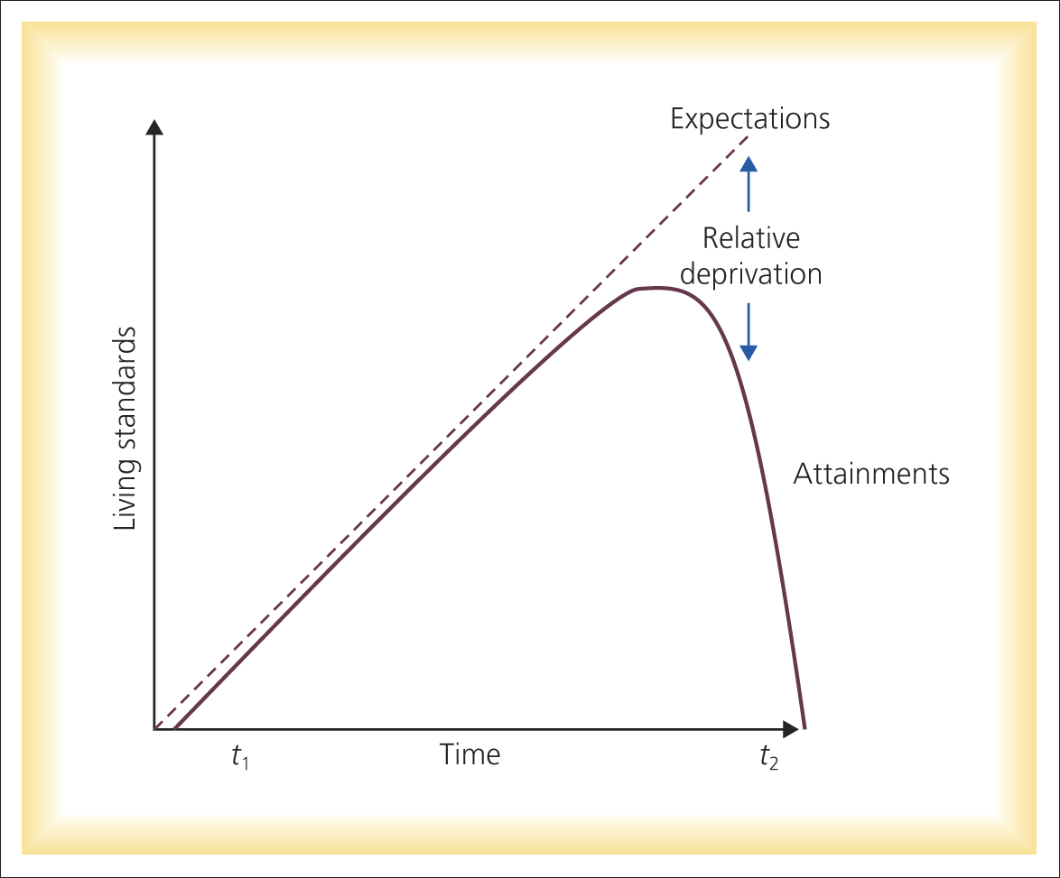

* Not all relative deprivation produces collective action. If you feel deprived as an individual relative to other individuals (**egoistic relative deprivation**), you are more likely to feel depressed and de-motivated.
* It is **fraternalistic relative deprivation**, a sense that your group is deprived relative to other groups, that plants the seeds of collective action and protest.
* For fraternalistic relative deprivation to have this effect, four other conditions need to be met:
  + (a) you need to identify with your group,
  + (b) social action needs to have some chance of succeeding in addressing your deprivation,
  + (c) a sense of injustice, both distributive and procedural, needs to be felt, and
  + (d) there needs to be a relevant comparison outgroup.
* Even if all the conditions are met for social protest or collective action, many sympathisers simply do not take part.
* This is a manifestation of the wider problem that people’s attitudes do not readily translate into behaviour
* Attitude-behaviour correspondence is increased if people identify strongly with the group, social action is normative of group membership, people feel they have the capacity to take part, and so forth.
* Social protest is also like a social dilemma. Even though effective protest benefits all, participation can be risky for the individual, so it is tempting to let others take the risk while they benefit from the success.
* **Lead to conflict.**
* **Ethnocentrism**, a perception that all things ‘ingroup’ are superior to all things ‘outgroup’, is intrinsic to intergroup behaviour.
* According to **realistic conflict theory**, ethnocentrism is produced when two groups have the same goal but only one group can achieve the goal, at the expense of the other. This kind of goal relationship produces competition and intergroup antipathy because the other group is effectively preventing your group from achieving its goal.
* Where two groups have the same goal but the goal can only be achieved by cooperative interaction (a **superordinate goal**), the groups cooperate and thus help each other, producing more favourable intergroup attitudes.

How interpersonal and intergroup behaviors are related:

Positive Interpersonal relationship leads to Intergroup Harmony

Intergroup Conflicts

Intergroup Competition

Interpersonal Competition

Group Formation/

Solidarity

Interpersonal Conflicts/ Reduced Group Solidarity

Intergroup Harmony

Intergroup Cooperation

Strong Interpersonal Relationship

**Social identity**

* Social identity is a theory formed by Tajfel and Turner to understand the psychological basis of intergroup discrimination. It comprises three elements:
* **Categorization**: We often put others (and ourselves) into categories. Labeling someone with a certain name (lecturer, student) are ways of saying other things about these people.
* **Identification**: We also associate with certain groups (our *ingroups*), which serves to bolster our self-esteem.
* **Comparison**: We compare our groups with other groups, seeing a favorable bias toward the group to which we belong.
* Social Identity Theory is a diffuse but interrelated group of social psychological theories concerned with when and why individuals identify with, and behave as part of, social groups, adopting shared attitudes to outsiders.
* It is also concerned with what difference it makes when encounters between individuals are perceived as encounters between group members. (i.e. when you ask a question, are you asking me (john), or can it perceived as a student asking a lecturer.
* Social Identity Theory is thus concerned both with the psychological and sociological aspects of group behaviour.
* Such groups are mentally represented by **prototypes** (fuzzy sets of attributes) that capture ingroup similarities and intergroup differences in such a way (i.e., conforming to the **metacontrast** principle) as to maximise group distinctiveness (i.e., **entitativity**).
* Categorization of self and others causes perception and behaviour to conform to the relevant prototype, a process of depersonalization. Establishment of norms

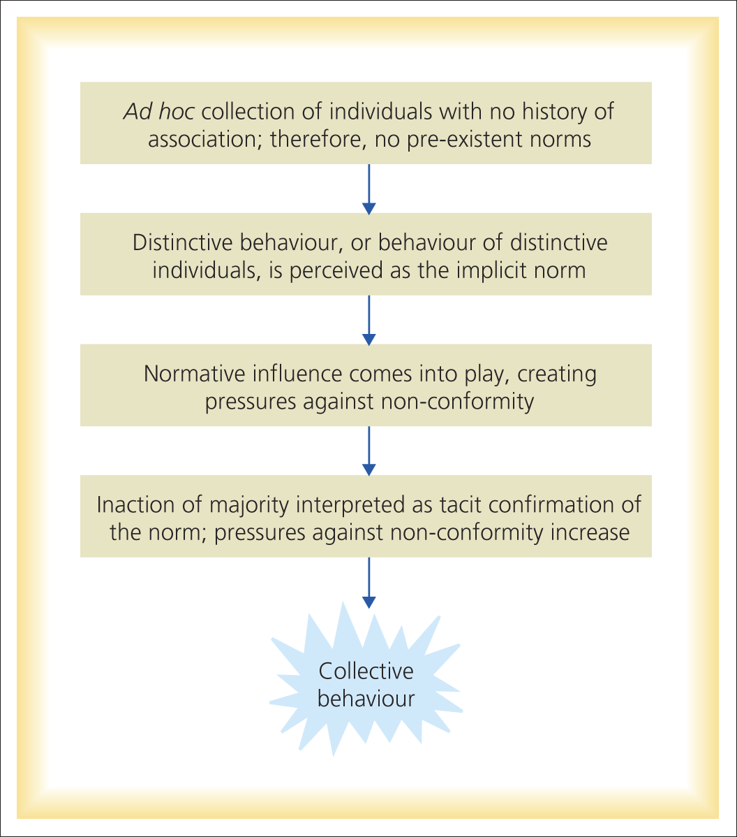

* How does this fit into conflict
* Because people like to think positively of themselves, and social identity is self-evaluative, intergroup behaviour is a struggle to protect, maintain, or achieve evaluatively positive social identity and ingroup distinctiveness.
* The strategies used to rectify unfavourable social identity depend on one’s beliefs about the nature of intergroup relations. If you believe it is easy to move into a higher status group (**social mobility belief system**), then that is what you will try to do. If you believe mobility is impossible (**social change belief system**), the status quo is legitimate, and there is no alternative system (no **cognitive alternatives** exist), then you will try to modify the evaluation of your group in quite creative ways (**social creativity**).
* Direct conflict with a dominant group (**social competition**) arises when the status quo is recognised to be illegitimate and changeable (cognitive alternatives exist).

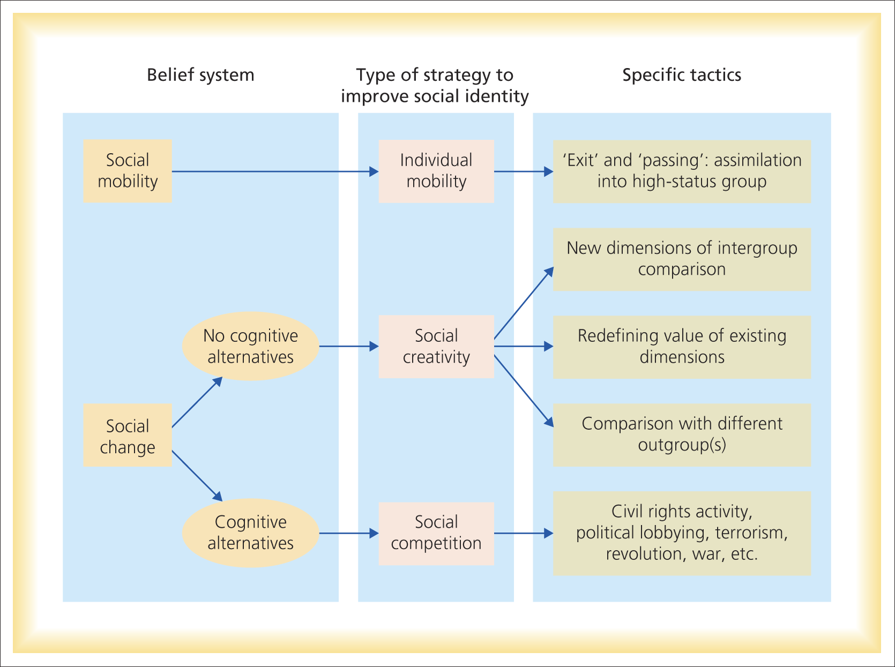

**Improving intergroup relations**

* At the societal level, a strategy of pluralism, or multiculturalism, holds some hope for better relations (for example, between ethnic groups within a larger nation). It nourishes a sense of cooperative intergroup relations within a wider superordinate identity, but at the same time does not threaten one's ethnic identity.
* Although propaganda and public education communicate social disapproval of prejudice, they are not very effective at improving intergroup attitudes when people's day-to-day lives are permeated by bigotry and anxiety about intergroup encounters.
* Bringing individuals together so they get to know one another may work better
* As it is long believed that prejudice is based in ignorance and the perception of irreconcilable intergroup differences
* Therefore, contact causes people to recognise that they are a great deal more similar than they thought
* Intergroup anxiety is one of the most significant hurdles to greater contact (Stephan & Stephan, 2000). Why?
  + Realistic threat: A sense of a real threat to one’s own group
  + Symbolic threat: A threat posed by the outgroup to one’s values, beliefs, morals and norms
  + Intergroup Anxiety: Fear of rejection or embarrassment
  + Negative Stereotypes: Fear of intergroup anxiety
* However, contact under the right circumstances can reduce intergroup anxiety and improve intergroup attitudes (Brown & Hewstone; 2005 Pettigrew, 1998)
  + Prolonged and involve co-operative activity. This activity should be purposeful
  + Within a framework of official or institutional support for integration
  + Involve people (or groups) or equal social status. Unequal status contact is more likely to conform stereotypes
* Other problems
* Similarity
  + Because groups are often very different, contact is likely to bring attention to other differences
  + Should we always assume different groups are similar
* Mediation
  + Mediation can help in several ways
  + Reduce emotional heath
  + Reduce misperceptions
  + Propose novel compromises
  + Help both parties make a graceful retreat
  + Inhibit unreasonable claims

Any collaborative process intended to address and manage intergroup conflict should have objectives to encourage it. In this major commitment of time and resources, success is its best reward, but to ensure an ADR approach suitable for you, it is important to:

* Build trust
* Clearly define participants' roles and authorities
* Establish ground rules
* Promote leadership
* Bring a collaborative attitude to the table
* Maintain participant continuity
* Recognize time and resource constraints
* Address cultural differences and power imbalances
* Build accountability and organizational commitment
* Make this a consensus process
* Produce early measurable results
* Link decision making and implementation
* Promote good communication and listening skills

Socio – psychology:

Socio-psychology is about understanding individual behavior in a social context. It therefore looks at human behavior as influenced by other people and the social context in which this occurs. Human beings are essentially social beings. Thoughts, feelings and behaviour of an individual are affected by the presence of others. At the same time, individual also influence the behaviour of other individuals. Social psychology is a discipline that tries to understand the human social behaviour.

**Gordon Allport (1954)** Social Psychology is best defined as the discipline that uses scientific methods in “an attempt to understand and explain how the thought, feeling and behavior of individuals are influenced by the actual, imagined, or implied presence of other human beings”.

**Myers and Spencer (2006)** define Social Psychology as the “scientific study of how people think about, influence, and relate to one another”.

**Barron and Byrne** (2007) defined social psychology as “the scientific field that seeks to understand the nature and cause of individual behaviour and thought in social situations”.

Social Cognition -> Social Perception -> Social Attitude -> Social Influence -> Social Behaviour

Social cognition

**Social perception**

Social perception is defined as the study of how we form impressions of and make inferences about other people. In order to know about other people, we depend on information gained from their physical appearance, and verbal and nonverbal communication. Missing informations are filled in by using an implicit personality theory: If a person is observed to have one particular trait, we assume that he or she has other traits related to this observed one. These assumptions help us to categorize people and then infer additional facts and predict behavior.

Social perception is one important component of social competence and successful social life. Being competent in social perception includes three domains of competence:

(1) knowing that other people have thoughts, beliefs, emotions, intentions, desires.

(2) being able to “read” other people’s inner states based on their words, behavior, facial expressions

(3) adjusting one’s actions based on those “readings”.

That is, a socially competent person can make note of other people’s facial expressions, tone of voice, posture, gestures, words, and the like, and on the basis of these clues, make reasonably accurate judgments about that person’s state of mind, emotions, and intentions. Socially competent people then use these inferences about other people’s inner states to make good decisions about how to behave socially.

Social perceptions can obviously be flawed - even skilled observers can misperceive, misjudge, and reach the wrong conclusions. Once we form wrong impressions, they are likely to persist.

Just as we form impressions about others, they also form impressions about us. At some point, most of us try to influence the impressions others hold of us.

**Stereotype**

A Stereotype is a thought that can be adopted about specific types of individuals or certain ways of doing things. Stereotypes reflect expectations and beliefs about the characteristics of members of other groups perceived as different from one's own. The possible reasons for stereotyping a group of people may be

* Justification or Ignorance
* Unwillingness to re-think one's attitudes and behavior towards stereotyped groups
* Preventing some people of stereotyped groups from entering or succeeding in activities or fields.

Stereotyping can serve rational functions on an interpersonal level, and social functions on an intergroup level. For stereotyping to function on an intergroup level an individual must see themselves as part of a group and being part of that group must also be salient for the individual.

Stereotyping of group of individual will favor any other group

* when stereotypes are used for explaining social events
* when stereotypes are used for justifying activities of one's own group to another groups.
* when stereotypes are used for differentiating the in-group as positively distinct from outgroups

**Attribution**

Attribution indicates an explanation for the cause of an event or behaviour. Individual always try to attribute any hostile event on others. Attribution theory explains how individuals pinpoint the causes of others behavior.

Attribution of an Individual may likely influence the group, if an individual always associates the cause of an unfavorable event towards individual from other groups. Gradually, all the members of a group may likely attribute any disapproving event towards other groups. Attributions of people as group members are ethnocentric and based on stereotypes.

**Prejudice**

A prejudice is a negative belief or feeling about a particular group of individuals. Prejudices may be passed on from one generation to the next. Prejudice is always a destructive phenomenon, and it is pervasive because it serves many psychological, social, and economic functions. It gives people scapegoats to blame in times of trouble and can boost self-esteem.

People’s social identities depend on the groups they belong to. From a person’s perspective, any group he belongs to is an in-group, and any group he doesn’t belong to is an outgroup. People generally have a lower opinion of outgroup members and a higher opinion of members of their own group. People who identify strongly with a particular group are more likely to be prejudiced against people in competing outgroups.

**Discrimination**

Discrimination is behavior that advantages or disadvantages people merely based on their group membership. Discrimination is treatment or consideration of, or making a distinction in favor of or against, a person or thing based on the group, class, or category to which that person or thing is perceived to belong to rather than on individual merit. This includes treatment of an individual or group, based on their actual or perceived membership in a certain group or social category.

Moral philosophers have defined discrimination as disadvantageous treatment or consideration. An individual need not be actually harmed in order to be discriminated against. They just need to be treated worse than others for some arbitrary reason. Discrimination strikes at the very heart of being human.  It is treating someone differently simply because of who they are or what they believe.

We all have the right to be treated equally, regardless of our race, ethnicity, nationality, class, caste, religion, belief, sex, language, sexual orientation, gender identity, age, health or other status.

Social Attitude

Social Influence

**Social Behaviour**

**ProSocial Behaviour**

**Aggression**

**Social Loafing**

HOW MEMBERS OF DIFFERENT GROUPS PERCEIVE INEQUALITY?

People’s perceptions always have to be analyzed carefully and critically and there can be several reasons why the society may be considered unequal. First of all, the inequality may be structurally reproduced. This means that the existing system in a society does not guarantee people justice principles that are promised by the state and expected by the people. It means that people’s basic needs in a society are not satisfied, equal liberties are not guaranteed, there is discrimination, no equal opportunity to get ahead in life and the input of people is not fairly rewarded. If structural inequality exists then everybody should notice that. Empirically it means that all or at least the majority of people in a society should perceive high inequality – independent of their own socio-economic position. The perceived inequality is often influenced by personal experiences. People who have a higher socio-economic position usually think they have achieved their status in a fair competition. On the other hand, people in a lower position in a society tend to think that the reasons for them to be unsuccessful are restrictions created by the society and the structural system. Generally, it can be seen that people from the lower socio-economic status perceive more inequality and vice versa. So an assumption can be made that perceived inequality depends on the individual’s position in a society. There are many types of inequality that leads one group to perceive the other group as less equal. E.g. Racial inequality. Racial group – a category of people who have been singled out, by others or themselves, as inferior or superior, on the basis of subjectively selected physical characteristics such as skin color, hair texture and eye shape. E.g. White or non-white. Racism is a 77 set of attitudes, beliefs and practices used to justify the superior treatment of one racial or ethnic group and the inferior treatment of another racial or ethnic group. Another very old and strong inequality that exists is gender inequality. Gender inequality leads to gender prejudice called sexism. It is a term coined in the mid- 20th century, refers to the belief or attitude that one gender or sex is inferior to, less competent, or less valuable than the other. Gender Prejudice is a universal phenomenon though more rampant in less advanced countries. India is a good example of rampant gender prejudice. In addition, today we have perceived regional and caste inequalities, religion, etc., all reasons for perceived inequalities to come into play. We see people from other religions as different and begin to associate negative characteristics with them.

Intergroup Conflict Questionnaire

Quantitative:

1. Majority of the groups in your workplace belongs to which of the following category?
2. Social Identity Groups (Based on Similar Race, Religion, etc.)
3. Behavioral Groups (Based on Similar Attitude, Characteristics, etc.)
4. Interest Groups (Based on Similar Interest in Sports, Hobbies, etc.)
5. Union and Cooperative Groups
6. If you are part of multiple groups, which of these category of group you have more affinity towards?
7. Social Identity Groups (Based on Similar Race, Religion, etc.)
8. Behavioral Groups (Based on Similar Attitude, Characteristics, etc.)
9. Interest Groups (Based on Similar Interest in Sports, Hobbies, etc.)
10. Union and Cooperative Groups
11. How often groups you are a part of have conflicts with other groups?
12. very often b) fairly often c) sometimes d) never
13. How long the conflicts with your group and other group will resist?
14. Always b) Few Months c) Few weeks d) Few Days
15. Do you observe the same groups always do have conflicts?
16. Yes b) No
17. What is your stand when there is a conflict scenario between your group and some other group?
18. Always support your group
19. Support group based on your behavior/moral values
20. Doesn’t support any one
21. Will try to resolve the conflict
22. How often in your workplace groups disputes and incidents of clash happened?
23. very often b) fairly often c) sometimes d) never
24. If you were a part of the dispute did you have a friendly relationship with the other group before the dispute?
25. Yes b) No
26. Is there any one whom you can report to immediately after an event of dispute?
27. Yes b) No
28. Are there any events in your company where you all will participate irrespective of your social identity or interests?
29. Yes b) No

Qualitative:

Is your relationship with in the group is emotional, cognitive or behavioral?

What are the events in your workplace where you manage to collaborate with other groups in your workplace?

Are you willing to forgive other groups in your workplace for their past behavior?

To what extent are the processes involved in intergroup contact emotional, cognitive and behavioural?

**ABOUT THE COMPANY**

Hinduja Foundries Ltd (HFL) (formerly known as Ennore Foundries Ltd) is a part of the $12 billion [Hinduja Group](https://en.wikipedia.org/wiki/Hinduja_Group).  Hinduja Foundries is [India](https://en.wikipedia.org/wiki/India)’s largest casting maker. Hinduja has three facilities in Chennai and Hyderabad which put together manufacturer’s 100,000 MT of castings in the form of cylinder blocks, heads, housings, manifolds, brake drums etc, made of aluminum and iron.

**RESEARCH METHODOLOGY**

Descriptive Research Methodology is used in the present study. Descriptive Study is one in which information is collected without changing or manipulating the environment. Sometimes these are referred to as “correlational” or “observational” studies.

**DATA SOURCES**

Primary Data

The Primary data was collected from the employees of Hinduja Foundries Ltd. by administering a structured questionnaire and also through observations, interviews & discussion with Management team.

Secondary Data

Apart from Primary data. The secondary data is being collected through Records of Induja Group of Companies Pvt. Limited, Journals from Library, Academic Reports, and Internet are used for this study.

**SAMPLING**

Sampling: Sample Population

There are total 115 employees working in the organization.

References

<http://www2.le.ac.uk/departments/psychology/extranet/undergraduate-materials/year-2/ps2017/social-psychology-handouts/PS2002-17-Lecture%206-Handout.ppt>

<https://wikispaces.psu.edu/pages/viewpage.action?pageId=41095610>

<http://archive.mu.ac.in/myweb_test/SYBA%20Study%20Material/socpsycho-II.pdf>