

**School of Computer Science Engineering and Information Systems (SCORE)**

**Winter Semester 2023-2024**

**BITE307P-SOFTWARE ENGINEERING LAB**

SystemDesignDocument

**TOURISM MANAGEMENT SYSTEM**

**SIVAPRIYA.A – 22BIT0679**

**l39+L40**

**Dr. GUNASEKARAN G**

|  |  |
| --- | --- |
| Document ID | SYSTEM DESIGN-v0.1 |
| Version Number | 0.1 |
| Issue Date | January 9,2024 |
| Classification | Public |

# Copyright Notice

© INDIA Trotter, (Jan 2024– May 2024)

All Rights Reserved

The information contained in this document is the property of INDIA Trotter. No part of this document may be reproduced, stored in a retrieval system, or transmitted in any form, or by any means; mechanical, photocopying, recording, or otherwise, without the prior written consent of INDIA Trotter. Under the law, copying includes translating into another language or format. Legal action will be taken against any infringement.

The information contained in this document is subject to change without notice and does not carry any contractual obligation for INDIA Trotter. INDIA Trotter reserves the right to make changes to any products or services described in this document at any time without notice. COMPANYNAME shall not be held responsible for the direct or indirect consequences of the use of the information contained in this document.

# Revision History

|  |  |  |  |
| --- | --- | --- | --- |
| **Date** | **Version** | **Description** | **Author (s)** |
| 09/01/2024 | 1.0 | Draft copy 1 | Sivapriya A |
| 23/01/2024 | 1.0 | Draft copy 2 | Sivapriya A |
| 30/01/2024 | 1.0 | Draft copy 3 | Sivapriya A |

**The reviewer signoff shall signify the recommendation for acceptance of this document.**

|  |  |  |
| --- | --- | --- |
| **Reviewed By (Customer)** | **Signature** | **Date** |
| Lakshmi Priya G | Sivapriya | 09/01/2024 |
| Rithanya K | Sivapriya | 23/01/2024 |
| Sivaprakash K | Sivapriya | 30/01/2024 |
| Sivaganesh K | Sivapriya | 30/01/2024 |
| Sivabalan A | Sivapriya | 03/02/2024 |

# Sign Off

|  |  |
| --- | --- |
| **Prepared By** | **Acknowledged By** |
|  |  |
| Sivapriya A | Silambarasan S |
| Title: Devoloper | Title: General Manager |
| INDIA Trotter | INDIA Trotter |
| Date:30/01/2024 | Date:30/01/2024 |

|  |  |
| --- | --- |
| **Accepted By** | **Accepted By** |
|  |  |
| Navanee V | Sivakami S |
| Title: SPA manager | Title: Specialist Tour Manager |
| TRAVEL OF INDIA | TRAVEL OF INDIA |
| Date: 03/02/2024 | Date: 03/02/2024 |

**Table of Contents**

[List of Tables 7](#_bookmark0)

[List of Figures 8](#_bookmark1)

1. [Introduction 9](#_bookmark2)
   1. [Purpose of Document 9](#_bookmark3)
   2. [Document Scope 9](#_bookmark4)
      1. [In-Scope 9](#_bookmark5)
      2. [Out-of-Scope 9](#_bookmark6)
      3. [Assumptions 9](#_bookmark7)
   3. [Methodology, Tools, and Approach 9](#_bookmark8)
   4. [Acronyms and Abbreviations 9](#_bookmark9)
2. [Design Overview 10](#_bookmark10)
   1. [Background Information 10](#_bookmark11)
   2. [System Evolution Description 10](#_bookmark12)
   3. [Required Environment 10](#_bookmark13)
   4. [Constraints 10](#_bookmark14)
   5. [Design Trade-offs 11](#_bookmark15)
3. [Structural Family Diagrams 11](#_bookmark16)
   1. Class Diagram .............................................................................................................
   2. Object Diagram ..........................................................................................................
   3. Package Diagram........................................................................................................

## [Behavioral Family Diagrams .......................................................................................](#_bookmark17)

* 1. Use Case Diagram
  2. Use Case Descriptions
  3. State Chart Diagram
  4. Activity Diagram
  5. Sequence Diagram
  6. Collaboration Diagram

## Architectural Family Diagrams....................................................................................

* 1. Deployment Diagram .................................................................................................
  2. [Component Diagram..................................................................................................](#_bookmark18)

[**Appendix ...........................................................................................................................**](#_bookmark19)

# List of Tables

# List of Figures

# Introduction

# This paper functions as a blueprint, outlining the essential components, architectural structure, and design objectives that support an advanced platform meant to maximize traveler and service provider experiences.

# Purpose of Document

This Software Design Document (SDD) aims to give a thorough

overview of the Tourism Management System's architectural choices, design elements, and functionality. Developers, testers, and other stakeholders involved in the system's implementation and upkeep can use this page as a guide.

* 1. Document Scope

Travel agencies, tour operators, and tourists are the target audience for

the Tourism Management System, which is made to optimize and improve tourism business operations. It seeks to offer a unified platform for organizing several facets of tourism, such as scheduling travel, making hotel reservations, and promoting easy contact between customers and service providers.

## In-Scope

1. User Registration and Authentication:

Creating and putting into place a safe system for user registration and authentication in order to manage system access according to user roles.

2. Itinerary Planning Module:

Developing a feature-rich itinerary planner that allows users to customize their travel plans, including activities, sightseeing, and accommodation preferences.

3. Accommodation Booking Integration:

Integrating with external services to enable users to browse, select, and book accommodations seamlessly within the Tourism Management System.

4. Communication Module:

Implementing a real-time messaging and notification system to facilitate communication between tourists and service providers, enhancing the overall travel experience.

5. Payment Gateway Integration:

Integrating a secure and reliable payment gateway to handle transactions for bookings and services.

## 

## Out-of-Scope

1. Flight Booking Functionality:

The system will not handle flight bookings; the focus is solely on accommodation and itinerary planning.

2. Currency Exchange Services:

The system will not include features related to currency exchange or financial services beyond payment processing for bookings.

3. Weather Forecasting:

Providing real-time weather forecasts or related services will not be part of the Tourism Management System.

4. Language Translation Services:

While communication features are included, the system will not provide automatic language translation services.

5. Tour Guide Hiring:

The system will not include features related to hiring tour guides; the focus is on facilitating communication and bookings.

## Assumptions

## 1. Internet Connectivity:

## It is presumed that in order to access and utilize the Tourism Management System, users would have dependable internet connectivity.

## 2. Browser Compatibility:

## Because the system is optimized for use with popular, current web browsers, compatibility problems with older browsers may occur.

## 3. Legal Compliance:

## The system is predicated on adherence to pertinent legal and regulatory obligations for online transactions, user privacy, and data protection.

## 4. User Understanding of System Features:

## The functionality of the Tourism Management System, such as itinerary planning and hotel booking, is expected to be fundamental knowledge for users.

## 5. Communication Responsiveness:

## Both parties' responsiveness determines how well real-time communication works between visitors and service providers.

## 

## 6. Scalability Requirements:

## Based on estimated user loads, the system assumes that the baseline scalability requirements are accurate. If the number of users significantly grows, adjustments can be required.

## 7. Security Measures:

## User authentication and data encryption are two examples of security methods whose efficacy depends on how well they are implemented and configured throughout development.

## 8. Payment Gateway Security:

## It is assumed that the chosen payment gateway complies with industry security guidelines, guaranteeing safe financial transaction processing.

## 

## Methodology, Tools, and Approach

**Methodology:**

Agile development technique will be used in the creation of the tourism management system. Agile places a strong emphasis on teamwork, iterative development, and flexibility in response to shifting needs. Frequent sprint cycles will facilitate ongoing feedback, guaranteeing that the system meets the expectations of stakeholders. This method encourages adaptability, allowing the group to react quickly to new needs and rank characteristics according to significance.

**Tools:**

1. Programming Language:

The system will be built with HTML, CSS, and JavaScript for front-end development, and a server-side language such as Node.js or Python for back-end development.

2. Database Management:

Because of its scalability and versatility, MongoDB will be the main database, enabling effective storing and retrieval of information about user profiles, reservations, and itineraries.

3. Framework:

The web application framework of choice will be Express.js, which offers a stable and understated foundation for developing scalable and maintainable apps.

4. User Interface (UI):

The user interface will be built with React.js, guaranteeing a responsive and dynamic user experience.

5. Version Control:

React.js will be used in the interface's construction to ensure a dynamic and responsive user experience.

6. Collaboration and Communication:

Jira will be used for project management and issue tracking, while Slack will be used for team communication, sharing updates, and debating progress.

7. Continuous Integration/Continuous Deployment (CI/CD):

In order to automate the build, testing, and deployment processes and optimize development workflows, Jenkins will be utilized to establish CI/CD pipelines.

**Approach:**

1. Requirement Analysis:

In order to ensure a thorough grasp of the functions and features anticipated from the tourism management system, gather detailed requirements from stakeholders.

2. Design:

Make thorough mockups of the user interface, the database schema, and the system architecture. The layout will prioritize usability, scalability, and modularity.

3. Development:

Use frequent sprints in an iterative development process. Start with essential features like user registration and authentication, then gradually incorporate extras like communication modules and itinerary planning.

4. Testing:

Conduct comprehensive user acceptance testing (UAT), integration testing, and unit testing to find and fix any problems early in the development process.

5. Deployment:

To ensure a smooth transition from development to production, use CI/CD pipelines to automate the deployment process. The deployments will be arranged for times when there is less traffic to reduce the impact on users.

6. Monitoring and Maintenance:

Use monitoring tools to keep tabs on system performance, spot possible problems, and install updates as required. Bug fixes, security updates, and feature improvements based on user feedback will all be part of routine maintenance work.

## Acronyms and Abbreviations

**TMS** : Tourism Management System

**SDD**  : Software Design Document

**UI** : User Interface

**API** : Application Programming Interface

**HTML** : Hypertext Markup Language

**CSS** : Cascading Style Sheets

**JS** : JavaScript

**Node.js** : Node.js (JavaScript runtime)

**MongoDB**  : MongoDB (NoSQL database)

**Git**  : Version Control System

**CI/CD**  : Continuous Integration/Continuous Deployment

**Jira** : Project Management and Issue Tracking Tool

**UAT** : User Acceptance Testing

**SQL** : Structured Query Language

**JWT** : JSON Web Token

**SSL** : Secure Sockets Layer

**HTTP** : Hypertext Transfer Protocol

**JSON** : JavaScript Object Notation

**IDE** : Integrated Development Environment

**QA** : Quality Assurance

# 1.2 Design Overview

## Background Information

The tourism industry's increasing demand for a unified solution gave rise to the Tourism Management System (TMS) initiative. With an emphasis on improving user experiences, TMS seeks to expedite traveler communications, hotel reservations, and itinerary planning. In order to provide tourists and businesses with a contemporary and flexible platform in the ever-changing tourism landscape, the project places a high priority on scalability, security, and user-centric design.

## System Evolution Description

It is envisaged that the Tourism Management System (TMS) will evolve in a dynamic manner, responding to shifting market trends, user input, and technology breakthroughs. Iterative improvements will be made to the system to guarantee that it remains relevant and successful in fulfilling the changing needs of both service providers and travelers.

**Phase 1: Initial Release**

The primary functions, such as user registration, itinerary planning, hotel reservations, and communication modules, are the emphasis of the first phase. The purpose of gathering first user feedback is to fix any pressing issues and enhance the overall user experience.

**Phase 2: Feature Expansion**

Phase 1's foundation will be built upon when the system's features are expanded. This could involve other linkages like language translation services, real-time collaboration tools, and user-preference-based tailored recommendations.

**Phase 3: Mobile Optimization**

Phase 3 will give priority on TMS mobile platform optimization in light of the growing dependence on mobile devices for trip planning. This covers mobile app development, responsive design, and enhanced accessibility across several platforms.

**Phase 4: Integration with Emerging Technologies**

TMS will investigate integration with cutting-edge technologies including blockchain for safe and transparent transactions, artificial intelligence (AI) for tailored suggestions, and augmented reality (AR) for virtual tours.

**Phase 5: Global Expansion**

TMS will concentrate on extending its reach to serve a worldwide audience as user adoption rises. In order to provide a comprehensive global travel solution, this phase entails localization efforts, multilingual assistance, and collaborations with international service providers.

**Phase 6: Continuous Optimization**

With regular updates and enhancements based on user feedback, market developments, and technology advancements, continuous optimization will be a continuous process. This guarantees that, in the always changing tourism industry, TMS will continue to be a cutting-edge solution.

## 

## Required Environment

|  |  |
| --- | --- |
| **Product/Solution** | **Environment** |
| Customer Relationship Management (CRM) system | -Production  - Development  -Testing  -Training |
| Enterprise Resource Planning (ERP) System | -Production  - Staging  -Development  -Quality Assurance/Test  -Training |
| E- Commerce Platform | -Production  -Staging  -Quality Assurance/Test  -Training  -Backup/Disaster Recovery |

## 

## Constraints

1. **Hardware or Software Environment:**

**Constraint :** Limited memory and processing capacity on end-user devices.

**Impact:** The system needs to be tuned to use resources as efficiently as possible, and it might even provide lite versions for devices with less power.

1. **End-User Environment:**

**Constraint :** Variations in language preferences and user proficiency levels.

**Impact:** The system ought to feature a user-friendly interface, support for several languages, and the ability to offer training materials to users with different levels of technical proficiency.

1. **Availability or Volatility of Resources:**

**Constraint:** certain tourist locations have spotty internet access.

**Impact:**  For the system to maintain basic functioning even in the event of an unstable internet connection, offline capabilities or caching methods are required.

**4. Interface/Protocol Requirements:**

**Constraint :** Display capabilities can differ between devices and browsers.

**Impact :** In order to provide a consistent user experience across various devices and browsers, the system should be responsively developed.

**5. Data Repository and Distribution Requirements:**

**Constraint :** Enormous amounts of data about traveler details and reservations.

**Impact :** Strong data management and storage options are required for the system; cloud services may be used to manage scalability and guarantee data availability.

**6. Security Requirements (or other such regulations):**

**Constraint :** strict laws governing privacy and data protection.

**Impact :** To secure sensitive user data, the system requires strong security mechanisms, encryption, and access controls.

**7. Memory and Other Capacity Limitations:**

**Constraint :** User devices' limited storage capacity.

**Impact:** To avoid memory problems, the system should optimize data storage and give users alternatives for managing cached data.

**8. Performance Requirements:**

**Constraint :** Expectations for real-time response in booking and information retrieval.

**Impact :** The system needs to be tuned for quickness and responsiveness; this may involve using caching techniques and effective data retrieval methods.

**9. Network Communications:**

**Constraint :** varying regions have varying network speeds..

**Impact :** Optimizing data transfer for slower networks and minimizing reliance on high-speed internet should be the design goals of the system.

**10. Verification and Validation Requirements (Testing):**

**Constraint :** Strict testing guidelines to guarantee system dependability.

**Impact :** It is imperative to implement comprehensive testing processes prior to system deployment in order to detect and resolve any potential difficulties.

## 1.5 Design Trade-offs

A tourism management system's design necessitates balancing trade-offs for optimum performance. It's critical to strike a balance between capability and simplicity, providing customers with just the right amount of features without going overboard. As real-time updates must trade off with offline functionality, clever syncing techniques are required to ensure timely information. Maintaining user happiness while making system maintenance easier requires striking a balance between customization and uniformity. A balanced strategy is needed to balance security and user convenience, incorporating strong security features without compromising usability. Furthermore, efficient performance is ensured by optimizing for scalability while taking resource limits into account. These trade-offs highlight how difficult it is to create a system that successfully satisfies the many demands of stakeholders and consumers.

# Structural Family Diagrams

## Class Diagram

Important classes including TourPackage, Booking, Customer, TourPackageService, BookingService, and DatabaseConnection are included in the class diagram of the tourism management system. Package information is stored in TourPackage, which has a one-to-many link with Booking. Booking gathers booking data and connects clients with travel packages.

The customer can make several bookings and has access to personal information. Through interactions with their respective classes, TourPackageService and BookingService offer package and booking-related functionalities. DatabaseConnection is responsible for managing the database connection for storing and retrieving data. This succinct graphic provides a straightforward summary of the relationships between classes in the system.

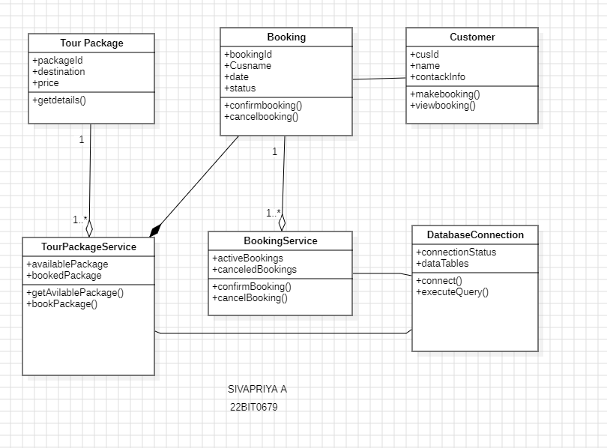

## Object Diagram

## Individual tourists with related personal information are represented by Tourists 1 and 2.

## Booking1 is an example of a booking that links a traveler (Tourist1 or Tourist2) to a certain tour package.TourPackage1 is an example of a tour package that may be connected to a reservation.

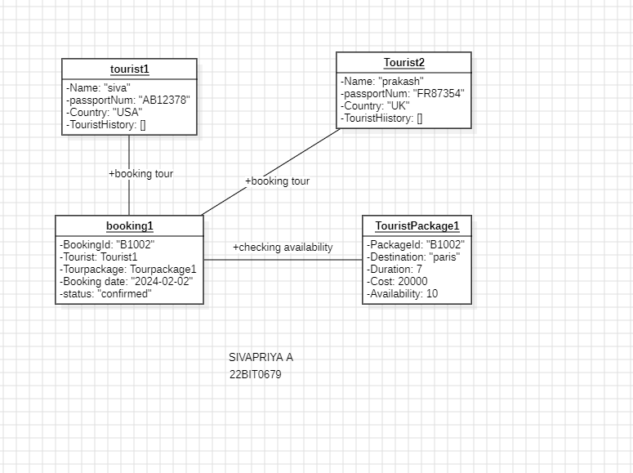

## Package Diagram

The GUI Components, DatabaseConnector, Tour Package, Booking, Tourist, and Reporting Module are the six packages shown in the Tourism Management System package diagram. DatabaseConnector handles database interactions, and GUIComponents wraps graphical user interface elements. TourPackage and Booking are responsible for managing tour package and reservation-related functions, respectively. Information pertaining to tourists is managed by the Tourist package, while reports and analytics are produced by the Reporting Module. These packages exhibit a modular structure that encourages maintainability and shows how different system components are dependent on one another.

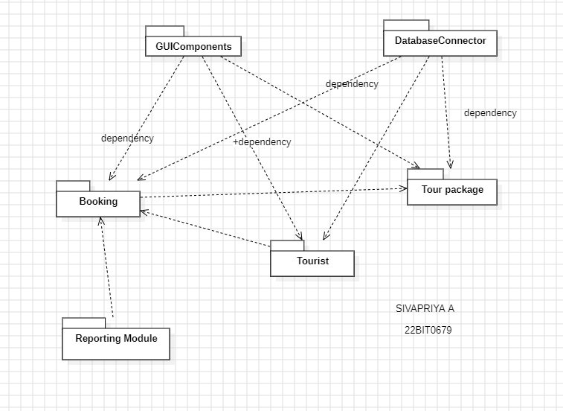

# Behavioral Family Diagrams

## Use Case Diagram

The main features that users and administrators can access are depicted in the Tourism Management System's use case diagram. Users can log in to the system, examine available tour packages, modify their profile information, check their booking history, make new bookings, submit queries, and log out. The "User" actor plays the role of the user. The "Admin" actor plays an administrator who has additional powers, such as the ability to add new tour packages to the system. These use cases enable smooth user-system interactions, giving consumers the ability to browse and reserve tour packages and giving administrators the resources they need to run the system efficiently.

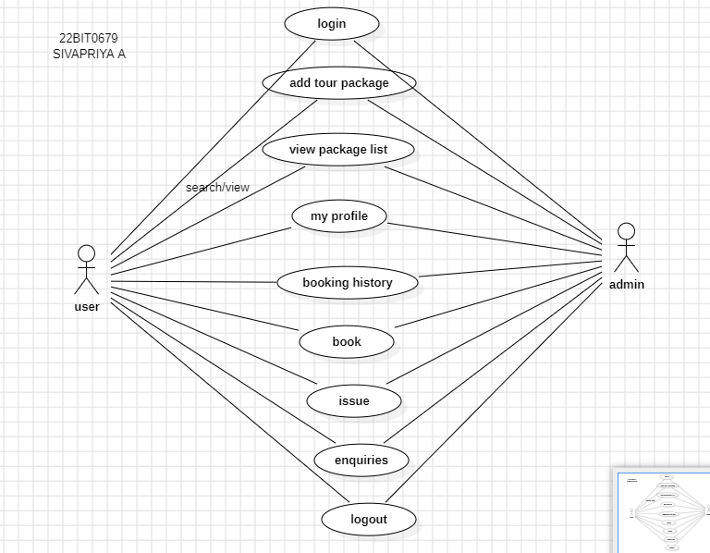

## Use Case Descriptions

1.Browse package

Pre conditions:

The system is operational and reachable.

The user of the system is logged in.

Post conditions:

The client has looked over the available tour schedules.

Depending on the customer's selections, the system could recommend related packages.

2.Book package

Pre conditions:

The system is operational and reachable.

The user of the system is logged in.

You can make reservations for tour packages.

Post conditions:

Customer and package information is entered into a booking record.

The chosen package's availability is updated and it is noted as booked.

3.Cancel booking

Pre conditions:

The system is operational and reachable.

The user of the system is logged in.

The client has a reserved trip itinerary.

Post conditions:

The package availability is updated and the booking is canceled.

The client is given an acknowledgement of the canceled booking and updated in the package availability

4.View booking history

Pre conditions:

The system is operational and reachable.

- The user has successfully logged into the system.

- The client has made reservations in the past.

Post conditions:

The client sees a summary of their recent and historical reservations.

- Each booking's details, including its status, are shown.

5.General reports

Pre conditions:

The system is operational and reachable.

The system has the administrator logged in.

The database contains enough information to produce reports.

Post conditions:

Reports on booking patterns, well-liked travel locations, and financial performance are generated by the system.

The generated reports are viewable or downloadable by the administrator.

## State Chart Diagram

1. Tour Booking Process:

Beginning in the "New Booking" stage, travelers choose a tour during the "Tour Selection" stage, which advances to the "Payment Processing" stage, where payment confirmation takes place. When a payment is successful, the page displays "Booking Confirmed," but when one is unsuccessful, it displays "Payment Failed" with a retry or cancel option.

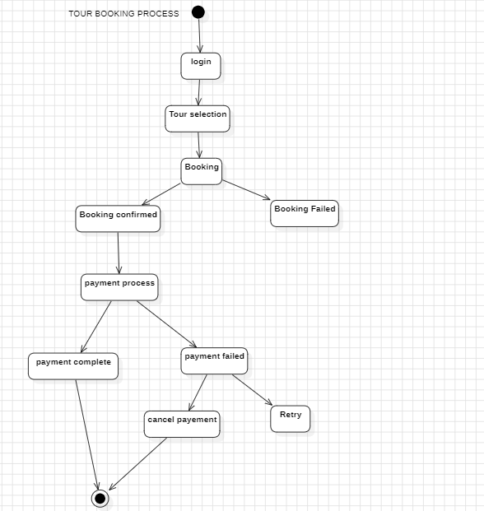

1. Tourist Registration: -

Users are guided through the registration process by first registering as a "New Tourist" and then providing personal details in the "Personal Details" and "Passport Details" states. After finishing, the system displays "Registration Completed," signifying that the touris tregistration was uccessful.

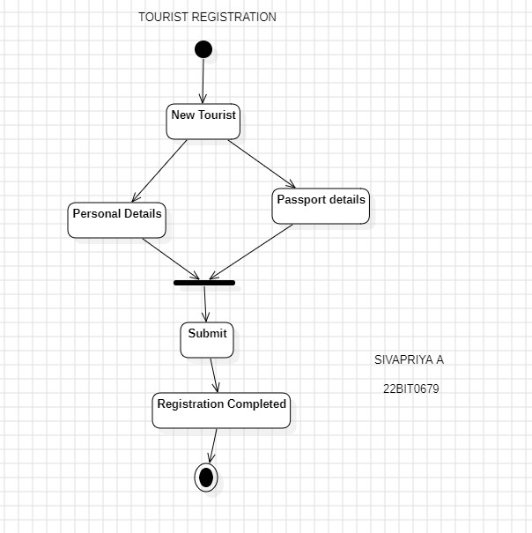

3.Tour Guide Assignment

After entering the "No Guide Assigned" stage, the guide assignment procedure moves on to the "Guide Selection" stage, where guides are confirmed and assigned. When the assignment is finished, the system changes to "Guide Assigned," indicating that it was successful.

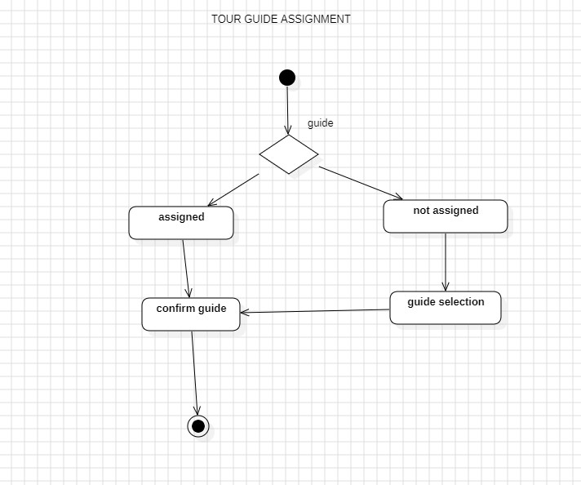

4.Tour Status Tracking

Tour status is monitored using statuses like "Upcoming Tour," which changes to "In Progress" once the tour starts. The procedure can also result in "Cancelled Tour" in the event that the tour is canceled or "Completed Tour" following successful completion, ultimately arriving at a completion state.



## 5.Feedback Collection

## 

## The "Collect Feedback" state is when the feedback gathering process starts, assisting users in submitting their comments. The successful submission of feedback is indicated by the confirmation state "Confirm Feedback," which ends the feedback collection procedure.

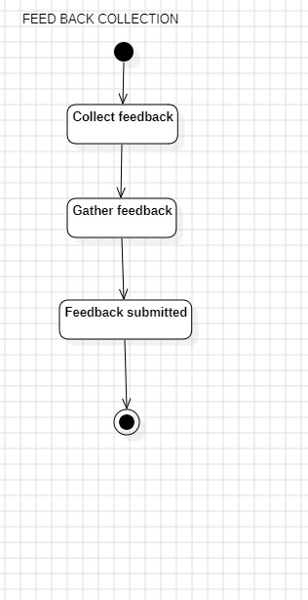

## An activity Diagram

## Tour Booking Process:

## The "Initiate Booking" action starts the tour booking process. After determining whether a tour has been chosen, the algorithm moves on to the "Tour Selection" task. When the booking is validated, the payment is processed by the system; if this is successful, the booking is confirmed; if not, it is canceled.

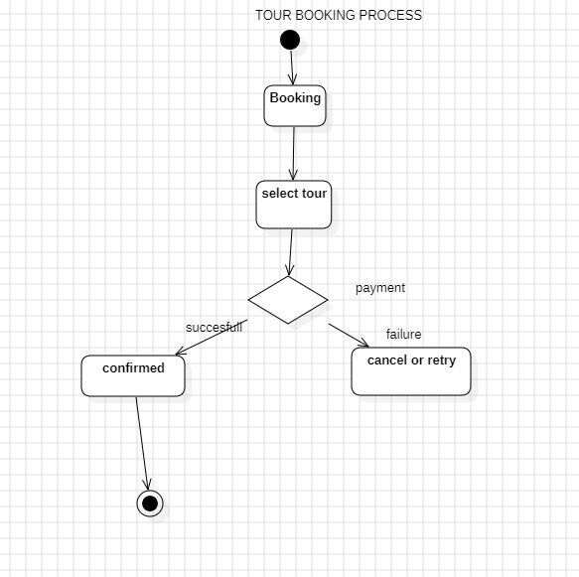

## Tour registration

## The "Start Registration" activity is the first step in the tourist registration process, after which personal information and passport information must be entered and submitted. The registration is considered successful after it is submitted successfully.

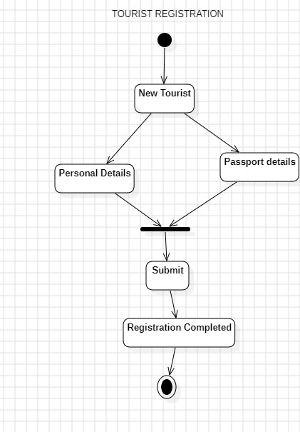

3.Tour Guide Assignment

"Start Guide Assignment" is the first activity in the Tour Guide Assignment. The "Guide Assigned" state results from the system assigning a guide and validating the assignment.

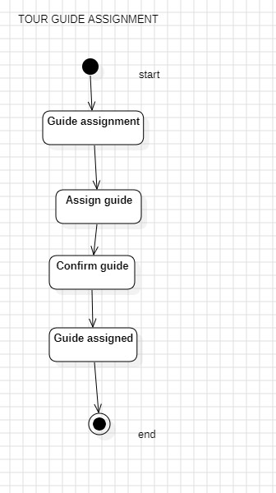

4.Tour status Tracking

Tour Status Tracking begins with the "Commence Tour" activity. If the tour is in progress, it proceeds to completing the tour; otherwise, it is canceled.

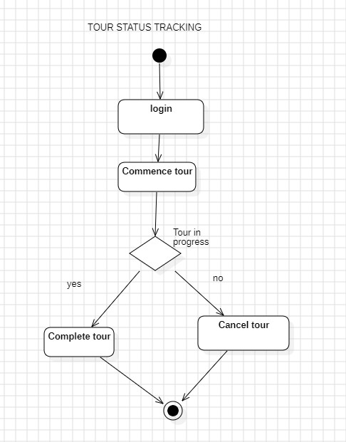

5.Feedback collection

The process of collecting and submitting feedback begins with the "Start Feedback Collection" step. The feedback is marked as submitted once it is successfully submitted.

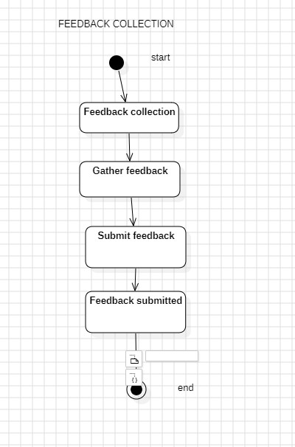

## Sequence Diagram

## Tour Booking Process

## The tourist initiates the booking process to start the tour. After choosing a tour through communication with the TourPackage, the System engages with the PaymentGateway to complete the payment. The System notifies the Traveler of the status of their reservation based on the outcome of the payment.

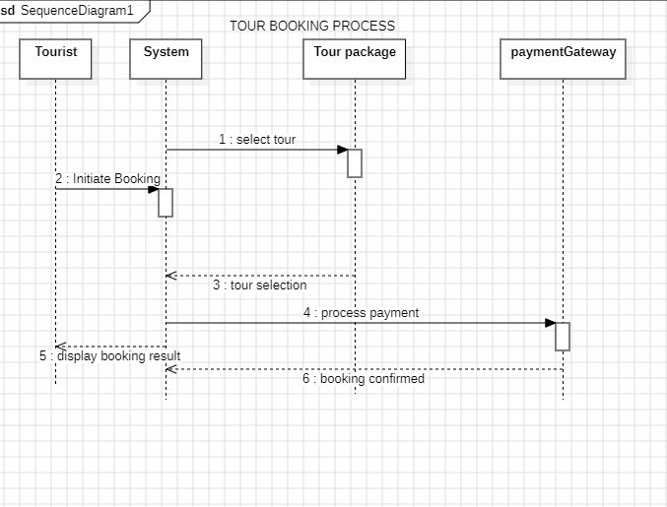

## 2.Tour Registration

## Starting the registration process is what is meant by "tourist registration." In order to enter and submit passport and personal information, the System talks with the Database. The System notifies the Traveler that their registration was successful after a successful submission.

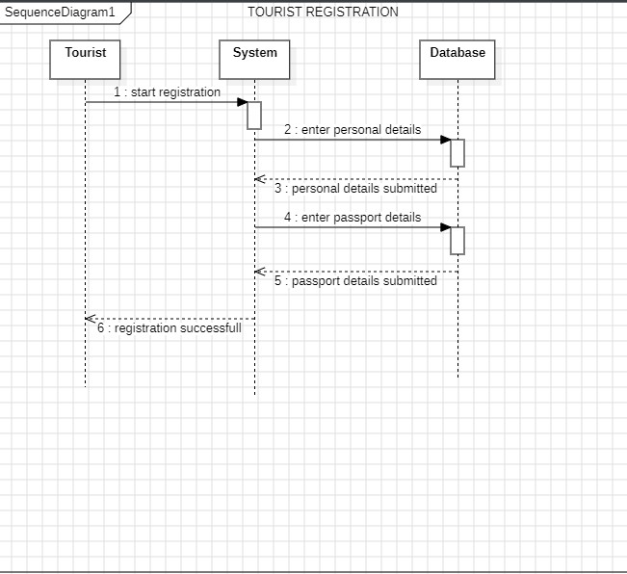

## 3.Tour Guide Assignment

## The Tour Guide task starts when an administrator starts the task. The GuideManagement module is contacted by the System to assign a guide, which is subsequently reported to the Administrator.

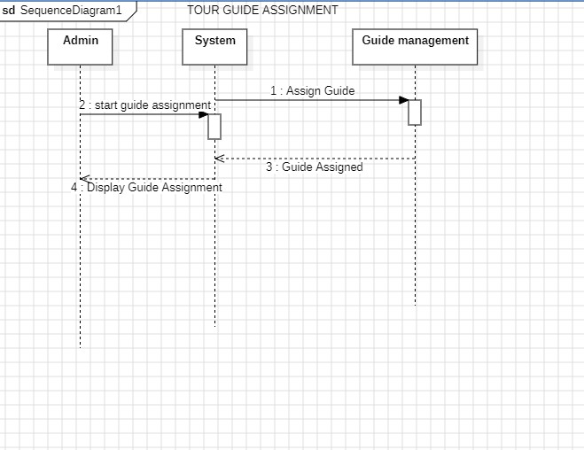

## 4.Tour status Tracking

## A tourist who is tracking a tour's status does so by checking its status. The TourStatus module is contacted by the System to obtain the tour status, which is subsequently shown to the Tourist.

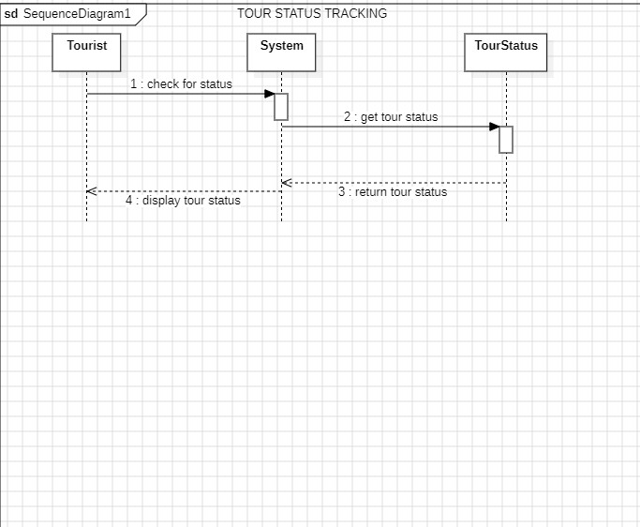

## 5.Feedback Collection

## A visitor initiates the feedback collection process. After feedback is successfully sent, the System notifies the Tourist by interacting with the FeedbackModule.

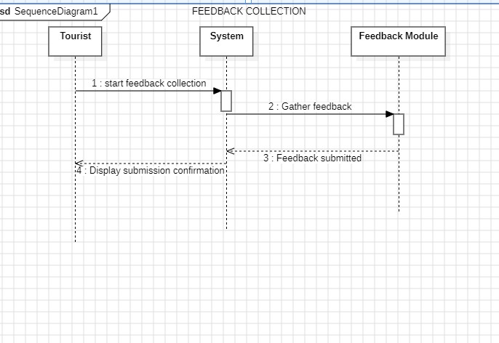

## Collaboration Diagram

## Tour Booking Process

## The Tourist uses the Booking System to start the tour booking process, which connects with the Payment Gateway to process the payment. The Booking System saves the booking information after the payment is approved. Concurrently, the information is received by the Tour Coordinator, who then assigns a tour guide to make sure the Tourist has a smooth booking experience.

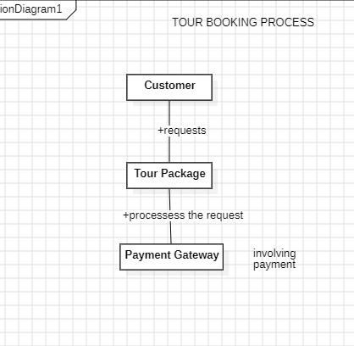

## Managing Accommodation

## The tourist using the reservation system to request lodging is part of the accommodation management process. The Accommodation Manager replies with pertinent information after receiving a communication from the Reservation System to verify availability. The Reservation System utilises this data to validate or reject the reservation, guaranteeing effective coordination throughout the lodging procedure.

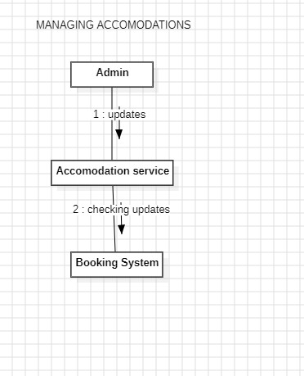

## Customer Review and Ratings

## The customer engages with the feedback system and provides insightful input regarding ratings and feedback. Customer ratings are processed simultaneously by the Rating System, and ratings and feedback are recorded for later study. Customer Support may interact with consumers for additional resolution or acknowledgement based on the input they get.

## C:\Users\Admin\AppData\Local\Packages\Microsoft.Windows.Photos_8wekyb3d8bbwe\TempState\ShareServiceTempFolder\Screenshot (72).jpeg

## Tour Guide Assignment

## The Tour Manager is contacted by the Tour Coordinator to seek a tour guide throughout the tour guide assignment procedure. The Tour Guide Manager utilises the Employee Database to locate a suitable guide, after which the details of the chosen guide are relayed to the Tour Coordinator. This cooperative endeavour guarantees the prompt and efficient allocation of tour guides.

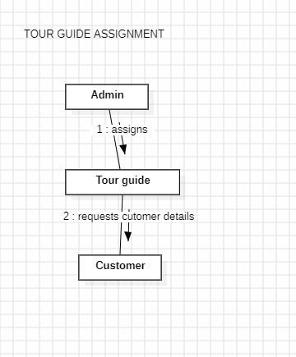

## Trip Itinerary Generation

## The Itinerary Generator and the Travel Agent work together to create trip itineraries. The Itinerary Generator is used by the Travel Agent to generate a new tour package, and it interacts with the Database to obtain details about the location, lodging, and activities. The collaborative process is then finished when the finalised tour package details are saved back in the database.

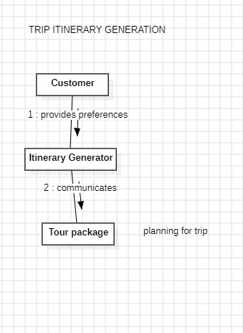

1. Architectural Family Diagrams

## Component Diagram

The Customer component stands for the end users who interact with the system, make reservations, and send comments. Travel Agent facilitates the creation and booking of trip packages by acting as an interface between clients and the system. The Package component contains information about tour packages, such as lodging, activities, and destinations. The logistics are handled by Transportation, guaranteeing smooth travel experiences. The Booking component manages payments and bookings, directing the booking procedure. Sensitive information is protected during user interactions via the Security component, which also guarantees data integrity. The Database component acts as the central repository for vital information, enabling the system's fundamental functions, while Persistence manages data storage and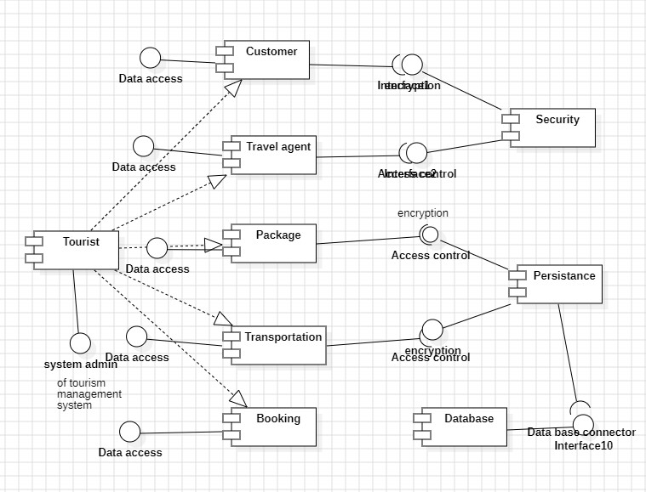 retrieval.

## Deployment Diagram

The Web Server, Application Server, Database Server, and External Services are the four nodes that make up the deployment diagram.The Web Application, which has interfaces for Administrators and Tourists, is hosted by the Web Server.The User Interface, Booking System, and Tour Management components are all part of the Application Server.The Database is hosted by the Database Server and contains data for the Booking System and Tour Management.The External Services node stands for services that are not part of the system, like the Payment Gateway that is connected to the Banking Services.

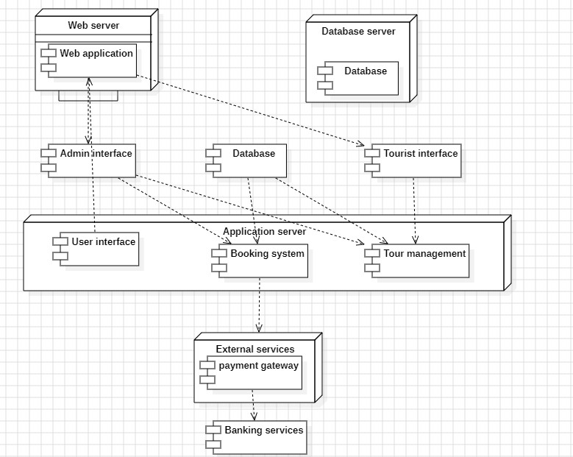

# 

# Appendix

Appendix A: Glossary

A glossary of terms used in the text that offers definitions and clarifications for technical and domain-specific phrases.

Appendix B: User Interface Mockups

wireframes, or graphic representations, of important user interfaces that highlight the style and arrangement of screens for travellers, travel agents, and administrators.

Appendix C: Database Schema

A thorough grasp of the data structure is provided by the comprehensive documentation of the database schema, which includes tables, relationships, and attributes.

Appendix D: System Flowcharts

flowcharts that show how data and control move through the system for important operations like reservation, lodging administration, and itinerary creation.

Appendix E: API Documentation

documentation that includes information about endpoints, arguments, and expected replies for any APIs (Application Programming Interfaces) that the system uses or exposes.

Appendix F: External Service Integration

Details on any third-party APIs or payment gateways that are integrated into the system, along with any pertinent agreements or paperwork.

Appendix G: Security Measures

thorough documentation on the system's security precautions, such as access controls, authentication methods, and encryption protocols.

Appendix H: Testing Plan

A thorough testing strategy that describes the scenarios, test cases, and testing procedures used to guarantee the functioning and dependability of the system.

Appendix I: Performance Metrics

benchmarks and metrics for measuring system performance, such as resource usage, scalability issues, and reaction times.

Appendix J: User Manuals

user manuals that offer detailed instructions on how to use and operate the system for visitors, travel agencies, and administrators.