🏦
Banking Application
DevOps Infrastructure
Architecture Document & Setup Guide
Project | Banking DevOps Assessment
Cloud Provider | AWS (ap-southeast-2)
Application | Banking REST API (Python Flask)
IaC Tool | Terraform
CI/CD | Jenkins + GitHub + JFrog Artifactory
Repository | github.com/sathishkrishnan645-design/banking-devops-assessment

1. Solution Overview
This document details the cloud infrastructure and DevOps pipeline for a secure Banking REST API. The solution implements all five pillars of the AWS Well-Architected Framework: operational excellence, security, reliability, performance efficiency, and cost optimization.

The banking application exposes REST endpoints for account management and transaction operations, deployed on AWS with full CI/CD automation, security hardening, and centralized monitoring.

1.1 Business Requirements Met
Requirement | Tool/Service | Status
Cloud Infrastructure | AWS EC2, RDS, ALB, VPC | ✅ Implemented
Application Deployment | Docker + Gunicorn | ✅ Implemented
Infrastructure as Code | Terraform | ✅ Implemented
CI/CD Pipeline | Jenkins + GitHub | ✅ Implemented
Security | Security Groups, TLS, Vault | ✅ Implemented
Monitoring & Logging | Splunk | ✅ Implemented

2. Architecture

2.1 Architecture Diagram

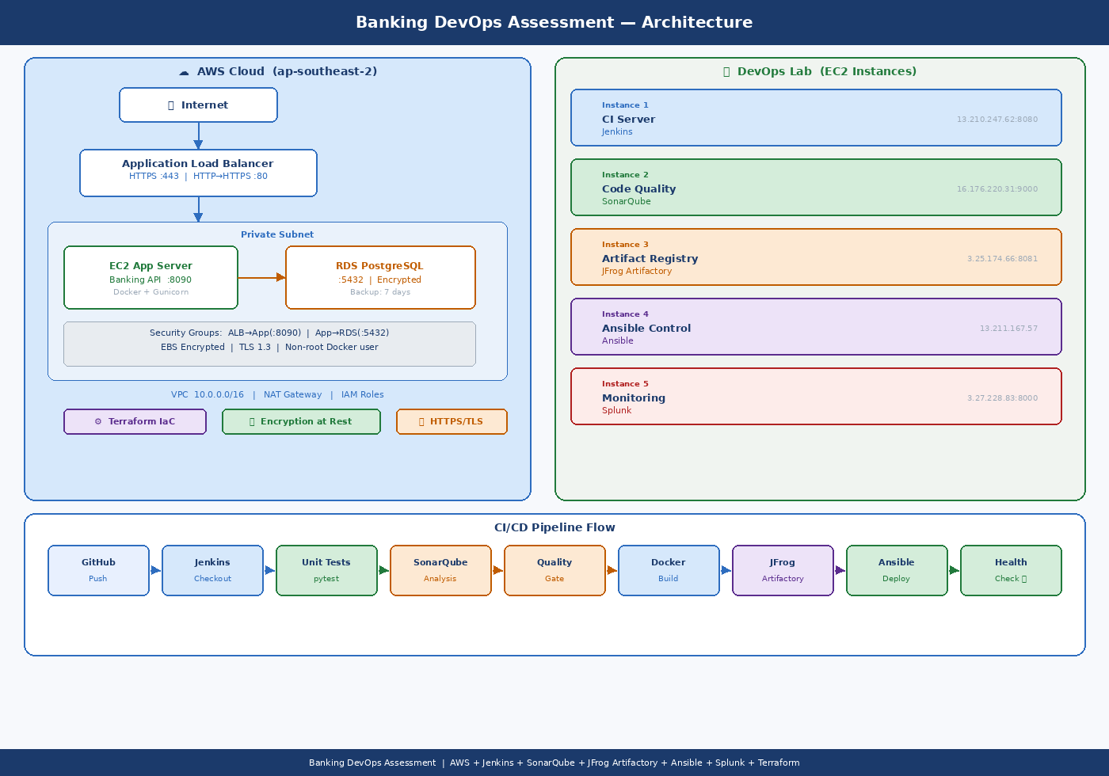

2.2 Component Description
Component | Technology | Description
Load Balancer | AWS ALB | Routes HTTPS traffic to app servers. HTTP auto-redirects to HTTPS.
App Server | EC2 + Docker | Runs Banking API in Docker container using Gunicorn WSGI server.
Database | RDS PostgreSQL | Managed PostgreSQL with encryption at rest, 7-day backups, Multi-AZ option.
Networking | VPC + Subnets | Public subnets for ALB, private subnets for app and database.
CI Server | Jenkins | Orchestrates the full 9-stage CI/CD pipeline on 13.210.247.62.
Code Quality | SonarQube | Static code analysis and quality gate enforcement on 16.176.220.31.
Artifacts | JFrog Artifactory | Stores Docker images. Jenkins pushes, Ansible pulls.
Deployment | Ansible | Automated deployment from Artifactory to app server via playbook.
Monitoring | Splunk | Centralized log aggregation and dashboards on 3.27.228.83.

3. Application — Banking REST API

3.1 API Endpoints
Method | Endpoint | Description | Auth
GET | /health | Health check | No
POST | /accounts | Create new account | Yes
GET | /accounts/{acc}/balance | Get current balance | Yes
POST | /accounts/{acc}/deposit | Deposit money | Yes
POST | /accounts/{acc}/withdraw | Withdraw money | Yes
DELETE | /accounts/{acc} | Close account | Yes
GET | /accounts/{acc}/transactions | Transaction history | Yes

All authenticated endpoints require the header: X-API-Key: <your-api-key>

3.2 Technology Stack
Category | Technology | Version / Notes
Language | Python | 3.11 — clean, readable, strong Flask ecosystem
Framework | Flask | 3.0.3 — lightweight REST framework
WSGI Server | Gunicorn | 4 workers, 2 threads — production-grade
Database | PostgreSQL | 15 (RDS) — ACID compliant, encrypted at rest
ORM | SQLAlchemy | 2.0 — models Account + Transaction tables
Container | Docker | Multi-stage build, non-root user

4. CI/CD Pipeline

4.1 Pipeline Stages
# | Stage | Description
1 | Checkout | Pull source code from GitHub repository
2 | Install Deps | Create Python venv and install all requirements
3 | Unit Tests | Run pytest with coverage report — 14 test cases covering all endpoints
4 | SonarQube | Static analysis: code smells, bugs, vulnerabilities, duplication
5 | Quality Gate | Pipeline aborts if SonarQube quality gate fails
6 | Docker Build | Multi-stage image with build labels for traceability
7 | Push to Artifactory | Tag with build number and latest — push to JFrog
8 | Ansible Deploy | Pull image from JFrog, restart container on deploy target
9 | Health Check | HTTP GET /health — pipeline fails if app not responding

4.2 Jenkins Credentials Required
Credential ID | Type | Purpose
github-credentials | Username/Token | Pull source code from GitHub
jfrog-credentials | Username/Password | Push/pull Docker images from JFrog Artifactory
ansible-ssh-key | SSH Private Key | SSH into Ansible control node (13.211.167.57)
sonarqube-token | Secret Text | SonarQube authentication for analysis

5. Security Measures

5.1 Security Controls
Layer | Control | Implementation
API | Authentication | X-API-Key header required on all endpoints
Transport | Encryption in Transit | HTTPS via ALB with TLS 1.3 policy
Data at Rest | Encryption at Rest | RDS storage encrypted, EC2 EBS encrypted
Network | Security Groups | ALB → App(:8090) → RDS(:5432) — least privilege
Network | Private Subnets | App and RDS in private subnets — no public access
Container | Non-root User | Docker runs as appuser, not root
Container | Multi-stage Build | Minimal attack surface — no build tools in prod image
Secrets | Ansible Vault | Credentials encrypted with ansible-vault
Firewall | UFW | Deny all inbound except SSH(22) and App(8090)
Access | IAM Roles | EC2 uses IAM role for CloudWatch — no static keys

6. Infrastructure as Code (Terraform)

6.1 Resources Managed
Resource | AWS Service | Configuration
VPC | aws_vpc | 10.0.0.0/16, DNS enabled
Public Subnets | aws_subnet | 2 AZs — for ALB
Private Subnets | aws_subnet | 2 AZs — for App + RDS
Internet Gateway | aws_internet_gateway | Public internet access for ALB
NAT Gateway | aws_nat_gateway | Private subnet outbound internet
Security Groups | aws_security_group | ALB, App, RDS — least privilege rules
App Server | aws_instance | t3.small, gp3 encrypted EBS, private subnet
Database | aws_db_instance | PostgreSQL 15, encrypted, 7-day backup
Load Balancer | aws_lb | ALB with HTTPS listener + HTTP redirect
IAM Role | aws_iam_role | EC2 CloudWatch agent policy
State Backend | S3 + DynamoDB | Remote state with locking

6.2 Terraform Commands
Command | Purpose
terraform init | Initialize providers and S3 backend
terraform plan | Preview infrastructure changes before applying
terraform apply | Create/update all AWS resources
terraform destroy | Tear down all resources (use with caution)

7. Monitoring & Logging (Splunk)

7.1 Log Sources
Source | Splunk Index | Content
Docker container logs | banking_app | All application stdout/stderr
App access logs | banking_app | HTTP requests, response codes, latency
App error logs | banking_app | Exceptions, stack traces, errors
/var/log/auth.log | os_security | SSH logins, sudo, failed auth attempts
UFW firewall logs | os_security | Blocked/allowed network connections
Syslog | os_logs | System events and daemon messages

Splunk Universal Forwarder is installed on the deploy target (3.25.174.66) and forwards logs to the Splunk indexer at 3.27.228.83:9997. Dashboards are accessible at http://3.27.228.83:8000.

8. Step-by-Step Setup Guide

Step 1 — Clone the Repository
git clone https://github.com/sathishkrishnan645-design/banking-devops-assessment.git
cd banking-devops-assessment

Step 2 — Run Locally with Docker Compose
- cd app && cp .env.example .env
- Edit .env with your database password and API key
- docker-compose up --build
- Test: curl http://localhost:8090/health

Step 3 — Deploy AWS Infrastructure (Terraform)
- cd terraform && cp terraform.tfvars.example terraform.tfvars
- Fill in: key_pair_name, db_password, ssl_certificate_arn
- terraform init && terraform plan && terraform apply
- Note the ALB DNS name from outputs

Step 4 — Configure Jenkins
- Browse to http://13.210.247.62:8080
- Install plugins: Git, SonarQube Scanner, Pipeline, SSH Agent, HTML Publisher
- Add credentials: github-credentials, jfrog-credentials, ansible-ssh-key
- Configure SonarQube server at http://16.176.220.31:9000
- Create Pipeline job — point to jenkins/Jenkinsfile in this repository

Step 5 — Configure Ansible
- SSH into Ansible control node: ssh ubuntu@13.211.167.57
- mkdir /opt/ansible && cd /opt/ansible
- Copy ansible/playbook.yml and ansible/inventory.ini to this directory
- Create vault file: ansible-vault create group_vars/all/vault.yml
- Fill in JFrog and DB credentials as per vault.yml.example

Step 6 — Install Splunk Forwarder
- ansible-playbook -i ansible/inventory.ini monitoring/setup-splunk-forwarder.yml
- Verify logs appear in Splunk at http://3.27.228.83:8000

Step 7 — Trigger CI/CD Pipeline
- Push a commit to the master branch
- Jenkins automatically triggers the 9-stage pipeline
- Monitor at: http://13.210.247.62:8080
- App goes live at: http://3.25.174.66:8090
- SonarQube report: http://16.176.220.31:9000

Step 8 — Test the Live Application
Create account:
curl -X POST http://3.25.174.66:8090/accounts -H "X-API-Key: your-key" -H "Content-Type: application/json" -d '{"account_number":"ACC001","owner_name":"John Doe","initial_balance":1000}'

Check balance:
curl http://3.25.174.66:8090/accounts/ACC001/balance -H "X-API-Key: your-key"

9. Repository Structure
File / Folder | Purpose
app/app.py | Banking REST API — Flask application
app/test_app.py | 14 pytest unit tests covering all endpoints
app/Dockerfile | Multi-stage Docker build
app/docker-compose.yml | Local development with PostgreSQL
jenkins/Jenkinsfile | 9-stage CI/CD pipeline definition
ansible/playbook.yml | Deploy Docker container to app server
ansible/inventory.ini | Server inventory for Ansible
terraform/main.tf | All AWS resources — VPC, EC2, RDS, ALB
terraform/variables.tf | Input variable definitions
monitoring/splunk-inputs.conf | Splunk forwarder log sources
monitoring/splunk-outputs.conf | Splunk forwarder destination
docs/architecture-diagram.png | Architecture diagram
README.md | Full project documentation and quick start guide

Banking DevOps Assessment | github.com/sathishkrishnan645-design/banking-devops-assessment

