LC#907
Given an array of integers arr, find the sum of min(b), where b ranges over every (contiguous) subarray of arr. Since the answer may be large, return the answer modulo 10⁹ + 7.

Example 1:
Input: arr = [3,1,2,4]
Output: 17
Explanation:
Subarrays are [3], [1], [2], [4], [3,1], [1,2], [2,4], [3,1,2], [1,2,4], [3,1,2,4].
Minimums are 3, 1, 2, 4, 1, 1, 2, 1, 1, 1.
Sum is 17.
Example 2:
Input: arr = [11,81,94,43,3]
Output: 444

To tell simply find the minimum value in every subarray and add it finally return it

CODE:
->this is a tougher problem but given mid
->what we have done here is found the next smaller element and previous smaller element of every thing and stored its indexes
->then we go through the loop and multiply since n+n+n => 3n right so likewise we are doing I assume
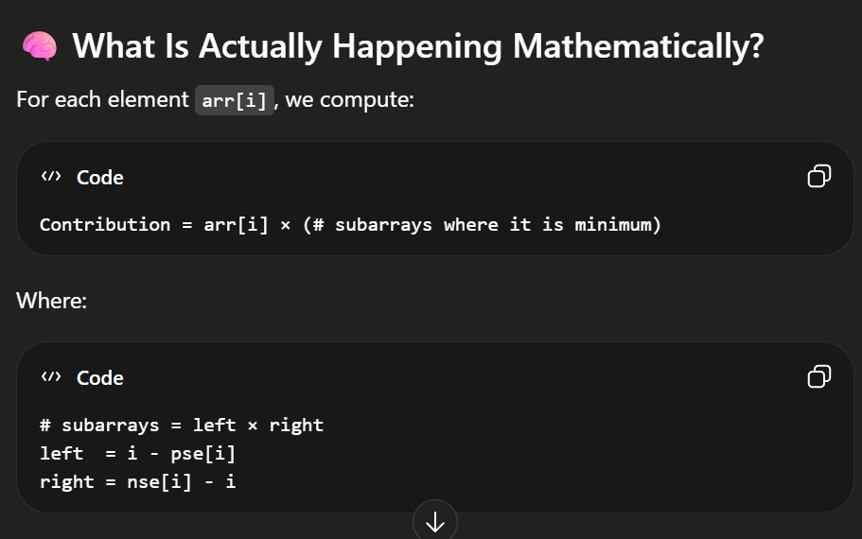

class Solution {
public int sumSubarrayMins(int[] arr) {
int[] pse = new int[arr.length];
int[] nse = new int[arr.length];

pse = findPSE(arr);
nse = findNSE(arr);
long sum = 0;
int mod = (int)(Math.pow(10 , 9)+7);
for(int i = 0 ; i< arr.length;i++)
{
int left = i-pse[i];
int right = nse[i] -i;
long val = (1l*right*left*arr[i])%mod;
sum = (sum +val)%mod;
}
return (int)sum;

}

public int[] findNSE(int arr[])
{
int res[] = new int[arr.length];
Stack<Integer> s = new Stack();
for(int i = arr.length-1 ; i>=0;i--)
{
while(!s.isEmpty() && arr[s.peek()]>arr[i])
s.pop();
if(s.isEmpty())
res[i] = arr.length;
else
res[i] = s.peek();
s.push(i);
}
return res;
}

public int[] findPSE(int arr[]) {
int res[] = new int[arr.length];
Stack<Integer> s = new Stack();
for (int i = 0; i < arr.length; i++) {
while (!s.isEmpty() && arr[s.peek()] >= arr[i])
s.pop();
if (s.isEmpty()) {
res[i] = -1;
} else
res[i] = s.peek();
s.push(i);
}
return res;
}
}

