LC#102 : BINARY TREE LEVEL ORDER TRAVERSAL
Given the root of a binary tree, return the level order traversal of its nodes' values. (i.e., from left to right, level by level).

Example 1:
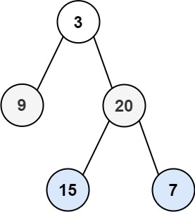
Input: root = [3,9,20,null,null,15,7]
Output: [[3],[9,20],[15,7]]
Example 2:
Input: root = [1]
Output: [[1]]
Example 3:
Input: root = []
Output: []
APP:
->firstly push the root node to the queue
->get the size of the queue(outside loop) because it shows the count of element in the list inside list
->get the top element and add it to the temp list then if left and right have means push

CODE: TC:O(N) SC :O(N)
class Solution {
public List<List<Integer>> levelOrder(TreeNode root) {
List<List<Integer>> res = new ArrayList();
if(root==null)
return res;
ArrayDeque<TreeNode> dq = new ArrayDeque();
dq.offer(root);//first push the root node to access
while(!dq.isEmpty())
{
int size = dq.size();
List<Integer> temp = new ArrayList();
for(int i = 0 ; i< size ; i++)
{
TreeNode top = dq.poll();
temp.add(top.val);//this is in loop so if top have child it is pushed and their values are got when it becomes top

if(top.left!=null)
dq.offer(top.left);
if(top.right!=null)
dq.offer(top.right);
}
res.add(temp);
}
return res;
}
}
LC#103 BT BFS ZIGZAG:
Given the root of a binary tree, return the zigzag level order traversal of its nodes' values. (i.e., from left to right, then right to left for the next level and alternate between).

Example 1:

Input: root = [3,9,20,null,null,15,7]
Output: [[3],[20,9],[15,7]]
Example 2:
Input: root = [1]
Output: [[1]]
Example 3:
Input: root = []
Output: []
APP:
->same thing as level order traversal
->only add on is a variable that is inverting the inserting position
->firstly true and then invert

CODE: TC:O(N) , SC :O(N)
class Solution {
public List<List<Integer>> zigzagLevelOrder(TreeNode root) {
List<List<Integer>> res = new ArrayList();
if(root==null)
return res;
ArrayDeque<TreeNode> dq = new ArrayDeque();
dq.offer(root);//first push the root node to access
boolean zigzag = true;
while(!dq.isEmpty())
{
int size = dq.size();
List<Integer> temp = new ArrayList();
for(int i = 0 ; i< size ; i++)
{
TreeNode top = dq.poll();
if(zigzag) temp.add(top.val);
else temp.add(0,top.val);
if(top.left!=null)
dq.offer(top.left);
if(top.right!=null)
dq.offer(top.right);
}
res.add(temp);
zigzag = !zigzag;
}
return res;
}}
LC#1161 MAXIMUM LEVEL SUM OF A BINARY TREE
Given the root of a binary tree, the level of its root is 1, the level of its children is 2, and so on.
Return the smallest level x such that the sum of all the values of nodes at level x is maximal.
Example 1:
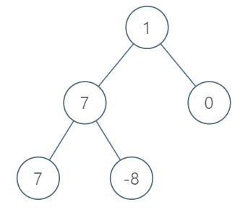
Input: root = [1,7,0,7,-8,null,null]
Output: 2
Explanation:
Level 1 sum = 1.
Level 2 sum = 7 + 0 = 7.
Level 3 sum = 7 + -8 = -1.
So we return the level with the maximum sum which is level 2.
Constraints:
- The number of nodes in the tree is in the range [1, 10⁴].
- -10⁵ <= Node.val <= 10⁵
APP:
->values only so no arraylist needed only queue is enough just traverse and add
->check and update the maxSum and resLevel
CODE: TC:O(N) SC:O(N)
class Solution {
public int maxLevelSum(TreeNode root) {
int resLevel = 1 , maxSum = root.val , level = 1;
Deque<TreeNode> dq = new ArrayDeque();
dq.offer(root);
while(!dq.isEmpty())
{
int currSum = 0;
int size = dq.size();
for(int i = 0 ; i<size;i++)
{
TreeNode top = dq.poll();
currSum+=top.val;
if(top.left!=null)
dq.offer(top.left);
if(top.right!=null)
dq.offer(top.right);
}
if(currSum>maxSum)
{
resLevel = level;
maxSum = currSum;
}
level++;//for keeping track of level
}
return resLevel;
}}
LC#515 LARGEST VALUE IN EACH TREE ROW
Given the root of a binary tree, return an array of the largest value in each row of the tree (0-indexed).

Example 1:
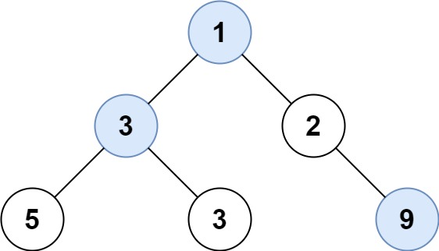
Input: root = [1,3,2,5,3,null,9]
Output: [1,3,9]
Example 2:
Input: root = [1,2,3]
Output: [1,3]
APP:
->do normal BFS and keep a maxVal inside the loop and finally after the loop add it to the list

CODE: TC:O(N) , SC:O(N)
class Solution {
public List<Integer> largestValues(TreeNode root) {
List<Integer> res = new ArrayList();
if(root==null)
return res;
ArrayDeque<TreeNode> dq = new ArrayDeque();
dq.offer(root);

while(!dq.isEmpty())
{
int size = dq.size();
int maxVal = Integer.MIN_VALUE;
for(int i = 0 ; i< size ; i++)
{
TreeNode top = dq.poll();
if(top.left!=null)
dq.offer(top.left);
if(top.right!=null)
dq.offer(top.right);
maxVal = Math.max(maxVal , top.val);
}
res.add(maxVal);
}
return res;
}
}

LC#199 : BT RIGHT SIDE VIEW
FGiven the root of a binary tree, imagine yourself standing on the right side of it, return the values of the nodes you can see ordered from top to bottom.

Example 1:
Input: root = [1,2,3,null,5,null,4]
Output: [1,3,4]
Explanation:
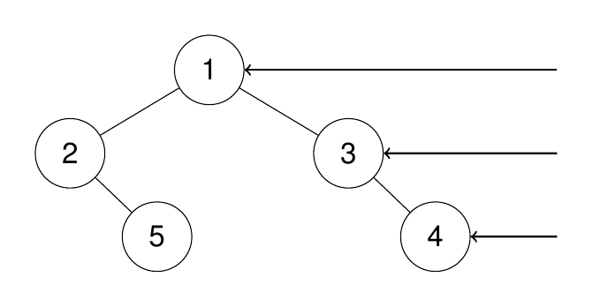
Example 2:
Input: root = [1,2,3,4,null,null,null,5]
Output: [1,3,4,5]
Explanation:
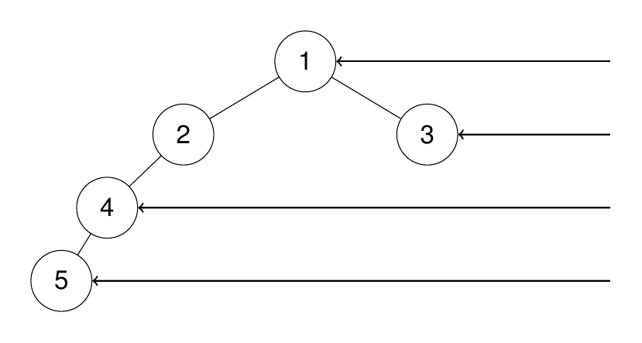
APP:
->same traversal but add only condition put and the push right first
1)using a variable
2)if i==0
class Solution {
public List<Integer> rightSideView(TreeNode root) {
List<Integer> res = new ArrayList();
if(root==null)
return res;
ArrayDeque<TreeNode> dq = new ArrayDeque();
dq.offer(root);
while(!dq.isEmpty())
{
int size = dq.size();
int temp = 0;
boolean value = false;
for(int i = 0 ; i < size ; i++)
{
TreeNode top = dq.poll();
if(!value) // if(i==0) no needed of value
{
temp = top.val;
value = true;
}
if(top.right!=null)
dq.offer(top.right);
if(top.left!=null)
dq.offer(top.left);
}
res.add(temp);
}
return res;

}
}

