THIS IS CP KINDA IF USE ARRAY AND THEN COMPUTE THERE WILL SOME SPACE USED O(N) FINALLY BUT REDUCING IT TO THE VERY LOWEST USE THIS TEMPLATE

Deque<Integer> st = new ArrayDeque<>();
for(int i = 0; i <= n; i++)
{
int curr;
if(i == n)
curr = SENTINEL; // force stack to empty
else
curr = arr[i];

while(!st.isEmpty() && CONDITION(arr[st.peek()], curr))
{
int mid = st.pop();

int left = st.isEmpty() ? -1 : st.peek();
int right = i;

// contribution / width calculation
}

st.push(i);
}

Subarray problems → (mid-left)*(right-mid)
Histogram problems → right-left-1
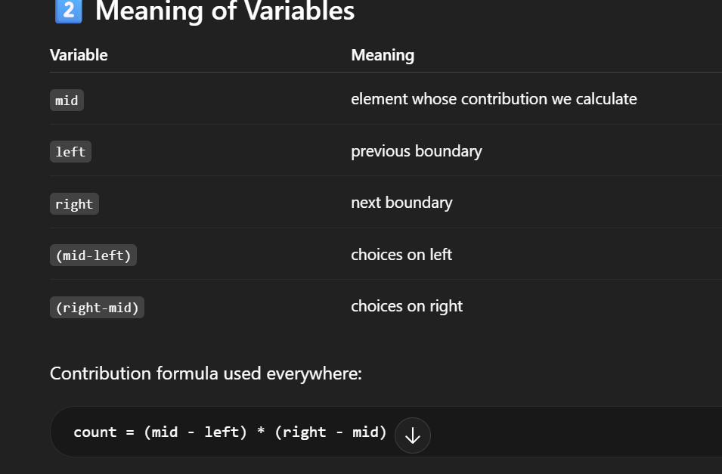
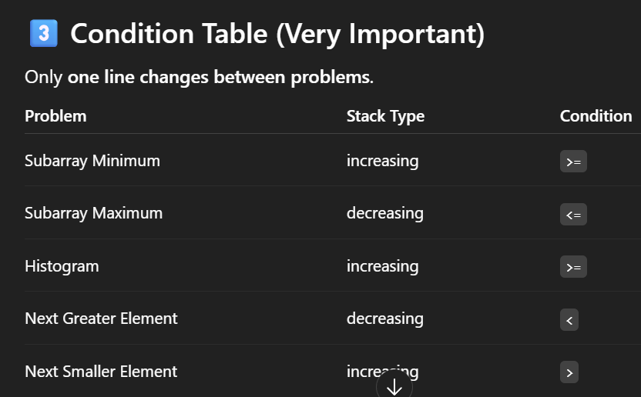

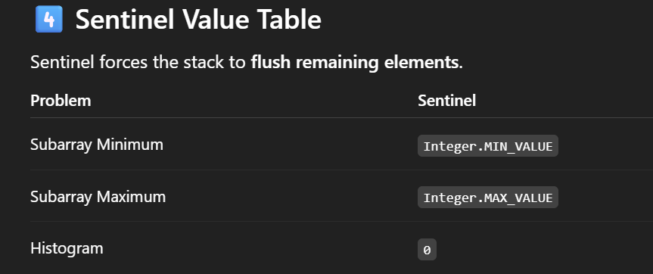

BASIC CODES:
1)public long maxSumSubarray(int[] nums)
{
long res = 0L;
Stack<Integer> s = new Stack();
int n = nums.length;
for(int i = 0 ; i<=n;i++)
{
int curr;
if(i==n)
curr = Integer.MAX_VALUE;
else
curr = nums[i];
while(!s.isEmpty() && nums[s.peek()]<=curr)
{
int mid = s.pop();
int left = s.isEmpty()?-1:s.peek();
int right = i;
long count = (long)((mid-left)*(right-mid));
res = res + (count*nums[mid]);
}
s.push(i);
}
return res;

}

2)
public long minSumSubArray(int[] nums)
{
long res = 0l;
Stack<Integer> s = new Stack();
int n = nums.length;
for(int i = 0 ; i<=n;i++)
{
int curr;
if(i==n)
curr = Integer.MIN_VALUE;
else
curr = nums[i];
while(!s.isEmpty() && nums[s.peek()]>=curr)
{
int mid = s.pop();
int left = s.isEmpty()?-1:s.peek();
int right = i;
long count = (long)(mid-left)*(right-mid);
res = res + (count*nums[mid]);
}
s.push(i);
}
return res;
}
}

