Target
Business Case
Scaler

Topic: SQL
Duration: 2 week

Context
- Target is a globally renowned brand and a prominent retailer in the United States. Target makes itself a preferred shopping destination by offering outstanding value, inspiration, innovation and an exceptional guest experience that no other retailer can deliver.
- This particular business case focuses on the operations of Target in Brazil and provides insightful information about 100,000 orders placed between 2016 and 2018. The dataset offers a comprehensive view of various dimensions including the order status, price, payment and freight performance, customer location, product attributes, and customer reviews.
- By analyzing this extensive dataset, it becomes possible to gain valuable insights into Target's operations in Brazil. The information can shed light on various aspects of the business, such as order processing, pricing strategies, payment and shipping efficiency, customer demographics, product characteristics, and customer satisfaction levels.

Dataset: https://drive.google.com/drive/folders/1TGEc66YKbD443nslRi1bWgVd238gJCnb?usp=sharing

The data is available in 8 different csv files:
- customers.csv
- geolocation.csv
- order_items.csv
- payments.csv
- reviews.csv
- orders.csv
- products.csv
- sellers.csv

The column description for these csv files is given below.

The customers.csv contain following features:
Features | Description
customer_id | ID of the consumer who made the purchase
customer_unique_id | Unique ID of the consumer
customer_zip_code_prefix | Zip Code of consumer’s location
customer_city | Name of the City from where order is made
customer_state | State Code from where order is made (Eg. são paulo - SP)

The orders.csv contain following features:
Features | Description
order_id | A Unique ID of order made by the consumers
customer_id | ID of the consumer who made the purchase
order_status | Status of the order made i.e. delivered, shipped, etc.
order_purchase_timestamp | Timestamp of the purchase
order_delivered_carrier_date | Delivery date at which carrier made the delivery
order_delivered_customer_date | Date at which customer got the product
order_estimated_delivery_date | Estimated delivery date of the products

The order_items.csv contain following features:
Features | Description
order_id | A Unique ID of order made by the consumers
order_item_id | A Unique ID given to each item ordered in the order
product_id | A Unique ID given to each product available on the site
seller_id | Unique ID of the seller registered in Target
shipping_limit_date | The date before which the ordered product must be shipped
price | Actual price of the products ordered
freight_value | Price rate at which a product is delivered from one point to another

The payments.csv contain following features:
Features | Description
order_id | A Unique ID of order made by the consumers
payment_sequential | Sequences of the payments made in case of EMI
payment_type | Mode of payment used (Eg. Credit Card)
payment_installments | Number of installments in case of EMI purchase
payment_value | Total amount paid for the purchase order

The geolocations.csv contain following features:
Features | Description
geolocation_zip_code_prefix | First 5 digits of Zip Code
geolocation_lat | Latitude
geolocation_lng | Longitude
geolocation_city | City
geolocation_state | State

The sellers.csv contains following features:
Features | Description
seller_id | Unique ID of the seller registered
seller_zip_code_prefix | Zip Code of the seller’s location
seller_city | Name of the City of the seller
seller_state | State Code (Eg. são paulo - SP)

The reviews.csv contain following features:
Features | Description
review_id | ID of the review given on the product ordered by the order id
order_id | A Unique ID of order made by the consumers
review_score | Review score given by the customer for each order on a scale of 1-5
review_comment_title | Title of the review
review_comment_message | Review comments posted by the consumer for each order
review_creation_date | Timestamp of the review when it is created
review_answer_timestamp | Timestamp of the review answered

The products.csv contain following features:
Features | Description
product_id | A Unique identifier for the proposed project.
product_category_name | Name of the product category
product_name_lenght | Length of the string which specifies the name given to the products ordered
product_description_lenght | Length of the description written for each product ordered on the site
product_photos_qty | Number of photos of each product ordered available on the shopping portal
product_weight_g | Weight of the products ordered in grams
product_length_cm | Length of the products ordered in centimeters
product_height_cm | Height of the products ordered in centimeters
product_width_cm | Width of the product ordered in centimeters

Dataset schema:
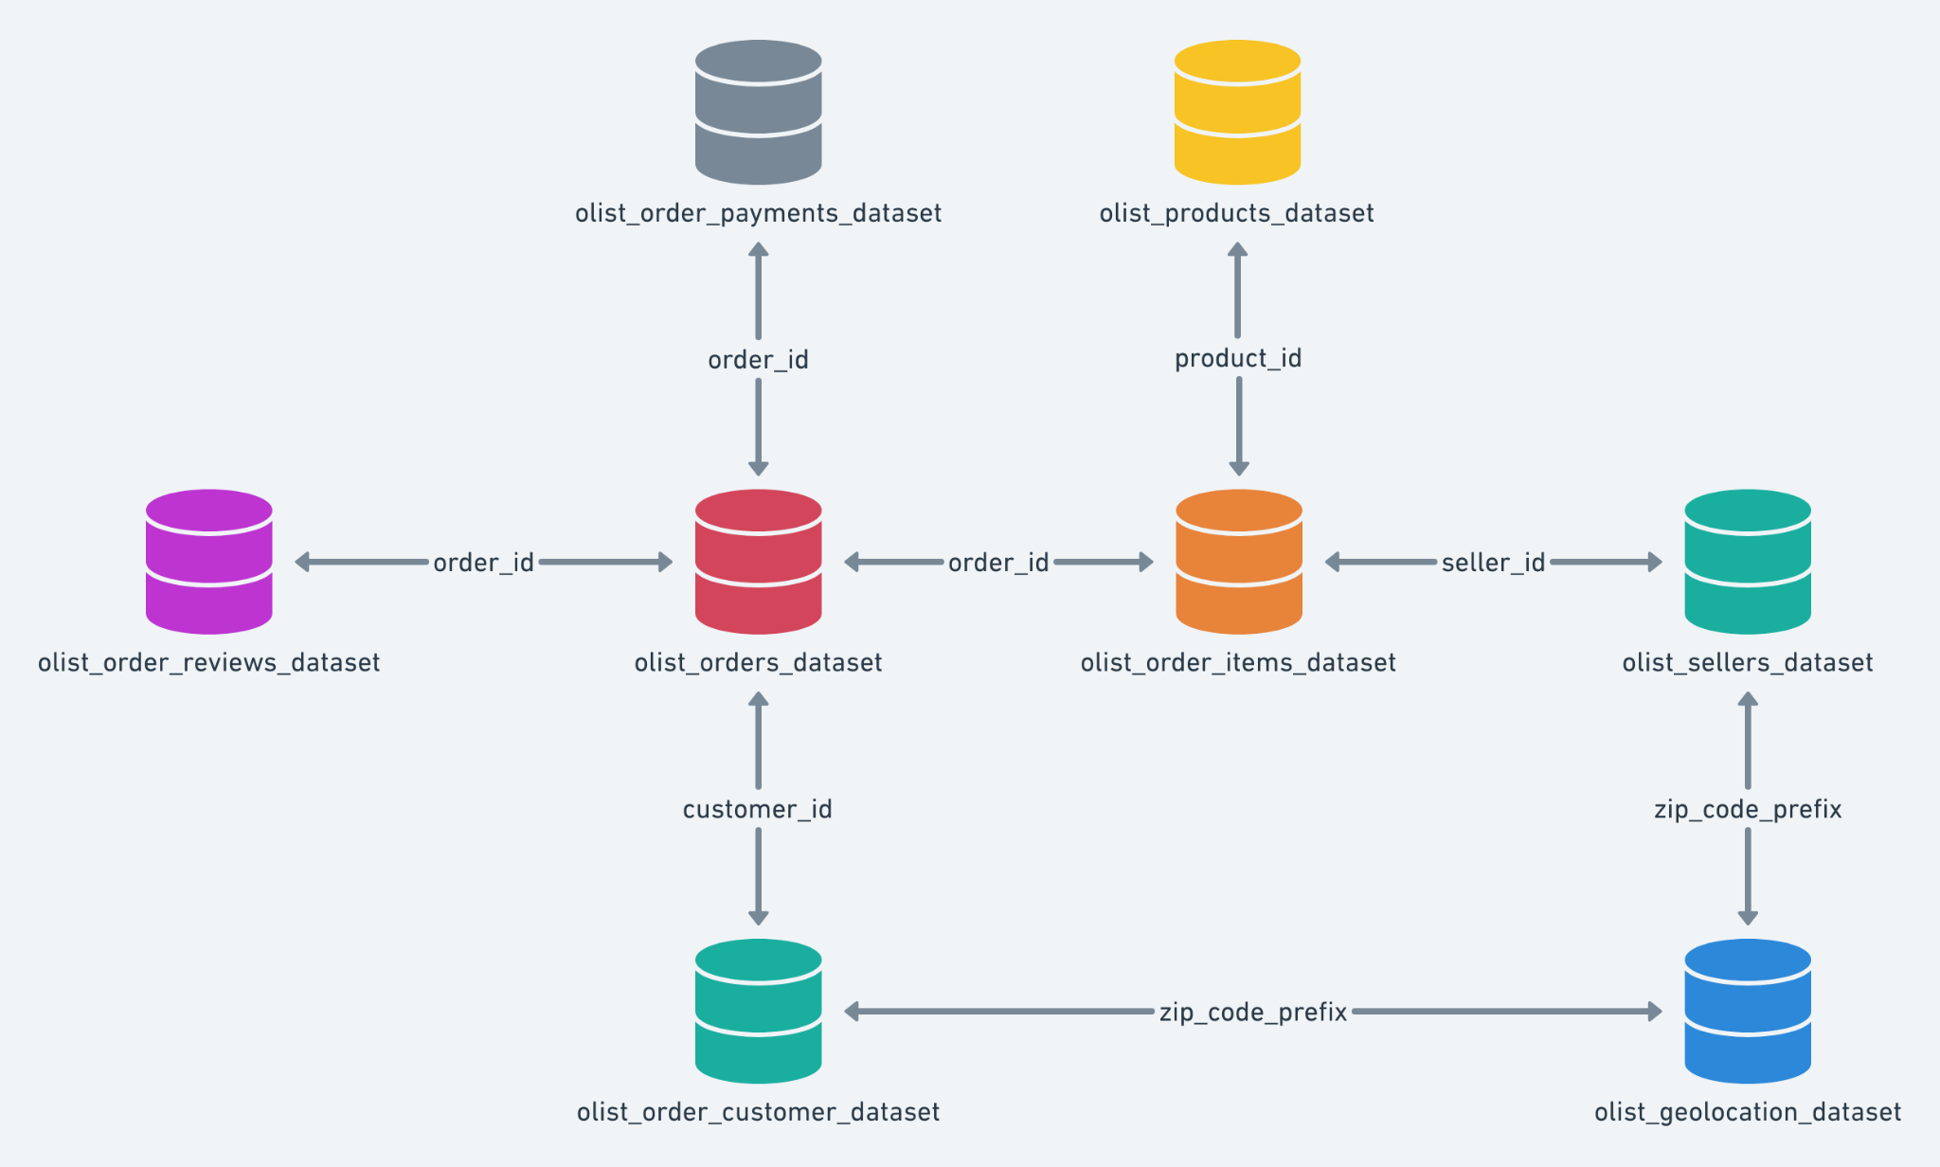

Problem Statement:
Assuming you are a data analyst/ scientist at Target, you have been assigned the task of analyzing the given dataset to extract valuable insights and provide actionable recommendations.

What does ‘good’ look like?
- Import the dataset and do usual exploratory analysis steps like checking the structure & characteristics of the dataset:
  - Data type of all columns in the “customers” table.
  - Get the time range between which the orders were placed.
  - Count the Cities & States of customers who ordered during the given period.

- In-depth Exploration:
  - Is there a growing trend in the no. of orders placed over the past years?
  - Can we see some kind of monthly seasonality in terms of the no. of orders being placed?
  - During what time of the day, do the Brazilian customers mostly place their orders? (Dawn, Morning, Afternoon or Night)
- 0-6 hrs : Dawn
- 7-12 hrs : Mornings
- 13-18 hrs : Afternoon
- 19-23 hrs : Night

- Evolution of E-commerce orders in the Brazil region:
  - Get the month on month no. of orders placed in each state.
  - How are the customers distributed across all the states?

- Impact on Economy: Analyze the money movement by e-commerce by looking at order prices, freight and others.
  - Get the % increase in the cost of orders from year 2017 to 2018 (include months between Jan to Aug only).
You can use the “payment_value” column in the payments table to get the cost of orders.
  - Calculate the Total & Average value of order price for each state.
  - Calculate the Total & Average value of order freight for each state.

- Analysis based on sales, freight and delivery time.
  - Find the no. of days taken to deliver each order from the order’s purchase date as delivery time.
Also, calculate the difference (in days) between the estimated & actual delivery date of an order.
Do this in a single query.
You can calculate the delivery time and the difference between the estimated & actual delivery date using the given formula:
- time_to_deliver = order_delivered_customer_date - order_purchase_timestam.
- diff_estimated_delivery = order_estimated_delivery_date - order_delivered_customer_date
  - Find out the top 5 states with the highest & lowest average freight value.
  - Find out the top 5 states with the highest & lowest average delivery time.
  - Find out the top 5 states where the order delivery is really fast as compared to the estimated date of delivery.
You can use the difference between the averages of actual & estimated delivery date to figure out how fast the delivery was for each state.

- Analysis based on the payments:
  - Find the month on month no. of orders placed using different payment types.
  - Find the no. of orders placed on the basis of the payment installments that have been paid.z

Evaluation Criteria (100 points)
- Initial exploration like checking the structure & characteristics of the data (15 points)
- In-depth Exploration (15 points)
- Evolution of E-commerce orders in the Brazil region (10 points)
- Impact on Economy (20 points)
- Analysis on sales, freight and delivery time (20 points)
- Analysis based on the payments (10 points)
- Actionable Insights & Recommendations (10 points)

Submission Process
Once you’re done with the case study...
- Use a Word document to paste your SQL queries along with a screenshot of the first 10 rows from the output.
- List down any valuable insights that you find during the analysis and provide some action items from the company’s perspective in order to improve the current situation.
- Convert your solutions doc into a PDF, and upload the same on the platform.
- Please note that after submitting once, you will not be allowed to edit your submission.

Initial exploration like checking the structure & characteristics of the data
Sathish Kumar’s Submission

Importing the Data to BigQuery
Importing
List of Tables
Checking the size of dataset/tables
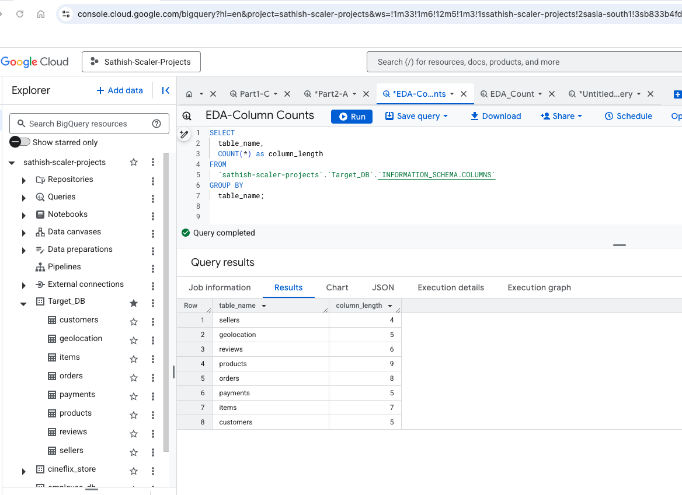
Table - Counts
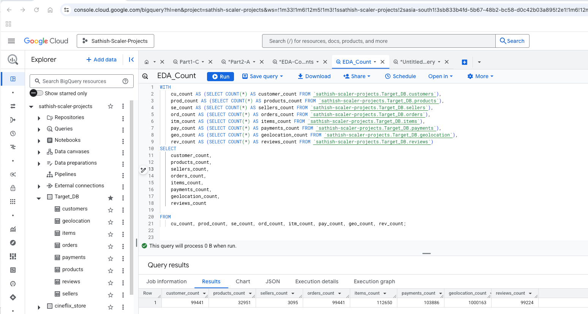

  - Data type of all columns in the “customers” table.

Query
SELECT
column_name,
data_type
FROM
`sathish-scaler-projects.Target_DB.INFORMATION_SCHEMA.COLUMNS`
WHERE
table_name = 'customers';

Output
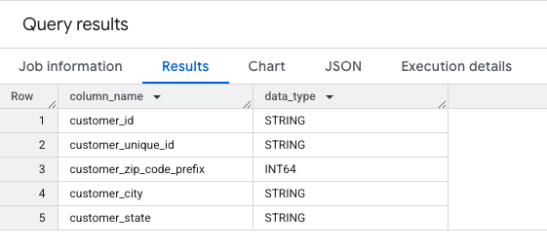

Insights

  - Get the time range between which the orders were placed.

SQL Query
SELECT MIN(order_purchase_timestamp) AS start_date,
MAX(order_purchase_timestamp) AS end_date
FROM `sathish-scaler-projects.Target_DB.orders`;
Output

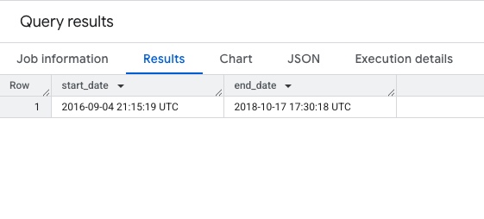
Insights

  - Part1-C: Count the Cities & States of customers who ordered during the given period.

SQL Query
SELECT
COUNT(DISTINCT customer_city) as city_count,
COUNT(DISTINCT customer_state) as state_count
FROM
`sathish-scaler-projects`.`Target_DB`.`orders` AS orders
INNER JOIN
`sathish-scaler-projects`.`Target_DB`.`customers` AS customers
ON
orders.customer_id = customers.customer_id
WHERE
--- Giving an Example where i can provide a time range here
orders.order_purchase_timestamp BETWEEN '2017-01-01'AND '2018-01-01'

Output
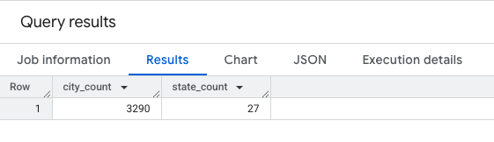

Insights

2. In-depth Exploration:

  - Is there a growing trend in the no. of orders placed over the past years?

SQL Query
WITH find_trend AS
( -- Primary Query , this is suffient to find the order count
SELECT
EXTRACT(YEAR FROM order_purchase_timestamp) AS order_year,
COUNT(*) AS orders_placed
FROM `sathish-scaler-projects`.`Target_DB`.`orders`
GROUP BY order_year
)
-- Adding this to indicate the percentage of increase
SELECT
order_year,
orders_placed,
round((orders_placed - LAG(orders_placed, 1, 0) OVER (ORDER BY order_year)) * 100.0 /
NULLIF(LAG(orders_placed, 1) OVER (ORDER BY order_year), 0),2) AS order_increase_percentage
FROM find_trend
ORDER BY order_year;

Output
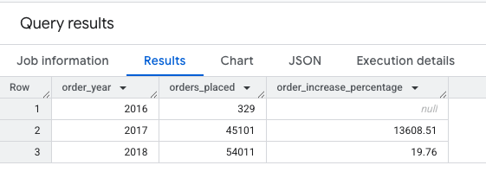

Insights

2.2 : Can we see some kind of monthly seasonality in terms of the no. of orders being placed?

SQL Query
WITH orders_with_year AS
(
SELECT
EXTRACT(YEAR FROM order_purchase_timestamp) AS order_year,
EXTRACT(MONTH FROM order_purchase_timestamp) AS order_month,
COUNT(*) AS order_count
FROM
`sathish-scaler-projects`.`Target_DB`.`orders`
GROUP BY order_year, order_month
)
SELECT
order_year,
order_month,
order_count,
CASE
WHEN order_count > ( SELECT AVG(order_count) FROM `orders_with_year`) THEN 'High'
ELSE 'Low'
END
AS order_volumes
FROM `orders_with_year`
ORDER BY order_year, order_month;

Output

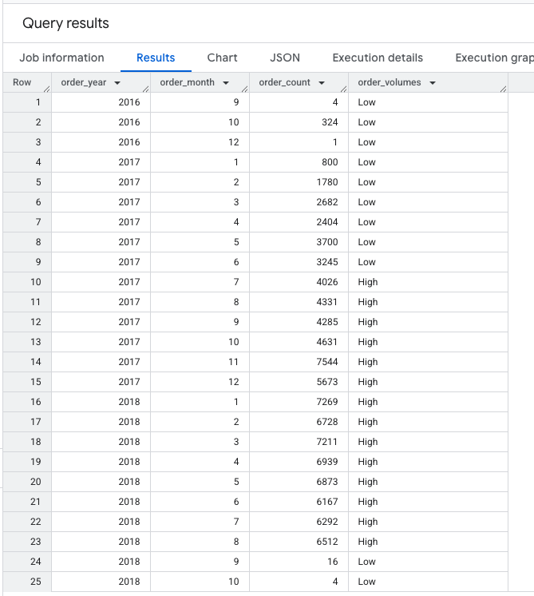

Insights

2.3 During what time of the day, do the Brazilian customers mostly place their orders? (Dawn, Morning, Afternoon or Night)
0-6 hrs : Dawn
7-12 hrs : Mornings
13-18 hrs : Afternoon
19-23 hrs : Night
Query 1
Query 2 ( Just specifying also the minutes inorder not to miss
WITH
classify_time AS (
SELECT
order_id,
CASE
WHEN TIME(order_purchase_timestamp) BETWEEN '00:00:00' AND '06:59:59' THEN 'DAWN'
WHEN TIME(order_purchase_timestamp) BETWEEN '07:00:00' AND '12:00:00' THEN 'MORNINGS'
WHEN TIME(order_purchase_timestamp) BETWEEN '12:00:01' AND '18:59:59' THEN 'AFTERNOON'
WHEN TIME(order_purchase_timestamp) BETWEEN '19:00:00' AND '23:59:59' THEN 'NIGHT'
END
AS purchase_time
FROM `sathish-scaler-projects`.`Target_DB`.`orders` )
SELECT
purchase_time,
COUNT(*) AS total_orders
FROM `classify_time`
GROUP BY purchase_time
ORDER BY total_orders DESC;

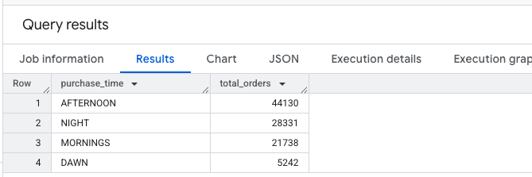

- Evolution of E-commerce orders in the Brazil region:

3.1 Get the month on month no. of orders placed in each state.

WITH CTE1 AS
(
SELECT
o.order_id,
o.order_purchase_timestamp,
EXTRACT(YEAR FROM order_purchase_timestamp) AS year,
EXTRACT(MONTH FROM order_purchase_timestamp) AS month,
FORMAT_DATE('%b %Y', DATE(ORDER_PURCHASE_TIMESTAMP)) AS time_period,
c.customer_state AS state
FROM `sathish-scaler-projects`.`Target_DB`.`orders` AS o
INNER JOIN `sathish-scaler-projects`.`Target_DB`.`customers` AS c
ON o.customer_id = c.customer_id
)
SELECT
state,
time_period,
COUNT(*) AS total_orders,
LAG(COUNT(*)) OVER (PARTITION BY state ORDER BY year, month) AS prev_month_orders_count,
ROUND( ( (COUNT(*) - LAG(COUNT(*)) OVER (PARTITION BY state ORDER BY year, month)) / LAG(COUNT(*)) OVER (PARTITION BY state ORDER BY year, month)) * 100, 2) AS MoM_percent_growth
FROM `CTE1`
GROUP BY state, time_period,year,month
ORDER BY state;

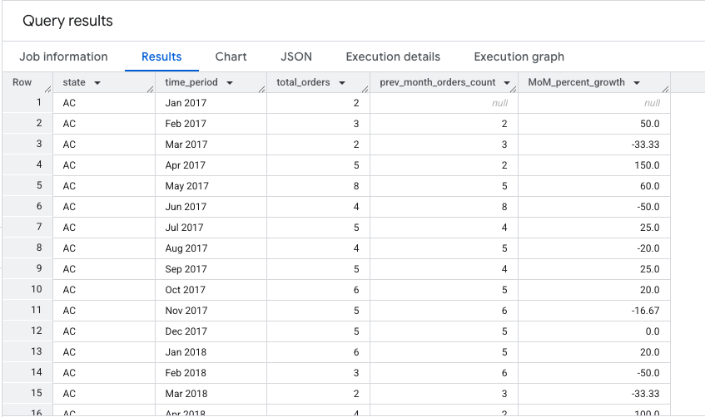

Part3.2 How are the customers distributed across all the states?

SELECT
DISTINCT customer_state,
count(customer_unique_id) AS No_of_unique_customers

FROM `sathish-scaler-projects.Target_DB.customers`
GROUP BY customer_state
ORDER BY No_of_unique_customers DESC;

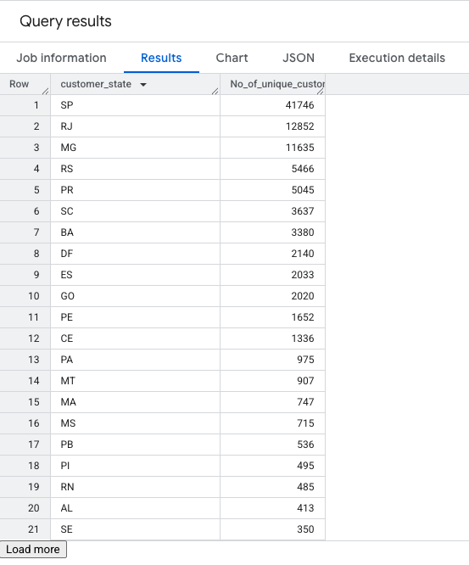

- Impact on Economy: Analyze the money movement by e-commerce by looking at order prices, freight and others.

  - Get the % increase in the cost of orders from year 2017 to 2018 (include months between Jan to Aug only).
WITH orders_with_payment AS (
SELECT
o.order_id,
EXTRACT(YEAR FROM o.order_purchase_timestamp) AS Year,
EXTRACT(MONTH FROM o.order_purchase_timestamp) AS Month,
p.payment_value
FROM `sathish-scaler-projects`.`Target_DB`.`orders` AS o
INNER JOIN `sathish-scaler-projects`.`Target_DB`.`payments` AS p
ON o.order_id = p.order_id
WHERE o.order_status = 'delivered'
),
monthly_total_payment AS (
SELECT
Year,
Month,
ROUND(SUM(payment_value),2) AS total_payment
FROM orders_with_payment
WHERE Month BETWEEN 1 AND 8
GROUP BY Year, Month
),
yearly_total_payment AS (
SELECT
Year,
ROUND(SUM(total_payment),2) AS yearly_total_payment
FROM monthly_total_payment
GROUP BY Year
)
SELECT
y.Year,
y.yearly_total_payment,
COALESCE(
ROUND(((y.yearly_total_payment - LAG(y.yearly_total_payment) OVER (ORDER BY y.Year))
/ LAG(y.yearly_total_payment) OVER (ORDER BY y.Year)) * 100, 2),
0
) AS YOY_percent_increase
FROM yearly_total_payment AS y
ORDER BY y.Year;

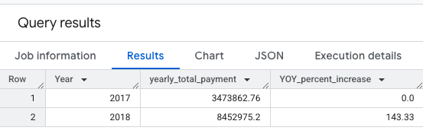

  - Calculate the Total & Average value of order price for each state.

SQL Query
WITH payment_collection as
(
SELECT
c.customer_state,
p.payment_value
FROM `sathish-scaler-projects.Target_DB.payments` p
JOIN `sathish-scaler-projects.Target_DB.orders` o
USING(order_id)
JOIN `sathish-scaler-projects.Target_DB.customers` c
USING(customer_id)
)
SELECT
DISTINCT customer_state,
ROUND(AVG(payment_value) OVER (partition by customer_state),2) as avg_state_order_price,
ROUND(SUM(payment_value) OVER (partition by customer_state),2) as total_state_order_price
FROM payment_collection
ORDER BY customer_state

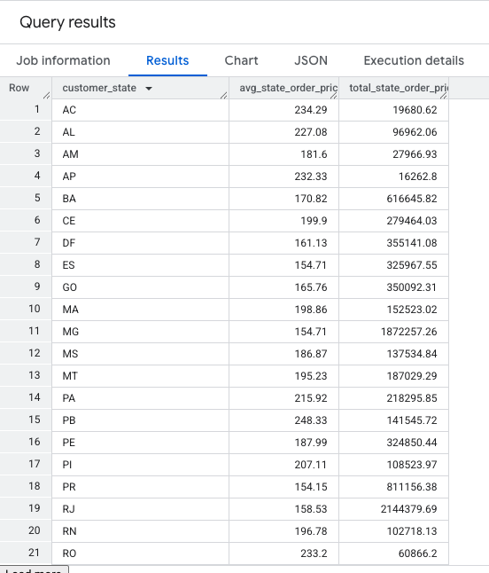

  - Calculate the Total & Average value of order freight for each state.

SQL Query
SELECT
c.customer_state,
ROUND(SUM(i.price)) total_price, -- calculating total for price value
ROUND(AVG(i.price)) avg_price, -- calculating avg for price value
ROUND(SUM(i.freight_value)) total_freight_value,-- calc total for freight value
ROUND(AVG(i.freight_value)) avg_freight_value -- calculating avg for freight value
FROM `Target_DB.items` i
JOIN `Target_DB.orders` o
USING (order_id)
JOIN `Target_DB.customers` c
ON c.customer_id = o.customer_id
GROUP BY c.customer_state;

Output
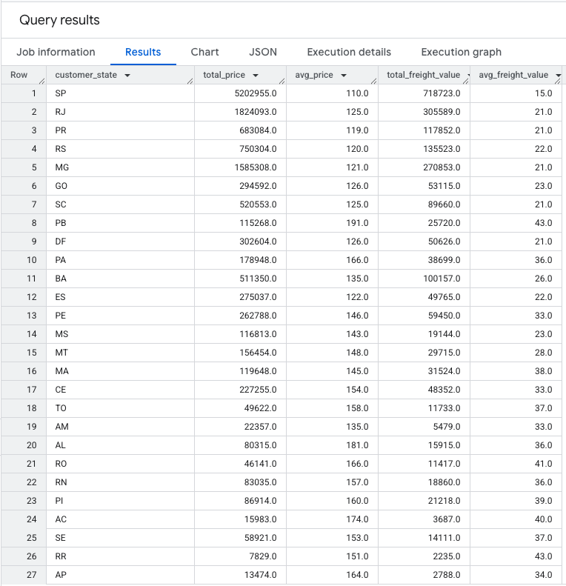

SQL Query
Output

Insights

- Analysis based on sales, freight and delivery time.

  - Find the no. of days taken to deliver each order from the order’s purchase date as delivery time.
Also, calculate the difference (in days) between the estimated & actual delivery date of an order.

Do this in a single query.
You can calculate the delivery time and the difference between the estimated & actual delivery date using the given formula:
- time_to_deliver = order_delivered_customer_date - order_purchase_timestam.
- diff_estimated_delivery = order_estimated_delivery_date - order_delivered_customer_date

SQL Query
SELECT
orders.order_id,
DATE_DIFF( DATE(orders.order_delivered_customer_date), DATE(orders.order_purchase_timestamp), DAY) AS time_to_deliver_days,
DATE_DIFF( DATE(orders.order_estimated_delivery_date), DATE(orders.order_delivered_customer_date), DAY) AS diff_estimated_delivery_days
FROM `sathish-scaler-projects.Target_DB.orders` AS orders
WHERE
orders.order_delivered_customer_date IS NOT NULL
AND orders.order_purchase_timestamp IS NOT NULL;
Output
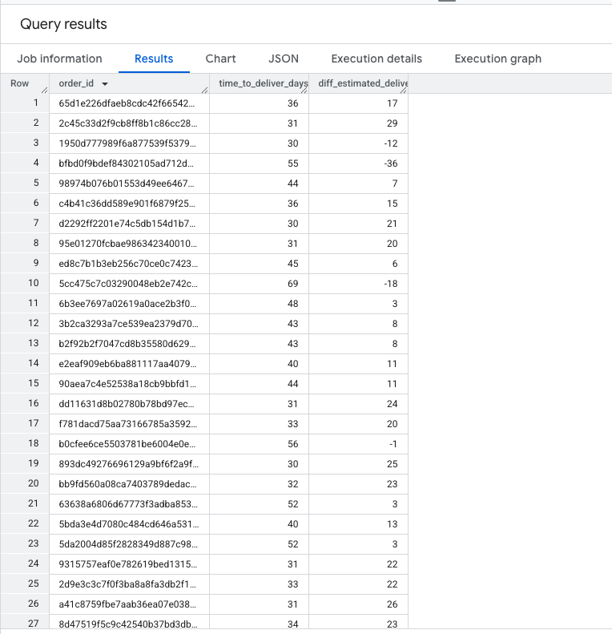

Insights

  - Find out the top 5 states with the highest & lowest average freight value.

SQL Query
WITH StateAvgFreight AS --1st query to find avg_fright cost
(
SELECT
customers.customer_state,
AVG(items.freight_value) AS avg_freight
FROM `sathish-scaler-projects.Target_DB.customers` AS customers
INNER JOIN`sathish-scaler-projects.Target_DB.orders` AS orders
ON customers.customer_id = orders.customer_id
INNER JOIN `sathish-scaler-projects.Target_DB.items` AS items
ON orders.order_id = items.order_id
GROUP BY
customers.customer_state
),
RankedStates AS --2nd Query to rank the states, output same as DENSE_RANK
(
SELECT
customer_state,
avg_freight,
RANK() OVER (ORDER BY avg_freight DESC) AS rank_highest,
RANK() OVER (ORDER BY avg_freight ASC) AS rank_lowest
FROM `StateAvgFreight`
)
SELECT
'Highest FV' AS Category,
customer_state,
avg_freight
FROM `RankedStates`
WHERE rank_highest <= 5 -- To find top 5 from ranked states (ASC)
UNION ALL -- Combining Highest with lowest to see in single output
SELECT
'Lowest FV' AS Category,
customer_state,
avg_freight
FROM `RankedStates`
WHERE rank_lowest <= 5 -- To find lowest 5 from ranked (DESC)
ORDER BY
Category,
avg_freight DESC;

Output
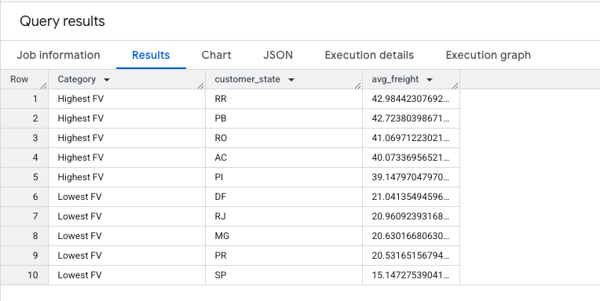

Insights

5.3. Find out the top 5 states with the highest & lowest average delivery time.

SQL Query
WITH StateAvgDeliverytime AS
(
SELECT
c.customer_state,
AVG(TIMESTAMP_DIFF(order_delivered_customer_date, order_purchase_timestamp, DAY)) AS avg_delivery_time
FROM `sathish-scaler-projects.Target_DB.customers` c
INNER JOIN `sathish-scaler-projects.Target_DB.orders` o
ON c.customer_id = o.customer_id
GROUP BY c.customer_state
),
RankedStates AS
(
SELECT
customer_state,
avg_delivery_time,
DENSE_RANK() OVER (ORDER BY avg_delivery_time DESC) AS rank_highest,
DENSE_RANK() OVER (ORDER BY avg_delivery_time) AS rank_lowest
FROM StateAvgDeliverytime
)
SELECT
'Highest' AS Category,
customer_state,
avg_delivery_time
FROM RankedStates
WHERE rank_highest <= 5
UNION ALL
SELECT
'Lowest' AS Category,
customer_state,
avg_delivery_time
FROM RankedStates
WHERE rank_lowest <= 5
ORDER BY Category, avg_delivery_time DESC;

Output
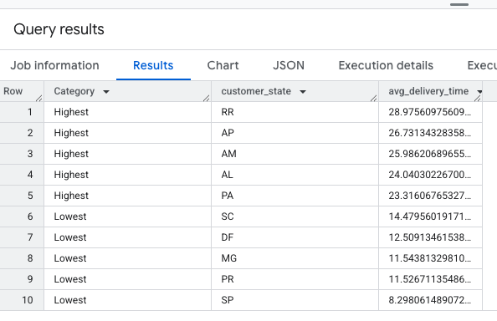
Insights

5.4 Find out the top 5 states where the order delivery is really fast as compared to the estimated date of delivery.
You can use the difference between the averages of actual & estimated delivery date to figure out how fast the delivery was for each state.

SQL Query
WITH DeliveryRanking AS
(
SELECT
c.customer_state,
AVG( DATE_DIFF( o.order_estimated_delivery_date,o.order_delivered_customer_date, DAY)) AS average_delivery_time_difference,
RANK() OVER (ORDER BY AVG(DATE_DIFF(o.order_delivered_customer_date, o.order_estimated_delivery_date, DAY)) DESC ) AS delivery_ranking
FROM `sathish-scaler-projects.Target_DB.orders` o
LEFT JOIN `sathish-scaler-projects.Target_DB.customers` c
ON o.customer_id = c.customer_id
WHERE
o.order_delivered_customer_date IS NOT NULL
AND o.order_estimated_delivery_date IS NOT NULL
GROUP BY c.customer_state
)
SELECT
customer_state,
average_delivery_time_difference,
delivery_ranking
FROM DeliveryRanking
WHERE delivery_ranking <= 5
ORDER BY delivery_ranking ASC;

Output
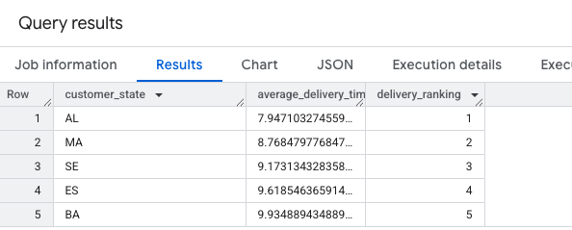

Insights

- Analysis based on the payments:

  - Find the month on month no. of orders placed using different payment types.

SQL Query
SELECT
FORMAT_TIMESTAMP('%Y-%m', o.order_purchase_timestamp)as period,
COUNT(case when payment_type='credit_card' then 1 end) as credit_card,
COUNT(case when payment_type='debit_card' then 1 end)as debit_card,
COUNT(case when payment_type='UPI' then 1 end) as UPI,
COUNT(case when payment_type='voucher' then 1 end) as voucher,
COUNT(case when payment_type='not_defined' then 1 end)as not_defined,
COUNT(case when payment_type is null then 1 end)as not_known,
COUNT(o.order_id)as total_orders
FROM `Target_DB.payments` p
JOIN `Target_DB.orders` o
ON p.order_id=o.order_id
WHERE payment_type is not null and order_status not in ('canceled','unavailable')
GROUP BY period
ORDER BY period;

Output
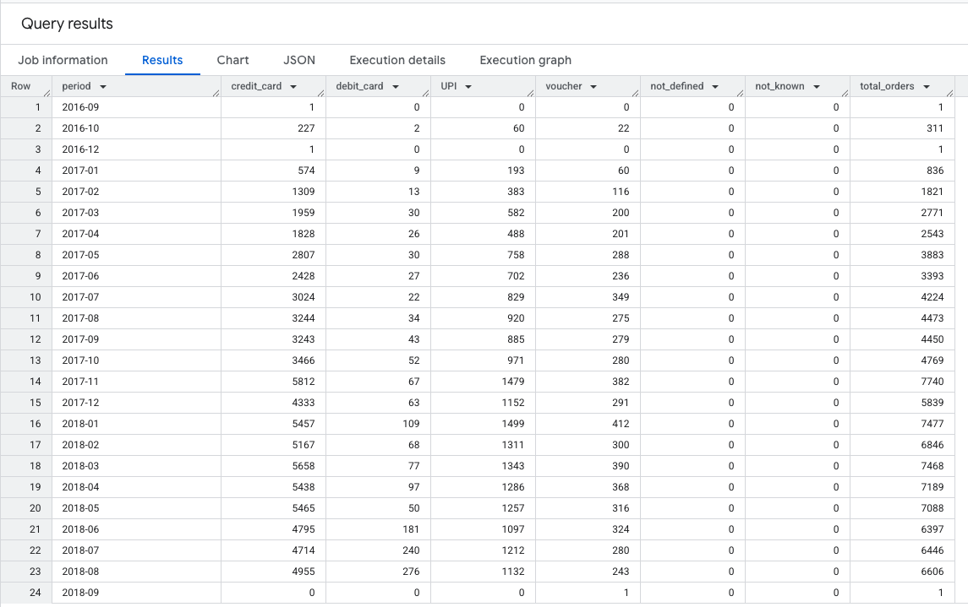
Insights

  - Find the no. of orders placed on the basis of the payment instalments that have been paid.
SQL Query
SELECT
p.payment_installments,
COUNT(o.order_id) as total_orders
FROM `sathish-scaler-projects.Target_DB.orders` o
JOIN `sathish-scaler-projects.Target_DB.payments` p
USING (order_id)
GROUP BY p.payment_installments
ORDER BY p.payment_installments;

Output
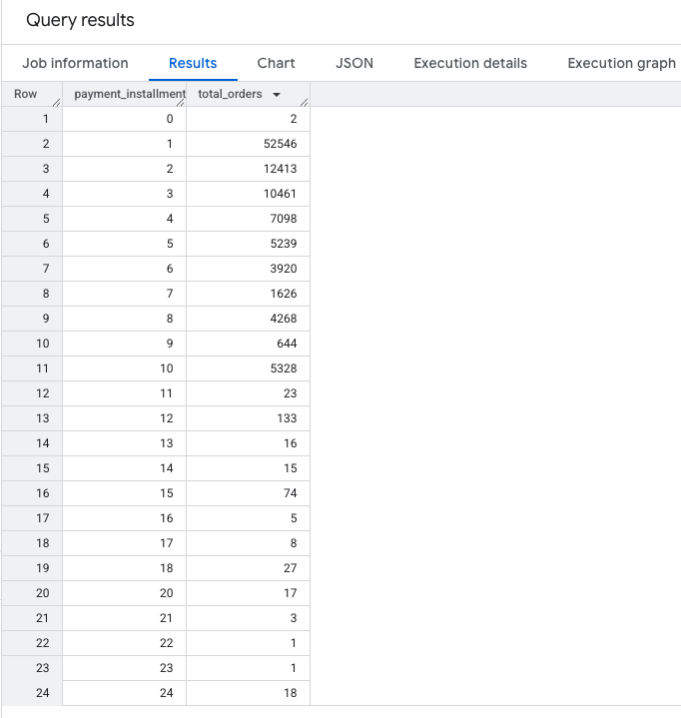
Insights

