Target SQL Analysis – Project Submission
S Sathish Kumar
Sathishkumar19@gmail.com

Table of Contents
Target SQL Analysis – Project Submission 1
A. Dataset 2
1. Dataset CSV Files 2
2. Business Case 2
B. Dataset uploading to BigQuery 2
3. Importing the Data to Big Query 2
4. DataSet Upload to Big_Query – Output 4
5. Validation of SQL Query 4
C. Exploratory Data Analysis - EDA 4
6. List of Tables 5
7. Checking the size of dataset/tables 5
8. Volume of Data in Each Table 6
D. Business Case Study tasks 8
1. Import the dataset and do usual exploratory analysis steps like checking the structure & characteristics of the dataset: 8
1.1 Data type of all columns in the “customers” table. 8
1.2 Get the time range between which the orders were placed. 9
1.3 Count the Cities & States of customers who ordered during the given period. 9
2. In-depth Exploration: 10
2.1 Is there a growing trend in the no. of orders placed over the past years? 10
2.2 Can we see some kind of monthly seasonality in terms of the no. of orders being placed? 11
2.3 During what time of the day, do the Brazilian customers mostly place their orders? 13
3. Evolution of E-commerce orders in the Brazil region: 14
3.1 Get the month on month no. of orders placed in each state. 14
3.2 How are the customers distributed across all the states? 16
4. Impact on Economy: Analyze the money movement by e-commerce by looking at order prices, freight and others. 17
4.1 Get the % increase in the cost of orders from year 2017 to 2018 (include months between Jan to Aug only). 17
4.2 Calculate the Total & Average value of order price for each state. 19
4.3 Calculate the Total & Average value of order freight for each state. 21
5. Analysis based on sales, freight and delivery time. 22
5.1 Find the no. of days taken to deliver each order from the order’s purchase date as delivery time. 22
5.2 Find out the top 5 states with the highest & lowest average freight value. 24
5.3 Find out the top 5 states with the highest & lowest average delivery time. 26
5.4 Find out the top 5 states where the order delivery is really fast as compared to the estimated date of delivery. 28
6. Analysis based on the payments: 29
6.1 Find the month on month no. of orders placed using different payment types. 29
6.2 Find the no. of orders placed on the basis of the payment instalments that have been paid. 30
E. Overall Insights – Key takeaways 31

Dataset

Dataset CSV Files
Dataset is provided and is downloaded from the following link
https://drive.google.com/drive/folders/1TGEc66YKbD443nslRi1bWgVd238gJCnb

Business Case
Business case is described in the following document .
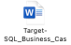

Dataset uploading to BigQuery

Importing the Data to Big Query
Since there are multiple CSV Files, I have used python Script to upload multiple CSV at ONCE. The source of all code is located in the following google colab Notebook
Click Here : Google Colab Notebook – Target – Busines Case -SQL
or
https://colab.research.google.com/drive/1SfuO3JJDonvXPV0lUo_U3wNWDYGXmsOy?usp=sharing

!pip install google-cloud-bigquery

# ✅ Create datasets and load CSVs
import os
import zipfile # Import zipfile
from google.cloud import bigquery
client = bigquery.Client(project=project_id)
# ✅ Ensure the base directory exists
os.makedirs(base_extract_path, exist_ok=True) # Create the directory if it doesn't exist
# ✅ Extract the uploaded ZIP file
for filename, content in uploaded.items():
with open(os.path.join(base_extract_path, filename), 'wb') as f:
f.write(content)
with zipfile.ZipFile(os.path.join(base_extract_path, filename), 'r') as zip_ref:
zip_ref.extractall(base_extract_path) # Extract to the base path
for dataset_id, subfolder in dataset_mapping.items():
dataset_ref = bigquery.Dataset(f"{project_id}.{dataset_id}")
try:
client.get_dataset(dataset_ref)
print(f"✅ Dataset already exists: {dataset_id}")
except Exception:
client.create_dataset(dataset_ref)
print(f"🆕 Created dataset: {dataset_id}")
# ✅ Find the actual directory where CSV files are extracted
folder_path = base_extract_path # Start with the base path
for root, dirs, files in os.walk(base_extract_path):
for file in files:
if file.endswith(".csv"):
folder_path = root # Update folder_path if a CSV is found
break
else:
continue
break # Break out of the outer loop as soon as a CSV is found
for file in os.listdir(folder_path):
# Check if the file ends with .csv
if file.endswith(".csv"):
# Extract table_id from the filename by removing .csv and prefix
table_id = file.replace(".csv", "").split("_", 1)[-1]
file_path = os.path.join(folder_path, file)
table_ref = f"{project_id}.{dataset_id}.{table_id}"
job_config = bigquery.LoadJobConfig(
source_format=bigquery.SourceFormat.CSV,
skip_leading_rows=1,
autodetect=True
)
with open(file_path, "rb") as source_file:
job = client.load_table_from_file(source_file, table_ref, job_config=job_config)
job.result() # Wait for the job to complete
print(f"📥 Uploaded: {file} → {table_ref}")
print("✅ All CSV files uploaded to BigQuery.")

DataSet Upload to Big_Query – Output
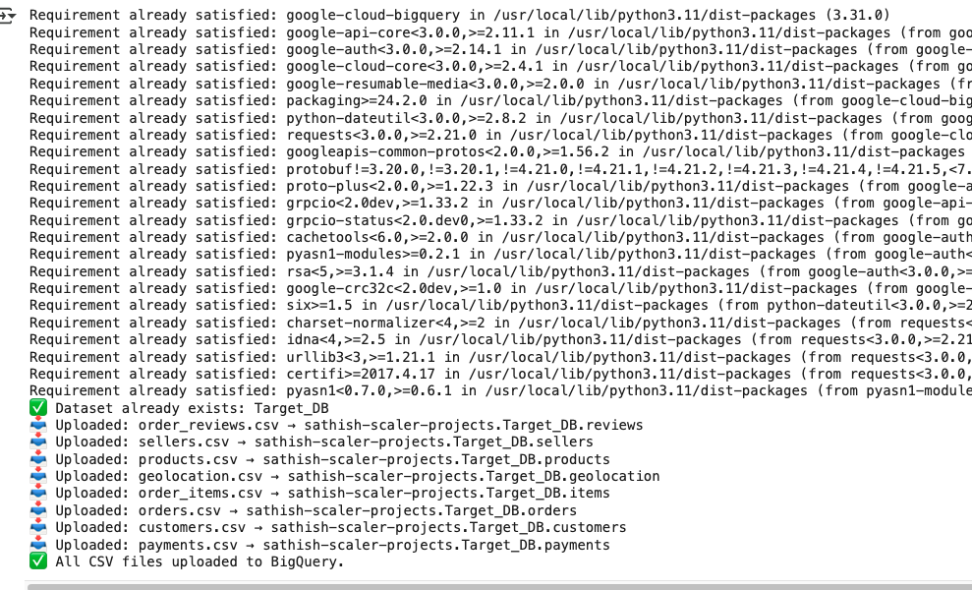

Validation of SQL Query
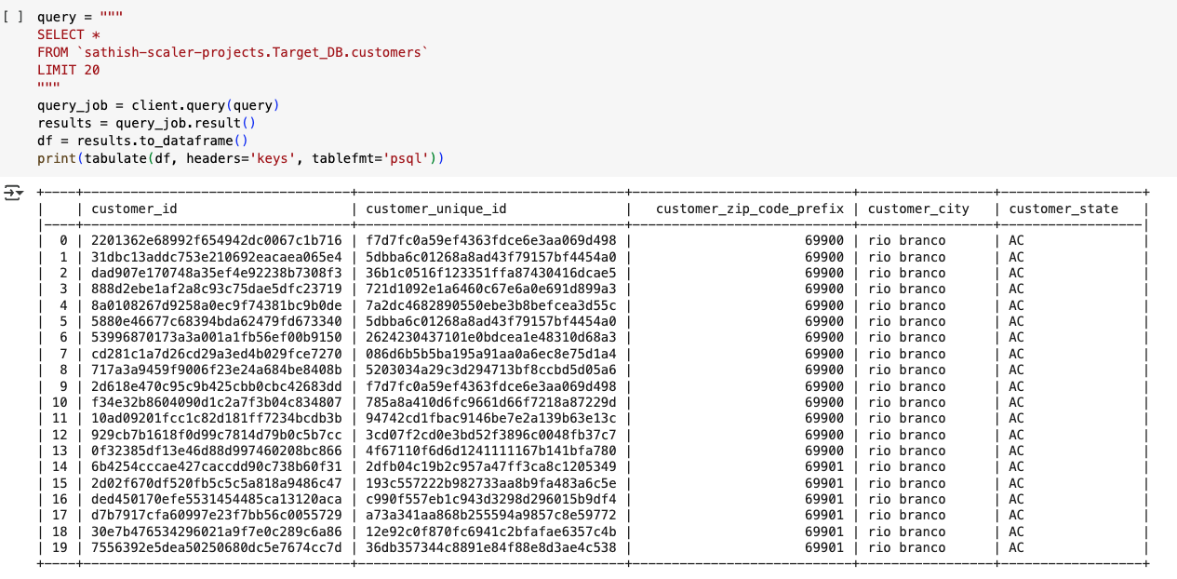

Exploratory Data Analysis - EDA
Getting used of dataset , now onwards , the outputs will be switched to Big query console for better readability

List of Tables
SQL Query
SELECT
table_schema,
table_name,
column_name,
data_type
FROM `Target_DB.INFORMATION_SCHEMA.COLUMNS`
ORDER BY
table_schema, table_name, ordinal_position;
Output
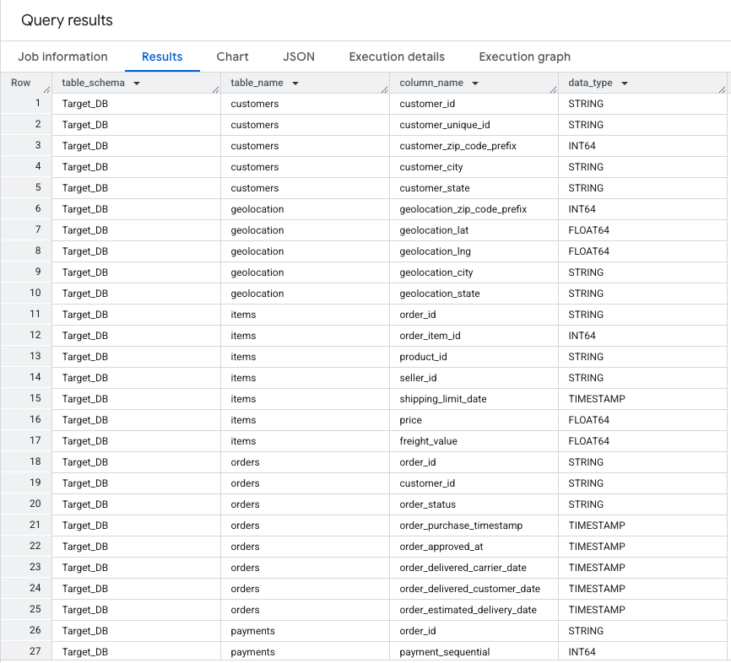

Insights
- Since there is a lack of ER diagram, I will use this output for quick mapping of columns when writing subsequent queries.
- INFORMATION_SCHEMA.COLUMNS provides the information about all tables and their corresponding column names

Checking the size of dataset/tables
SQL Query
SELECT
table_name,
COUNT(*) as column_length
FROM
`sathish-scaler-projects`.`Target_DB`.`INFORMATION_SCHEMA.COLUMNS`
GROUP BY table_name;
Output
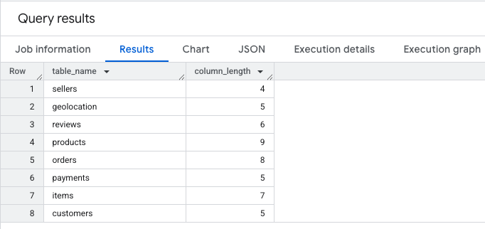
Insights
- The output matches the list of CSV provided in the spreadsheet as per the business case,
- It also provides the no. of columns that we are dealing with at a quick glance

Volume of Data in Each Table
SQL Query
WITH
cu_count AS (SELECT COUNT(*) AS customer_count FROM `sathish-scaler-projects.Target_DB.customers`),
prod_count AS (SELECT COUNT(*) AS products_count FROM `sathish-scaler-projects.Target_DB.products`),
se_count AS (SELECT COUNT(*) AS sellers_count FROM `sathish-scaler-projects.Target_DB.sellers`),
ord_count AS (SELECT COUNT(*) AS orders_count FROM `sathish-scaler-projects.Target_DB.orders`),
itm_count AS (SELECT COUNT(*) AS items_count FROM `sathish-scaler-projects.Target_DB.items`),
pay_count AS (SELECT COUNT(*) AS payments_count FROM `sathish-scaler-projects.Target_DB.payments`),
geo_count AS (SELECT COUNT(*) AS geolocation_count FROM `sathish-scaler-projects.Target_DB.geolocation`),
rev_count AS (SELECT COUNT(*) AS reviews_count FROM `sathish-scaler-projects.Target_DB.reviews`)
SELECT
customer_count,
products_count,
sellers_count,
orders_count,
items_count,
payments_count,
geolocation_count,
reviews_count

FROM
cu_count, prod_count, se_count, ord_count, itm_count, pay_count, geo_count, rev_count;

Output
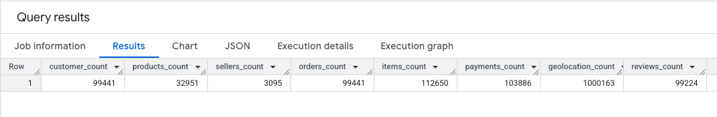
Insights

- The output provides the volume of data that we are dealing with
- It also provides the view of no of customers, orders , reviews, products etc for the data set in a given period of time
- It also helps to provide a view point of which table is heavy in-terms of data count

Business Case Study tasks

Import the dataset and do usual exploratory analysis steps like checking the structure & characteristics of the dataset:

Data type of all columns in the “customers” table.
SQL Query

SELECT
column_name,
data_type
FROM
`sathish-scaler-projects.Target_DB.INFORMATION_SCHEMA.COLUMNS`
WHERE
table_name = 'customers';

Output
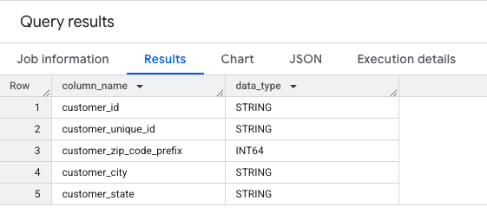
Insights

- The “customers” table has relatively low no of columns(features) compared to other columns and provides only necessary information related to customer’s information.
- As in above the output , except zipcode all others are in STRING format.
- The table does not have any constraints defined(i.e primary key and foreign key) at this moment

Get the time range between which the orders were placed.

SQL Query
SELECT MIN(order_purchase_timestamp) AS start_date,
MAX(order_purchase_timestamp) AS end_date
FROM `sathish-scaler-projects.Target_DB.orders`;

Output
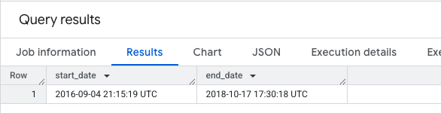

Insights
- The data set has captured purchase order details from 4th September 2016 till 17th October 2018
- Since there are few dates missed in Sep 2016 (4days) and Oct 2018(14 days) , these months should be considered as outliers in-terms of any insights to be taken. Rest of the months in-between can be considered for analysis.

Count the Cities & States of customers who ordered during the given period.

SQL Query
SELECT
COUNT(DISTINCT customer_city) as city_count,
COUNT(DISTINCT customer_state) as state_count
FROM `sathish-scaler-projects`.`Target_DB`.`orders` AS orders
INNER JOIN`sathish-scaler-projects`.`Target_DB`.`customers` AS customers
ON orders.customer_id = customers.customer_id
WHERE
--- Giving an Example where i can provide a time range here
orders.order_purchase_timestamp BETWEEN '2017-01-01'AND '2018-01-01'

Output
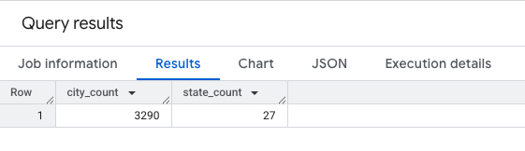
Insights
- The data set has captured details of orders that is spread across 27 states and 3290 cities in the region of Brazil.
- I have added a where statement to provide during a time range from which city/states the orders are coming from.

In-depth Exploration:

Is there a growing trend in the no. of orders placed over the past years?

SQL Query
WITH find_trend AS
( -- Primary Query , this is suffient to find the order count
SELECT
EXTRACT(YEAR FROM order_purchase_timestamp) AS order_year,
COUNT(*) AS orders_placed
FROM `sathish-scaler-projects`.`Target_DB`.`orders`
GROUP BY order_year
)
-- Adding this to indicate the percentage of increase
SELECT
order_year,
orders_placed,
round((orders_placed - LAG(orders_placed, 1, 0) OVER (ORDER BY order_year)) * 100.0 /
NULLIF(LAG(orders_placed, 1) OVER (ORDER BY order_year), 0),2) AS order_increase_percentage
FROM find_trend
ORDER BY order_year;
Output
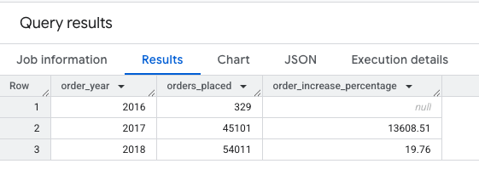
Insights
- The data set has captured details of orders that is spread across 27 states and 3290 cities in the region of Brazil.
- I have added a where statement to provide during a time range from which city/states the orders are coming from.

Can we see some kind of monthly seasonality in terms of the no. of orders being placed?

SQL Query
WITH orders_with_year AS
(
SELECT
EXTRACT(YEAR FROM order_purchase_timestamp) AS order_year,
EXTRACT(MONTH FROM order_purchase_timestamp) AS order_month,
COUNT(*) AS order_count
FROM
`sathish-scaler-projects`.`Target_DB`.`orders`
GROUP BY order_year, order_month
)
SELECT
order_year,
order_month,
order_count,
CASE
WHEN order_count > ( SELECT AVG(order_count) FROM `orders_with_year`) THEN 'High'
ELSE 'Low'
END
AS order_volumes
FROM `orders_with_year`
ORDER BY order_year, order_month;

Output

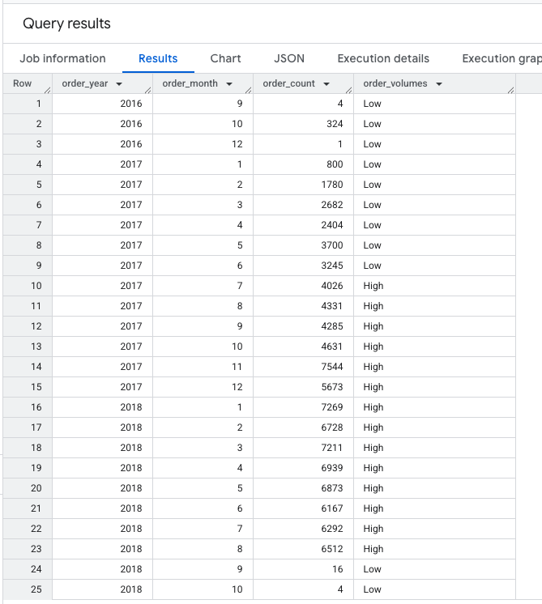

Insights
- The 2016 September and 2018 Oct will be left as outlier as there are few dates are missing with details
- Order count increased in 2017 and 2018, compared to previous year, i.e 2016
- High order volumes account for approx. 85% of the total order count while low order volumes represent 15%.

During what time of the day, do the Brazilian customers mostly place their orders?
(Dawn, Morning, Afternoon or Night)
0-6 hrs : Dawn
7-12 hrs : Mornings
13-18 hrs : Afternoon
19-23 hrs : Night

SQL Query 1 ( Just specifying also the minutes in-order not to miss certain null values )
WITH
classify_time AS (
SELECT
order_id,
CASE
WHEN TIME(order_purchase_timestamp) BETWEEN '00:00:00' AND '06:59:59' THEN 'DAWN'
WHEN TIME(order_purchase_timestamp) BETWEEN '07:00:00' AND '12:00:00' THEN 'MORNINGS'
WHEN TIME(order_purchase_timestamp) BETWEEN '12:00:01' AND '18:59:59' THEN 'AFTERNOON'
WHEN TIME(order_purchase_timestamp) BETWEEN '19:00:00' AND '23:59:59' THEN 'NIGHT'
END
AS purchase_time
FROM `sathish-scaler-projects`.`Target_DB`.`orders` )
SELECT
purchase_time,
COUNT(*) AS total_orders
FROM `classify_time`
GROUP BY purchase_time
ORDER BY total_orders DESC;

Output1 (In this output I have taken care of all null values by specifying the minutes )
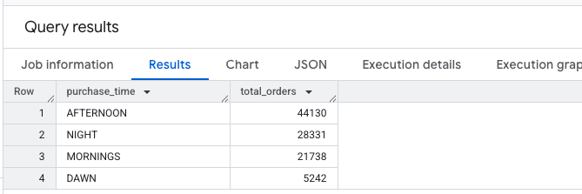

Insights
- Customers are busy ordering items during Afternoon,
- Afternoon sees the highest total orders, approx. 40% of the total.
- Customers don’t purchase much during Dawn, as Dawn experiences the lowest total orders, approx5% of the total.

Evolution of E-commerce orders in the Brazil region:

Get the month on month no. of orders placed in each state.
SQL Query
WITH CTE1 AS
(
SELECT
o.order_id,
o.order_purchase_timestamp,
EXTRACT(YEAR FROM order_purchase_timestamp) AS year,
EXTRACT(MONTH FROM order_purchase_timestamp) AS month,
FORMAT_DATE('%b %Y', DATE(ORDER_PURCHASE_TIMESTAMP)) AS time_period,
c.customer_state AS state
FROM `sathish-scaler-projects`.`Target_DB`.`orders` AS o
INNER JOIN `sathish-scaler-projects`.`Target_DB`.`customers` AS c
ON o.customer_id = c.customer_id
)
SELECT
state,
time_period,
COUNT(*) AS total_orders,
LAG(COUNT(*)) OVER (PARTITION BY state ORDER BY year, month) AS prev_month_orders_count,
ROUND( ( (COUNT(*) - LAG(COUNT(*)) OVER (PARTITION BY state ORDER BY year, month)) / LAG(COUNT(*)) OVER (PARTITION BY state ORDER BY year, month)) * 100, 2) AS MoM_percent_growth
FROM `CTE1`
GROUP BY state, time_period,year,month
ORDER BY state;

Output

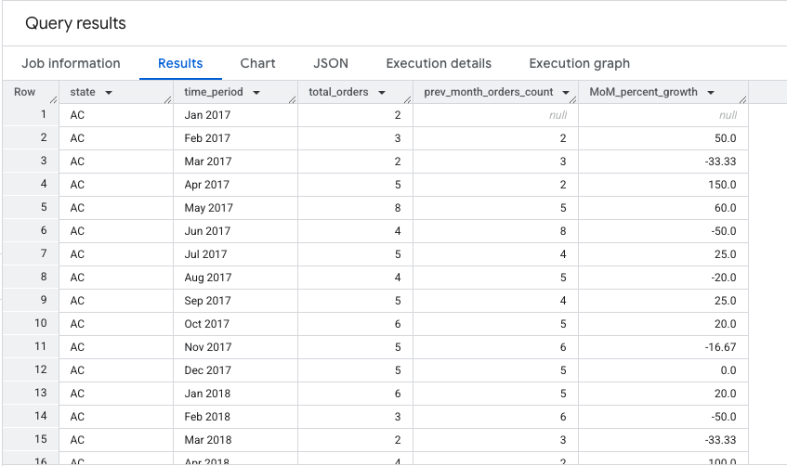

Insights

- The order details are given as per each state over the period of time
- Calculated % of Month on Month growth by comparing to the previous month using LAG function to provide better visibility
- Also added previous month in the output to provide comparison and calculation of the output

How are the customers distributed across all the states?
SQL Query
SELECT
DISTINCT customer_state,
count(customer_unique_id) AS No_of_unique_customers

FROM `sathish-scaler-projects.Target_DB.customers`
GROUP BY customer_state
ORDER BY No_of_unique_customers DESC;

Output
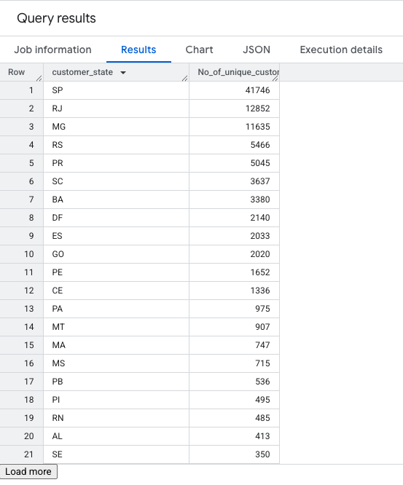
Insights
- The Brazil’s Capital region SP-Sao Paulo and surrounding RJ - Rio de Janeiro RJ and MJ - states has more customers compared to other states
- The SP account for 42% of unique customers compared to overall customers
- RR has the lowest customer acquisition accounting for the least among unique customers
- The average no of customers per state is ~3683

Impact on Economy: Analyze the money movement by e-commerce by looking at order prices, freight and others.

Get the % increase in the cost of orders from year 2017 to 2018 (include months between Jan to Aug only).
SQL Query
WITH orders_with_payment AS (
SELECT
o.order_id,
EXTRACT(YEAR FROM o.order_purchase_timestamp) AS Year,
EXTRACT(MONTH FROM o.order_purchase_timestamp) AS Month,
p.payment_value
FROM `sathish-scaler-projects`.`Target_DB`.`orders` AS o
INNER JOIN `sathish-scaler-projects`.`Target_DB`.`payments` AS p
ON o.order_id = p.order_id
WHERE o.order_status = 'delivered'
),
monthly_total_payment AS (
SELECT
Year,
Month,
ROUND(SUM(payment_value),2) AS total_payment
FROM orders_with_payment
WHERE Month BETWEEN 1 AND 8
GROUP BY Year, Month
),
yearly_total_payment AS (
SELECT
Year,
ROUND(SUM(total_payment),2) AS yearly_total_payment
FROM monthly_total_payment
GROUP BY Year
)
SELECT
y.Year,
y.yearly_total_payment,
COALESCE(
ROUND(((y.yearly_total_payment - LAG(y.yearly_total_payment) OVER (ORDER BY y.Year))
/ LAG(y.yearly_total_payment) OVER (ORDER BY y.Year)) * 100, 2),
0
) AS YOY_percent_increase
FROM yearly_total_payment AS y
ORDER BY y.Year;

Output
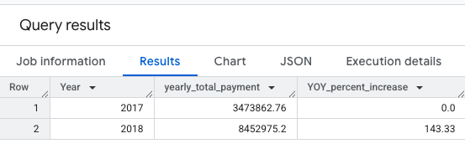

Insights
- The Brazil’s Capital region SP-Sao Paulo and surrounding RJ - Rio de Janeiro RJ and MJ - states has more customers compared to other states
- The SP account for 42% of unique customers compared to overall customers
- RR has the lowest customer acquisition accounting for the least among unique customers
- The average no of customers per state is ~3683

Calculate the Total & Average value of order price for each state.
SQL Query
WITH payment_collection as
(
SELECT
c.customer_state,
p.payment_value
FROM `sathish-scaler-projects.Target_DB.payments` p
JOIN `sathish-scaler-projects.Target_DB.orders` o
USING(order_id)
JOIN `sathish-scaler-projects.Target_DB.customers` c
USING(customer_id)
)
SELECT
DISTINCT customer_state,
ROUND(AVG(payment_value) OVER (partition by customer_state),2) as avg_state_order_price,
ROUND(SUM(payment_value) OVER (partition by customer_state),2) as total_state_order_price
FROM payment_collection
ORDER BY total_state_order_price desc ,avg_state_order_price desc,customer_state

Output
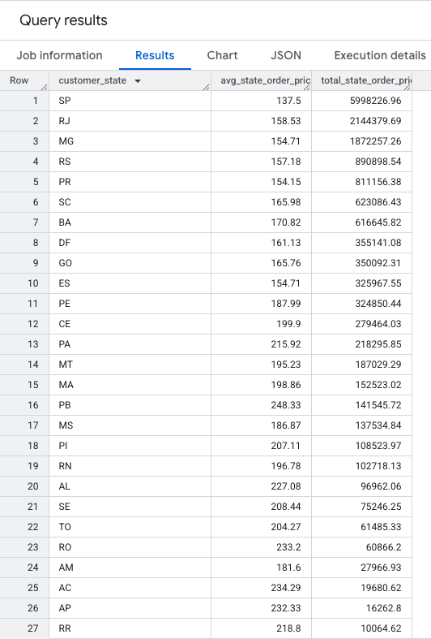

SQL Query
- There is an inverse relationship between average order price and total order price by state
- Few states such as PB, AL ,PA has better average price compared to the highest order value
- SP – Sao Paulo has topped with total no of sales and sales volume. Due to volume of trade customers also benefit with reduced price in their purchases.

Calculate the Total & Average value of order freight for each state.

SQL Query
SELECT
c.customer_state,
ROUND(SUM(i.price)) total_price, -- calculating total for price value
ROUND(AVG(i.price)) avg_price, -- calculating avg for price value
ROUND(SUM(i.freight_value)) total_freight_value,-- calc total for freight value
ROUND(AVG(i.freight_value)) avg_freight_value -- calculating avg for freight value
FROM `Target_DB.items` i
JOIN `Target_DB.orders` o
USING (order_id)
JOIN `Target_DB.customers` c
ON c.customer_id = o.customer_id
GROUP BY c.customer_state;

Output
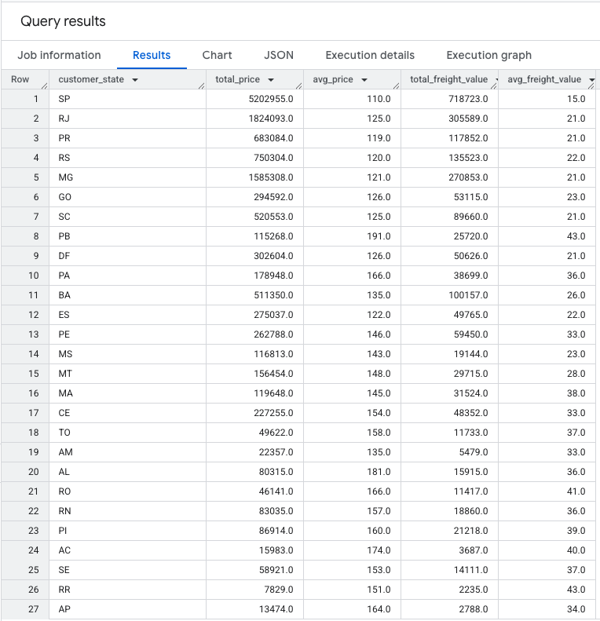

Insights
- There's a positive correlation between total price and total freight value, as well as between average price and average freight value.
- SP leads in both total price and total freight value and value of the total, respectively.
- RR has the lowest values in both total price and total freight value, in both categories.
- While PB has the highest average price , SP has the lowest and also the lowest average freight value .

Analysis based on sales, freight and delivery time.

Find the no. of days taken to deliver each order from the order’s purchase date as delivery time.
Also, calculate the difference (in days) between the estimated & actual delivery date of an order.

Do this in a single query.
You can calculate the delivery time and the difference between the estimated & actual delivery date using the given formula:
- time_to_deliver = order_delivered_customer_date - order_purchase_timestam.
- diff_estimated_delivery = order_estimated_delivery_date - order_delivered_customer_date

SQL Query
SELECT
orders.order_id,
DATE_DIFF( DATE(orders.order_delivered_customer_date), DATE(orders.order_purchase_timestamp), DAY) AS time_to_deliver_days,
DATE_DIFF( DATE(orders.order_estimated_delivery_date), DATE(orders.order_delivered_customer_date), DAY) AS diff_estimated_delivery_days
FROM `sathish-scaler-projects.Target_DB.orders` AS orders
WHERE
orders.order_delivered_customer_date IS NOT NULL
AND orders.order_purchase_timestamp IS NOT NULL;

Output
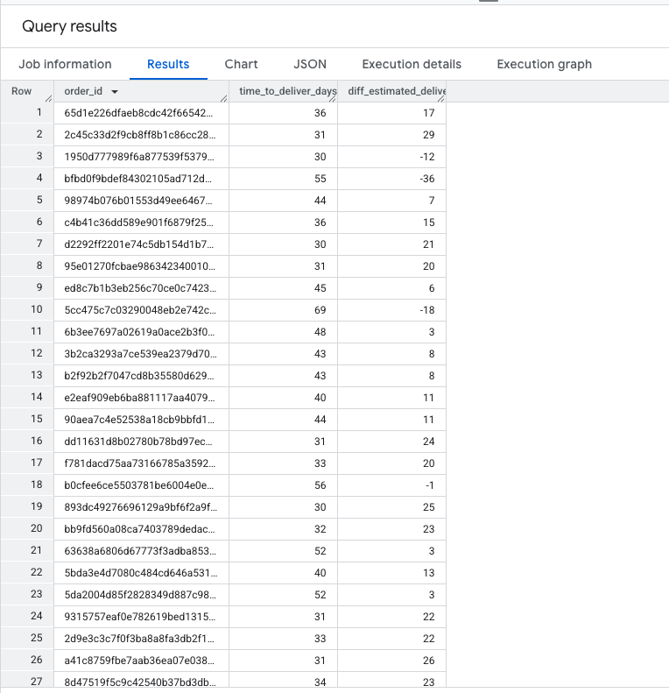

Insights
- The average time to deliver is 12.29 days, while the average difference from estimated delivery is 7.69 days.
- There are outliers like few order ID (ca07593549f1816d26a572e06dc1eab6) has taken 210 days likely due to incorrect information provided during delivery.
- There are instances also where some of the delivery has been done on the same day (0 days)
- There are some information not captured properly resulting in negative values, this requires proper data input and cleanup.

Find out the top 5 states with the highest & lowest average freight value.

SQL Query
WITH StateAvgFreight AS --1st query to find avg_fright cost
(
SELECT
customers.customer_state,
AVG(items.freight_value) AS avg_freight
FROM `sathish-scaler-projects.Target_DB.customers` AS customers
INNER JOIN`sathish-scaler-projects.Target_DB.orders` AS orders
ON customers.customer_id = orders.customer_id
INNER JOIN `sathish-scaler-projects.Target_DB.items` AS items
ON orders.order_id = items.order_id
GROUP BY
customers.customer_state
),
RankedStates AS --2nd Query to rank the states, output same as DENSE_RANK
(
SELECT
customer_state,
avg_freight,
RANK() OVER (ORDER BY avg_freight DESC) AS rank_highest,
RANK() OVER (ORDER BY avg_freight ASC) AS rank_lowest
FROM `StateAvgFreight`
)
SELECT
'Highest FV' AS Category,
customer_state,
avg_freight
FROM `RankedStates`
WHERE rank_highest <= 5 -- To find top 5 from ranked states (ASC)
UNION ALL -- Combining Highest with lowest to see in single output
SELECT
'Lowest FV' AS Category,
customer_state,
avg_freight
FROM `RankedStates`
WHERE rank_lowest <= 5 -- To find lowest 5 from ranked (DESC)
ORDER BY
Category,
avg_freight DESC;

Output

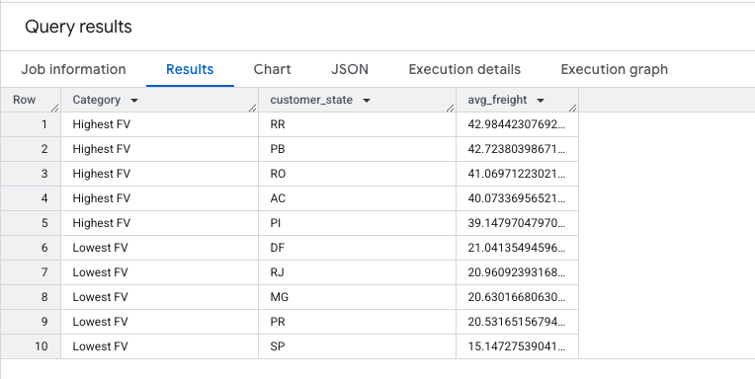

Insights

- For the Highest Freight Value category, RR has the highest average freight at 42.98, while PI has the lowest at 39.15 Frieght Value
- Conversely, for the Lowest Frieght Value category, DF exhibits the highest average freight at 21.04, and SP the lowest at 15.15.
- The average freight varies significantly by category, with a range of 27.83 between the highest (RR in Highest FV) and lowest (SP in Lowest FV) values.

Find out the top 5 states with the highest & lowest average delivery time.

SQL Query
WITH StateAvgDeliverytime AS
(
SELECT
c.customer_state,
AVG(TIMESTAMP_DIFF(order_delivered_customer_date, order_purchase_timestamp, DAY)) AS avg_delivery_time
FROM `sathish-scaler-projects.Target_DB.customers` c
INNER JOIN `sathish-scaler-projects.Target_DB.orders` o
ON c.customer_id = o.customer_id
GROUP BY c.customer_state
),
RankedStates AS
(
SELECT
customer_state,
avg_delivery_time,
DENSE_RANK() OVER (ORDER BY avg_delivery_time DESC) AS rank_highest,
DENSE_RANK() OVER (ORDER BY avg_delivery_time) AS rank_lowest
FROM StateAvgDeliverytime
)
SELECT
'Highest' AS Category,
customer_state,
avg_delivery_time
FROM RankedStates
WHERE rank_highest <= 5
UNION ALL
SELECT
'Lowest' AS Category,
customer_state,
avg_delivery_time
FROM RankedStates
WHERE rank_lowest <= 5
ORDER BY Category, avg_delivery_time DESC;

Output
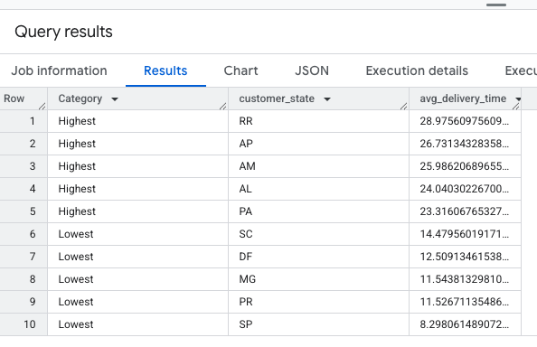
Insights
- Average delivery time varies significantly by customer state and category due to proximity. For better delivery times we need local distribution and warehouses for states like RR, AP AM , AL and PA.
- For the "Highest" category, RR has the longest average delivery time at 28.98, while PA has the shortest at 23.32, a difference of 19.5%.
- Conversely, for the "Lowest" category, SC has the longest average delivery time at 14.48, while SP has the shortest at 8.3, a difference of 42.7%. This indicates the delivery and distribution network is better

Find out the top 5 states where the order delivery is really fast as compared to the estimated date of delivery.
You can use the difference between the averages of actual & estimated delivery date to figure out how fast the delivery was for each state.

SQL Query
WITH DeliveryRanking AS
(
SELECT
c.customer_state,
AVG( DATE_DIFF( o.order_estimated_delivery_date,o.order_delivered_customer_date, DAY)) AS average_delivery_time_difference,
RANK() OVER (ORDER BY AVG(DATE_DIFF(o.order_delivered_customer_date, o.order_estimated_delivery_date, DAY)) DESC ) AS delivery_ranking
FROM `sathish-scaler-projects.Target_DB.orders` o
LEFT JOIN `sathish-scaler-projects.Target_DB.customers` c
ON o.customer_id = c.customer_id
WHERE
o.order_delivered_customer_date IS NOT NULL
AND o.order_estimated_delivery_date IS NOT NULL
GROUP BY c.customer_state
)
SELECT
customer_state,
average_delivery_time_difference,
delivery_ranking
FROM DeliveryRanking
WHERE delivery_ranking <= 5
ORDER BY delivery_ranking ASC;

Output
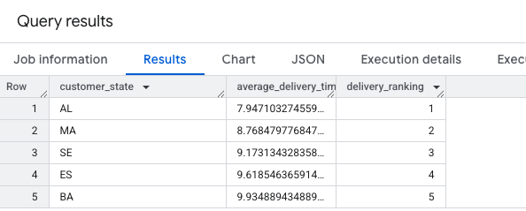

Insights

- A positive relationship exists between the average delivery time difference and the delivery ranking.
- AL boasts the fastest average delivery time difference at around 7.95 days and secures the highest delivery ranking.
- Delivery ranking declines as the average delivery time difference increases, culminating in BA's lowest ranking with an average of approximately 9.93 days.
- The gap in average delivery time between the top-ranked AL and the bottom-ranked BA is roughly 1.98 days.

Analysis based on the payments:

Find the month on month no. of orders placed using different payment types.
SQL Query
SELECT
FORMAT_TIMESTAMP('%Y-%m', o.order_purchase_timestamp)as period,
COUNT(case when payment_type='credit_card' then 1 end) as credit_card,
COUNT(case when payment_type='debit_card' then 1 end)as debit_card,
COUNT(case when payment_type='UPI' then 1 end) as UPI,
COUNT(case when payment_type='voucher' then 1 end) as voucher,
COUNT(case when payment_type='not_defined' then 1 end)as not_defined,
COUNT(case when payment_type is null then 1 end)as not_known,
COUNT(o.order_id)as total_orders
FROM `Target_DB.payments` p
JOIN `Target_DB.orders` o
ON p.order_id=o.order_id
WHERE payment_type is not null and order_status not in ('canceled','unavailable')
GROUP BY period
ORDER BY period;

Output
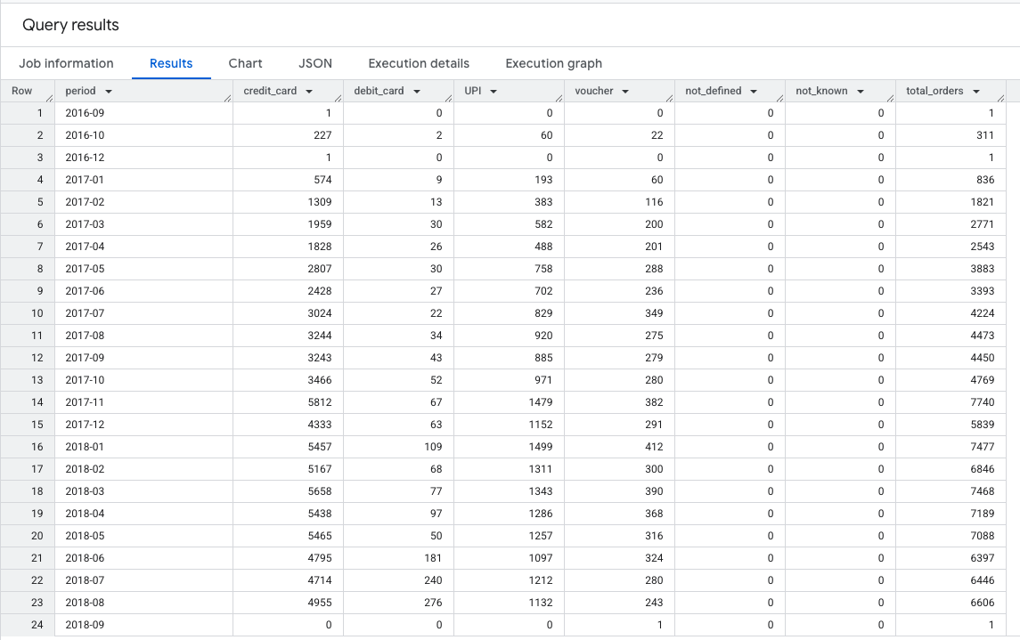
Insights
- Total orders experienced a significant decline of 99.98% from August 2018 to September 2018.
- All payment methods (credit card, debit card, and UPI) decreased by 100% between August and September 2018.
- A positive correlation exists between credit card usage and debit card usage, as well as between total orders and credit card usage.
- Total orders peaked at 7740 in November 2017, while credit card transactions reached a maximum of 5812 during the same period.

Find the no. of orders placed on the basis of the payment instalments that have been paid.

SQL Query
SELECT
p.payment_installments,
COUNT(o.order_id) as total_orders
FROM `sathish-scaler-projects.Target_DB.orders` o
JOIN `sathish-scaler-projects.Target_DB.payments` p
USING (order_id)
GROUP BY p.payment_installments
ORDER BY p.payment_installments;

Output
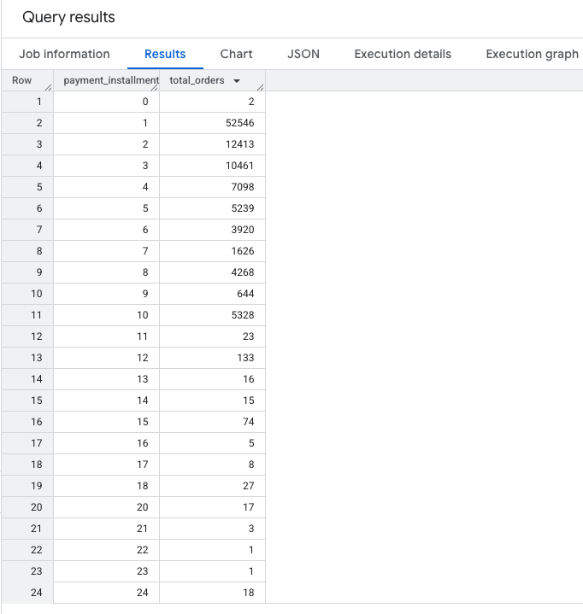
Insights
- A large number of orders are paid in a single instalment, indicating a preference for immediate payment.
- The frequency of orders decreases as the number of instalments increases from 2 to 6, suggesting a preference for shorter payment plans.
- There is a sharp decline in orders using more than 6 instalments, showing limited adoption of extended payment plans.

Overall Insights – Key takeaways
Customer Distribution & Trends:
The highest number of unique customers are concentrated in SP (Sao Paulo) and surrounding regions. There's a consistent increase in order volume over the years, highlighting growing e-commerce adoption.
Seasonality & Purchase Timing:
Orders exhibit monthly seasonality, with peak volumes in certain months. Brazilian customers predominantly place orders in the afternoon, accounting for approximately 40% of total purchases.
Economic Impact & Payment Behaviour:
There was a notable increase in e-commerce transaction value from 2017 to 2018. Single-instalment payments dominate, with fewer orders using extended payment plans, signalling consumer preferences for upfront transactions.
Freight & Delivery Optimization:
Sao Paulo benefits from reduced freight costs due to high trade volume, while RR has the highest freight rates. Delivery speeds vary significantly, with states like AL experiencing the fastest order fulfillment compared to estimated delivery dates.
Operational Improvements & Outliers:
Some orders took exceptionally long to deliver, indicating potential logistical issues. Cleaning up data inaccuracies (e.g., negative delivery time values) will improve reporting reliability and strategic insights.
Regional Expansion & Customer Acquisition:
High customer concentration in São Paulo and Rio de Janeiro suggests strong demand. Expanding localized marketing efforts and fulfilment centres in emerging regions like RR and PB can boost growth.
Freight & Logistics Partnerships:
Freight costs vary significantly across states. Partnering with local carriers and warehouses to reduce delivery time and cost, especially in high-freight states like RR, can improve margins.
Delivery Optimization & Outlier Mitigation:
Orders with long delivery times and negative values indicate logistical issues or data inaccuracies. Streamlining delivery routes and improving order tracking accuracy will minimize inefficiencies.

