Step1:

***Fail case:***

Invalid scopes:

https://www.instagram.com/oauth/authorize/?client_id=b0940040034c49319c0e543fb94034da&redirect_uri=http://dev.tapetickets.com/public/&scope=basics&state=csrfstate&response_type=code



Client id missing:

https://www.instagram.com/oauth/authorize/?redirect_uri=http://dev.tapetickets.com/public/&scope=basic&state=csrfstate&response_type=code

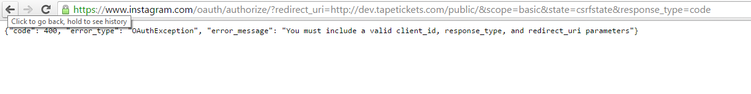

Wrong client id:

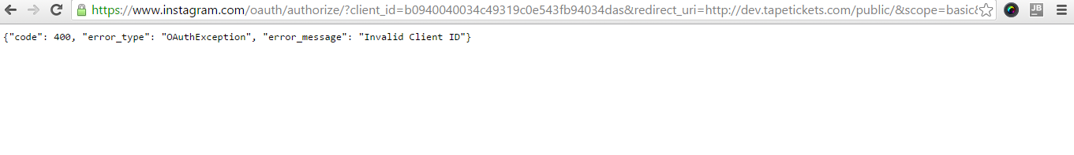

Invalid URL:

https://www.instagram.com/oauth/authorize/?client_id=b0940040034c49319c0e543fb94034da&redirect_uri=http://dev.tapetickets.com/publics/&scope=basic&state=csrfstate&response_type=code



Null client id: client id omitted in code

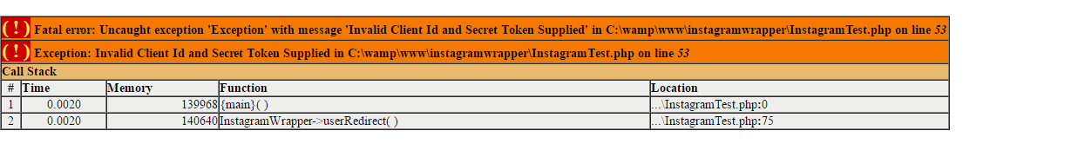

***Pass case:***

User Denied:

https://www.instagram.com/oauth/authorize/?client_id=b0940040034c49319c0e543fb94034da&redirect_uri=http://dev.tapetickets.com/public/&scope=basic&state=csrfstate&response_type=code

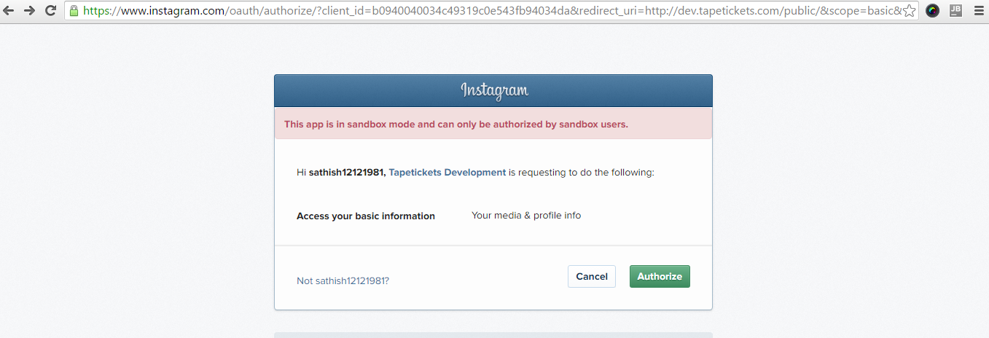

[**http://dev.tapetickets.com/public/?error_reason=user_denied&error=access_denied&error_description=The+user+denied+your+request.&state=csrfstate**](http://dev.tapetickets.com/public/?error_reason=user_denied&error=access_denied&error_description=The+user+denied+your+request.&state=csrfstate)

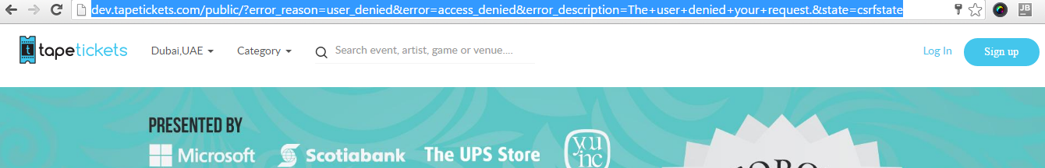

Authorized Case:

<https://api.instagram.com/oauth/authorize/?client_id=b0940040034c49319c0e543fb94034da&redirect_uri=http://dev.tapetickets.com/public/&scope=basic&state=csrfstate&response_type=code>

