TC1319079_AccountIssueCreation_MultipleTransactions_AutoAcceptTrue_RC

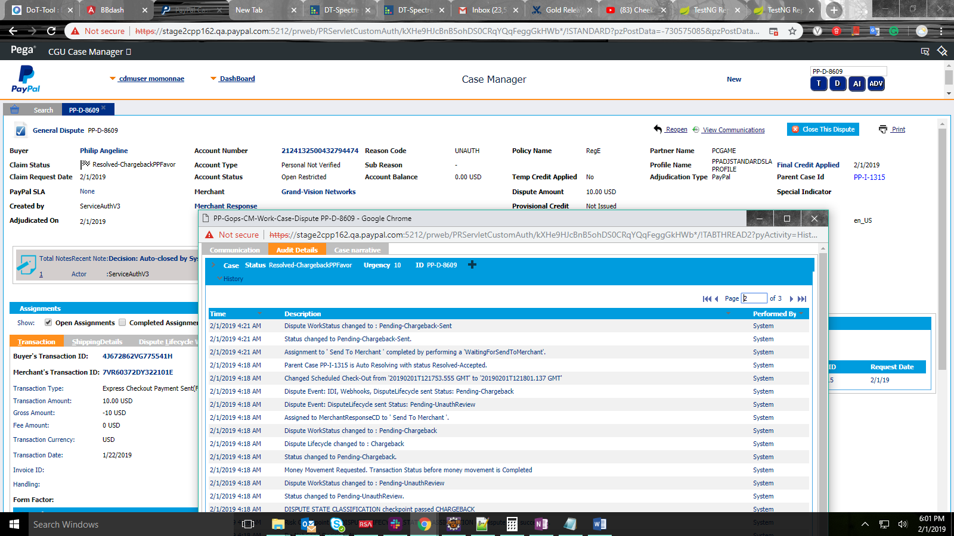

TC1306870_IssueAcceptWithOneTransaction

PP-I-1317 162/5202

TC1299899_VictimCommunication_UpdateToAI

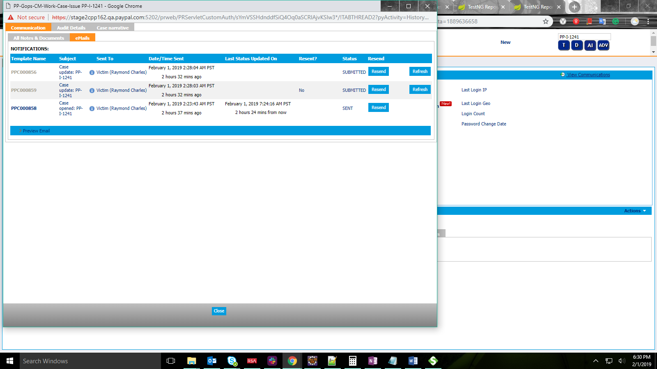

TC1279799_AI_CombinedLog_Filtering_ByNegativeCustomDateRange_GroupsRadioButton

pp-i-1330 162/5212

TC1277830_VerifyTransactionLogTabPaginationSize

PP-I-1362