(22AIE205 ) Introduction to Python

Lab Assignment 2

Name: CHADA S V N S K ABHISHIKTH
Reg.NO: CH.SC.U4AIE25005
Department: AIE 25-29

1 . Take no.of users from user and for each user take details such as name,age,salary and calculate tax based on tax regime and store them in seperate lists.

CODE:
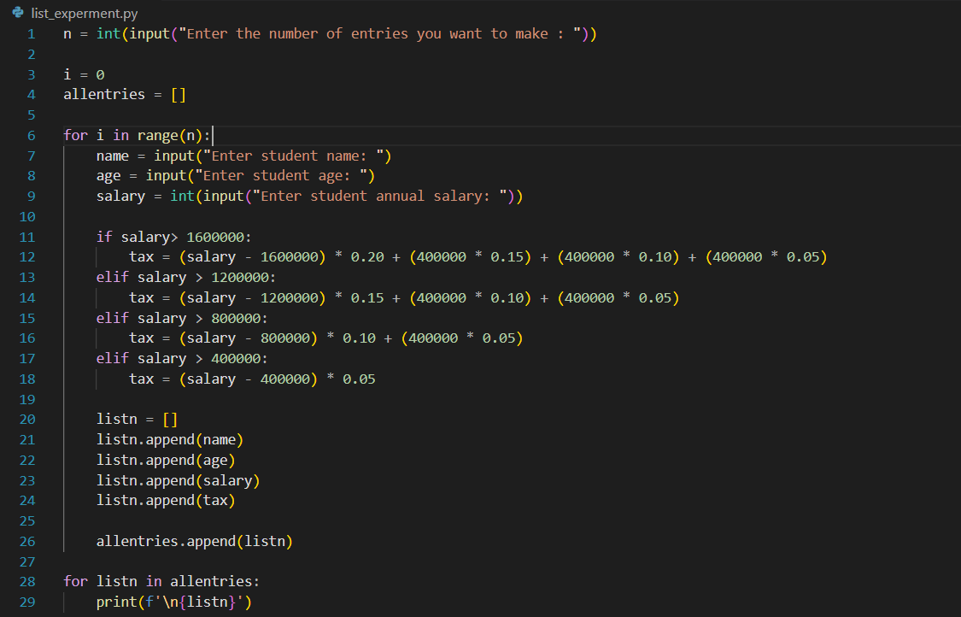
OUTPUT:
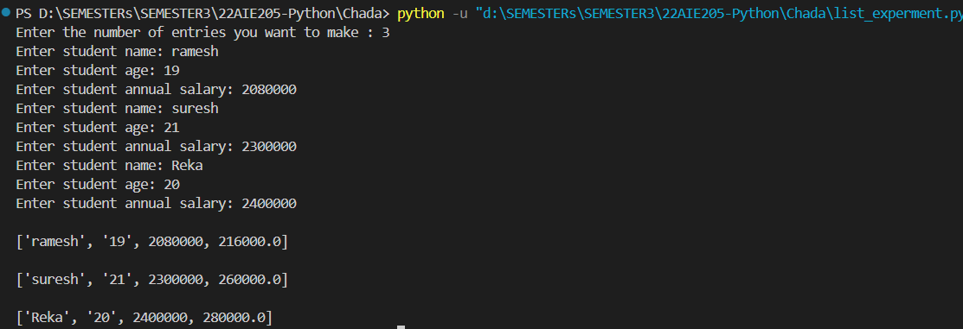

2 . write a program to generate roll number of a student by taking campus,domain,degree,year,branch,year of joining.

CODE:
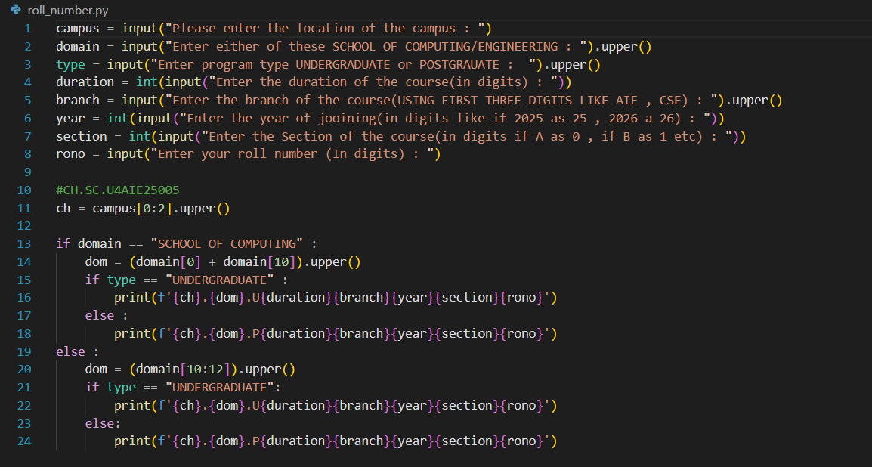

OUTPUT:
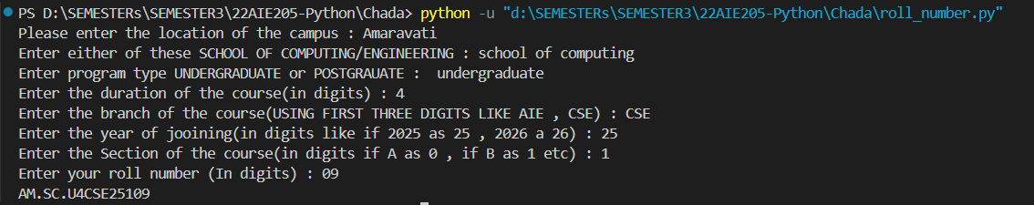

3 . validate PAN number.

CODE:
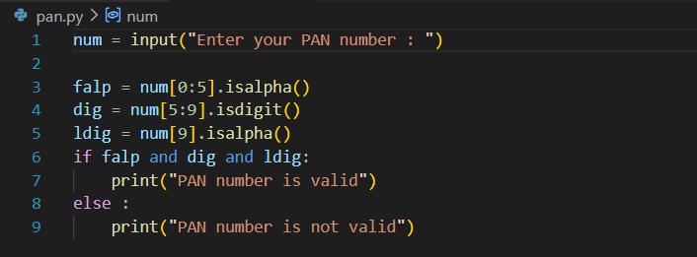

OUTPUT:

