22AIE205 – Introduction to Python

Lab Activity 3

Name: AKEPATI SATHISH REDDY
Reg.NO: CH.SC.U4AIE25001
Department: AIE 25-29

# **Electricity Bill Generator (Slab-Based, Multiple Households)**
The Electricity Board wants to calculate electricity bills for multiple households.
Store the electricity tariff slabs in a tuple.
Units rate (₹/unit),
First 100 ₹1.50,
Next 100 ₹2.50,
Next 300 ₹4.00,
Above 500 ₹6.00,
The program should:
i) Ask the user for the number of households.
ii) Store the household names in a list.
iii) Store the units consumed by each household in another list.
iv) Calculate the electricity bill according to the slab rates.
Display the details in a neat table.
If the PAN number starts with 'A', add an additional charge of ₹8 × Units Consumed.

CODE:
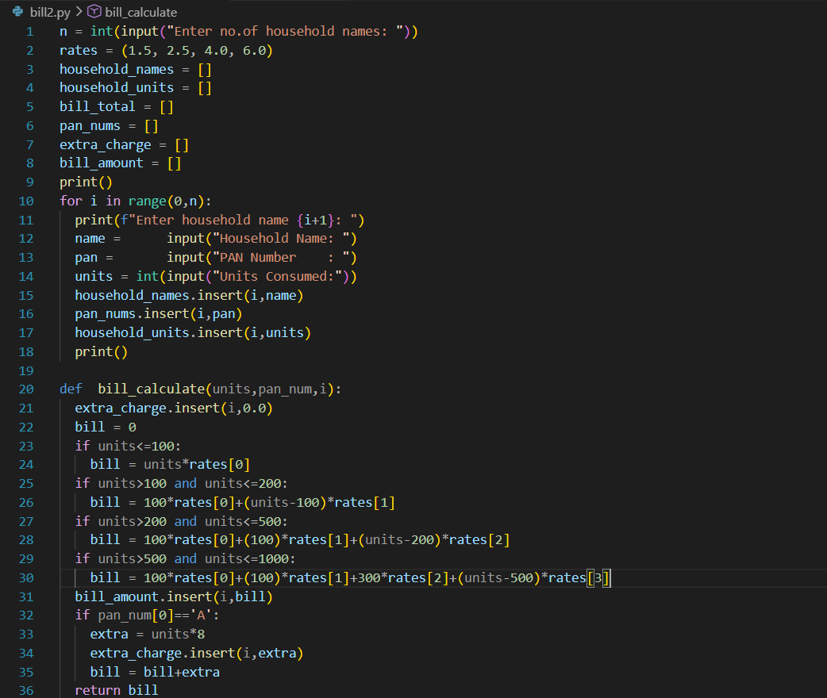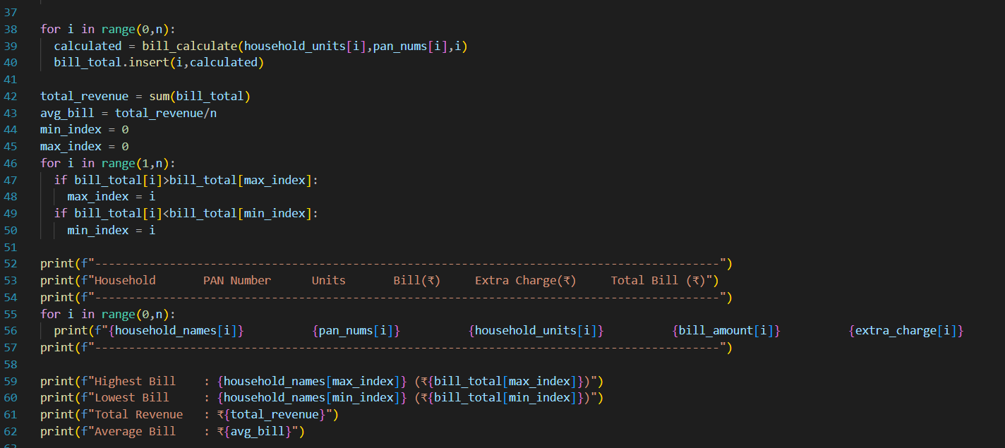

OUTPUT:


