22AIE205 – Introduction to Python

Lab Assignment 1

Name: AKEPATI SATHISH REDDY
Reg.NO: CH.SC.U4AIE25001
Department: AIE 25-29

Lab Challenge: Indian Income Tax Calculator (FY 2025-26 - Simplified)
Problem Statement: Develop a Python program to calculate the annual income tax payable by a salaried employee.
The program should:
1. Read Employee Name.
2. Read Annual Income.
3. Read Regime Choice:
- 1 → New Tax Regime
- 2 → Old Tax Regime
4. If Old Regime is selected:
- Read deductions under 80C.
5. Calculate taxable income.
6. Calculate tax based on slabs.
7. Display detailed tax report.

CODE:
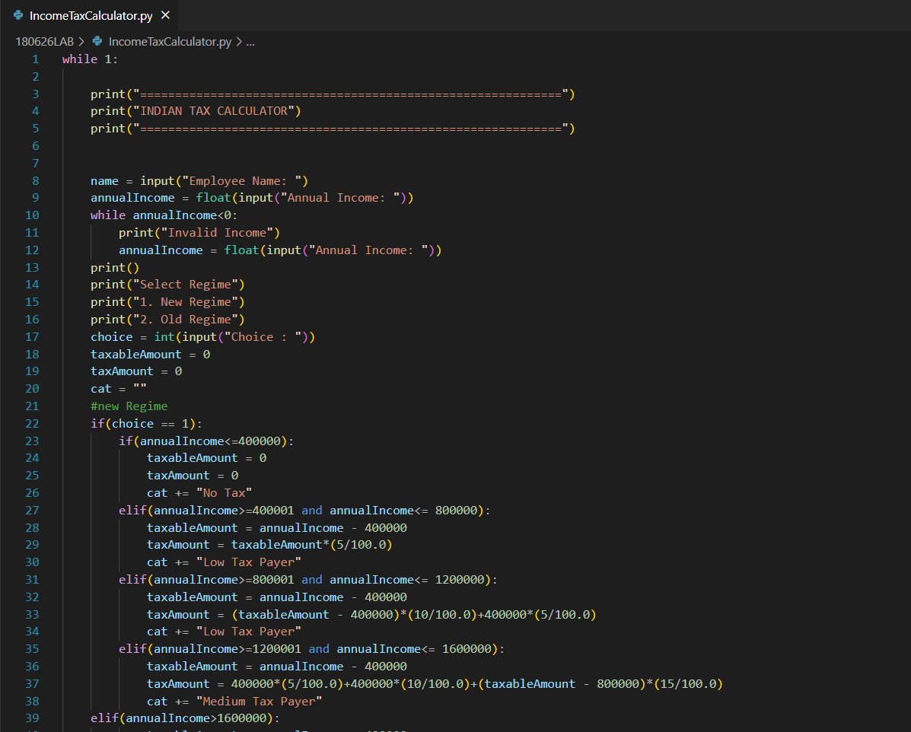

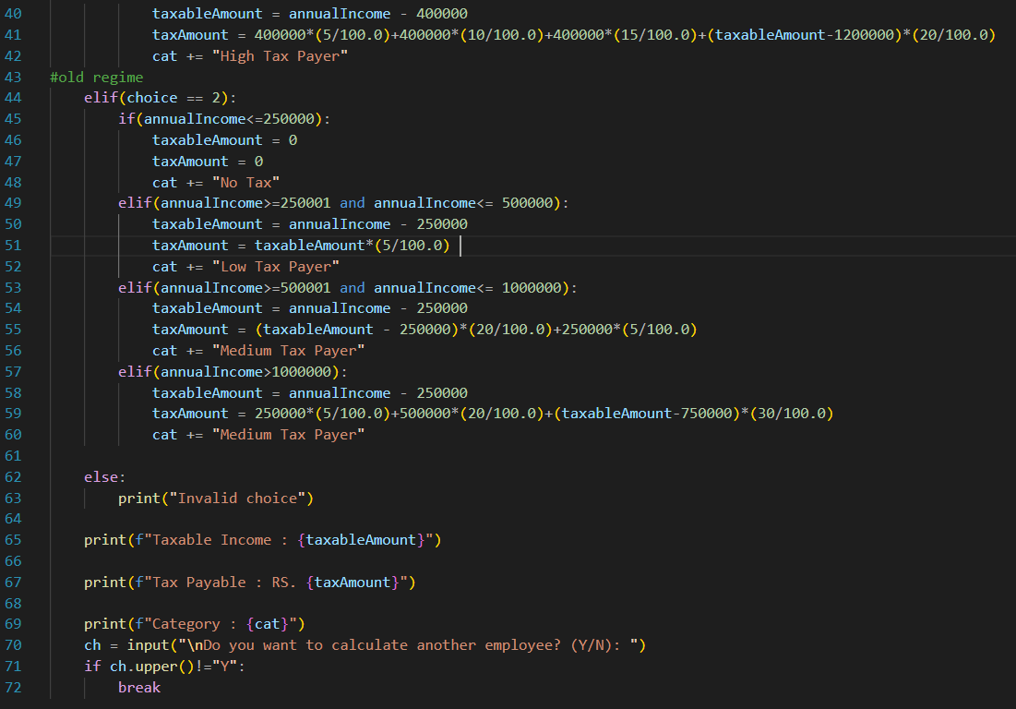

OUTPUT:


