22AIE205 – Introduction to Python

Class Activity 1

Name: AKEPATI SATHISH REDDY
Reg.NO: CH.SC.U4AIE25001
Department: AIE 25-29

Write a Python program to manage the marks of 10 students using a list.
Your program should:
1. Read the marks of 10 students from the user and store them in a list.
2. Display all the marks.
3. Find and display the highest and lowest marks.
4. Calculate and display the average mark.
5. Count and display the number of students who scored:
o Above the average
o Below 40 (Fail)
6. Display the marks in ascending and descending order.
7. Allow the user to search for a mark and display whether it exists in the list.
8. Replace all marks below 40 with 40 (grace marks) and display the updated list.
9. Display the final list along with the total, average, maximum, and minimum marks.
Constraints:
• Use only Python basics (variables, input/output, operators, conditional statements, loops,
and functions) and list operations.
• Do not use tuples, sets, or dictionaries.
• Use appropriate built-in list methods and functions wherever applicable

CODE:
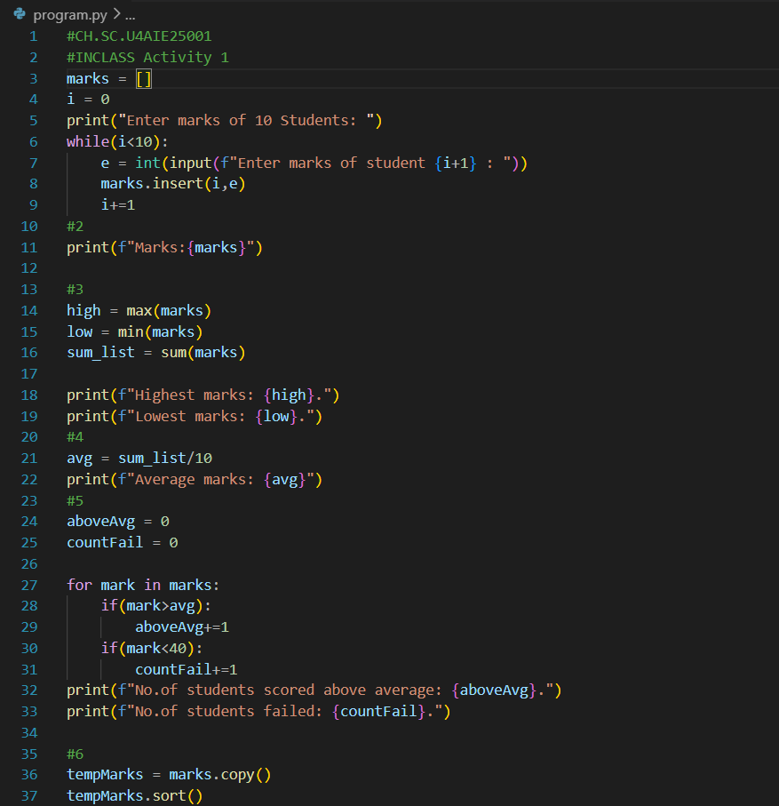
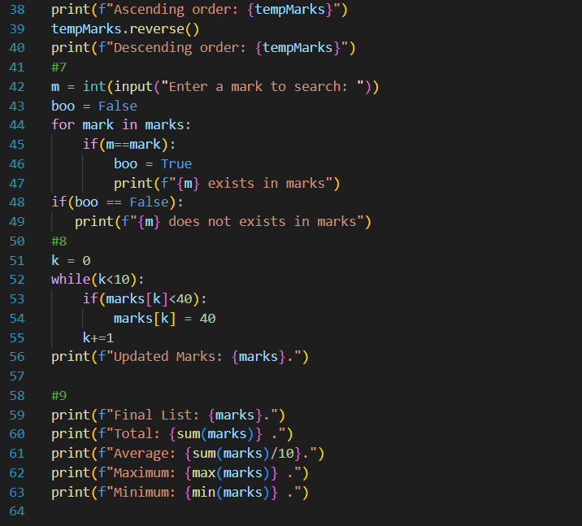
OUTPUT:


