22AIE205-Introduction to Python

Lab Exercise 6

Name: AKEPATI SATHISH REDDY
Reg No: CH.SC.U4AIE25001
Department: AIE(25 - 29)
Assignment 1 — Add tags column
Code:
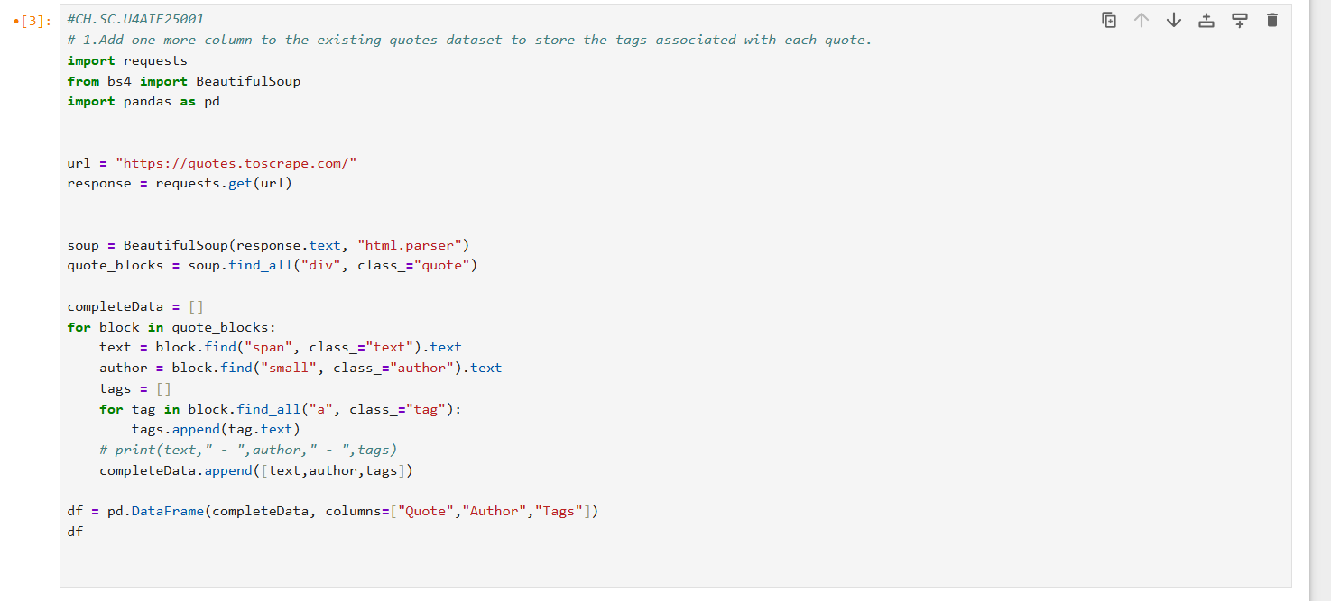
Output:
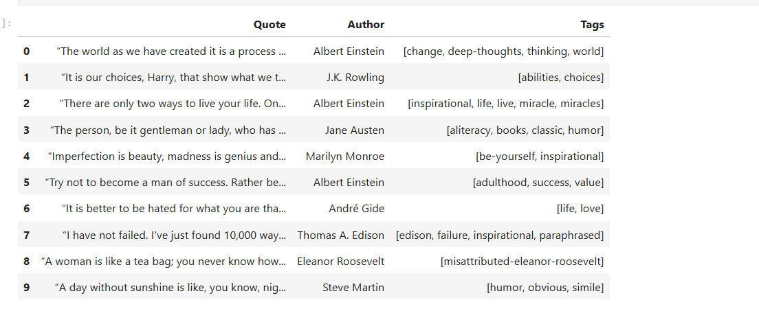
Result: Tags column was successfully added to the quotes dataset.

Assignment 2 — Filter "love"
Code:
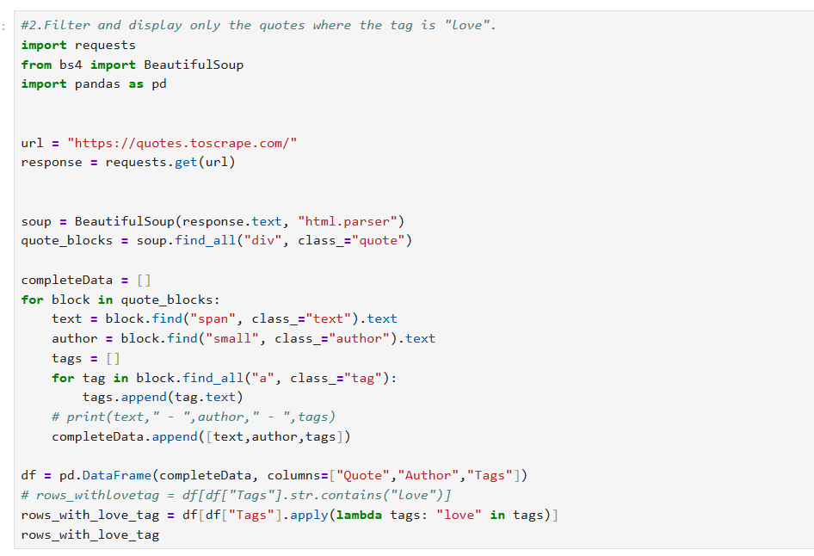
Output:

Result: First fetched all data(rows) then filtered the dataframe using lamda function(the rows with love tag).

Assignment 3 — BookMyShow
Code:
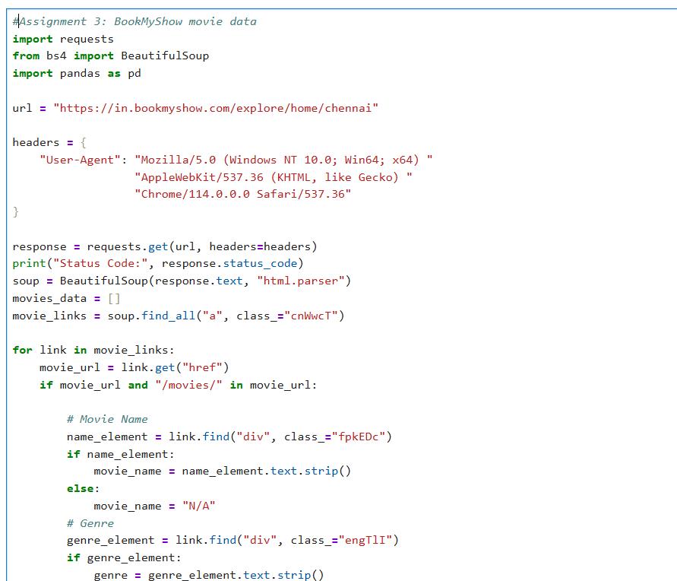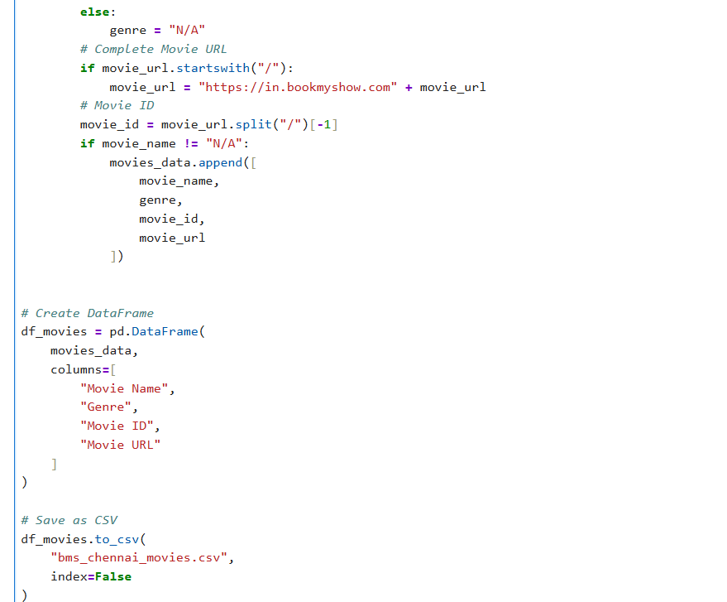
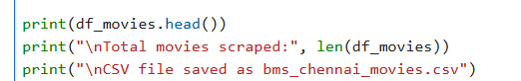

Output:
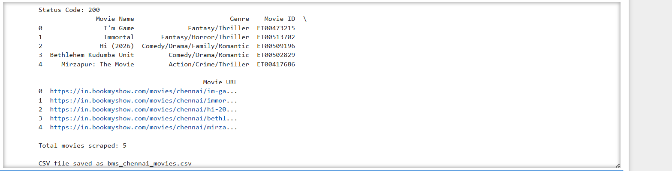
Result: Fetched movie name, genre, movie id and movie url from bookmyshow and saved data in csv file.


