**INDEX SHEET**

|  |  |  |
| --- | --- | --- |
| S. No. | Index | Page No. |
|  | Aim | 03 |
|  | Introduction |  |
|  | Key Components of AEW&C | 05 |
|  | Communication Equipment in AEW&C | 06 |
|  | Working | 07 |
|  | Current Systems | 08 |
|  | Applications | 09 |
|  | Advantages and Disadvantages | 10 |
|  | Conclusion | 11 |

**AIM**

1. To study about the communication equipment for Airborne Early Warning and Control ( AEW&C) briefly and acquire knowledge about this equipment.

**SCOPE**

1. The scope of communication equipment for communication equipment for Airborne Early Warning and Control ( AEW&C) is given below :
2. Introduction to AEW&C
3. Key Components of AEW&C
4. Communication equipment in AEW & C
5. Working
6. Applications in Military
7. Advantages and Disadvantages
8. Conclusion

**INTRODUCTION**

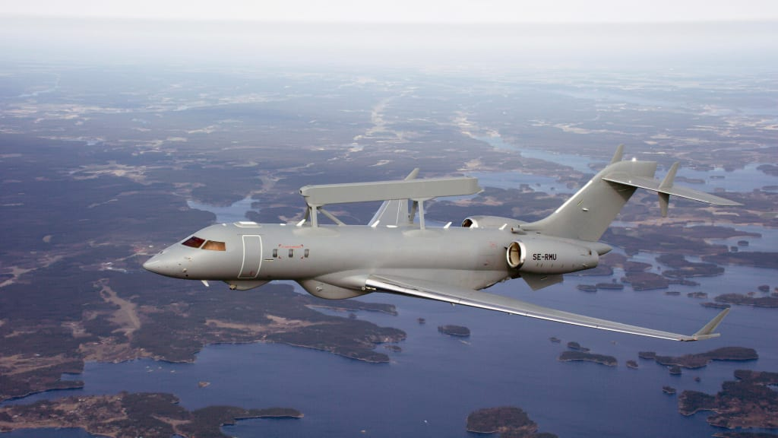

3. Airborne Early Warning and Control (AEW&C) systems are critical components of modern military operations. These platforms, typically aircraft equipped with advanced radar and communication systems, serve as the vigilant sentinels of the skies, providing a comprehensive view of the battlespace below. AEW&C systems are characterized by their ability to detect and track a wide range of threats, from enemy aircraft and missiles to maritime vessels and ground forces.

One of the primary functions of AEW&C systems is early threat detection. With their powerful radar systems, they can identify and track hostile aircraft and missiles long before they enter striking range. This early warning capability is crucial for ensuring the survival of friendly forces and allows commanders to make informed decisions about how to respond to potential threats.

AEW&C platforms also play a vital role in command and control (C2) operations. They serve as airborne command posts, enabling military leaders to communicate with and coordinate the actions of their forces spread across vast areas. This C2 capability is particularly valuable in scenarios where traditional ground-based command centers may be vulnerable to enemy attacks. Furthermore, AEW&C systems are instrumental in air defense. They can guide interceptor aircraft to intercept and neutralize incoming threats, such as enemy fighter jets or ballistic missiles. This capability enhances the overall effectiveness of a nation's air defense network.

In addition to their defensive roles, AEW&C platforms have offensive capabilities, particularly in electronic warfare. They can jam enemy communication and navigation systems, disrupting the adversary's ability to coordinate and execute its operations effectively. This electronic warfare capability can significantly degrade an opponent's combat effectiveness.

AEW&C systems are also valuable in non-combat roles. They are often used in search and rescue missions, helping locate downed aircraft or personnel in remote or challenging terrain. Their ability to cover large areas quickly makes them well-suited for these humanitarian missions. Moreover, these platforms provide critical support to naval forces. By extending their radar coverage far beyond the horizon, AEW&C aircraft can detect and track maritime threats, such as hostile ships or submarines. This capability enhances the security of naval fleets and helps safeguard vital sea lanes.

On a strategic level, AEW&C systems contribute to national security by providing early warning of potential threats to a nation's sovereignty. They offer the ability to monitor airspace and maritime areas, identifying any unusual or unauthorized activity.

Importantly, AEW&C systems mitigate risks in military operations, reducing the likelihood of friendly fire incidents and minimizing collateral damage. Their real-time situational awareness allows for precise and effective targeting, enhancing the safety of military personnel and the protection of civilian populations.

In conclusion, AEW&C systems are indispensable assets for modern armed forces. They provide early warning, enhance command and control, support air defense, conduct electronic warfare, assist in search and rescue missions, protect naval forces, contribute to national security, and reduce operational risks. These capabilities make AEW&C platforms a cornerstone of contemporary military operations, ensuring the safety and effectiveness of armed forces around the world.

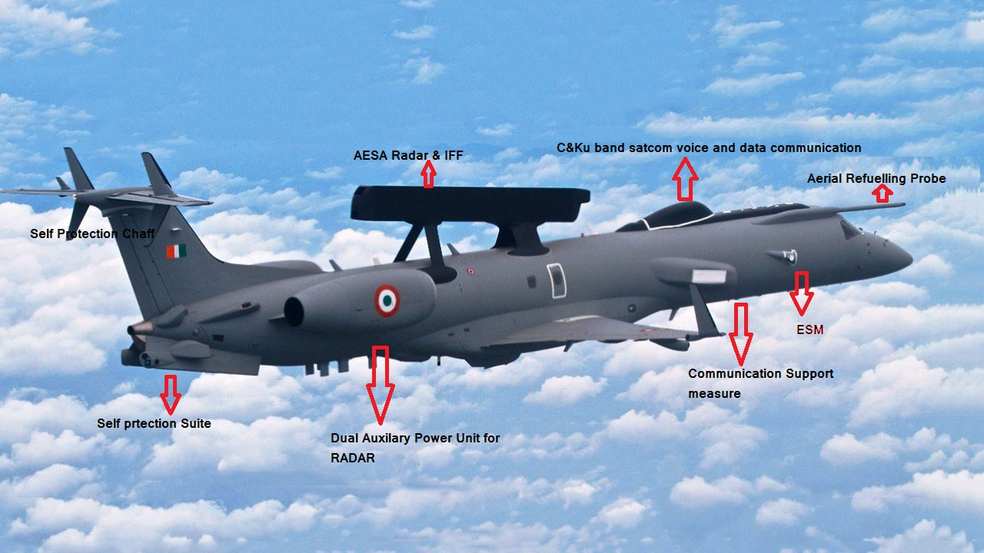

4. **KEY COMPONENTS OF AEW&C**

1. **Radar System:** AEW&C aircraft feature a rotating radar antenna for surveillance.
2. **Command and Control (C2) System:** Mission crew use mission consoles and secure data links for communication and decision-making.
3. **Electronic Support Measures (ESM):** ESM equipment detects and identifies electronic emissions from potential threats.
4. **Identification Friend or Foe (IFF) System:** IFF transponders positively identify friendly aircraft.
5. **Self-Protection Systems**: Countermeasures and defensive aids enhance survivability.
6. **Communication Relay:** AEW&C aircraft extend communication range and coverage.
7. **Power Generation:** Advanced power systems support electronic equipment.
8. **Mission Crew Stations:** Specialized crew members operate AEW&C systems.
9. **Data Processing and Fusion:** Systems collect, analyze, and fuse data for real-time situational awareness.
10. **Airframe and Propulsion:** The aircraft's structure and propulsion system enable mobility and endurance.

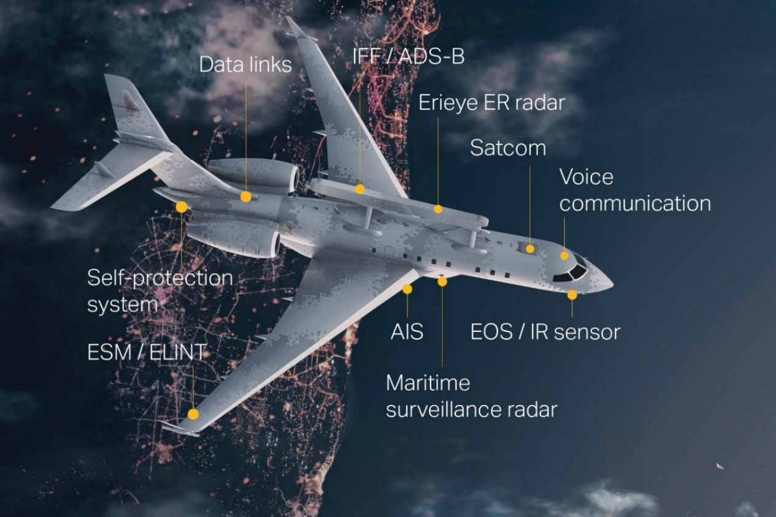

5.  **COMMUNICATION EQUIPMENT IN AEW&C**

Communication equipment in Airborne Early Warning and Control (AEW&C) systems includes the following key components and devices:

1. **Data Links:** AEW&C systems are equipped with various data links, such as Link 11, Link 16, and Link 22, which facilitate secure data communication between aircraft and other platforms. These data links ensure real-time exchange of radar and sensor information, threat assessments, and mission updates.
2. **Antennas:** Specialized antennas are essential components for communication in AEW&C platforms. These antennas are designed to operate within specific frequency bands, including UHF (Ultra High Frequency) and VHF (Very High Frequency), to enable effective data transmission and reception.
3. **Satellite Communication (SATCOM) Terminals:** SATCOM terminals are integrated into AEW&C systems to establish beyond-line-of-sight (BLOS) communication. These terminals enable connectivity over vast distances by utilizing satellite links, enhancing the operational range and flexibility of AEW&C platforms.
4. **Encryption Devices:** Given the sensitive nature of the data exchanged by AEW&C systems, encryption devices are used to secure communications. These devices employ advanced encryption algorithms to protect transmitted data from unauthorized access or interception.
5. **Multiplexers and Data Processors:** Multiplexers and data processors are responsible for organizing and managing the data exchanged within the AEW&C platform's communication network. They ensure efficient data handling and routing to the appropriate recipients.
6. **Secure Voice Communication Systems:** AEW&C systems include secure voice communication systems that allow personnel onboard the aircraft to communicate verbally. These systems are designed to maintain the confidentiality of voice conversations.
7. **Line-of-Sight (LOS) Radios:** LOS radios provide short-range, line-of-sight communication capabilities for AEW&C platforms. They are used for communication with nearby aircraft and ground-based stations, enabling close coordination during missions.
8. **Ground Communication Stations:** AEW&C systems may have ground-based communication stations that serve as communication hubs. These stations facilitate data exchange between the aircraft and ground control centers, enhancing command and control capabilities.
9. **Frequency Bands:** Communication equipment in AEW&C systems operates across a range of frequency bands, allowing for compatibility with various communication systems and platforms. This diversity ensures effective data exchange with different entities.
10. **Redundancy Systems:** To enhance reliability, AEW&C communication equipment often incorporates redundancy systems. Redundant components and backup communication links are in place to mitigate the risk of communication failures during critical missions.

6. **WORKING**

Certainly, let's break down the working methodology of communication equipment in Airborne Early Warning and Control (AEW&C) systems into clear steps:

1. Data Collection: AEW&C platforms use advanced radar and sensors to continuously scan the airspace and detect threats like enemy aircraft, missiles, and naval vessels.
2. Data Processing: Data collected by sensors is processed in real-time. Communication equipment interfaces with data processing systems to receive analyzed information, including threat assessments.
3. Data Prioritization: Communication equipment categorizes and prioritizes data based on importance, ensuring critical threat data receives top priority.
4. Data Encryption: To ensure security, sensitive data is encrypted using advanced algorithms.
5. Data Transmission: Communication equipment uses secure data links, satellite communication (SATCOM), and line-of-sight (LOS) radios to transmit data over short and long distances.
6. Data Distribution: Relevant parties, including allied forces and command centers, receive real-time threat information and situational updates.
7. Secure Voice Communication: Communication equipment enables secure voice communication among personnel on the AEW&C platform.
8. Redundancy: Redundancy measures, like backup channels and systems, ensure uninterrupted communication.
9. Integration with Command and Control (C2): Communication equipment seamlessly integrates with command-and-control systems for coordination and decision-making.
10. Interoperability: It maintains compatibility with various military communication standards, allowing collaboration with different assets.
11. Continuous Monitoring and Adaptive Communication: Communication equipment constantly checks communication links and data flow for disruptions, and it adapts to changing scenarios.

7. **CURRENT SYSTEMS**

Many countries have developed their own AEW&C systems, but the most common systems worldwide are the Boeing E-3 Sentry and the Northrop Grumman E-2 Hawkeye.

currently available AEW&C Systems around the world are listed below:

* Airborne Warning and Control System (AWACS)
* E-2 Hawkeye
* Beriev A-50
* KJ-2000
* Netra
* Boeing 737 AEW&C
* Erieye/Global Eye

Israel has developed an IAI/Elta EL/M-2075 Phalcon system that uses AESA (Active Electronically Scanned Array) instead of a rotodome antenna. This system is the first of its kind to be put into operation. The original Falcon powered the Boeing 707 and was developed for the Israel Defense Forces and for export. Israel uses the IAI EL/W-2085 airborne early warning and control multi-band radar system on its Gulfstream G550. The platform is believed to have more capabilities and lower operating costs than the older Boeing 707-based Phalcon fleet.

8. **APPLICATIONS**

1. **Threat Reporting:** Quick identification and reporting of threats to facilitate rapid responses.
2. **Command and Control:** Serving as airborne command posts for coordinated military operations.
3. **Air Defense:** Guiding interceptors to neutralize incoming threats.
4. **Electronic Warfare:** Jamming enemy systems to disrupt adversary operations.
5. **Search and Rescue:** Aiding in locating and rescuing personnel in distress.
6. **Naval Operations:** Enhancing maritime threat detection for naval fleet security.
7. **Sovereignty Protection:** Providing early warning against unauthorized airspace and maritime activity.
8. **Risk Reduction:** Minimizing friendly fire and collateral damage, ensuring precise targeting.

9. **ADVANTAGES**

1. Rapid Response: AEW&C platforms offer swift reaction times, enabling timely countermeasures against threats.
2. Interoperability: AEW&C systems can seamlessly integrate with various military assets, enhancing overall operational effectiveness.
3. Strategic Flexibility: These platforms can be deployed to different theaters of operation, adapting to evolving security needs.
4. Force Multiplier: AEW&C platforms amplify the capabilities of existing military assets, optimizing resource utilization.
5. Coastal and Border Security: They aid in monitoring and securing maritime and land borders, curbing unauthorized activities.

10. **DISADVANTAGES**

1. Costly Investment: AEW&C platforms are expensive to develop, procure, and maintain, making them a significant financial commitment for nations.
2. Complexity: The advanced technology and systems on board AEW&C aircraft require highly trained personnel to operate and maintain effectively.
3. Vulnerability: AEW&C aircraft are vulnerable to enemy attacks, as they are high-value assets that adversaries may target to disrupt military operations.
4. Limited Endurance: These platforms typically have limited endurance due to fuel constraints, requiring aerial refueling or frequent return to base.
5. Size and Mobility: AEW&C aircraft are relatively large and may require extensive infrastructure, limiting their agility and deployment options.
6. Electronic Warfare Threats: Adversaries can employ electronic warfare to jam or interfere with AEW&C systems, affecting their performance.
7. Training Requirements: Personnel operating AEW&C systems require specialized training, adding to the overall training burden.

**CONCLUSION**

In conclusion, communication equipment plays a pivotal role in the functioning of the Airborne Early Warning and Control (AEW&C) system. It serves as the vital link that connects AEW&C aircraft with ground-based command centers, other military assets, and even allied forces. The importance of communication equipment in AEW&C systems cannot be overstated, as it enables real-time data sharing, coordination, and decision-making in complex and dynamic operational environments.

The AEW&C's ability to detect, track, and relay information about potential threats relies heavily on the efficiency and reliability of its communication equipment. These systems facilitate secure voice, data, and video communication, ensuring that military leaders have a comprehensive situational awareness and can respond effectively to emerging threats.

Furthermore, the integration of advanced communication technologies enhances the interoperability of AEW&C platforms with other defense systems, enabling seamless cooperation among various branches of the armed forces. This interoperability is vital for joint military operations and coalition efforts.

In essence, communication equipment is the lifeline of AEW&C systems, enabling them to fulfill their critical roles in early threat detection, command and control, air defense, electronic warfare, and more. As these systems continue to evolve and adapt to the challenges of modern warfare, their communication capabilities remain at the forefront of ensuring the safety and effectiveness of military operations.

**REMARKS BY ADS**

**REMARKS BY DS**

**REMARKS BY HOD**