STB AUTOMATION TESTING FRAMEWORK
GOAL:
We have PiBox HDMI capture card and RedRat-x IR blaster hardware tool. Build STB automation framework.

ARCHITECTURE:
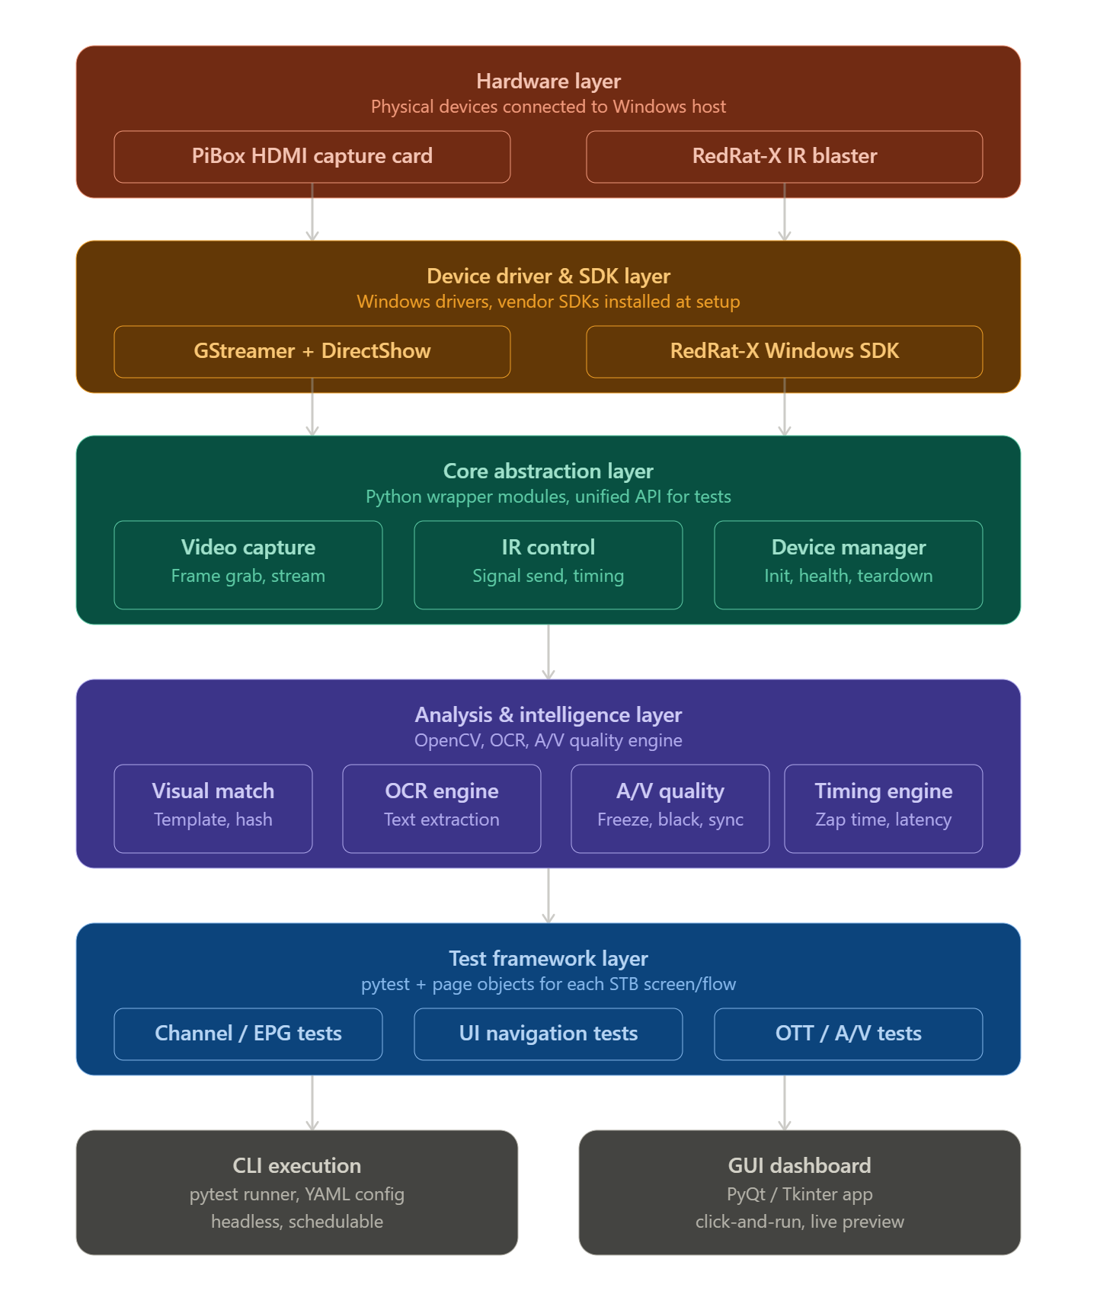
- Hardware layer — PiBox exposes as a DirectShow/V4L2 device on Windows; RedRat-X connects via USB with its own Windows driver. No other hardware needed.
- Driver & SDK layer — installed once during setup. GStreamer (with the Windows binary bundle) handles the HDMI capture pipeline; the RedRat-X Windows SDK handles IR signal management and learning. This layer is invisible to test writers.
- Core abstraction layer — three Python wrapper modules that hide vendor-specific details: a VideoCapture module (wraps GStreamer), an IRControl module (wraps RedRat SDK), and a DeviceManager that handles start-up, health checks, and graceful teardown. Tests only ever talk to this layer.
- Analysis & intelligence layer — the "brain." OpenCV for template matching and image diff, Tesseract for OCR, custom detectors for black screen / freeze / A/V sync, and a timing engine for measuring zap times with millisecond precision.
- Test framework layer — pytest-based, with page objects modelling each STB screen (EPG, Home, Settings, and Player). Test cases read like plain English and are completely decoupled from hardware.
- Execution layer — the plug-and-play entry point. CLI for headless/scheduled runs with YAML config; GUI dashboard (PyQt or Tkinter) for manual triggering with live frame preview.

Layers 3, 4, and 5 are fully reusable across all device types — only the Core Abstraction layer needs to change. The solution is introducing a Device Interface pattern with pluggable control backends.
Here's how the revised architecture looks with multi-device support:
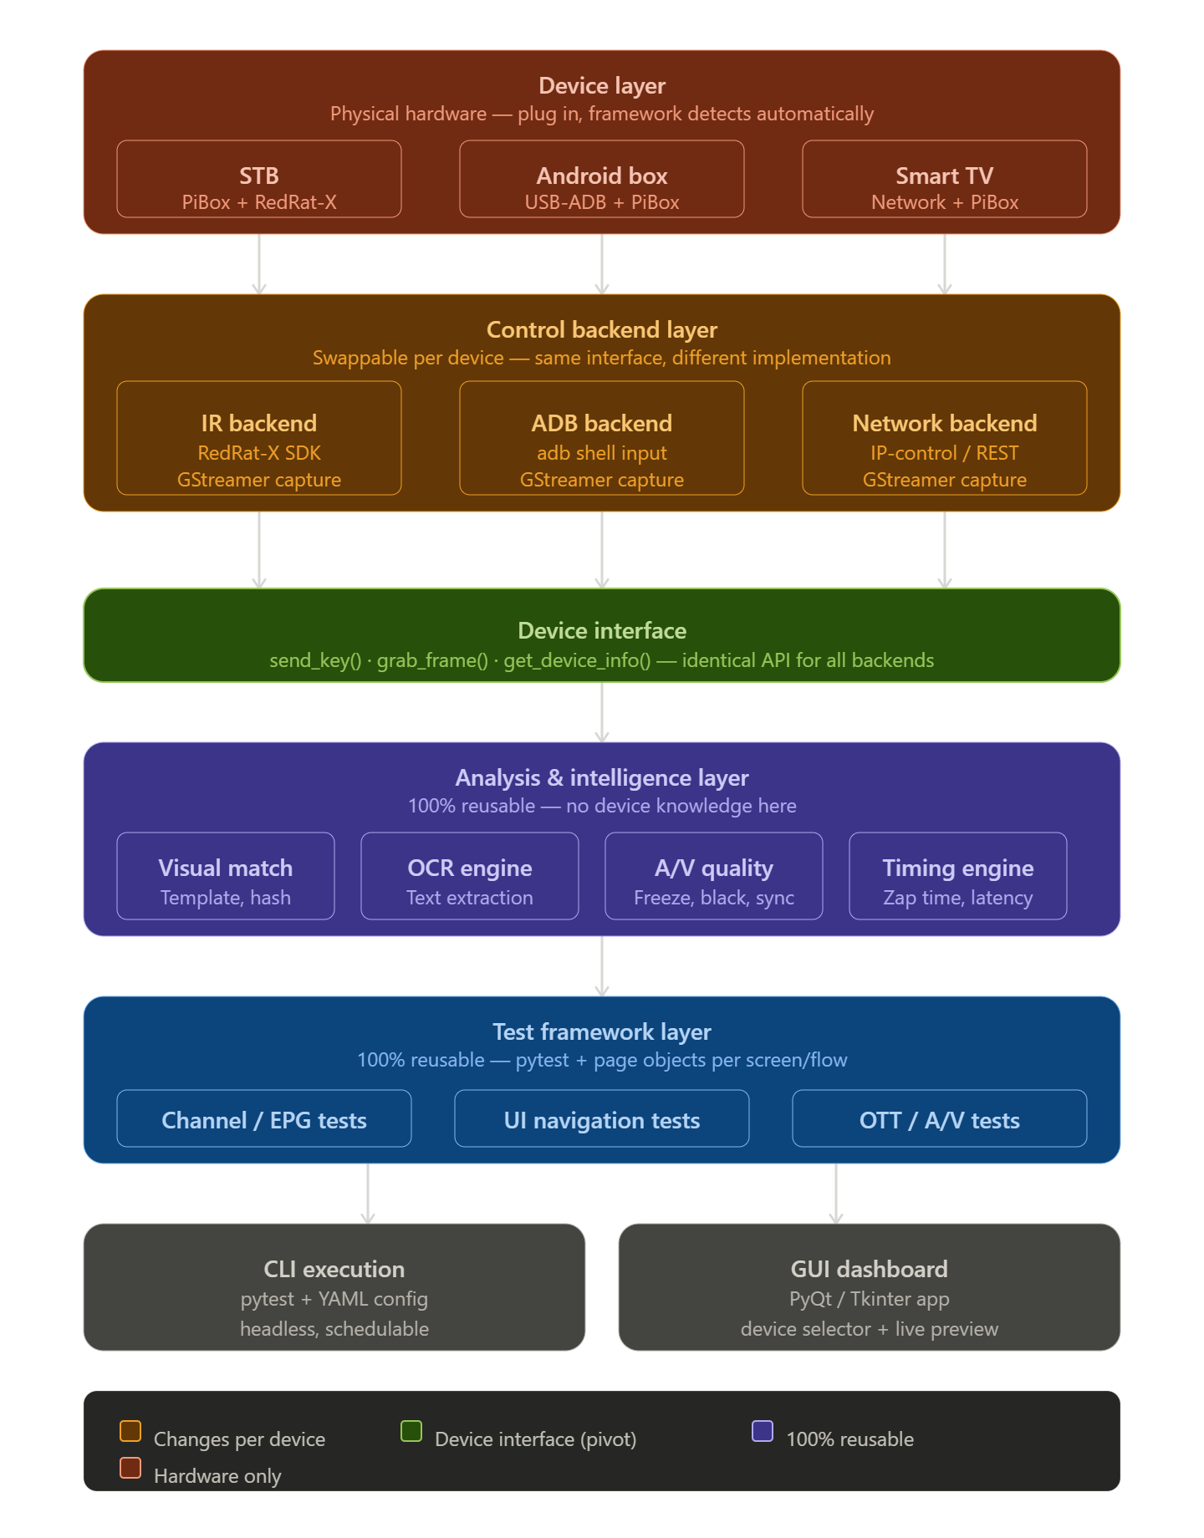

The entire framework is reusable — except the Control Backend, and that's by design.
The critical architectural decision is the Device Interface (the green layer). It defines exactly three contract methods — send_key(), grab_frame(), and get_device_info() — that every backend must implement. Everything above that line never knows or cares what device is connected.
The three backends differ only in how they fulfil that contract:
- The IR backend calls the RedRat-X SDK to send key signals
- The ADB backend calls adb shell input keyevent to send the same logical keys
- The Network backend calls an IP-control or REST API (used by many Smart TVs via DIAL, HbbTV, or vendor SDKs)
All three share the same GStreamer pipeline for video capture since PiBox is still connected regardless of the control method.
The practical result is that your YAML config file becomes the only thing that changes between device types — something like device: stb or device: android_box — and the framework auto-selects the right backend at startup. Your test cases, page objects, visual matchers, OCR, and reports stay completely untouched.
Milestone:
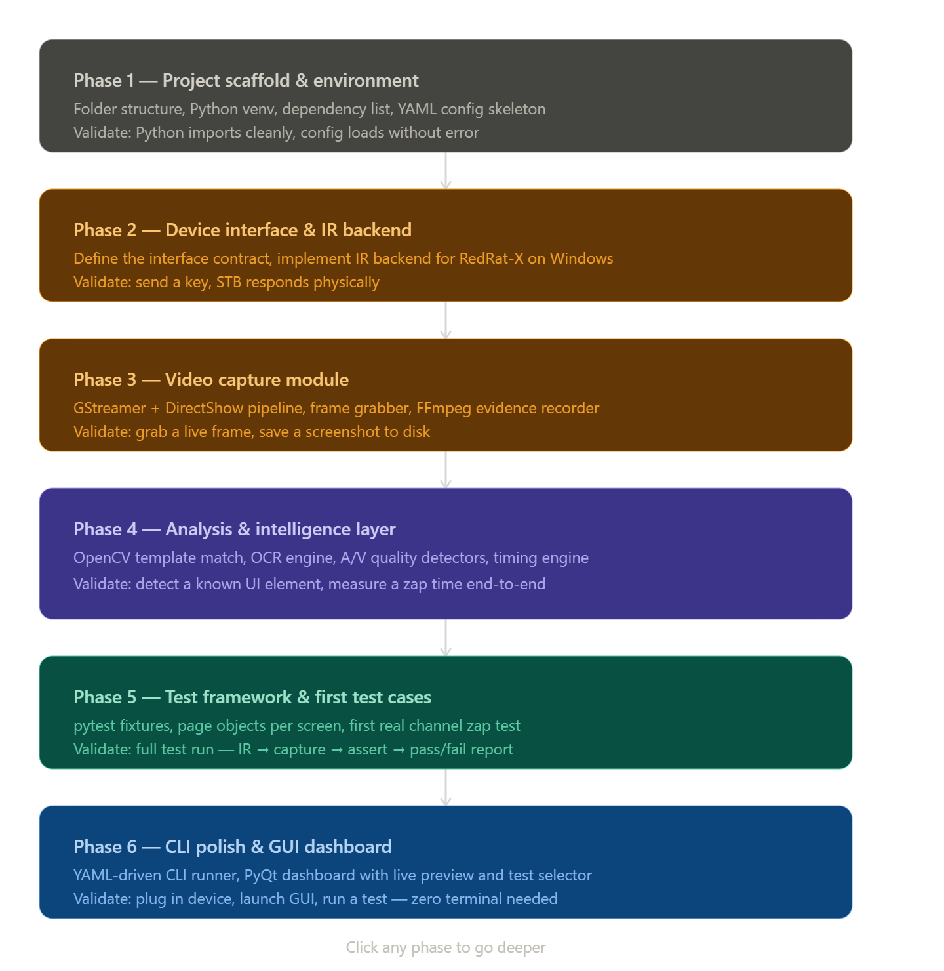

PHASE – 1: Project Scaffold & Environment:

Root: STB_Automation
STB_Automation/ root directory
|-- requirements.txt external libraries (dependencies)
|-- setup.py to install and setup the current setup
|-- .env.sample secrets
|-- conftest.py pytest root
|-- run.py CLI entry

DEVICE DRIVERS & SDK LAYER
|-- backends/ control backends
||-- base.py device interface
||-- ir_backend.py IR device drivers (i.e RedRat-X)
||-- adb_backend.py Android / ADB derivers
||-- network_backend.py Smart TV drivers

CORE ABSTRACTION LAYER
|-- core/ core abstraction
||-- device_manager.py inti & health
||-- capture.py GStreamer media framework
||-- ir_control.py IR Wrapper

ANALYSIS & INTELLIGENCE LAYER
|-- analysis/ analysis
||-- visual_match.py OpenCV (Tool)
||-- ocr.py Tesseract OCR (Tool)
||-- av_quality.py A/V detectors
||-- timing.py latency engine

TEST FRAMEWORK LAYER
|-- pages/ page objects module (POM)
||-- home_screen.py Home screen
||-- epg_screen.py EPG Screen
||-- setting_screen.py setting screen
||-- player_screen.py player screen
.
|-- tests/ Test cases
||-- test_channel_zap.py Channel zap test
||-- test_ui_navigation.py UI navigation test
||-- test_av_quality.py A/V Quality test
.

CONFIG, ASSETS & OUTPUT
|-- config/ configuration directory
||-- devices.yaml device profiles
||-- settings.yaml framework settings
|-- assets/ Static assets
||-- ir_signals/ .irdb files
||-- templates/ UI reference images
|-- reports/ test reports
|-- outputs/ screenshots & clips
|-- logs/ logs for setup, tests, & device manager, etc.

drivers/ holds all three control implementations — base.py defines the device interface contract that ir_backend.py, adb_backend.py, and network_backend.py all implement. This is the only folder that differs between device types.
core/ is the thin wrapper that test code talks to — it never imports directly from backends/.
pages/ is the page object layer. Each file models one STB screen as a Python class. Test files only ever call page object methods — they never call analysis/ directly.
assets/ir_signals/ stores the RedRat-X .irdb signal database for your specific STB remote. assets/templates/ holds the reference screenshots used by visual_match.py for template matching.
config/devices.yaml is the only file you touch when switching between STB, Android box, or Smart TV — the framework reads it at startup and loads the right backend automatically.

PHASE – 2: DEVICE INTERFACE & IR BACKEND:
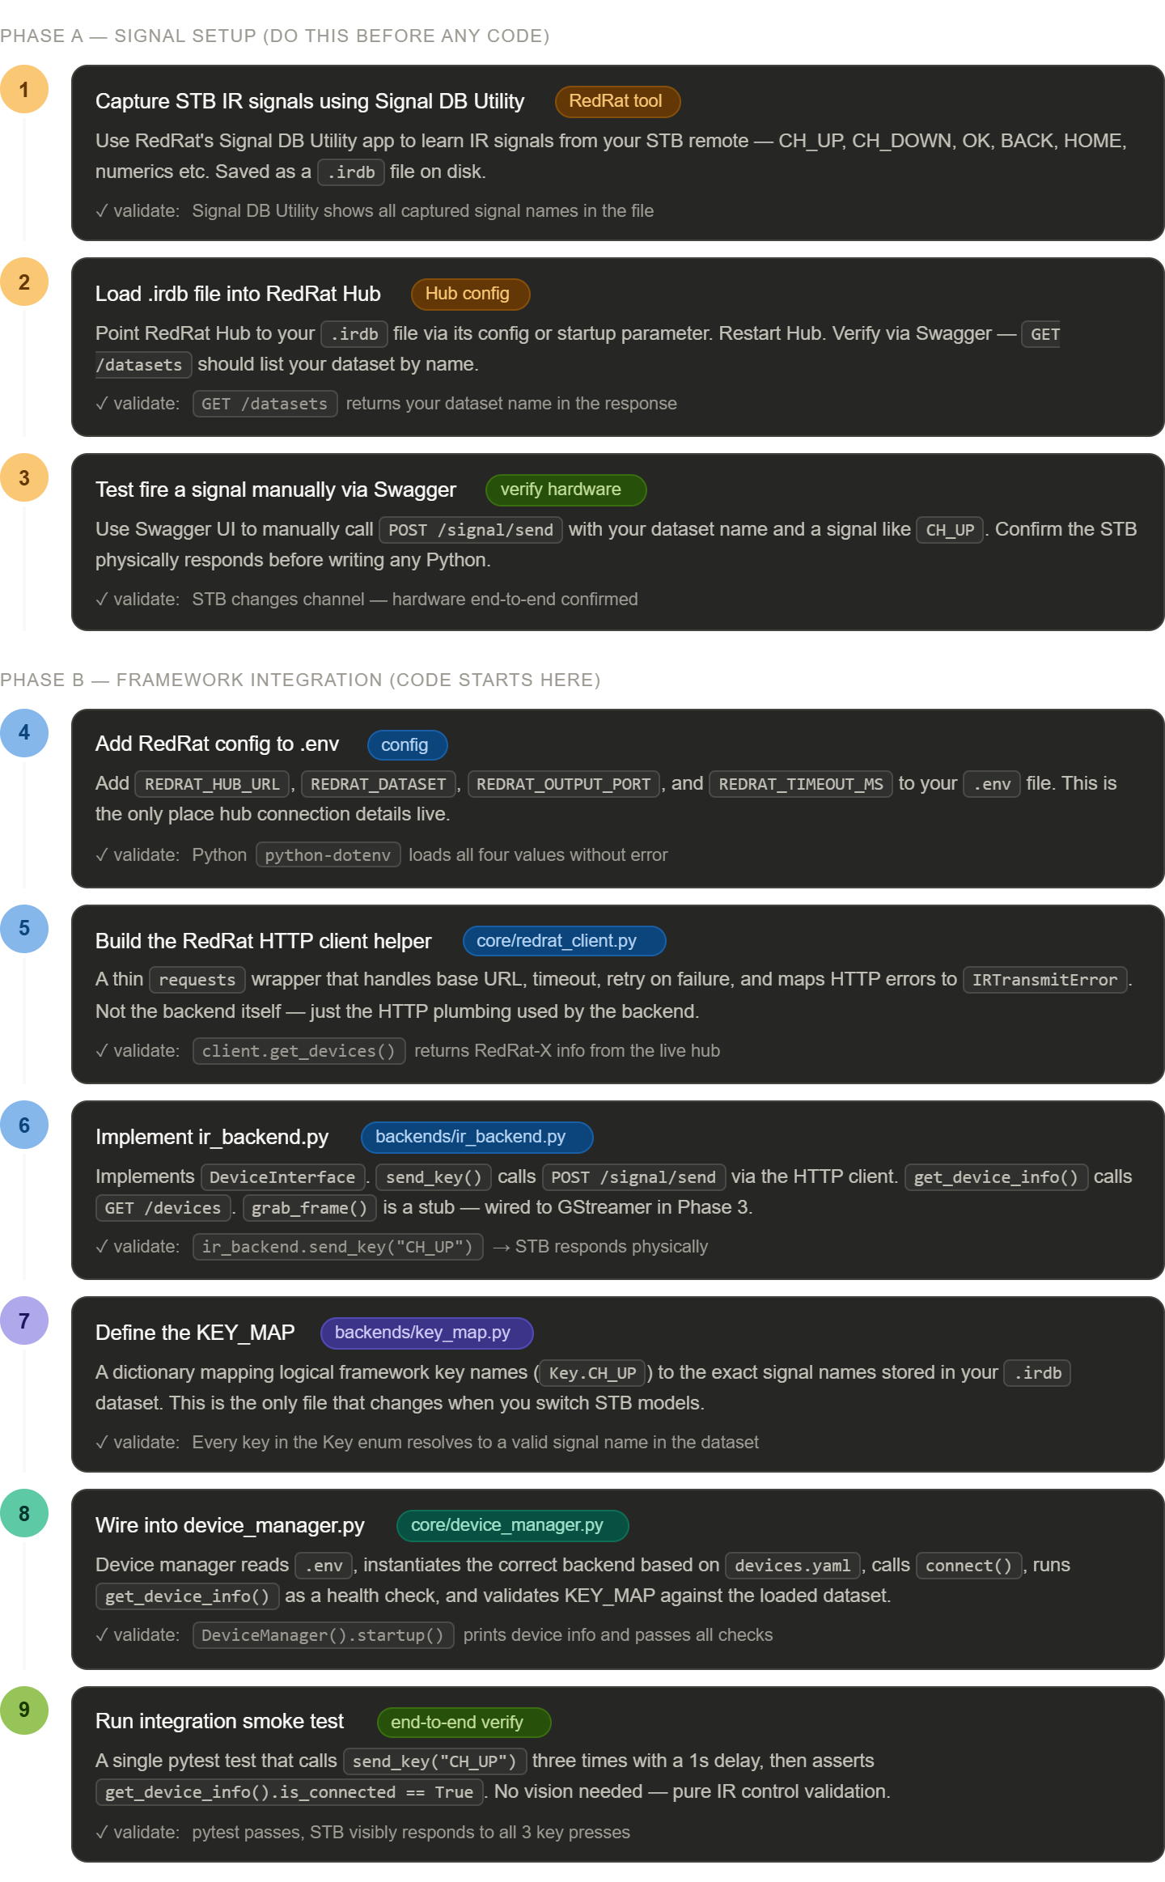

Phase A: Signal Setup:

Redrat Setup:
THe RedRat Hub can in Docker container using Ubuntu 22.04.5 server or Windows system, refer following details have….
For Docker: (Testing in progress)
- Install required server or VM. In this case I installed VM with Ubuntu 22.04.5 server
- And install Docker.
- Create a dockerfile (using nano cmd), and add below given docker cmds
FROM mcr.microsoft.com/dotnet/aspnet:8.0
WORKDIR /app
RUN apt-get update && apt-get install -y \ libusb-1.0-0 \ libusb-1.0-0-dev \ && ln -sf /usr/lib/x86_64-linux-gnu/libusb-1.0.so.0 /usr/lib/libusb-1.0.so \ && ldconfig \ && rm -rf /var/lib/apt/lists/*
# Copy the unzipped RedRatHub contents here
COPY ./ RedRatHub-V8.01 / .
EXPOSE 8080
ENTRYPOINT ["dotnet", "RedRatHub.dll"]
- Download the RedRat Hub file from official site (https://www.redrat.co.uk/software/redrat-hub/) or directly you can download using wget cmd.

# wget https://www.redrat.co.uk/downloads/RedRatHub-V8.01.zip
- Unzip RedRatHub-V8.01.zip into a folder called RedRatHub next to your Dockerfile
- Build the image:
# docker build -t redrathub .
- Now run the docker file
# docker run -d -p 8080:5248 --device=/dev/bus/usb -v /dev/bus/usb:/dev/bus/usb --name redrathub redrathub
- Then check the site - http://localhost:8080 in web browser (i.e Replace the server IP and check)
Note: If it’s not working, then check docker logs, may be it running in different port.
- Print the log using below cmds…
# docker ps
# docker logs redrathub

For Windows:
- Go to the directory - STB_Automation_Framework\setup\IR_blaster
- Install the .NET_Runtime .exe files (3 files there).
- After then go to RedRatHub-V8.01 folder, run below cmd
# .\RedRatHub.exe
Or
# dotnet RedRatHub.dll
Note: Refer the offcial documents - https://www.redrat.co.uk/software/redrat-hub/

IR Signal Device Setup:
- Capture the IR signals using SignalDBUtility app (Refer official site - https://www.redrat.co.uk/software/ir-signal-database-utility/)
- After installed and capture the IR signal and save as (.xml or .irdb) in assets/ir_signals/ directory.
- Then load the new signal and restart the RedRat Hub
# .\RedRatHub.exe --irdata "C:\Users\sathi\Desktop\STB_Automation_Framework\assets\ir_signals\OVT_NXT_Digital_RCU_COPY.xml"
Note: Created .bat script file for multiple singals load (Refer run_redrathub.bat file in root dir.)

Manual test the RedRat Device:
- Go to the API page of RedRat hub - http://127.0.0.1:8080/swagger/index.html
Note: Replace your IP & Port.
- Verify your remote signal XML loaded properly (using GET /api/irdata/{dataset})
Note: Replace your remote .DB or .xml name.
- List all captured keys (using GET /api/irdata/{dataset}/{singal})
Note: Replace your dataset name and captured singal
- Confirm your RedRat-X device is detected (using GET /api/redrats/)
- Send a real IR signal to your STB/TV (using POST /api/{id}/{outputs}/
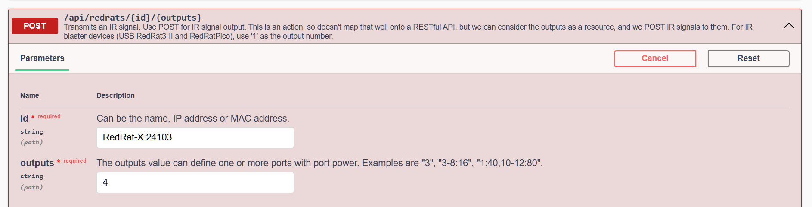
- And give the request body dataset & signal only.
Ex: dataset – OVT_NXT_Digital_Remote & signal – VOL+

PHASE -B: FRAMEWORK INTEGRATION:

.env with redrat config.
- Before start implementing, need to know the tool sets
- We’re going to use .env library for device information store.

Why .env for secrets and machine-specific values
- The .env file stores things that change per machine or per person — Hub URL, device ID, passwords. These should never go into Git. .env is the universal standard for this — every developer immediately understands .env should be in .gitignore.
Note: We’re going to use both .env & .yaml lib.

Why unittest.mock — simple explanation
- Think of it this way:
Real test without mock:
test calls send_signal()
→ needs Hub running
→ needs RedRat-X plugged in
→ needs STB connected
→ takes 3 seconds
❌ fails on CI/CD machine with no hardware

Test with mock:
test calls send_signal()
→ mock pretends to be requests.post
→ instantly returns fake HTTP 200
→ no Hub, no hardware needed
✅ runs anywhere in milliseconds
- A mock is just a fake replacement for something your code depends on — in this case requests.post. You tell it what to return, and your code never knows the difference.

Ir_backends.py
Refer below architecutre to purpose to crwated ir_backend.py
Test case
↓ calls
DeviceInterface ← send_key(), grab_frame(), get_device_info()
↓ implemented by
IRBackend ← uses RedRatClient (STB)
ADBBackend ← uses adb commands (Android box)
NetworkBackend ← uses REST API (Smart TV)

Folter Structure of backends:

backends/

├── base.py ← shared — contract, never changes

├── ir_backend.py ← shared — all IR devices

├── adb_backend.py ← shared — all Android devices

├── network_backend.py ← shared — all Smart TVs

│

└── key_maps/

├── key_map_ovt.py ← OVT NXT STB

├── key_map_samsung.py ← Samsung TV

└── key_map_firetv.py ← Fire TV / Android box

Note: Key map to maintain indual key map files, when using different model/vendor.

IR_Backend work flows:
test case
↓
ir_backend.send_key("CH_UP")
↓ looks up KEY_MAP
↓ signal = "CH+"
↓
redrat_client.send_signal("CH+")
↓ POST /api/redrats/{device_id}/4
↓
RedRat Hub
↓
RedRat-X IR blaster
↓
STB responds ✅

8. Device_manager work flow:
DeviceManager()
|
v
load .env
|
v
load devices.yaml
|
v
backend = ir or adb ?
|
v
create IRBackend()
|
v
backend.connect()
|
v
backend.get_device_info()
|
v
verify dataset
|
v
ready

PHASE – 3: Capture card :
- GStreamer warned ksvideosrc is deprecated — use mfvideosrc instead. So we use mfvideosrc in the pipeline.

