Ollama

Tev1 Model
It can be used for tasks such as classification, intent detection, sentiment analysis, policy checking, and other decision-making workflows.
Tev1 is available in different model sizes, including 0.8B and 4B, making it possible to run the model locally with relatively low hardware requirements.
https://ollama.com/library/tev1

Tev1 Used For
- Customer email classification
- Customer intent detection
- Support ticket routing
- Sentiment classification
- Yes/No decisions
- Policy compliance checking
- Priority classification
- Categorizing documents or messages
- Extracting structured decisions from text

Major Advantages
Small Model Size : The 0.8B model is particularly useful for learning and experimentation because it requires significantly less storage and computing resources.
Fast Processing :
Customer Message : Tev1 Sales Support Billing

Local AI
Tev1 can run locally through Ollama.
This can provide advantages such as:
- Local processing
- Reduced dependency on cloud APIs
- Potentially lower API costs
- Better control over data
- Useful environment for learning AI development

Tev1 can be integrated with Python and FastAPI.
For example:
Email
↓
Python
↓
FastAPI
↓
Tev1
↓
Classification
↓
CRM / Ticketing System

Major Disadvantages
It is not primarily designed for:
- Long conversations
- Complex coding
- Large content generation
- Creative writing
- Extensive reasoning
- Long document analysis

Conclusion
Tev1 is a specialized AI model focused on decision-making and classification rather than general-purpose conversation.
Its main advantages are its relatively small size, local execution through Ollama, fast classification capabilities, and suitability for automation.
Its main disadvantages are its limited general-purpose capabilities, smaller model capacity, experimental nature, and the possibility of incorrect decisions.

Claude Sonnet 5.5
Claude Sonnet 5.5 is a new AI model made by Anthropic, the company behind Claude. It was released on September 28, 2026, and it replaces the older Sonnet 5.
- Faster: It gives answers about 30% quicker than the older version.
- Cheaper: It usually costs less to get the same job done, because it uses fewer words (tokens) to finish tasks.
- Same price as before: The price per use did not go up.
- Good at daily work: Great for writing documents, making slides and spreadsheets, and fixing simple problems.
- Writes clearly: Its answers are easier to read and understand.
- Reads a lot at once: It can handle very long documents in one go.
- Safer: It's harder to trick into doing something wrong.

Dis-Advantage
- Not the smartest: For very difficult or tricky problems, the bigger model (Opus 5.5) is better.
- Best for clear tasks: It works best when you know exactly what you want.
- Claims not fully proven yet: The "faster and cheaper" numbers mostly come from Anthropic itself.
- Sometimes says no: It may refuse more often on certain sensitive topics.
- Small hassle for tech teams: Developers may need to make a few changes to switch to it.
Conclusion
Sonnet 5.5 is a fast, affordable, and reliable helper for everyday work. For really hard thinking or complex decisions, the bigger Opus model is the better choice.

Hugging Face Model
Hugging Face is a popular platform that provides pre-trained AI and machine learning models. In this exercise, we used Python and VS Code to run a small Hugging Face model locally. The DistilBERT model was used for sentiment analysis, where the model analyzes a sentence and predicts whether the sentiment is Positive or Negative, along with a confidence score. This exercise helps understand the basic process of using pre-trained AI models in Python.
- Open the Day5 project in VS Code.
- Create and activate the .venv virtual environment.
- Install transformers and torch using pip.
- Create a Python file called download_model.py.
- Select the model distilbert-base-uncased-finetuned-sst-2-english.
- Download the model and tokenizer using Hugging Face Transformers.
- Save the downloaded model inside the my_model folder.
- Create app.py and load the model from ./my_model.
- Enter an English sentence and run the Python program.
- Get the POSITIVE/NEGATIVE sentiment and confidence score as the output.

https://huggingface.co/distilbert/distilbert-base-uncased-finetuned-sst-2-english

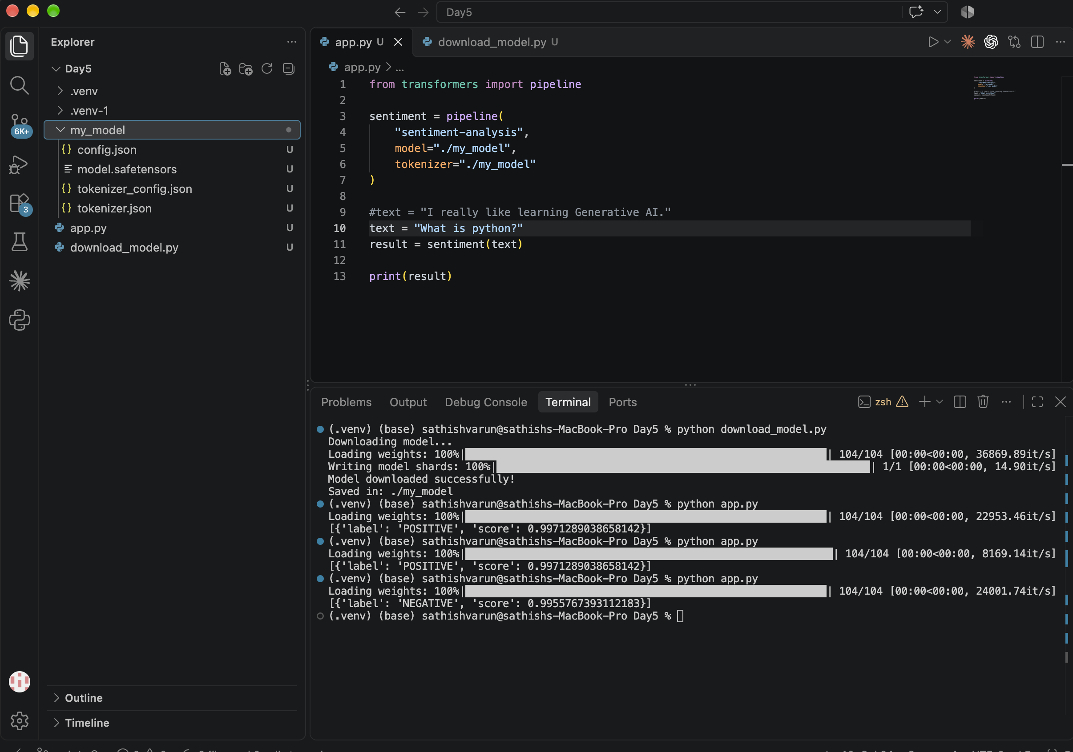

Ollama – Qwen2.5 0.5B Installation
- Qwen2.5 0.5B is a lightweight Large Language Model (LLM) developed by Alibaba Cloud’s Qwen team.
- It can run locally on your laptop using Ollama without requiring cloud-based AI services.
- The model size is approximately 398 MB, making it suitable for systems with limited RAM and storage.
- It can perform basic tasks such as question answering, text generation, and simple reasoning.
- It is useful for learning Generative AI and understanding how local LLMs work.
- Ollama provides an easy way to download, manage, and run the model locally.
- The official model is available in the Ollama Model Library.
- Official model page: Qwen2.5 on Ollama
- After downloading, the model can be accessed directly through the Ollama application and terminal.
- Recommended for beginners: It provides a simple, low-resource starting point for experimenting with local AI models.

https://ollama.com/library/qwen2.5

