DEPARTMENT OF COMPUTER SCIENCE AND ENGINEERING
CSY06 - MOBILE APPLICATION DEVELOPMENT III YEAR - V SEM-SECTION A/B/MCA
27/11/2023 INTERNAL ASSESSMENT – I Marks: 25
Answer ALL the questions
PART- A (5 *2 =10 Marks)
- Why bytecode cannot be run in Android?
- Enumerate Fragment life cycle methods.
- How do you handle configuration changes like screen rotations in an Android application?
- What are the different types of layouts available in Android, and when would you use each one?
- What is the importance of the AndroidManifest.xml file in an Android application?
PART –B
1. Design an android application for a simple calculator as shown below. Explain the procedure involved in designing the app with appropriate coding segments.
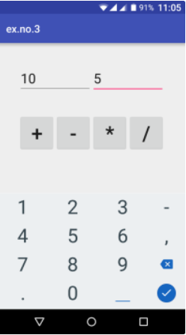
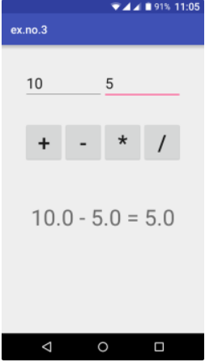
(7.5 marks)

- Design a simple UI with radio button, check box, list/combo box, text view for a student registration form using activity embedded with fragments in android. Write appropriate event handling mechanism. (7.5 marks)

DEPARTMENT OF COMPUTER SCIENCE AND ENGINEERING
CSY06 - MOBILE APPLICATION DEVELOPMENT III YEAR - V SEM-SECTION A/B/MCA
27/11/2023 INTERNAL ASSESSMENT – I Marks: 25
Answer ALL the questions
PART- A (5 *2 =10 Marks)
- Why bytecode cannot be run in Android?
- Enumerate Fragment life cycle methods.
- How do you handle configuration changes like screen rotations in an Android application?
- What are the different types of layouts available in Android, and when would you use each one?
- What is the importance of the AndroidManifest.xml file in an Android application?
PART –B
1. Design an android application for a simple calculator as shown below. Explain the procedure involved in designing the app with appropriate coding segments.
(7.5 marks)

- Design a simple UI with radio button, check box, list/combo box, text view for a student registration form using activity embedded with fragments in android. Write appropriate event handling mechanism. (7.5 marks)

