DOCPANEL QA

User Manual
  - A screenshot-guided manual testing workflow
From project setup to a downloadable execution report
Demonstration project | DEMOQA - Sample Storefront QA
Example test case | Guest checkout with valid payment
Plan and cycle | Checkout smoke coverage - 2026.10 / QA staging
Example report | Cycle-filtered CSV with one sample Passed attempt
IMPORTANT - DEMONSTRATION DATA
The example Passed result in the sample project is for demonstration only. Do not use it as evidence of a real test or as a release decision. Record the outcome of an actual test run in your own cycle.
Prepared 13 October 2026 | Application: Docpanel QA

Before you begin
Sign in to Docpanel QA and select your project from the selector in the left navigation. Available actions depend on your global role and project membership.

Roles and access
Role | Typical access
Admin | Create projects, manage users, and access project workflows.
QA Lead / Test Lead | Access projects and manage plans, cycles, and project workflows.
Project Admin / Lead | Manage project membership, plans, cycles, and assignments.
Project Tester | Create or edit cases and execute cases assigned to them.
Viewer | View project information without making changes.

Workflow at a glance
- Create a project and select it.
- Write a test case with preconditions and expected results.
- Add case IDs to a release test plan.
- Create a cycle for an environment and release.
- Add cases to the cycle, assign testers, and record outcomes.
- Review the dashboard and export a cycle-filtered CSV report.
A plan and a cycle are separate. Creating a cycle does not automatically add the plan cases; add each case explicitly from the Execution page.

1. Create and select a project
- Open Projects in the left navigation.
- Enter a unique project key and a descriptive name, then click Save project. Keys are 2-40 letters, numbers, underscores, or hyphens.
- The project creator is added automatically. Choose the new project in the selector at the top of the left navigation.
- To add teammates, use Project membership, select the user and role, then grant or update access.
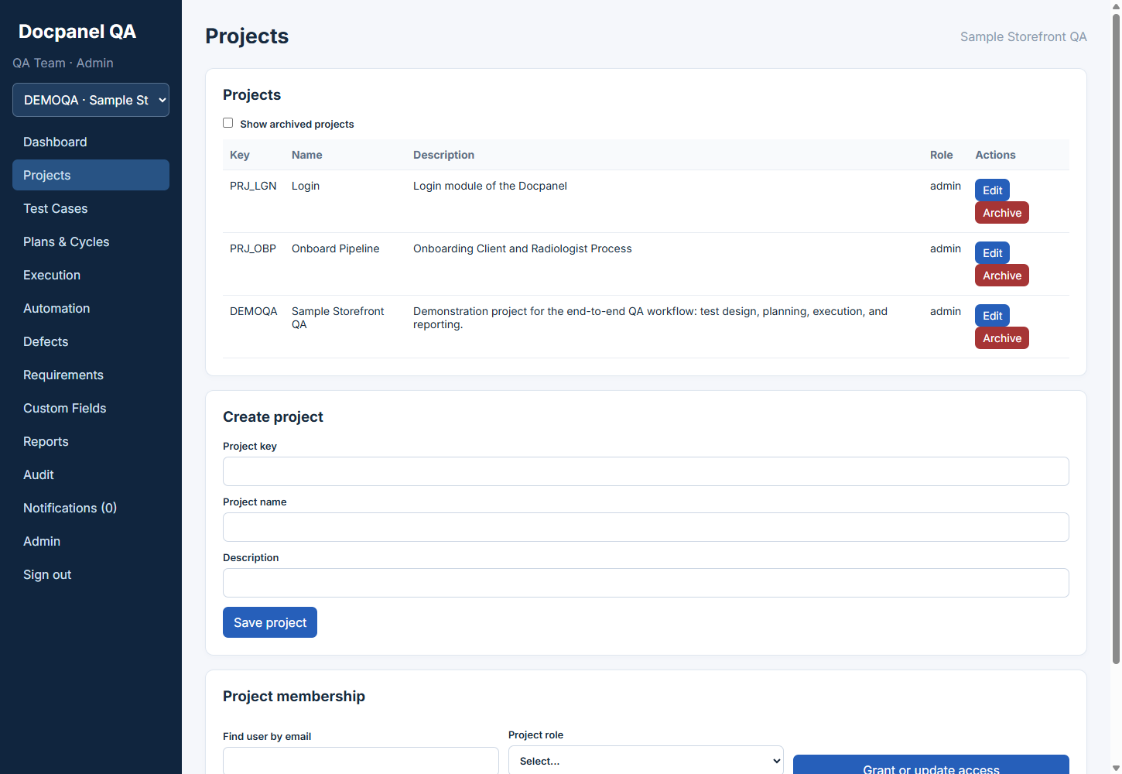
Projects page showing the sample project and project setup controls.

2. Write a test case
- Open Test Cases. Enter a specific title, then select priority, type (Manual, Automated, or Both), and status.
- Describe setup under Preconditions. Add reproducible actions and observable expected outcomes under Steps as JSON array; each step needs action and expected fields.
- Leave Custom field values as {} unless your project has custom fields. Click Create case.
- The repository displays a key such as TC-12. Use its numeric ID (12) when adding it to a plan.
- Editing a case creates a new version. Use History to review previous versions.
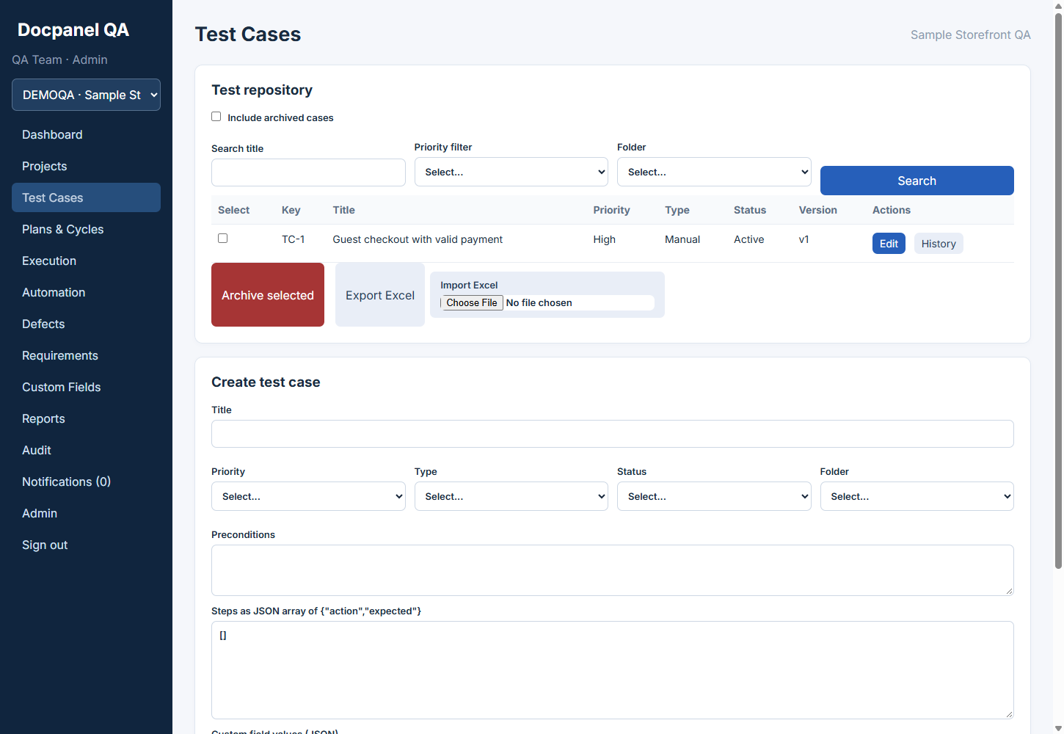
Test Cases page showing the repository and the new-case form.
[{"action":"Add an in-stock product to the cart.","expected":"The cart shows the product."}]

3. Create a test plan and cycle
- Open Plans & Cycles. Enter a plan name, release, scope, and case IDs separated by commas (for example: 12,13).
- Click Create plan with cases. Use View in the Plans table to confirm the included cases.
- Under Create cycle, select the plan, enter a cycle name and environment (for example, QA staging), then click Create cycle. Dates are optional.
- A created cycle does not automatically include its plan cases. Add them in Execution next.
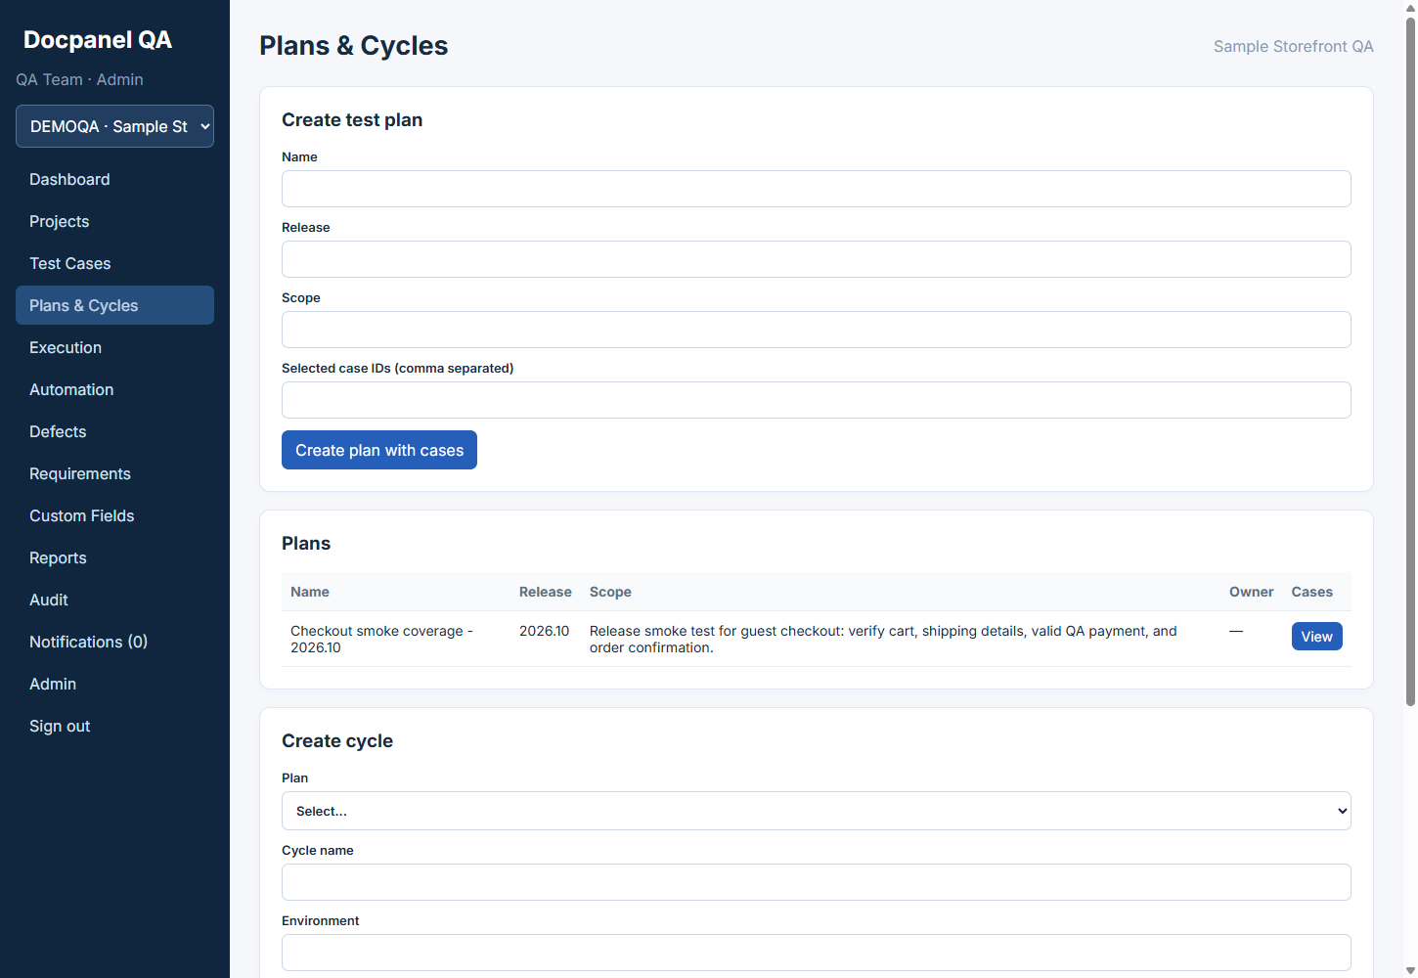
Plans & Cycles page showing the sample plan, release, and cycle setup.

4. Add cases and record execution
- Open Execution and select the cycle. Under Cycle setup, select a case and optionally assign it to a project member. Click Add to cycle for each case.
- Under Manual execution, review preconditions and steps. Select a result for each step and enter what actually happened.
- Enter an overall Actual result and Comments. PNG, JPEG, WEBP, TXT, or LOG evidence can be attached within the configured size limit.
- Submit Passed, Failed, Blocked, or Skipped. Each submission creates a separate attempt and preserves retest history.
Not Run is the initial cycle state, not an execution attempt. Testers can execute cases assigned to them; leads can assign cases in Cycle setup.

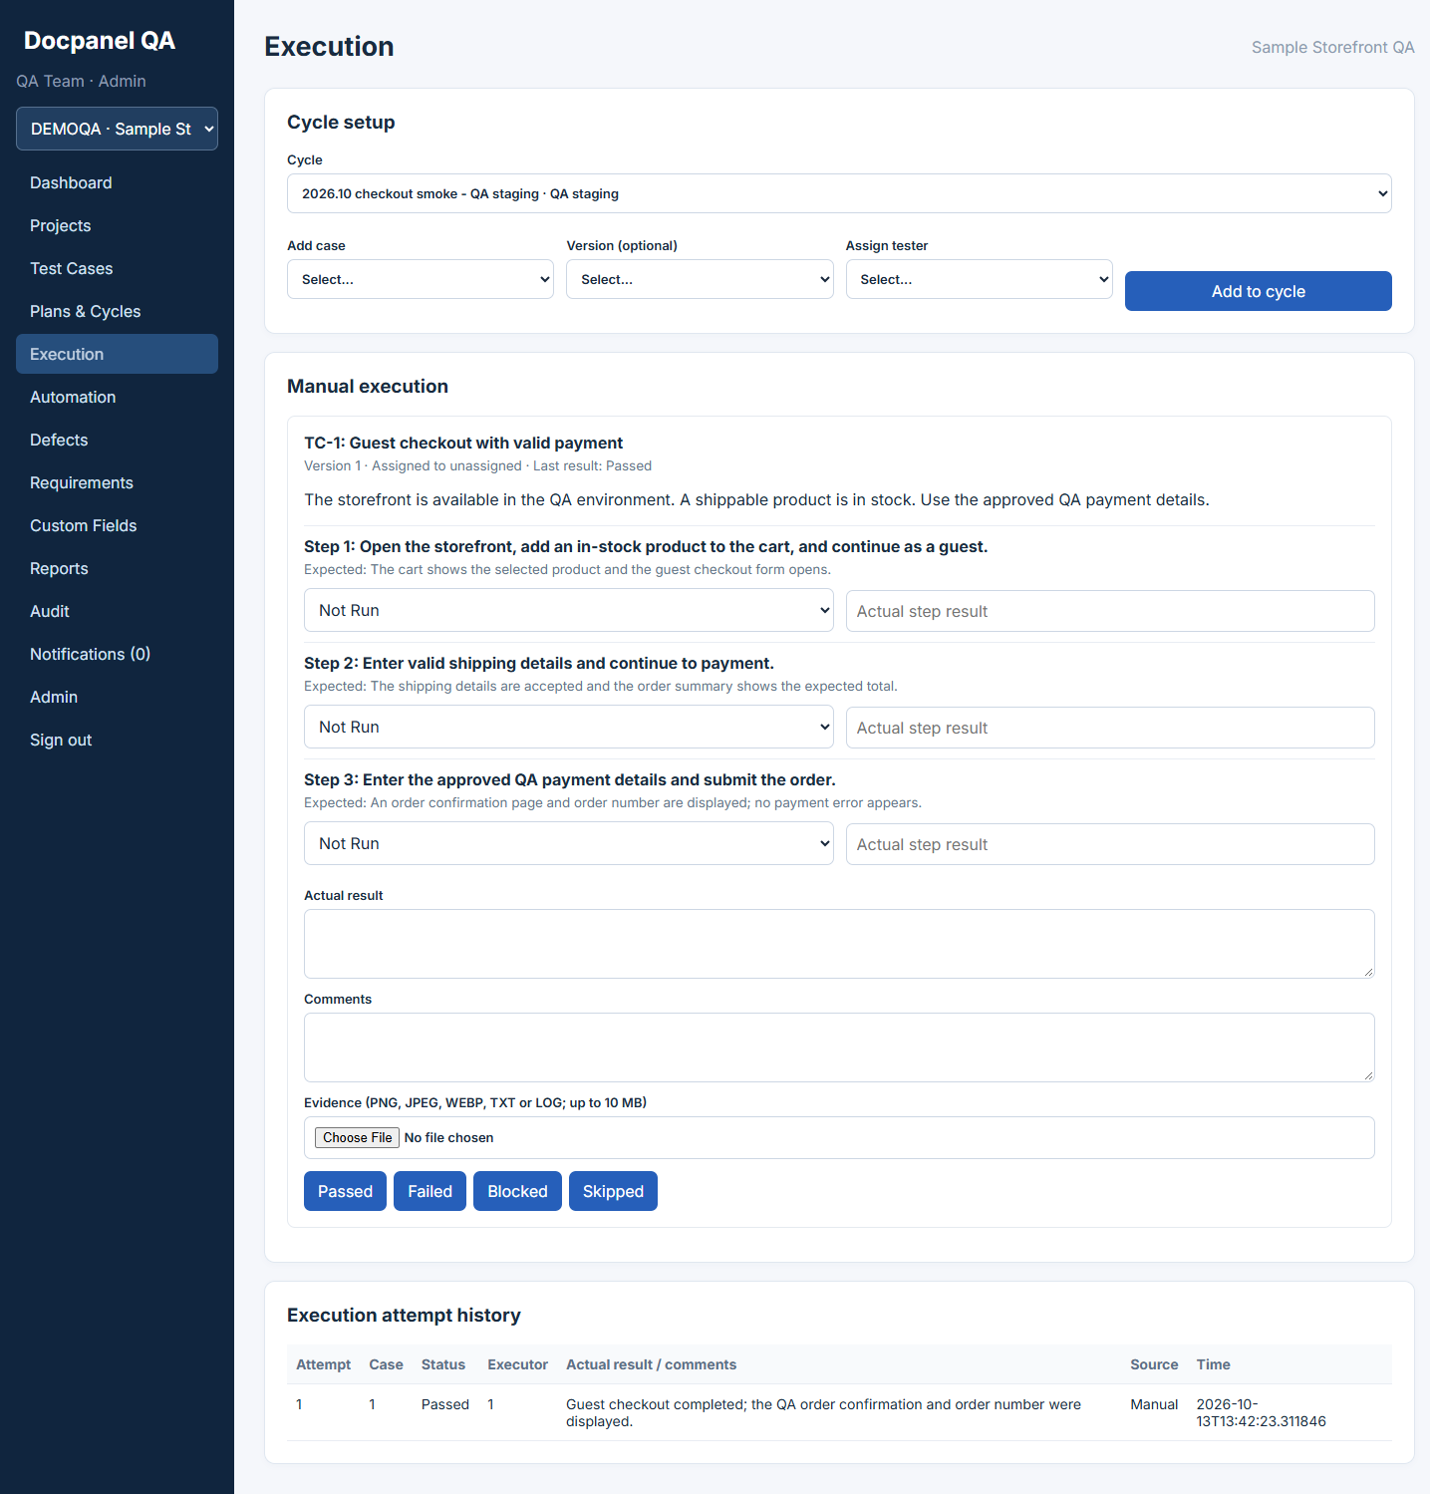
Execution page showing cycle setup, test steps, result controls, and attempt history.

5. Export an execution report
- Open Reports. Choose a cycle under Optional cycle filter for that cycle only, or choose All cycles for the project.
- Click Export execution report. The CSV includes execution ID, case ID, cycle ID, status, source, user ID, and timestamp.
- Only recorded execution attempts appear. Cases still in the Not Run state are not included.
- Use Export defect report for a project defect summary.
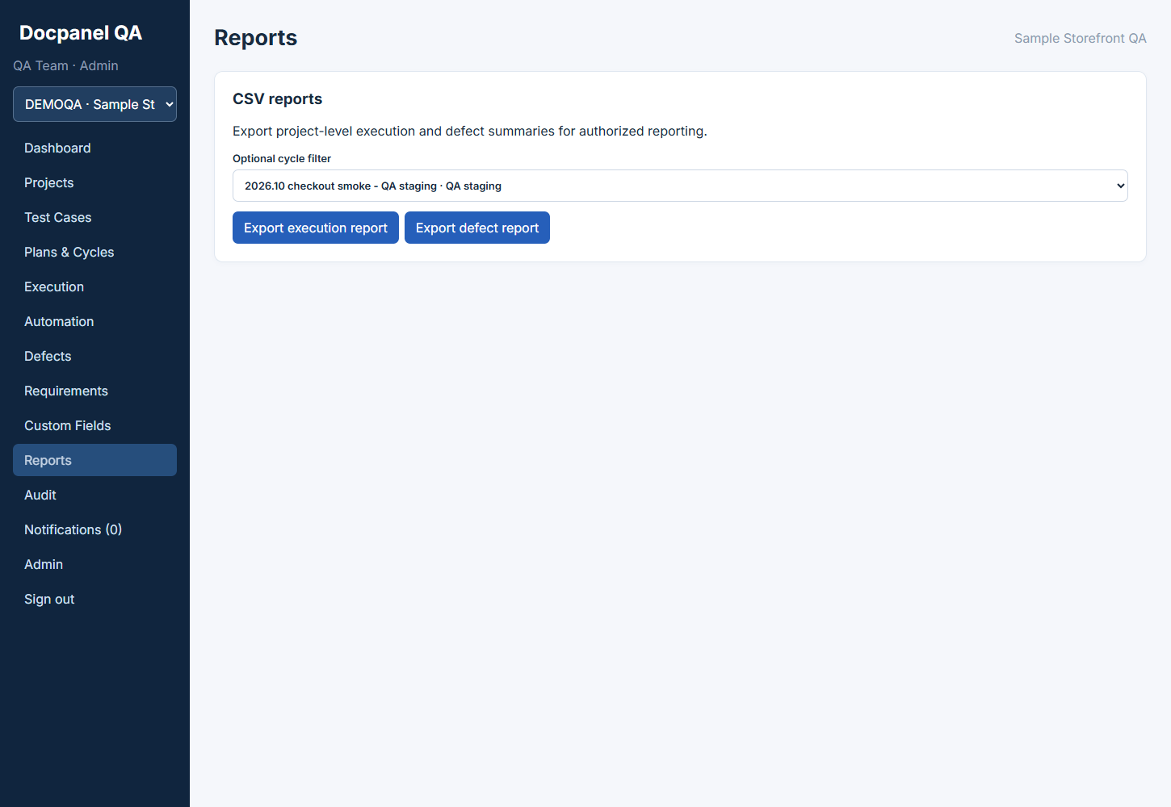
Reports page with the sample QA staging cycle selected and CSV export controls.

6. Review progress on the dashboard
- Open Dashboard to review case and attempt counts, open defects, cycle count, progress, result totals, and recent activity.
- Use Cycle filter or Release filter and click Apply filter to narrow the overview.
- Use a CSV export when you need a downloadable record; the dashboard is a live project summary.
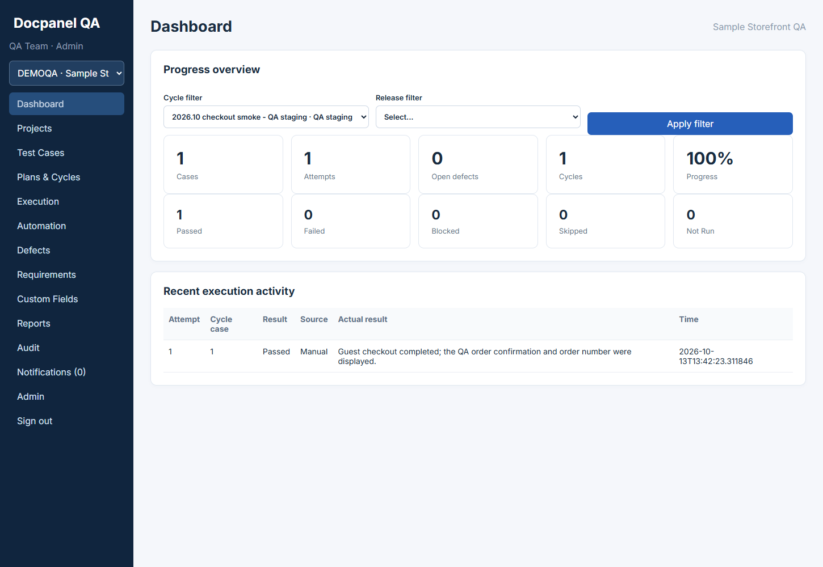
Dashboard showing sample project progress. The Passed result is demonstration data only.

Common questions

No project is selected or visible
Select a project from the left selector. If the project is missing, ask an administrator or lead to grant access.

A case is missing from the cycle
Add it from Execution > Cycle setup. Plan membership alone does not put a case in a cycle.

A tester cannot submit a result
Ask a project lead to assign that case to the tester in the cycle.

The step list is rejected
Check that the steps field is valid JSON and each step has action and expected fields.

An execution is absent from a CSV
Confirm an attempt was recorded and the report filter matches its cycle.

Sample report
The workspace also includes sample-test-execution-report.csv. It contains one example Passed execution for the DEMOQA checkout cycle. Treat this file and all sample results as illustrative only.

