**Devops Assignment : Stride.AI**

Task Objectives

- Setup Backend Application in Production Server using Docker Container.

- No Platform Lock-In. Deployment should be platform independent and it should run in any cloud vendor (AWS/GCP/Azure/On-Premise).

Your task is to setup the backend application in production server. The backend application is developed using Django Framework. For deploying Django as a production setup you need to use UWSGI/Gunicorn + NGINX

You need to containerize the whole backend application. MySQL Database is already running in the host machine. You don’t need to create separate MySQL container. But you need to make sure that the backend container can connect with the host MySQL database which runs by-default on port 3306.

This environment variable you need to set in your Docker-Compose file.

**\* DB_NAME**

**\* DB_USER**

**\* DB_PASSWORD**

**\* DB_HOST**

**\* DB_PORT**

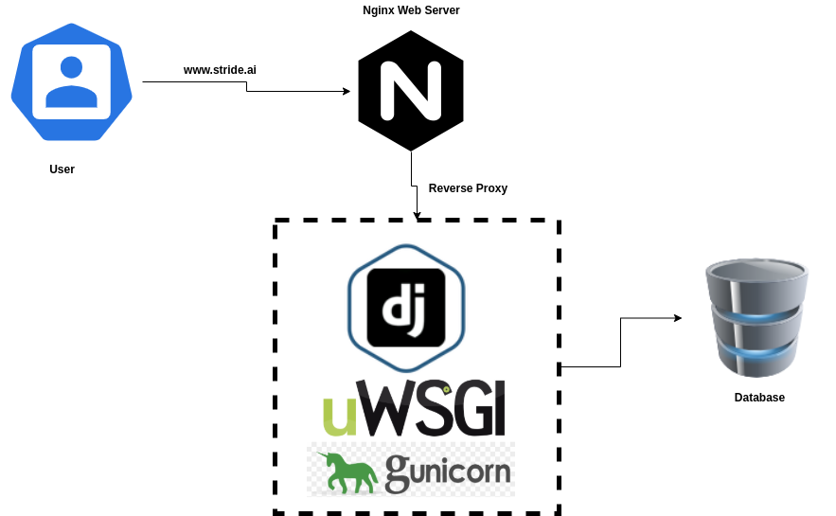

Bonus Point:

- Able to create different pipeline for (Dev, Stage, Prod, Test) using Docker-Compose

- Jenkinsfile containing complete automation pipeline (Code Checkout, Build, Test, Deploy).

For Reference:

<https://djangoforbeginners.com/introduction/>

<https://www.digitalocean.com/community/tutorials/how-to-install-the-django-web-framework-on-ubuntu-18-04>

<https://www.digitalocean.com/community/tutorials/how-to-create-a-django-app-and-connect-it-to-a-database>

<https://uwsgi-docs.readthedocs.io/en/latest/tutorials/Django_and_nginx.html>

<https://www.bogotobogo.com/python/Django/>

[Python_Django_tutorial_serving_Django_App_with_uWSGI_and_Nginx.php](https://www.bogotobogo.com/python/Django/Python_Django_tutorial_serving_Django_App_with_uWSGI_and_Nginx.php)

<https://www.devdungeon.com/content/how-deploy-django-nginx-and-uwsgi>

<https://www.digitalocean.com/community/tutorials/how-to-use-mysql-or-mariadb-with-your-django-application-on-ubuntu-14-04>