Guvi ZEN Class DB Model

Guvi Zen Class DB Model has been divided in to 4 Tables.

1. Course Table which has column attributes/fields as Course Id, Course Name/Title, a short description of Course and Instructor who will be taking the course. Each Row/Record will correspond to various Zen courses like Full Stack Development, Data Science, Machine Learning etc…
2. Student Table which has fields as Student Id, Name, Email address and Contact number. Rows corresponds to student details who are currently enrolled to one of the courses.
3. Task Table contains Task Id, Student Id, Task Description, Completion status and Due date. Row corresponds to tasks assigned to student and their completion status.
4. Enroll Table contains Course Id and Student Id as fields. Each record corresponds to students enrolled for particular course.

Below is the ER Diagram for the DB Model:

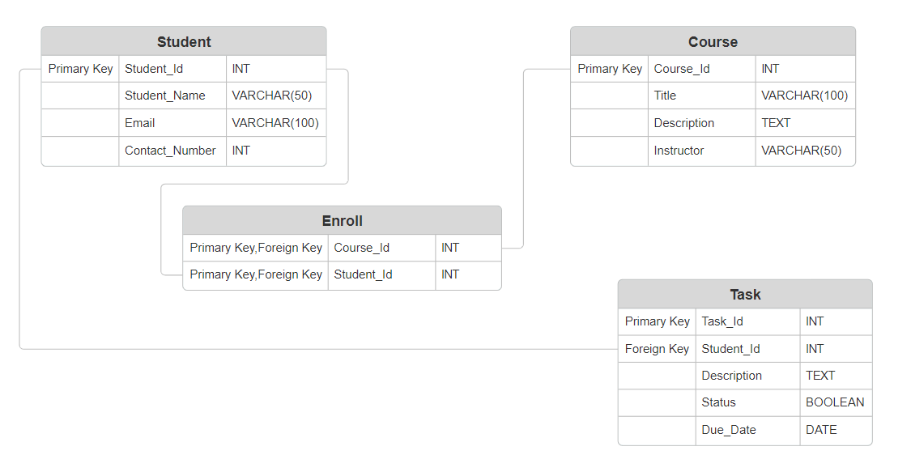

Respective Tables has been created in DB-Fiddle and their snapshots has been attached below:

Course Table Schema:

CREATE TABLE COURSE (

Course_Id INT AUTO_INCREMENT PRIMARY KEY,

Title VARCHAR(100),

Description TEXT,

Instructor VARCHAR(50)

) Engine=InnoDB;

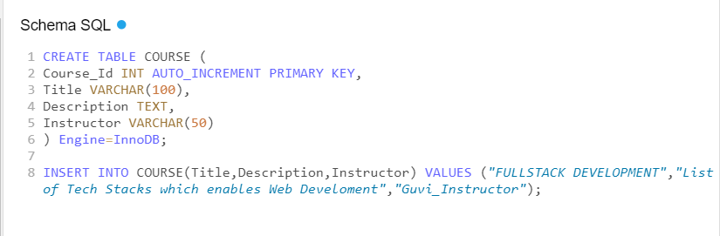

Student Table Schema:

CREATE TABLE STUDENT (

Student_Id INT AUTO_INCREMENT PRIMARY KEY,

Student_Name VARCHAR(50),

Email VARCHAR(100),

Contact_Number VARCHAR(15)

) Engine=InnoDB;

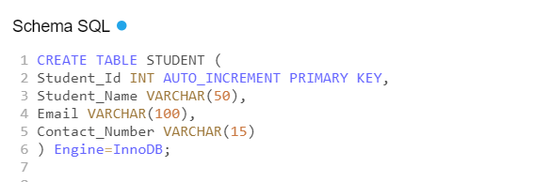

Task Table Schema:

CREATE TABLE TASK (

Task_Id INT AUTO_INCREMENT PRIMARY KEY,

Student_Id INT,

Description VARCHAR(50),

Completion_Status BOOLEAN DEFAULT False,

Due_Date DATE,

Foreign Key (Student_Id) REFERENCES STUDENT(Student_Id)

) Engine=InnoDB;

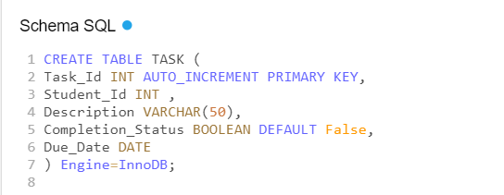

Enroll Table Schema:

CREATE TABLE ENROLL (

Student_Id INT,

Course _Id INT,

PRIMARY KEY (Student_Id, Course_Id),

Foreign Key (Student_Id) REFERENCES STUDENT(Student_Id),

Foreign Key (Course_Id) REFERENCES COURSE(Course_Id)

) Engine=InnoDB;

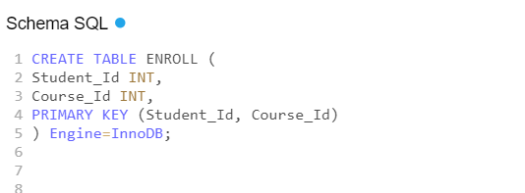

-------------END-----------