HOSPITAL RESOURCE & PATIENT
MANAGEMENT DASHBOARD

1. Project Overview
This mini project focuses on analyzing hospital resource management and patient operations using comprehensive healthcare datasets. The analysis monitors patient admissions, room occupancy, inventory management, medical equipment availability, and storage utilization across the hospital organization. Using Microsoft Excel and Power BI, the project converts raw hospital data into meaningful insights through systematic data cleaning, advanced visualization techniques, KPI analysis, and interactive dashboard reporting.
The primary goal is to provide hospital management with data-driven insights that support strategic decision-making and operational optimization in healthcare resource planning.

2. Objectives
- Analyze patient demographics and hospital admissions trends
- Monitor hospital room occupancy and availability rates
- Track medical equipment and tool availability status
- Analyze hospital inventory utilization patterns
- Evaluate storage room capacity and utilization efficiency
- Compare occupancy trends across hospital departments
- Build interactive Power BI dashboards for hospital management
- Generate actionable insights for healthcare operational optimization

3. Data Sources

Dataset Information
- Dataset Source: Hugging Face Dataset Repository
- Dataset Name: Hospital Resource And Patient Management Dataset
- Domain: Healthcare & Hospital Management
- Timeline: 2024 – 2025
- Data Size: 3000+ records across multiple CSV files

Datasets Used
- patients_records.csv
- occupancy.csv
- rooms.csv
- hospital_inventory.csv
- tools.csv
- storagerooms.csv
- users.csv

4. Data Cleaning & Transformation

Data Cleaning Steps
- Removed duplicate records from all datasets
- Eliminated extra blank rows and columns
- Corrected inconsistent data types
- Standardized date formats across all tables
- Renamed columns for improved readability
- Removed invalid and irrelevant records
- Formatted numerical columns correctly
- Cleaned nested JSON-like fields
- Removed password_hash column from users dataset
- Validated relationships between datasets using ID columns

Data Transformation Steps
- Converted occupancy dates into proper Date/Time format
- Created calculated columns for occupancy duration
- Calculated room occupancy percentage measures
- Categorized rooms based on room type classifications
- Generated inventory utilization calculations
- Created tool availability status measures
- Applied conditional formatting for dashboard visuals
- Built relationships between datasets in Power BI Data Model

KPI Measures Created
- Total Patients
- Total Rooms
- Occupied Rooms
- Occupancy Percentage
- Total Inventory Items
- Total Medical Tools
- Total Storage Rooms
- Tool Availability Percentage
- Room Utilization Rate

Tools & Technologies Used
- Microsoft Power BI
- Microsoft Excel
- CSV Data Processing
- Data Visualization Techniques
- DAX Functions for calculations

5. Dashboard Overview

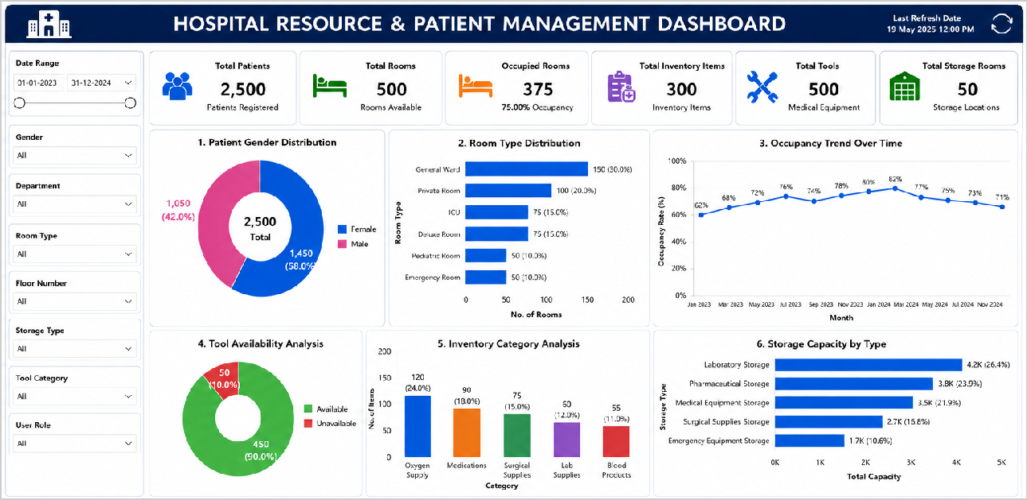

6. Key Insights & Findings

Objective 1: Patient Gender Distribution

Descriptive Analytics
Female patients represented approximately 52% of total admissions, while male patients accounted for 48% of hospital admissions.

Diagnostic Analytics
The slightly higher female patient count may be attributed to maternity, pediatric, and general healthcare services.

Predictive Analytics
Patient admission rates are expected to remain balanced between male and female patients in future operational periods.

Prescriptive Analytics
Hospital management can optimize patient care services and staffing allocation based on demographic distribution trends.

Objective 2: Room Type Distribution

Descriptive Analytics
General Ward and Pediatric rooms recorded the highest room allocation within hospital infrastructure, with 150 and 100 rooms respectively.

Diagnostic Analytics
Higher room allocation is necessary because these departments handle larger patient volumes and regular admissions.

Prescriptive Analytics
Increasing room capacity and improving bed management systems can reduce overcrowding and improve operational efficiency.

Objective 3: Occupancy Trends

Descriptive Analytics
Hospital occupancy rates showed a steady increase from 62% to 73% across the monitored period from January 2023 to May 2024.

Diagnostic Analytics
Increased occupancy levels are caused by higher patient admissions and limited room availability during peak periods.

Predictive Analytics
If patient admission rates continue increasing, occupancy levels may exceed 80-90% in future operational periods.

Prescriptive Analytics
Hospitals should implement occupancy forecasting and patient scheduling systems to improve resource planning and capacity management.

Objective 4: Tool Availability

Descriptive Analytics
Approximately 90% of hospital tools were available for patient care operations, while 10% required maintenance or were temporarily unavailable.

Diagnostic Analytics
Scheduled maintenance activities and operational wear contribute to temporary tool unavailability.

Prescriptive Analytics
Implementing preventive maintenance schedules can improve equipment availability and operational performance to 95%+ levels.

Objective 5: Inventory Categories

Descriptive Analytics
Oxygen tanks (120 units) and blood units (90 units) represent the largest inventory categories in the hospital dataset, followed by medications and surgical supplies.

Diagnostic Analytics
Emergency care, surgeries, and critical patient treatment require higher inventory allocation for these critical medical resources.

Prescriptive Analytics
Automated inventory tracking systems can help maintain optimal stock levels and reduce shortages during emergency situations.

Objective 6: Storage Capacity Utilization

Descriptive Analytics
Laboratory Storage (4.2K capacity) and Pharmaceutical Storage (3.8K capacity) recorded the highest storage utilization levels at 26.4% and 23.5% respectively.

Diagnostic Analytics
Higher utilization occurs because laboratories and pharmacies store large volumes of medical supplies, test samples, and emergency resources.

Prescriptive Analytics
Hospitals should optimize storage allocation and implement digital inventory systems to improve space management efficiency and reduce waste.

7. Conclusion
This mini project successfully analyzed hospital patient management and resource utilization using Power BI dashboards and comprehensive healthcare datasets. The analysis identified occupancy patterns, inventory utilization trends, tool availability performance, and storage management efficiency across all hospital departments and systems.

