NUMBER GUESSING GAME APPLICATION USING JAVA

1. Introduction
In modern software development, games are commonly used to demonstrate programming logic and user interaction. A Number Guessing Game is a simple application where the computer generates a random number, and the user attempts to guess it within a certain range.
This project demonstrates the implementation of a Number Guessing Game using the Java programming language. The game provides hints to the user whether the guessed number is too high or too low until the correct number is found.
The application is developed using basic Java concepts such as loops, conditional statements, random number generation, and user input handling.

2. Objective
The main objective of this project is to develop a simple interactive game that allows users to guess a randomly generated number.
The specific objectives are:
- To understand the use of Java programming concepts.
- To implement random number generation in Java.
- To create an interactive command-line game.
- To improve logical thinking and problem-solving skills.
- To demonstrate user input handling and control structures.

3. Scope of the Project
The Number Guessing Game can be used as a basic learning tool for understanding programming concepts. It demonstrates how programs can interact with users and provide feedback.
The project scope includes:
- Generating random numbers.
- Taking input from the user.
- Providing hints for incorrect guesses.
- Counting the number of attempts.
- Allowing users to play the game again.
Future improvements may include graphical user interface (GUI), scoring systems, and multiplayer functionality.

4. Software Requirements

Hardware Requirements
- Processor: Intel i3 or above
- RAM: 4 GB minimum
- Storage: 500 MB free space
- Keyboard and Monitor

Software Requirements
- Operating System: Windows 10 / Windows 11
- Programming Language: Java
- Java Development Kit (JDK)
- Code Editor: Visual Studio Code

5. System Design

Game Flow
The system follows a simple flow:
- The program starts.
- The user selects a difficulty level.
- The computer generates a random number.
- The user enters guesses.
- The program checks if the guess is correct.
- The program provides hints if incorrect.
- The game ends when the correct number is guessed.
- The user can choose to play again.

Difficulty Levels
Level | Range
Easy | 1 – 50
Medium | 1 – 100
Hard | 1 – 500

6. Algorithm
Step 1: Start the program
Step 2: Display difficulty level options
Step 3: Read user choice
Step 4: Generate random number within selected range
Step 5: Ask the user to guess the number
Step 6: Compare guess with generated number
Step 7: Display hint (Too High / Too Low)
Step 8: Repeat until correct guess
Step 9: Display number of attempts
Step 10: Ask user to play again
Step 11: Stop program if user selects "no"

7. Source Code
import java.util.Random;
import java.util.Scanner;
public class NumberGuessGame {
public static void main(String[] args) {
Scanner scanner = new Scanner(System.in);
Random random = new Random();
String playAgain = "yes";
while(playAgain.equalsIgnoreCase("yes")) {
int maxNumber = 100;
System.out.println("Select Difficulty Level:");
System.out.println("1. Easy (1-50)");
System.out.println("2. Medium (1-100)");
System.out.println("3. Hard (1-500)");
int choice = scanner.nextInt();
if(choice == 1)
maxNumber = 50;
else if(choice == 2)
maxNumber = 100;
else if(choice == 3)
maxNumber = 500;
int number = random.nextInt(maxNumber) + 1;
int guess = 0;
int attempts = 0;
System.out.println("Guess a number between 1 and " + maxNumber);
while(guess != number) {
System.out.print("Enter your guess: ");
guess = scanner.nextInt();
attempts++;
if(guess < number)
System.out.println("Too low!");
else if(guess > number)
System.out.println("Too high!");
else {
System.out.println("Correct! You win!");
System.out.println("Attempts used: " + attempts);
}
}
System.out.println("Do you want to play again? (yes/no)");
playAgain = scanner.next();
}
System.out.println("Thanks for playing!");
}
}

8. Output Screenshots
Insert your screenshots here.
Example:
Figure 1 – Program Execution
Figure 2 – Difficulty Selection
Figure 3 – Guess Input
Figure 4 – Correct Result Display
(Add the screenshots you showed earlier)

9. Advantages
- Easy to understand and implement.
- Demonstrates basic programming concepts.
- Interactive and user-friendly.
- Improves logical thinking.

10. Limitations
- Runs only in the command line.
- Single-player game.
- Limited graphics.

11. Future Enhancements
Future improvements may include:
- Graphical User Interface using Java Swing.
- Score tracking system.
- Multiplayer mode.
- Mobile application version.

- 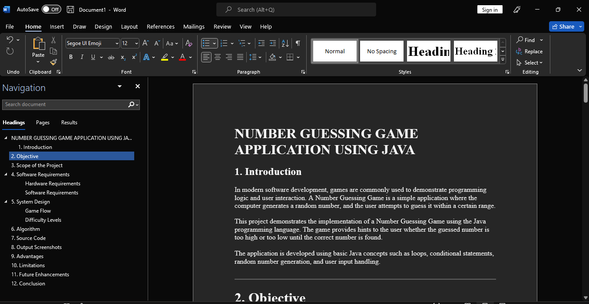
- 12. Conclusion
- The Number Guessing Game project demonstrates the use of Java programming concepts such as loops, conditionals, and random number generation.
The project successfully allows users to guess a randomly generated number and provides feedback until the correct number is found.
This project helps beginners understand how interactive programs are developed and how logic is implemented in real-world applications.
- This project helps beginners understand how interactive programs are developed and how logic is implemented in real-world applications.

