SATHIYA PRIYA S (1JT18IS051)

**Program-4:**

**Develop and demonstrate a HTML5 file that includes JavaScript script that uses functions for the following problems:**

**a. Parameter: A string | Output: The numbers of vowels in the string**

**b. Parameter: A number | Output: The number with its digits in the reverse order and Product of both number and its Reverse**

**Code:**

<!DOCTYPE html>

<html>

<head>

<title>Challenge-4</title>

</head>

<body>

<script>

var str = prompt("Enter the Input", "");

if (!(isNaN(str)))

{

var num, rev = 0, remainder;

num = parseInt(str);

while (num != 0)

{

remainder = num % 10;

num = parseInt(num / 10);

rev = rev * 10 + remainder;

}

const product = str * rev;

alert("Reverse of " + str + " is " + rev + " and the product is " + product);

}

else

{

str = str.toUpperCase();

function vowels(string) {

SATHIYA PRIYA S (1JT18IS051)

var vowels = 'AEIOUaeiou';

var count = 0;

for (i = 0; i < string.length; i++)

{

if (vowels.indexOf(string[i]) !== -1) {

count += 1;

}

}

return count;

}

n = vowels(str)

alert("The given string " + str + " has " + n + " Vowels in it")

}

</script>

</body>

</html>

**Output:**

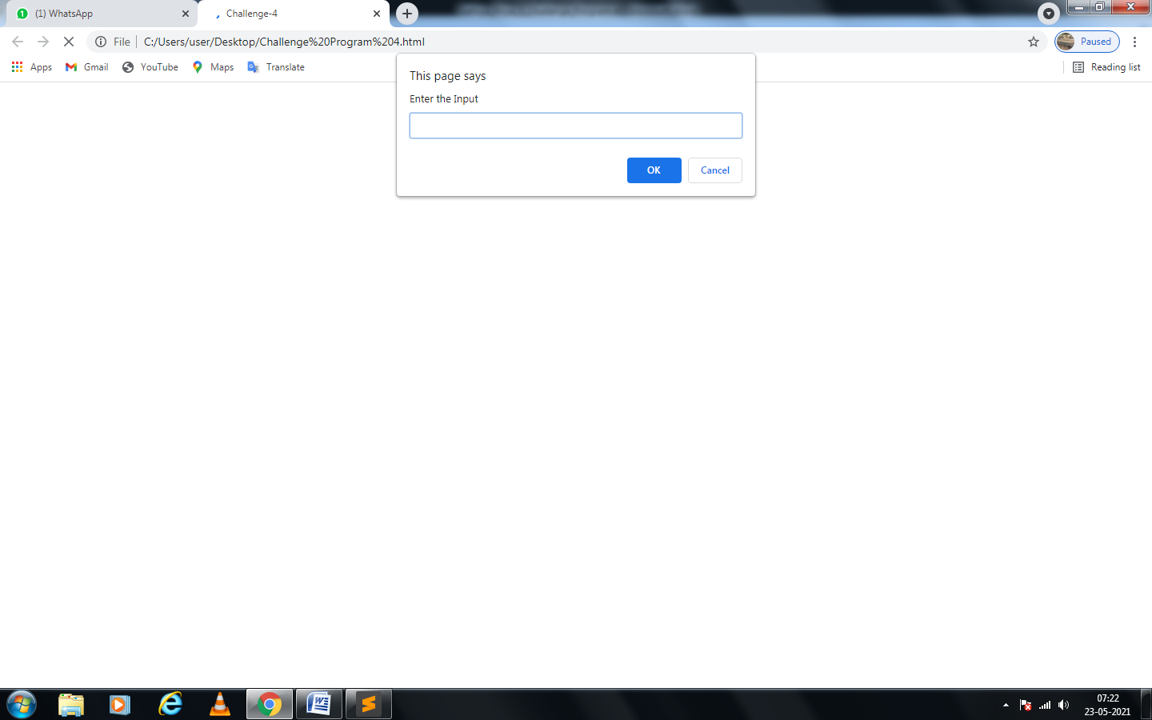

SATHIYA PRIYA S (1JT18IS051)

1. **TEST CASES:**

|  |  |  |  |
| --- | --- | --- | --- |
| **Test no** | **Test Case** | **Expected output** | **Actual Output** |
| **1** | a. Integer Value: 6532  b. Text Value:  how are you | a. Reverse of 6532 is 2356 and the product is 15389392  b. The given string how are you has 5 Vowles in it | a. Reverse of 6532 is 2356 and the product is 15389392  b. The given string how are you has 5 Vowles in it |
| **2** | a. Negative Integer value: -15  b. Text Value: -fox | a. Reverse of -15 is -51 and the product is 765  b. The given string -fox has 1 Vowles in it | a. Reverse of -15 is -51 and the product is 765  b. The given string -fox has 1 Vowles in it |
| **3** | Alpha numerical value: 1jt18is051 | The given string 1jt18is051 has 1 Vowles in it | The given string 1jt18is051 has 1 Vowles in it |
| **4** | Non vowel string: ssps | The given string ssps has 0 Vowles in it | The given string ssps has 0 Vowles in it |

SATHIYA PRIYA S (1JT18IS051)

**Case: 1a**

Given input is 6532

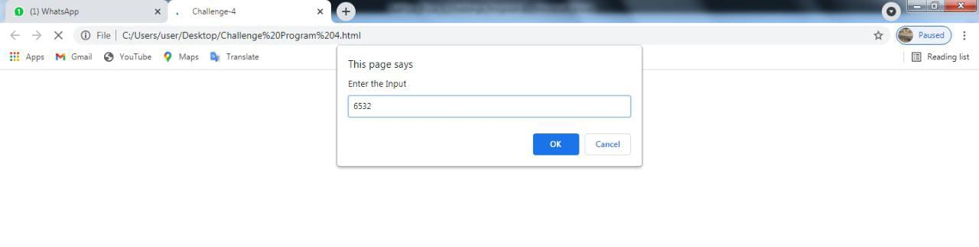

Output is:

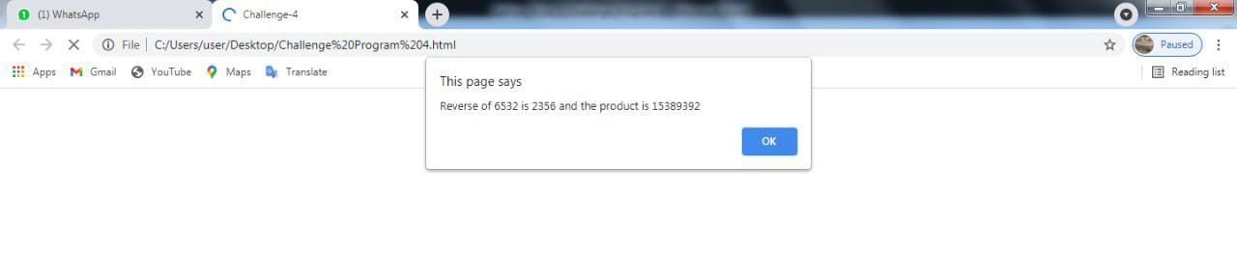

**Case: 1b**

Given input is “how are you”

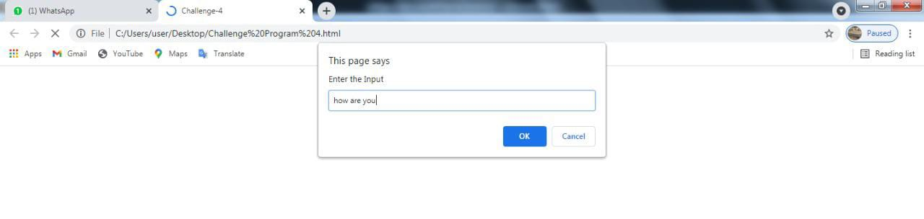

Output is:

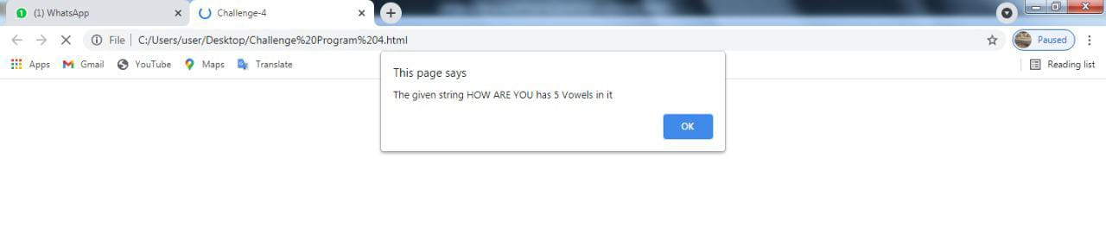

SATHIYA PRIYA S (1JT18IS051)

**Case: 2a**

Given input is -15

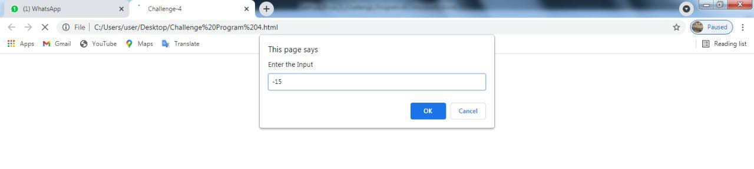

Output is:

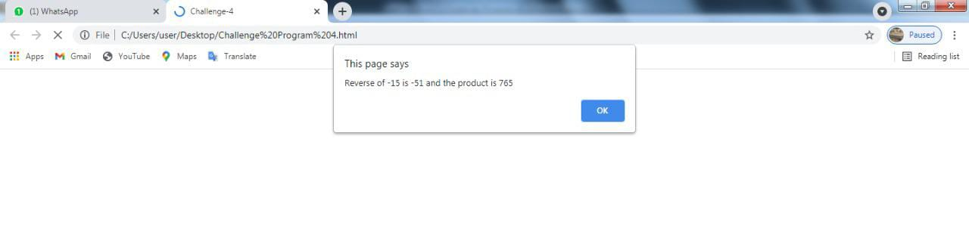

**Case: 2b**

Given input is –fox

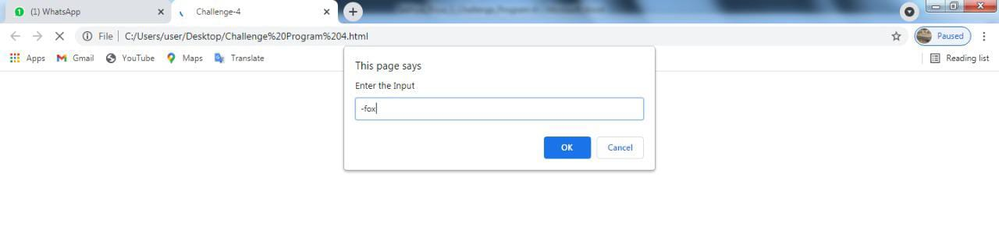

Output is:

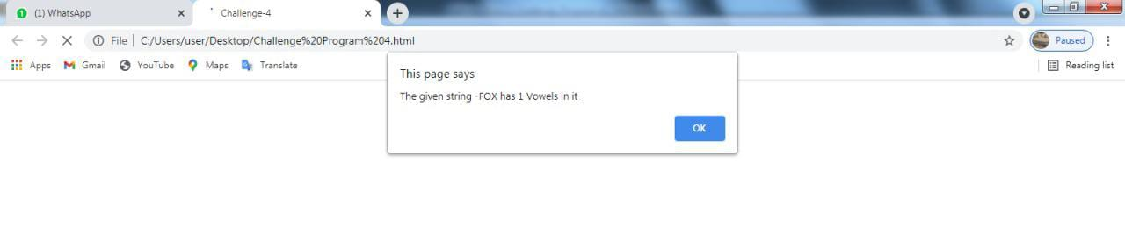

SATHIYA PRIYA S (1JT18IS051)

**Case: 3**

Given input is 1jt18is051

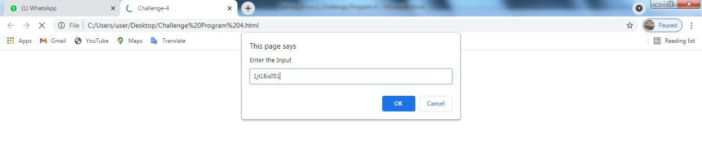

Output is:

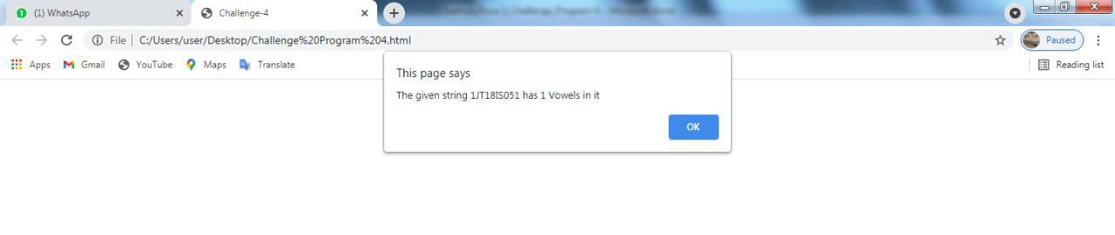

**Case: 4**

Given input is ssps

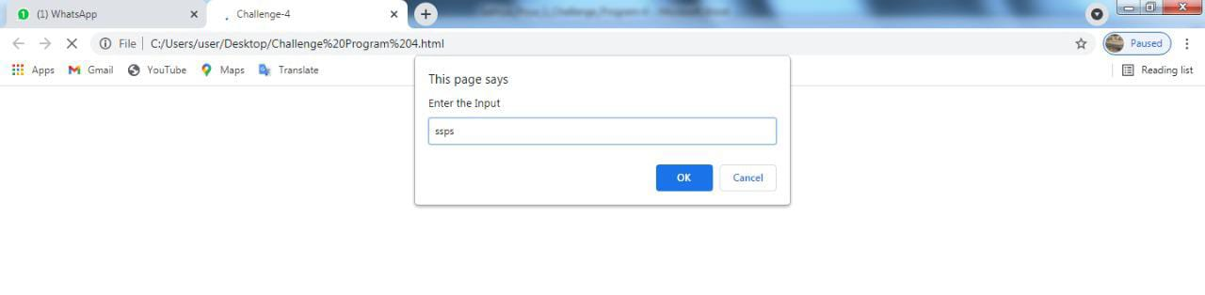

Output is:

