Program-2: Write a JavaScript that calculation the squares and cubes of the numbers from 0 to 10 and outputs HTML . Text that that displays the resulting values in an html table format.

SATHIYA PRIYA S (1JT18IS051)

<!DOCTYPE html>

<html>

<head>

<style>

table{

border: 3px solid;

background-color:lightgreen;

margin: auto;

}

.blink{

margin:3px;

background-color:white;

padding: 5px;

text-align: center;

line-height:50px;

}

span{

font-size: 25px;

color: black;

animation: blink 0.5s linear infinite;

}

@keyframes blink{

0%{opacity: 0;}

70%{opacity: .5;}

100%{opacity: 1;}

}

SATHIYA PRIYA S (1JT18IS051)

</style>

<title>Squares and Cubes</title>

</head>

<body>

<table border="2" align="center">

<cursive>

<tr>

<td colspan="3"><center>Squares and Cubes</center></td>

</tr>

<tr>

<td>NUMBER</td>

<td>SQUARE</td>

<td>CUBES</td>

</tr>

<script type="text/javascript">

for(var i=100;i<=1000; i=i+100)

{

document.write("<tr align='center'><td>" + i + "</td><td>" + i*i +"</td><td>" + i*i*i + "</td></tr>")

}

</script>

</table>

</cursive>

<center><h1= class="blink"><span>Completed Challenge Assignment-2 </span></h1></center>

</body>

</html>

Output:

SATHIYA PRIYA S (1JT18IS051)

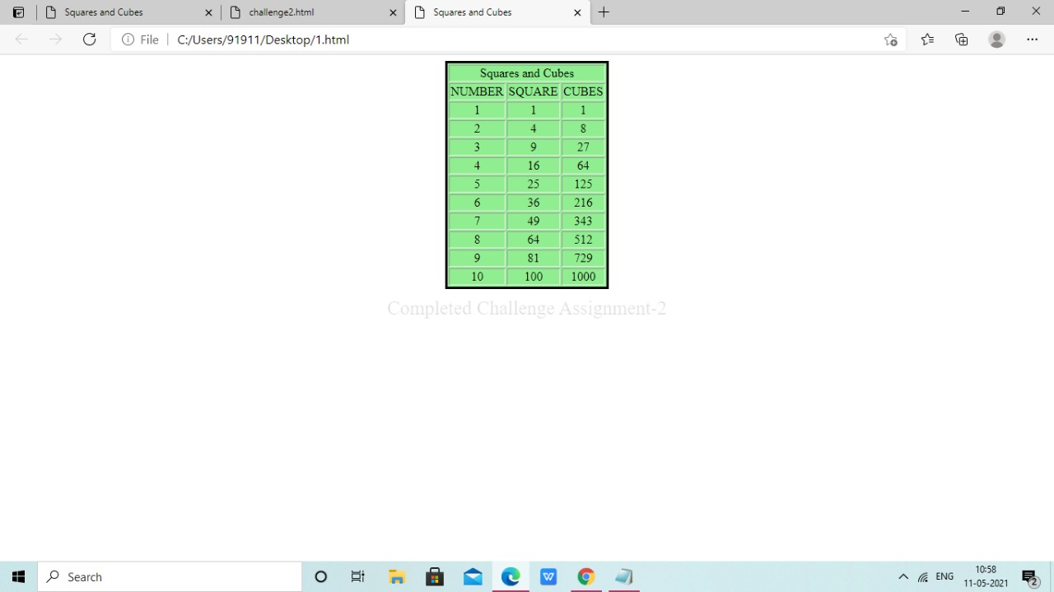

**OUTPUT TABLE**

SATHIYA PRIYA S (1JT18IS051)

|  |  |  |
| --- | --- | --- |
| Test no | Input Parameters | OUTPUT IMAGES |
| 1. | i=0 to 10,  increment of i+1 | C:\Users\user\Downloads\WhatsApp Image 2021-05-11 at 10.58.40 AM.jpeg |
| 2. | i=10 to 100,  increment of i+10 | C:\Users\user\Downloads\WhatsApp Image 2021-05-11 at 10.58.19 AM.jpeg |
| 3. | i=100 to 1000,  increment of i+100 | C:\Users\user\Downloads\WhatsApp Image 2021-05-11 at 10.57.55 AM.jpeg |

SATHIYA PRIYA S (1JT18IS051)