

ANALYSING PATTERNS IN LOAN DATA USING LOGISTIC REGRESSION

A PROJECT REPORT

Submitted by

SATHIYASEELAN A(2303811724321099)

in partial fulfillment of requirements for the award of the course
AGI1252 - FUNDAMENTALS OF DATA SCIENCE USING R

in

ARTIFICIAL INTELLIGENCE AND DATA SCIENCE

K. RAMAKRISHNAN COLLEGE OF TECHNOLOGY
(An Autonomous Institution, affiliated to Anna University Chennai and Approved by AICTE, New Delhi)

SAMAYAPURAM – 621 112

JUNE- 2025

K. RAMAKRISHNAN COLLEGE OF TECHNOLOGY (AUTONOMOUS)
SAMAYAPURAM – 621 112

BONAFIDE CERTIFICATE

Certified that this project report on “ANALYSING PATTERN LOAN DATA USING LOGISTIC REGRESSION” is the bonafide work of SATHIYASEELAN A(2303811724321099) who carried out the project work during the academic year 2024 - 2025 under my supervision.




SIGNATURE  Dr.T. AVUDAIAPPAN, M.E.,Ph.D., HEAD OF THE DEPARTMENT PROFESSOR  Department of Artificial Intelligence  K.Ramakrishnan College of Technology (Autonomous)  Samayapuram–621112. | SIGNATURE  Ms.S.Murugavalli., M.E.,(Ph.D).,  SUPERVISOR  ASSISTANT PROFESSOR  Department of Artificial Intelligence  K.Ramakrishnan College of Technology (Autonomous)  Samayapuram–621112.

Submitted for the viva-voce examination held on ….02.06.2025……

INTERNAL EXAMINER | EXTERNAL EXAMINER

DECLARATION

I declare that the project report on “ANALYSING PATTERN LOAN DATA USING LOGISTIC REGRESSION” is the result of original work done by me and best of my knowledge, similar work has not been submitted to “ANNA UNIVERSITY CHENNAI” for the requirement of Degree of BACHELOR OF TECHNOLOGY. This project report is submitted on the partial fulfilment of the requirement of the completion of the course AGI1252 - FUNDAMENTALS OF DATA SCIENCE USING R

.



Signature

SATHIYASEELAN A

Place: Samayapuram Date:02.06.2025

ACKNOWLEDGEMENT

It is with great pride that I express our gratitude and in-debt to our institution “K.Ramakrishnan College of Technology (Autonomous)”, for providing us with the opportunity to do this project.

I glad to credit honourable chairman Dr. K. RAMAKRISHNAN, B.E., for having provided for the facilities during the course of our study in college.

I would like to express our sincere thanks to our beloved Executive Director Dr. S. KUPPUSAMY, MBA, Ph.D., for forwarding to our project and offering adequate duration in completing our project.

I would like to thank Dr. N. VASUDEVAN, M.Tech., Ph.D., Principal, who
gave opportunity to frame the project the full satisfaction.

I whole heartily thanks to Dr. T. AVUDAIAPPAN, M.E.,Ph.D., Head of the department, ARTIFICIAL INTELLIGENCE for providing his encourage pursuing this project.

I express our deep expression and sincere gratitude to our project supervisor Ms.S.Murugavalli., M.E.,(Ph.D)., Department of ARTIFICIAL INTELLIGENCE, for her incalculable suggestions, creativity, assistance and patience which motivated us to carry out this project.

I render our sincere thanks to Course Coordinator and other staff members for
providing valuable information during the course.

I wish to express our special thanks to the officials and Lab Technicians of our departments who rendered their help during the period of the work progress.

INSTITUTE
Vision:
- To serve the society by offering top-notch technical education on par with global standards.
Mission:
- Be a center of excellence for technical education in emerging technologies by
exceeding the needs of industry and society.
- Be an institute with world class research facilities.
- Be an institute nurturing talent and enhancing competency of students to transform them as all – round personalities respecting moral and ethical values.
DEPARTMENT
Vision:
- To excel in education, innovation, and research in Artificial Intelligence and
Data Science to fulfil industrial demands and societal expectations.
Mission
- To educate future engineers with solid fundamentals, continually improving
teaching methods using modern tools.
- To collaborate with industry and offer top-notch facilities in a conducive learning environment.
- To foster skilled engineers and ethical innovation in AI and Data Science for global recognition and impactful research.
- To tackle the societal challenge of producing capable professionals by instilling employability skills and human values.
PROGRAM EDUCATIONAL OBJECTIVES (PEO)
- PEO1: Compete on a global scale for a professional career in Artificial Intelligence and Data Science.
- PEO2: Provide industry-specific solutions for the society with effective communication and ethics.
- PEO3 Enhance their professional skills through research and lifelong learning initiatives.

PROGRAM SPECIFIC OUTCOMES (PSOs)
- PSO1: Capable of finding the important factors in large datasets, simplify the data, and improve predictive model accuracy.
- PSO2: Capable of analyzing and providing a solution to a given real-world problem by designing an effective program.
PROGRAM OUTCOMES (POs)
Engineering students will be able to:
- Engineering knowledge: Apply knowledge of mathematics, natural science, computing, engineering fundamentals, and an engineering specialization to develop solutions to complex engineering problems.
- Problem analysis: Identify, formulate, review research literature and analyze complex engineering problems reaching substantiated conclusions with consideration for sustainable development.
- Design/development of solutions: Design creative solutions for complex engineering problems and design/develop systems/components/processes to meet identified needs with consideration for the public health and safety, whole-life cost, net zero carbon, culture, society and environment as required.
- Conduct investigations of complex problems: Conduct investigations of complex engineering problems using research-based knowledge including design of experiments, modelling, analysis & interpretation of data to provide valid conclusions.
- Engineering Tool Usage: Create, select and apply appropriate techniques, resources and modern engineering & IT tools, including prediction and modelling recognizing their limitations to solve complex engineering problems.
- The Engineer and The World: Analyze and evaluate societal and environmental aspects while solving complex engineering problems for its impact on sustainability with reference to economy, health, safety, legal framework, culture and environment.

- Ethics: Apply ethical principles and commit to professional ethics, human values, diversity and inclusion; adhere to national & international laws.
- Individual and Collaborative Team work: Function effectively as an individual, and as a member or leader in diverse/multi-disciplinary teams.
- Communication: Communicate effectively and inclusively within the engineering community and society at large, such as being able to comprehend and write effective reports and design documentation, make effective presentations considering cultural, language, and learning differences.
- Project management and finance: Apply knowledge and understanding of engineering management principles and economic decision-making and apply these to one's own work, as a member and leader in a team, and to manage projects and in multidisciplinary environments.
- Life-long learning: Recognize the need for, and have the preparation and ability for i) independent and life-long learning ii) adaptability to new and emerging technologies and iii) critical thinking in the broadest context of technological change.

ABSTRACT

This project presents an interactive Shiny application for predicting loan approval status using logistic regression, a widely used statistical method for binary mclassification problems. The application enables users to upload their own loan datasets in CSV format, select input features, and train a logistic regression model dynamically. The model is built using essential applicant data such as income, employment status, loan amount, and credit history, with key preprocessing steps including handling of missing values and feature engineering (e.g., calculating total income, EMI, and balance income). The app provides a user-friendly interface with multiple output tabs: a data preview, model summary, confusion matrix for performance evaluation, ROC curve for visualizing classification performance, and a feature importance plot based on model coefficients. The model’s accuracy and interpretability make it suitable for financial institutions aiming to automate and improve the decision-making process for loan approvals.

ABSTRACT WITH POs AND PSOs MAPPING
CO 5 : BUILD DATA SCIENCE USING R PROGRAMMING FOR SOLVING REAL-TIME PROBLEMS.
ABSTRACT | POs MAPPED | PSOs  MAPPED
This project focuses on analyzing patterns in loan approval data using logistic regression, implemented through R programming and the Shiny framework. The application allows users to upload datasets, preprocess missing or inconsistent values, select predictive features, and build a binary classification model to determine loan approval status. Key performance evaluation tools such as confusion matrices, ROC curves, and feature importance plots are integrated to provide insight into model reliability and interpretability. This hands-on solution addresses real-time problems in the finance sector by enabling data-driven decision-making and can be extended to various predictive modeling scenarios. The use of R's statistical modeling capabilities fosters a practical understanding of data science pipelines, including preprocessing, modeling, validation, and visualization. | PO1 -3  PO2 -3  PO4 -2  PO5 -3  PO9 -2  PO10 -3 | PSO1 -3  PSO2 -3
Note: 1- Low, 2-Medium, 3- High

TABLE OF CONTENTS

CHAPTER  NO. | TITLE | PAGE  NO.
 | ABSTRACT | 8
1 | INTRODUCTION
 | 1.1 Objective | 11
 | 1.2 Overview | 11
 | 1.3 Data Science related concepts | 12
2 | PROJECT METHODOLOGY
 | 2.1 Proposed Work | 13
 | 2.2 Block Diagram | 14
3 | MODULE DESCRIPTION
 | .3.1 Data Import Module | 15
 | 3.2 Processing Module | 16
 | 3.3 Model Training Module | 17
 | 3.4 Confusion Matrix Module | 18
 | 3.5 ROC Curve Module | 19
 | 3.6 Feature Importance Plots Module | 20
4 | CONCLUSION & FUTURE SCOPE | 21
5 | APPENDIX A SOURCE CODE | 22
 | APPENDIX B SCREENSHOTS | 26
 | REFERENCES | 30

CHAPTER 1
INTRODUCTION

1.1 Objective
The objective of this project is to develop an interactive web-based application using R and Shiny to predict loan approval status through logistic regression. The system enables users to upload loan datasets, select input features, and train a predictive model that classifies loan applications as approved or not approved. It also provides tools for data preprocessing, model evaluation, and visualization, making it easier for users to understand the factors influencing loan decisions and assess model performance without requiring programming expertise.
1.2 Overview
This project presents a Shiny-based web application designed to predict loan approval using logistic regression. Users can upload a CSV dataset, select relevant features, and train a binary classification model to predict whether a loan will be approved. The app performs automatic data preprocessing (handling missing values and feature engineering), trains the model using R's glm() function, and evaluates it using tools like the confusion matrix and ROC curve. It also visualizes key insights such as feature importance, helping users understand which factors most affect loan decisions—all through a clean, interactive interface.

1.3 Data Science related concepts
In this data science project, logistic regression is used to analyze patterns in loan approval decisions by identifying key predictors such as income, credit score, loan amount, and employment history. The model (glm()) estimates the probability of loan approval based on these features, helping uncover trends— for example, higher-income applicants with low debt-to-income ratios are more likely to be approved. Model performance is evaluated using metrics like accuracy (via caret::confusionMatrix()) and AUC-ROC curves (pROC::roc()), ensuring reliability in distinguishing between approved and rejected applications.

The insights derived from this analysis can optimize lending strategies by highlighting risk factors (e.g., high EMI burdens) and improving decision- making. Visualizations (ggplot2) of coefficients reveal feature importance, while interactive Shiny dashboards allow stakeholders to explore scenarios in real time. This approach not only enhances transparency in loan approvals but also demonstrates how predictive modeling can streamline financial processes while minimizing defaults.

CHAPTER 2
PROJECT METHODOLOGY

Proposed Work
This project aims to develop a predictive loan approval system using logistic regression in R to analyze patterns in historical loan data. The system will identify key factors influencing approval decisions, such as income level, credit score, loan amount, and employment history. By leveraging statistical modeling, we seek to create a transparent and data-driven approach to loan assessment that can help financial institutions make more objective decisions while minimizing risks.
The technical implementation will involve comprehensive data preprocessing using tidyverse packages, followed by exploratory analysis to uncover meaningful trends and relationships in the data. We will train and evaluate a logistic regression model using glm(), assessing its performance through accuracy metrics and ROC-AUC analysis. The model's predictive capabilities will be enhanced through feature engineering, including derived metrics like debt-to-income ratio, ensuring robust and interpretable results for decision-making.
To maximize practical utility, the project will culminate in an interactive Shiny application that allows users to simulate loan scenarios in real-time. This web-based tool will enable lenders to input applicant data, adjust parameters, and instantly receive approval predictions along with visualizations of key influencing factors. The final deliverable will serve as both a predictive model and an educational resource, demonstrating how data science can bring efficiency and transparency to financial services while maintaining regulatory compliance.

.
  - Block Diagram

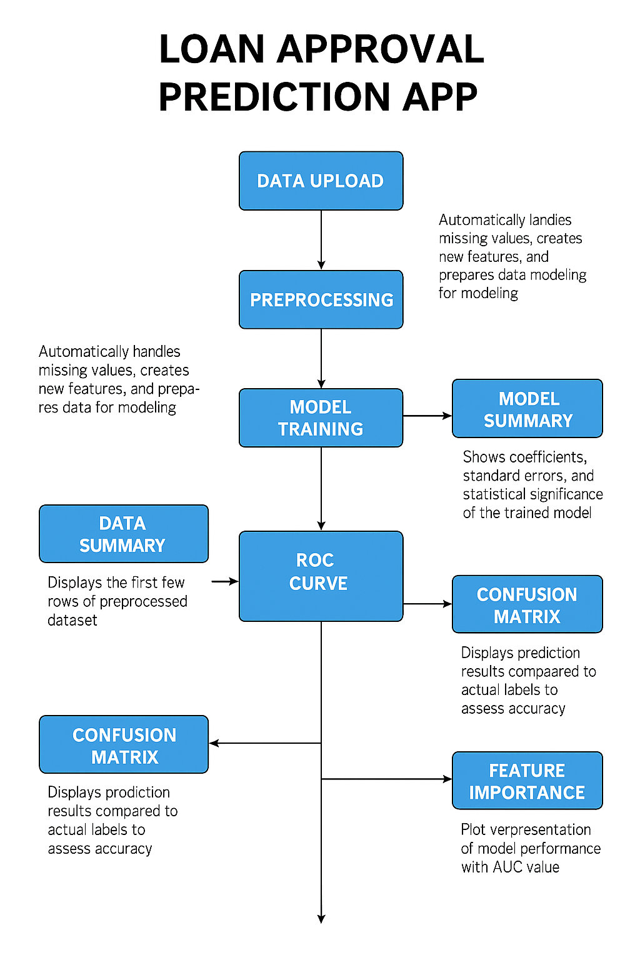

CHAPTER 3 MODULE DESCRIPTION

3.1 Data upload Module

Purpose:

To allow users to upload a loan dataset in .csv format so that further analysis and modeling can be performed.

Description:

This module serves as the entry point to the application. It includes a file input widget (fileInput) that lets users select and upload a CSV file from their local system. Once the file is uploaded, the server reads it into a data frame using read.csv() and stores it reactively for use in downstream modules. The req() function ensures the file is not null before processing starts. This module is crucial for enabling dynamic interaction with real user-supplied data, rather than using a fixed or hardcoded datase.

Key Functions Used:
fileInput() – UI component to select CSV file.
read.csv() – Reads the uploaded file into a data frame.
req() –Ensures that the file input is not empty before proceeding.

3.2 Processing Module

Purpose:
To clean, standardize, and transform raw input data to make it suitable for logistic regression modeling.

Description:
This module automatically handles missing values and prepares derived variables required for meaningful model training. For instance:Missing categorical values (e.g., Gender, Married, Self_Employed) are filled with common defaults.Numeric columns like LoanAmount are imputed using the median.Derived features such as TotalIncome (ApplicantIncome + CoapplicantIncome), EMI (LoanAmount/Loan_Amount_Term), and BalanceIncome (TotalIncome - EMI × 1000) are created to capture meaningful financial information.Character columns are converted into factors for modeling.Non-essential fields such as Loan_ID are removed.These steps ensure that the dataset is clean, structured, and consistent, ready to be used for training a predictive model.

Key Functions Used:

mutate() – Used to create new or modify existing columns.

replace_na() – Replaces missing values with defined defaults.

median(), + – Used to compute central tendencies and calculate new columns.

across(where(is.character), as.factor) – Converts character columns to factors.

select(-Loan_ID) – Drops irrelevant columns.

3.3 Model Training Module
Purpose:
To build and train a logistic regression model using the selected features to
predict whether a loan will be approved (Loan_Status).

Description:
Once the user selects features and clicks the "Train Model" button, this module constructs a formula dynamically in the format Loan_Status ~ Feature1 + Feature2 + .... This formula is passed to the glm() function to fit a logistic regression model using a binomial family, appropriate for binary classification tasks.The training process is wrapped inside eventReactive(), meaning the model only trains once the user explicitly triggers it. This modular design ensures the model reflects user choices without retraining unnecessarily

Key Functions Used:
eventReactive() – Triggers model training when the action button is clicked.
glm() – Fits a generalized linear model (logistic regression).
as.formula() – Dynamically builds the regression formula from selected features.

3.4 Confusion Matrix Module
Purpose:
To evaluate how well the model classifies approved vs rejected loans.
Description:
Generates predictions using the model, then compares them with actual outcomes to calculate a confusion matrix—showing metrics like accuracy, precision, recall.
Key Functions Used:
predict(..., type = "response") – Predicts probabilities from the model.
ifelse() – Converts probabilities to binary classes.
confusionMatrix() (from caret package) – Computes the confusion matrix.

3.5 ROC Curve Module
Purpose:
To visualize the trade-off between sensitivity and specificity of the model using an ROC curve.
Description:
Plots the ROC curve based on predicted probabilities and calculates the AUC (Area Under Curve), which summarizes the model's ability to distinguish between classes.
Key Functions used:
roc(): From the pROC package; computes the true/false positive rates at different thresholds.
auc(): Calculates the Area Under the ROC Curve—higher values (closer to 1) mean better classification performance.
plot(): Plots the ROC curve with colored lines and AUC value.
renderPlot(): Outputs the ROC plot in the app UI.

3.6 Feature Importance Plot Module
Purpose:
To interpret the model by visualizing how each feature affects loan approval predictions.
Description:
Extracts the model’s coefficients and displays them as a horizontal bar chart. Larger absolute values indicate stronger influence. Positive estimates increase approval odds; negative estimates reduce them.
Key Functions used:
summary()$coefficients: Accesses the coefficient table from the model.
as.data.frame(): Converts the coefficient matrix to a data frame for plotting.
filter(Feature != "(Intercept)"): Removes the intercept term so only actual features are plotted.
ggplot(): Constructs the bar chart for visualizing coefficients.
geom_col(): Creates vertical bars to represent each feature’s effect size.
coord_flip(): Flips the chart horizontally for better readability.
theme_minimal(), labs(): Adds titles, axis labels, and a clean theme for professional appearance.

CHAPTER 4
CONCLUSION & FUTURE SCOPE

Conclusion
In the conclusion, this Shiny application provides an interactive and comprehensive platform for analyzing loan approval patterns using logistic regression. By enabling users to upload their own dataset, select relevant features, and visualize key model diagnostics such as ROC curves, confusion matrices, and feature importance, the app offers a practical and intuitive approach to predictive modeling. The built-in data preprocessing ensures clean and consistent input, while the statistical summaries and plots enhance interpretability and decision-making. Overall, this tool effectively bridges data analysis and user-friendly visualization, making it valuable for financial analysts, data scientists, and decision-makers in the lending sector..

Future Scope

In the future, this application can be enhanced by incorporating advanced machine learning algorithms such as Random Forest, XGBoost, or Support Vector Machines to improve prediction accuracy. Integration of model evaluation techniques like cross-validation, as well as real-time data processing capabilities, would further strengthen its practical utility. Additionally, adding explainable AI (XAI) components like SHAP or LIME can provide deeper insights into model decisions. Expanding the application to support live deployment with database connectivity and user-specific dashboards would make it a robust decision support system for financial institutions and lending agencies.
CHAPTER 5
APPENDIX A – SOURCE CODE

library(shiny)
library(tidyverse)
library(caret)
library(pROC)

ui <- fluidPage(
titlePanel("Loan Approval Prediction with Logistic Regression"),

sidebarLayout(
sidebarPanel(
fileInput("file", "Upload Loan Data CSV", accept = ".csv"),
checkboxGroupInput("features", "Select Features", choices = NULL),
actionButton("trainModel", "Train Model")
),

mainPanel(
tabsetPanel(
tabPanel("Data Summary", tableOutput("dataSummary")),
tabPanel("Model Summary", verbatimTextOutput("modelSummary")),
tabPanel("Confusion Matrix", verbatimTextOutput("confMatrix")),
tabPanel("ROC Curve", plotOutput("rocPlot")),
tabPanel("Feature Importance", plotOutput("featurePlot"))
)
)
)
)

server <- function(input, output, session) {
data <- reactive({
req(input$file)
df <- read.csv(input$file$datapath)

# Preprocessing
df <- df %>%
mutate(
Gender = replace_na(Gender, "Male"),
Married = replace_na(Married, "Yes"),
Dependents = replace_na(Dependents, "0"),
Self_Employed = replace_na(Self_Employed, "No"),
Credit_History = replace_na(Credit_History, 1),
LoanAmount = replace_na(LoanAmount, median(LoanAmount, na.rm = TRUE)),
Loan_Amount_Term = replace_na(Loan_Amount_Term, 360),
TotalIncome = ApplicantIncome + CoapplicantIncome,
EMI = LoanAmount / Loan_Amount_Term,
BalanceIncome = TotalIncome - (EMI * 1000)
) %>%
mutate(across(where(is.character), as.factor)) %>%
select(-Loan_ID)

return(df)
})

observe({
updateCheckboxGroupInput(session, "features", choices = names(data())[!names(data()) %in% c("Loan_Status")])
})

model <- eventReactive(input$trainModel, {
df <- data()
form <- as.formula(paste("Loan_Status ~", paste(input$features, collapse = "+")))
glm(form, data = df, family = "binomial")
})

output$dataSummary <- renderTable({
head(data())
})

output$modelSummary <- renderPrint({
summary(model())
})

output$confMatrix <- renderPrint({
df <- data()
prob <- predict(model(), newdata = df, type = "response")
pred <- ifelse(prob > 0.5, "Y", "N")
confusionMatrix(as.factor(pred), df$Loan_Status)
})

output$rocPlot <- renderPlot({
df <- data()
prob <- predict(model(), newdata = df, type = "response")
roc_obj <- roc(df$Loan_Status, prob)
plot(roc_obj, col = "blue", main = paste("ROC Curve (AUC =", round(auc(roc_obj), 2), ")"))
})

output$featurePlot <- renderPlot({
coef_df <- as.data.frame(summary(model())$coefficients)
coef_df$Feature <- rownames(coef_df)
coef_df <- coef_df %>% filter(Feature != "(Intercept)")
ggplot(coef_df, aes(x = reorder(Feature, abs(Estimate)), y = Estimate)) +
geom_col(fill = "darkgreen") +
coord_flip() +
theme_minimal() +
labs(title = "Feature Importance", x = "Feature", y = "Estimate")
})
}

shinyApp(ui = ui, server = server)

APPENDIX B – SCREENSHOTS

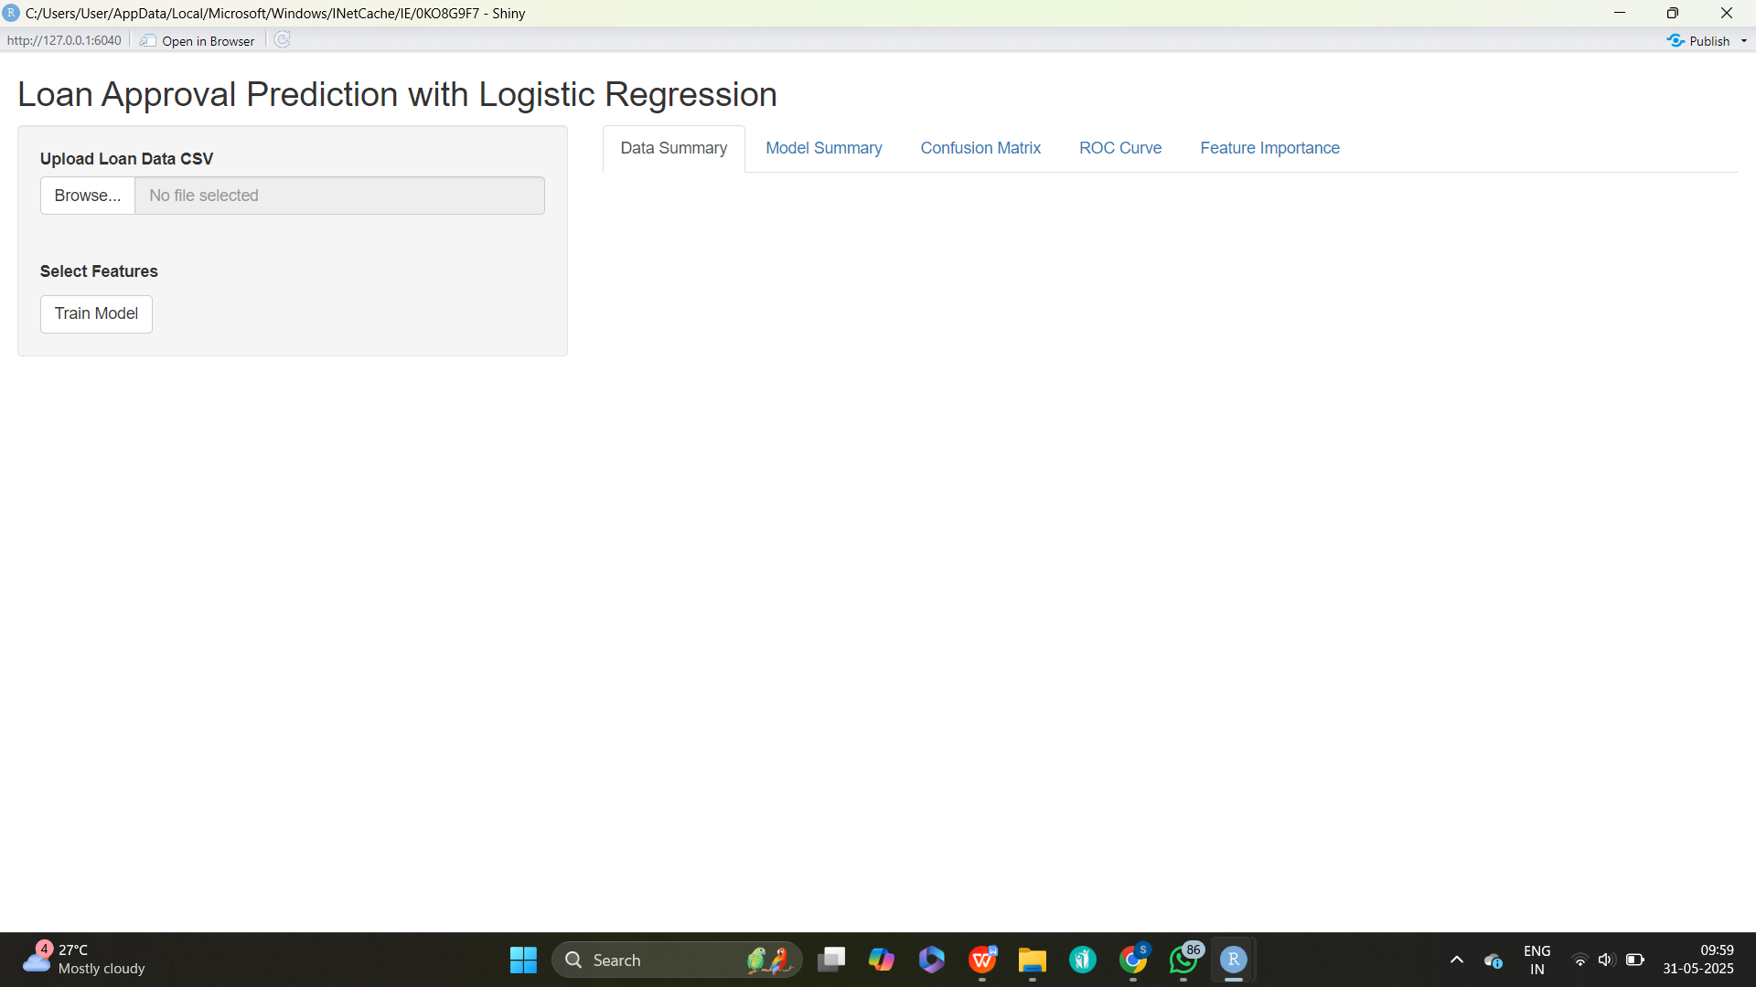

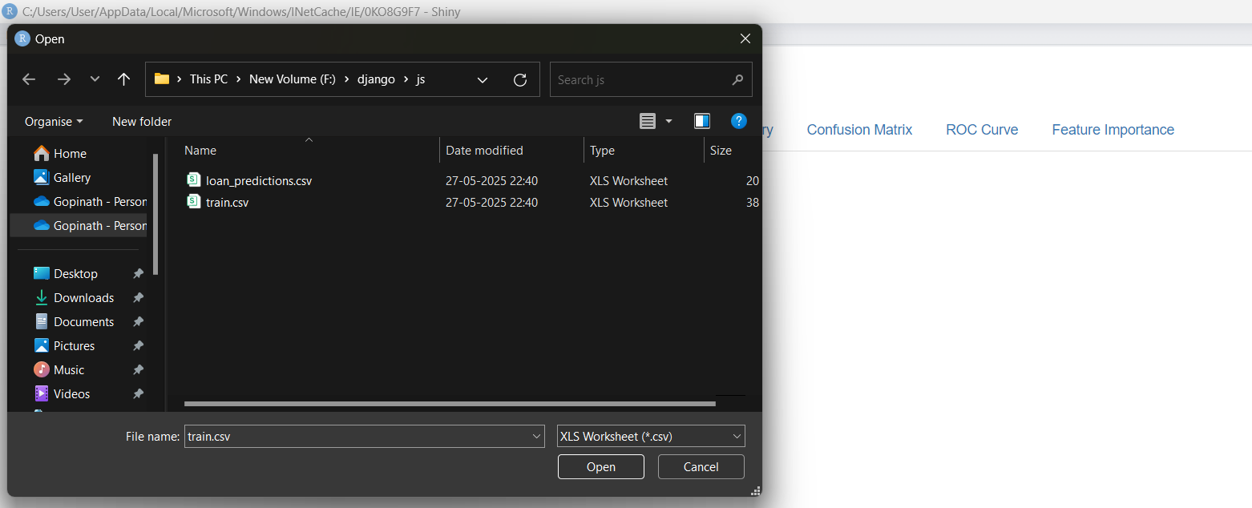

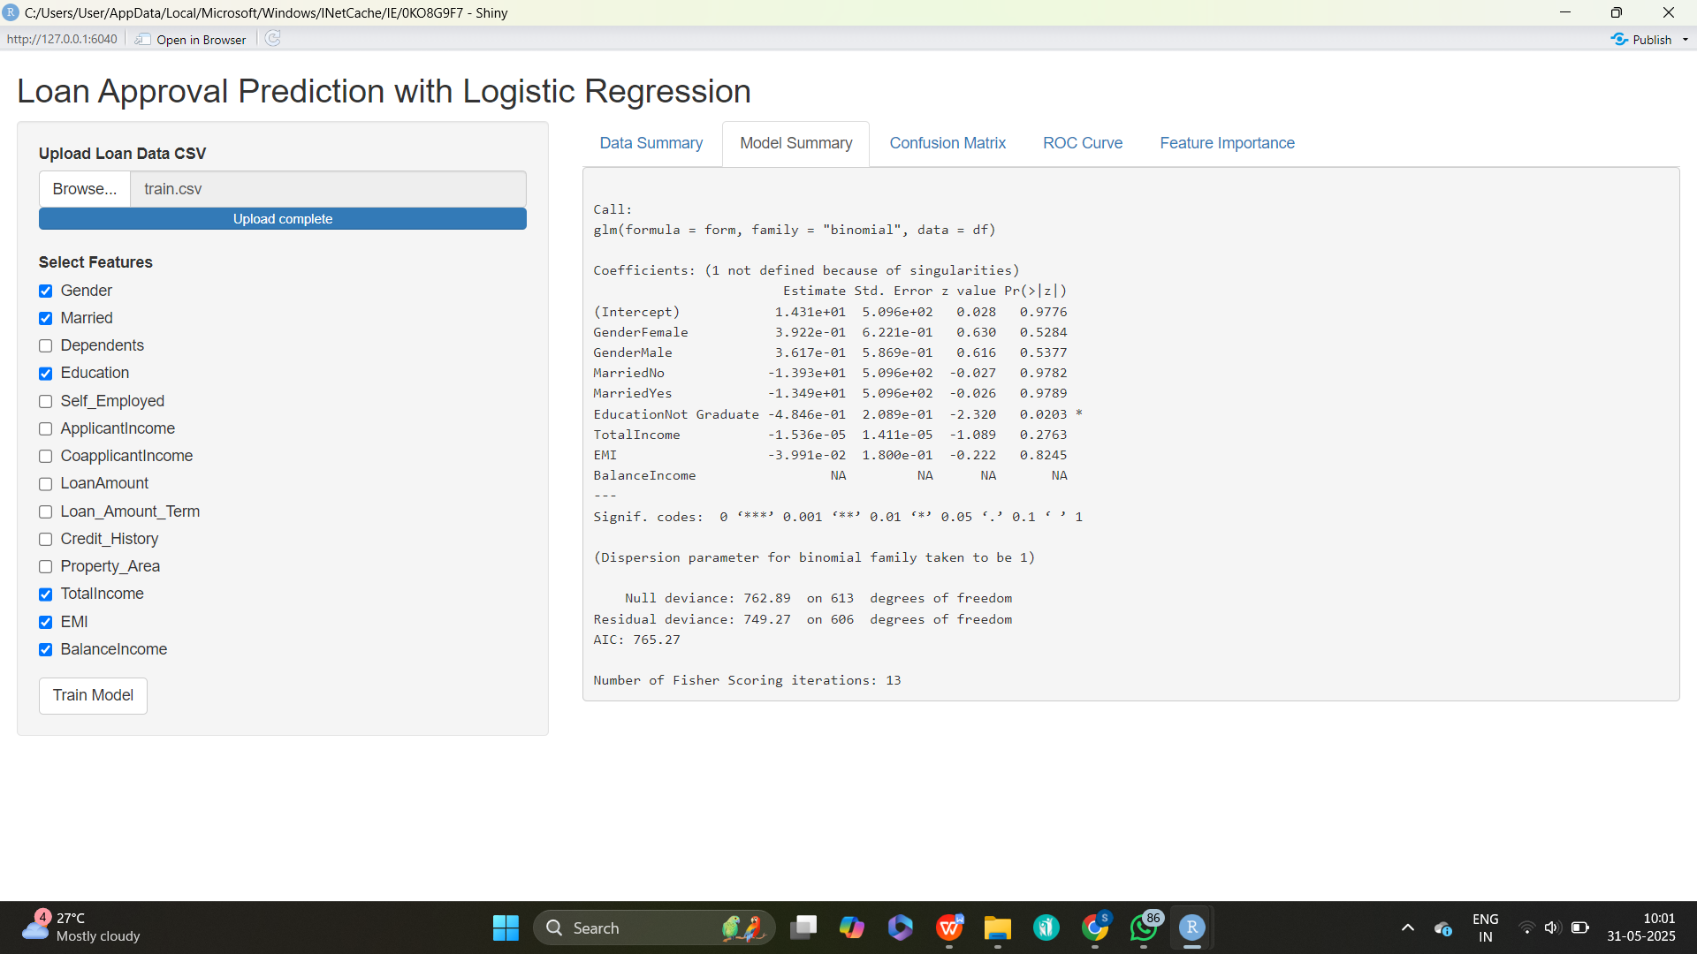

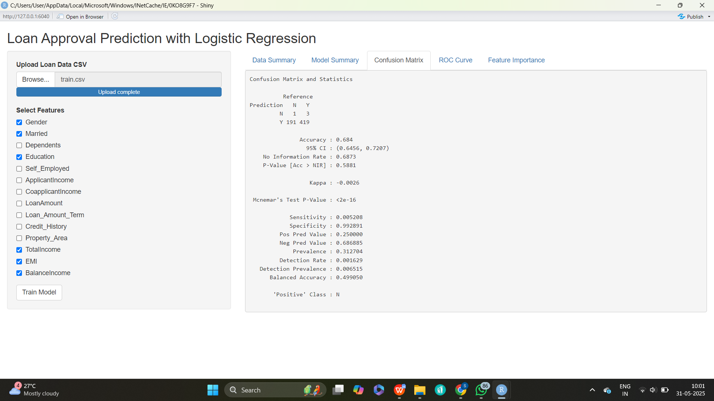

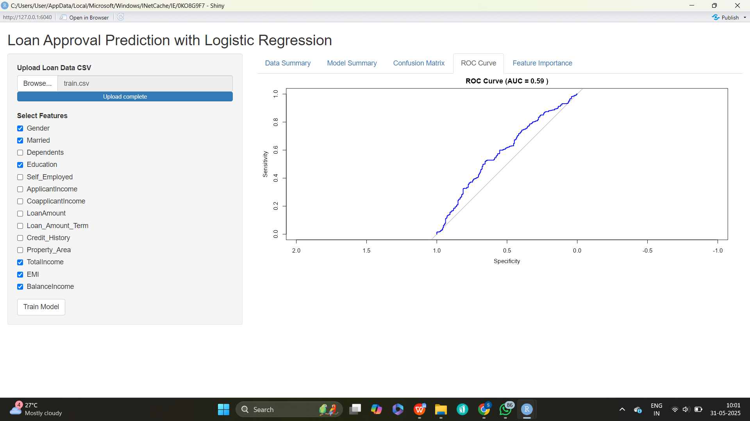

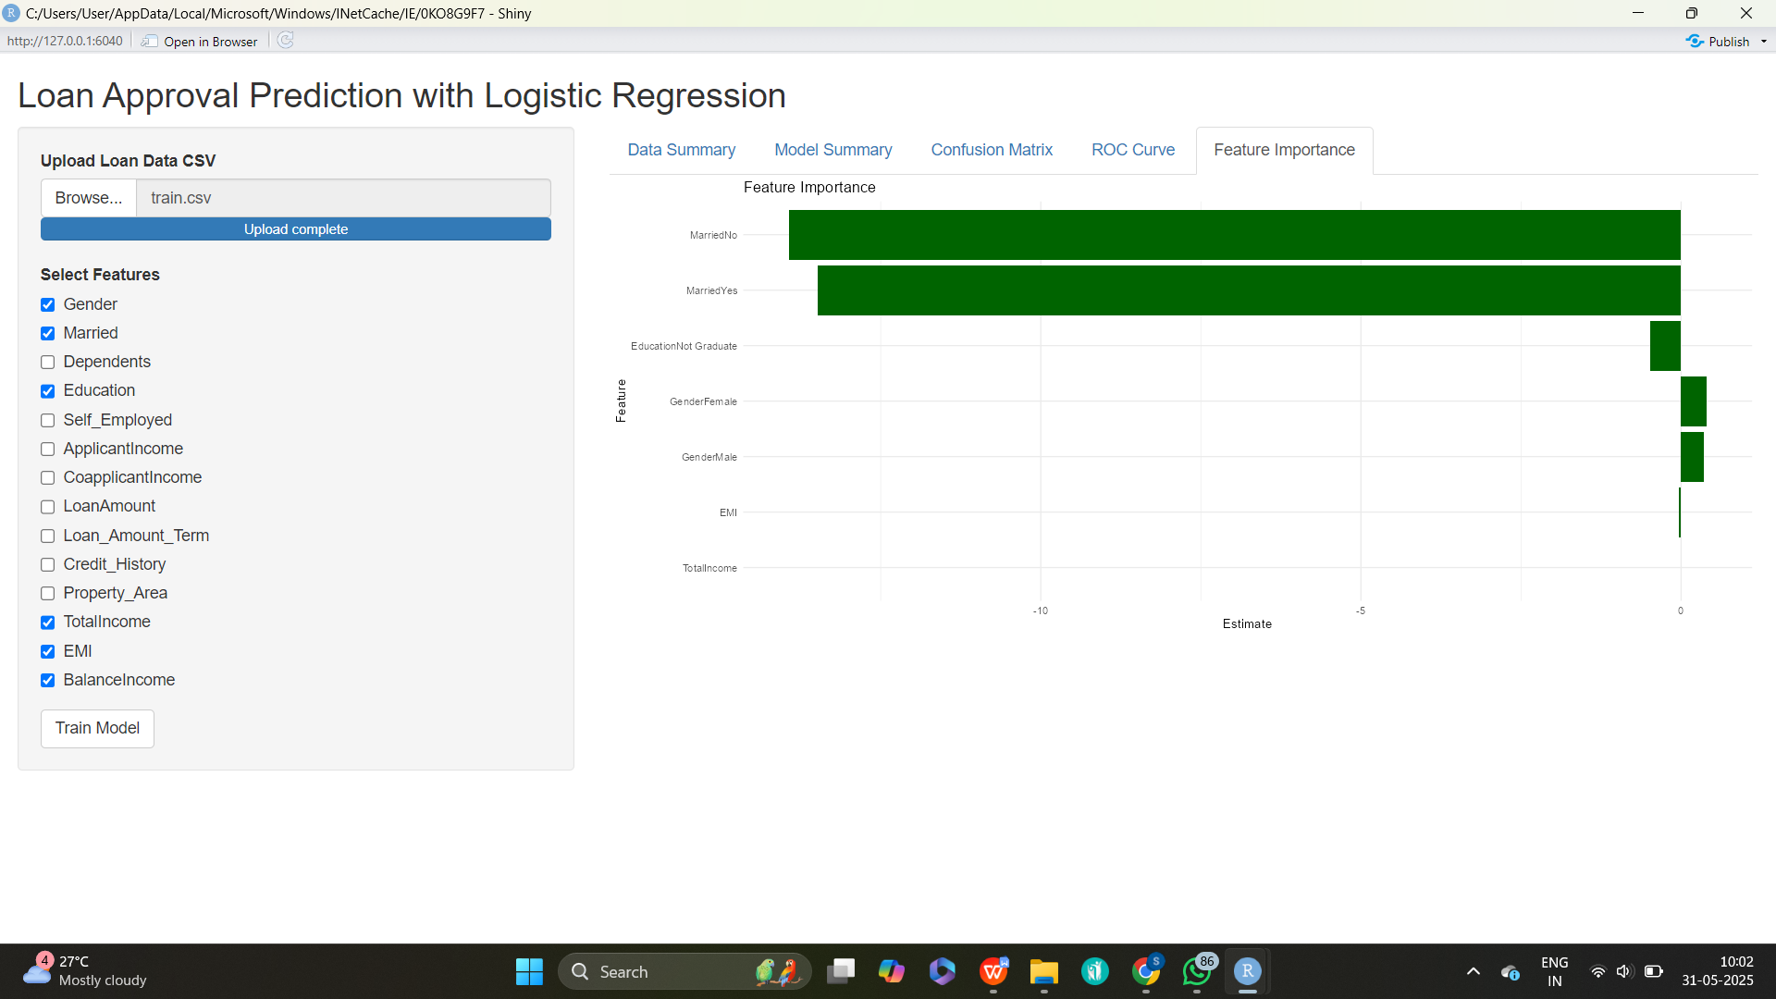

\REFERENCES

- Baumer, B. S., Kaplan, D. T., & Horton, N. J. (2017). Modern Data Science with R. CRC Press.
- Chang, W., Cheng, J., Allaire, J., Xie, Y., & McPherson, J. (2024). Shiny: Web Application Framework for R. R package version X.X.X. https://CRAN.R-project.org/package=shiny
- Official R Project Website
- RStudio. Shiny Tutorials by RStudio.
- Sievert, C. (2023). Interactive Web-Based Data Visualization with R, plotly, and shiny. Chapman and Hall/CRC.
- Wickham, H., François, R., Henry, L., & Müller, K. (2024). dplyr: A
Grammar of Data Manipulation. R package version X.X.X.
- Winston Chang et al. (2024). shinydashboard: Create Dashboards with 'Shiny'.

