**SMART PARKING SYSTEM**

**TEAM MEMBERS:**

1. **Alagu Sathiya M - au951221106003**
2. **Abirami M - au951221106002**
3. **Rajathi S - au951221106030**
4. **Sasi Rekha S - au951221106043**
5. **Venuka M - au951221106052**

**Phase 1 problem definition and design**

**Thinking:**

**By using ultrasonic sensors be able to keep the record of the number of cars parked inside of a parking garage consequently. Once a car enters a parking garage followed by a parking space, a ping ultrasonic sensor will then be able to determine if a car is parked in the space or not.**

**Shortage of parking space, high parking tariff's and traffic congestion due to visitors in search for a parking place are only a four examples of everyday parking problems.**

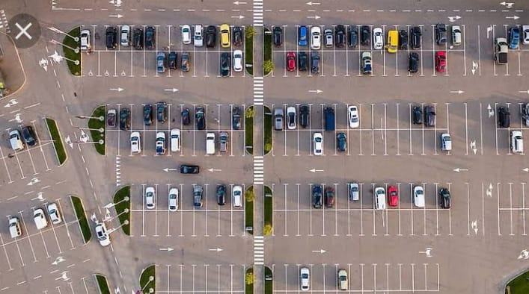

**Main objective of smart parking system:**

**To reduce the number of cars circling the streets for finding a parking spot.**