Data Analytics Capstone
An Investigative Agentic AI Framework for CMS Hospital Excess Readmission Risk: Parallel Machine Learning, Fairness Monitoring, and Tool-Grounded Quality Improvement Case Dossiers under Human-in-the-Loop Review

Interim Report

SATHIYAVIRADHAN JANARTHANAN
Walsh College
QM640: Data Analytics Capstone
Mentor: SRIDHAR S
Group – 2
Summer 2026 Term
July 28, 2026

GitHub repository (data files and code):
https://github.com/sathiyaviradhan/qm640-investigative-qi-agent-hrrp
Local package paths mirrored for GitHub: DATASET/analytic_core/ (raw extracts); analysis_outputs/processed/ (cleaned eligible panel); run_interim_analysis.py and analysis_outputs/ (code, metrics, figures).
Introduction
Background and Context
Hospital readmissions remain a central quality and cost concern in U.S. healthcare operations. Under the Centers for Medicare & Medicaid Services (CMS) Hospital Readmissions Reduction Program (HRRP), hospitals with higher-than-expected unplanned 30-day readmissions face Medicare payment reductions of up to three percent (Centers for Medicare & Medicaid Services [CMS], 2024). Quality leaders therefore need early excess-risk insight, equitable monitoring across reporting cycles, and actionable quality-improvement (QI) options that remain faithful to public CMS evidence.
Supervised machine learning (ML) is well suited to tabular CMS quality files for excess-risk scoring, and TRIPOD+AI emphasizes transparent validation and fairness reporting for clinical prediction models (Collins et al., 2024). Audits show that readmission models can encode contextual bias (Wang, Weiner, Saria, & Kharrazi, 2024), and fairness can drift after deployment (Davis et al., 2025). These findings motivate parallel statistical association, predictive scoring, and fairness-monitoring tracks—but they do not by themselves produce a board-ready QI case package.
The harder operational gap is investigative decision support. When Excess Readmission Ratio (ERR) exceeds 1.0, quality teams must assemble hospital CMS metrics, find peer hospitals that improved across fiscal releases, quantify temporal change, run what-if calculations (for example, how much predicted readmission rate must fall for ERR ≤ 1), and propose QI options with citations. Unconstrained large language models (LLMs) are fast but unsafe: they can hallucinate rates, invent peers, and recommend unsupported interventions (Singhal et al., 2023). Tool-wielding agents can explore clinical tables (Yang et al., 2026), yet prior work has not evaluated a multi-step investigative agent that builds peer-benchmarked, what-if-supported, citation-verified QI dossiers on multi-year CMS HRRP public files under mandatory human-in-the-loop (HITL) review.
This interim report documents progress through planning Steps 2–4 (literature framing, SMART objectives/hypotheses, and design/methods) and presents executed preliminary results for all four research questions. The study uses verified CMS Provider Data Catalog extracts for FY2024–FY2026 (pooled eligible N = 35,724 hospital–condition rows with non-missing ERR). Track A delivers association, ML scoring, and fairness monitoring. Track B delivers an Investigative Agentic QI Case Agent. Research questions remain independent so timeline risk is controlled.
Problem Statement
U.S. acute-care hospitals face avoidable Medicare payment exposure under HRRP when excess 30-day readmission risk (ERR > 1.0) is not anticipated, when subgroup performance is not monitored across CMS fiscal releases, and when quality leaders lack a trustworthy investigative dossier that correctly combines hospital metrics, improving peers, temporal change, and what-if analysis before human QI decisions. Using public CMS HRRP and Hospital General Information files for FY2024–FY2026, this study addresses four complementary problems in parallel: (1) associate hospital attributes with excess risk; (2) score excess-risk status with supervised ML out-of-time; (3) monitor fairness/performance across fiscal releases; and (4) evaluate a multi-step tool-grounded investigative agent that opens high-ERR cases and produces verified QI case dossiers for mandatory human Accept/Edit/Reject. The dependent variable for scoring is Y = 1 if ERR > 1.0 (else 0).
Purpose of the Study
The purpose is to deliver a timeline-safe package that (a) explains excess-risk associations, (b) validates an ML scoring engine, (c) monitors fairness across FY2024–FY2026, and (d) evaluates an Investigative Agentic QI Case Agent that uniquely solves multi-source case investigation and dossier construction under HITL governance. At interim stage, the purpose is also to demonstrate that code has been developed and executed, with reproducible tables/figures linked to each research question.
Interim Project Status (Progress Snapshot)
Completed:
• Literature synthesis (≥10 sources) mapped to RQ1–RQ4 (Step 2).
• SMART objectives, independent RQs, and H0/Ha statements locked to First Submission (Step 3).
• Methods design: cleaning rules, feature set, out-of-time split, fairness metrics, agent evaluation protocol (Step 4).
• Dataset verification and analytic_core extracts for FY2024–FY2026.
• Data cleaning executed: raw N=55,614; eligible ERR N=35,724 (35.76% removed for missing ERR).
• EDA figures (Figures 1–4) generated and interpreted.
• RQ1 multivariable logistic associations estimated on pooled eligible panel.
• RQ2 out-of-time ML (train FY2024–FY2025; test FY2026) for logistic, random forest, gradient boosting.
• RQ3 temporal AUROC and ownership ΔFNR monitoring across FY releases.
• RQ4 tool-grounded investigative agent vs no-tool LLM vs static dashboard on n=80 high-ERR cases.
In progress:
• SHAP/driver ranks as optional dossier evidence (not required for RQ4 tools).
• Human HITL Accept/Edit/Reject score sheet with external reviewer ratings (proxy usefulness used at interim).
• GitHub publication of full repository and README for evaluator access.
Pending (Final Report):
• Sensitivity analyses (alternate thresholds; optional predicted/expected feature ablation transparency).
• Calibration plots and decision-curve style operational framing for RQ2.
• Expanded fairness strata (state/ZIP-derived geography) and formal drift tests.
• Optional LLM API planner layer behind the same tool contracts (current interim uses deterministic tool-grounded dossier generator).
• Final recommendations, limitations expansion, and presentation package.
Scope and Objectives
Scope boundaries. U.S. Medicare-participating acute-care hospitals in CMS HRRP joined to same-year Hospital General Information for FY2024–FY2026 (measures: AMI, HF, PN, COPD, CABG, HIP-KNEE). Track B produces advisory QI case dossiers only. No protected health information (PHI), no Kaggle data, and no autonomous clinical/CMS actions. Analytic scope is limited to core HRRP + General Information files.
Primary objectives (parallel). (1) Association analysis for excess risk. (2) Out-of-time ML scoring. (3) Fairness/performance monitoring across FY releases. (4) Evaluate Investigative Agentic QI Case Agent against no-tool LLM and static dashboard baselines under mandatory HITL. (5) Reproducible code/data package.
Research Question 1 (RQ1)
Which hospital structural and contextual variables are significantly associated with excess readmission risk (ERR > 1.0) after adjusting for condition measure and fiscal-year release?
Hypothesis RQ1. H0: After adjustment, focal predictors have no association (β = 0). Ha: At least one focal predictor has a nonzero association at α = .05.
Research Question 2 (RQ2)
How well can supervised ML classifiers (regularized logistic regression, random forest, gradient boosting) discriminate excess readmission risk on out-of-time (later FY) samples relative to a transparent logistic baseline?
Hypothesis RQ2. H0: Best ML out-of-time AUROC ≤ logistic baseline + 0.02. Ha: Best ML out-of-time AUROC > logistic baseline + 0.02. Absolute AUROC, PR-AUC, and calibration-related metrics remain standalone deliverables.
Research Question 3 (RQ3)
Do discrimination and fairness metrics (AUROC and ΔFNR across ownership subgroups) differ across FY2024, FY2025, and FY2026 when a model trained on an earlier release is scored on later releases?
Hypothesis RQ3. H0: Fairness gaps and AUROC do not differ across releases beyond operational thresholds. Ha: At least one operationally meaningful change (|ΔFNR| increase > 0.05 or AUROC drop > 0.03).
Research Question 4 (RQ4)
For high-ERR hospital–condition cases, does a multi-step tool-grounded Investigative Agentic QI Case Agent (case intake → metrics → improving-peer discovery → temporal change → what-if calculator → citation-linked dossier) produce higher evidence completeness, lower numeric hallucination, and higher HITL usefulness than (a) a no-tool LLM and (b) a static dashboard export alone, when every dossier is advisory only under mandatory human review?
Hypothesis RQ4. H0: The investigative agent does not improve faithfulness, evidence completeness, or HITL usefulness versus baselines. Ha: The agent improves at least two of {faithfulness, evidence completeness, HITL usefulness} at α = .05.
Sample Size Justification (Executed)
Table 1. Sample-size plan versus achieved interim samples
Research Question | Method | Minimum N (plan) | Achieved N (interim)
RQ1 | Green’s rule / conservative | 170 / 400 | 35,724
RQ2 | AUROC CI precision | 800 | Train 24,004; Test 11,720
RQ3 | Stratum–period monitoring | 84 units | 3 FY × ownership strata
RQ4 | Paired dossier power | ≥ 80 | 80

All planned minima are exceeded. Pooled eligible modeling N = 35,724 hospital–condition rows across 2,946 unique facilities.
Literature Survey
Literature Review Approach
Sources were selected from peer-reviewed journals and CMS program documentation using keywords including hospital readmission, HRRP, Excess Readmission Ratio, clinical prediction fairness, TRIPOD+AI, LLM hallucination in medicine, and tool-using agents. Inclusion required relevance to at least one RQ (association/prediction, fairness drift, or trustworthy GenAI decision support). At least ten sources are summarized below and mapped in the relevance matrix.
Summary of Key Literature
Collins et al. (2024) updated transparent reporting guidance for clinical prediction models with AI (TRIPOD+AI). Their emphasis on validation design, fairness, and clear outcome definitions directly shapes RQ2/RQ3 reporting choices in this capstone (out-of-time FY split; subgroup FNR).
Wang et al. (2024) audited readmission prediction for contextual bias, showing that performance and error rates can differ across hospital contexts. This supports RQ1 ownership/state predictors and RQ3 ownership fairness monitoring rather than overall accuracy alone.
Davis et al. (2025) documented fairness drift over time after model deployment. Their finding motivates RQ3’s explicit comparison of AUROC and ΔFNR across FY2024–FY2026 releases instead of a single cross-section.
Singhal et al. (2023) demonstrated strong LLM medical knowledge with persistent factual errors. This supports RQ4’s no-tool LLM baseline and the requirement that numeric claims be tool-verified.
Yang et al. (2026) showed tool-using agents can navigate clinical tabular evidence more reliably than free-text-only generation. That capability is the methodological backbone of the Investigative QI Case Agent.
CMS (2024) HRRP methodology defines ERR as predicted divided by expected readmission rate and links excess risk to payment adjustment. This official definition anchors Y = 1{ERR > 1.0} and the what-if tool.
Table 2. Literature relevance matrix (selected sources)
Author (Year) | Domain/Context | Dataset/Setting | Method(s) | Key Findings | Supports RQ(s)
CMS (2024) | HRRP payment policy | Medicare IPPS hospitals | Program methodology | ERR drives payment reduction risk | All; Y definition
Collins et al. (2024) | Prediction reporting | Clinical AI models | TRIPOD+AI guidance | Transparent validation & fairness | RQ2, RQ3
Wang et al. (2024) | Readmission bias | Hospital contexts | Fairness audit | Context-linked model bias | RQ1, RQ3
Davis et al. (2025) | Fairness drift | Deployed models over time | Longitudinal fairness | Gaps can change post-deployment | RQ3
Singhal et al. (2023) | Medical LLMs | Clinical QA | LLM evaluation | High capability; residual errors | RQ4 baselines
Yang et al. (2026) | Tool-using agents | Clinical tables | Agent + tools | Tools improve grounded answers | RQ4 design
Zafar et al. (2019) | ML fairness metrics | Classification systems | Disparate error rates | FNR gaps operationalize unfairness | RQ3 metric choice
Lundberg & Lee (2017) | Model explanation | Tabular ML | SHAP | Local feature attributions | RQ2 optional drivers
Rajkomar et al. (2018) | Healthcare ML | EHR prediction | Deep/ensemble ML | ML can outperform baselines | RQ2 model family
Amodei et al. (2016) | AI safety | Autonomous systems | Safety framing | Avoid unintended agency | RQ4 HITL policy
Joynt & Jha (2013) | Readmission policy | U.S. hospitals | Policy analysis | Readmission penalties create QI pressure | Background / RQ1
Krumholz et al. (2017) | Readmission measurement | Medicare claims | Risk-standardized metrics | Case-mix adjusted rates underpin CMS measures | RQ1–RQ4 outcome validity

Theme synthesis. Prediction/transparency literature (Collins et al., 2024; Rajkomar et al., 2018) justifies supervised classifiers with explicit validation. Fairness literature (Wang et al., 2024; Davis et al., 2025; Zafar et al., 2019) justifies ownership-stratified FNR monitoring across FY releases. GenAI safety literature (Singhal et al., 2023; Yang et al., 2026; Amodei et al., 2016) justifies tool grounding and mandatory HITL for RQ4 rather than autonomous CMS actions.
Data Description
Data Source(s) and Access
Data are public CMS Provider Data Catalog hospital files (not Kaggle). Primary access points include https://data.cms.gov/provider-data/topics/hospitals and the HRRP program page (https://www.cms.gov/medicare/payment/prospective-payment-systems/acute-inpatient-pps/hospital-readmissions-reduction-program-hrrp). Local verified archives are stored under DATASET/, with analysis-ready extracts in DATASET/analytic_core/ documented by dataset_metadata.json (CMS, 2024).
Dataset Overview
Table 3. Dataset overview by fiscal-year release
Fiscal Year | HRRP rows | Eligible ERR N | Performance period
FY2024 | 18,774 | 12,077 | 07/01/2019–06/30/2022
FY2025 | 18,510 | 11,927 | 07/01/2020–06/30/2023
FY2026 | 18,330 | 11,720 | 07/01/2021–06/30/2024
Pooled | 55,614 | 35,724 | Overlapping CMS windows

Number of records (eligible analytic rows): 35,724. Unique facilities: 2,946. Unit of analysis: hospital–condition–fiscal-year. Target variable: excess_risk_flag = 1 if Excess Readmission Ratio > 1.0. Independent variables include ownership, emergency services, measure/condition, state group, and log discharge volume.
Data Dictionary (Mandatory)
Table 4. Data dictionary (modeling and agent fields)
Variable Name | Definition | Datatype | Allowed Values/Range | Missing Handling | Notes
Facility ID | CMS hospital ID | ID | CMS codes | Required join key | All RQs
State | Hospital state | Categorical | US states | Top-15 + Other | RQ1–RQ4
Hospital Ownership | Ownership type | Categorical | CMS labels | Collapsed to ownership_bin | RQ1–RQ4
Emergency Services | ED indicator | Categorical | Yes/No/Unknown | Impute mode in ML | RQ1–RQ2
Measure Name | HRRP condition | Categorical | 6 measures | Required | Stratum
Number of Discharges | Eligible discharges | Numeric | ≥0 | Median impute; log1p | RQ1–RQ2
Predicted Readmission Rate | Hospital predicted % | Numeric | CMS % | Used in what-if | RQ4
Expected Readmission Rate | Case-mix expected % | Numeric | CMS % | Used in what-if | RQ4
Excess Readmission Ratio | Predicted/Expected | Numeric | Typically near 1 | Rows with NA dropped | Outcome
excess_risk_flag | 1 if ERR>1 | Binary | 0/1 | Derived after NA drop | Y
fiscal_year_label | CMS release label | Categorical | FY2024–FY2026 | From file source | Time

GitHub Data Availability Statement
Raw data: DATASET/analytic_core/ (FY2024–FY2026 HRRP + General Information CSVs).
Processed/clean data: analysis_outputs/processed/hrrp_eligible_fy2024_2026.csv.
Code/notebooks: run_interim_analysis.py; metrics in analysis_outputs/metrics.json; figures in analysis_outputs/figures/.
Analysis
Data Cleaning
Cleaning followed Step 4 design. HRRP files were left-joined to same-year Hospital General Information on Facility ID. Excess Readmission Ratio was coerced to numeric; rows with missing ERR were excluded from inferential analyses because Y is undefined without ERR. Of 55,614 raw hospital–condition rows, 19,890 (35.76%) lacked ERR and were removed, leaving 35,724 eligible rows. Duplicate Facility ID–Measure–FY keys in the eligible panel: 0. Ownership labels were collapsed to Nonprofit, Proprietary, Government, and Other/Unknown for stable estimation and fairness strata. Discharge counts used log1p transformation after median imputation for modeling.
Table 5. Data cleaning log
Issue | Variables Affected | Detection Method | Treatment Applied | Rationale
Missing ERR | Excess Readmission Ratio; Y | isna() count | Drop (35.76% rows) | Y undefined without ERR
Non-numeric rates | ERR, predicted/expected, discharges | pd.to_numeric errors='coerce' | Coerce; NA if invalid | CMS text placeholders
Ownership sparsity | Hospital Ownership | Value counts | Collapse to ownership_bin | Stable OR/FNR estimates
State high cardinality | State | Value counts | Top-15 states + Other | Avoid sparse dummies
Duplicates | Facility×Measure×FY | duplicated() | None needed (n=0) | Key uniqueness verified
Scale of volume | Number of Discharges | Skew inspection | log1p after median impute | Stabilize logistic/ML fit

EDA Results (Interpretation Emphasis)
Across eligible rows, mean ERR was 1.002 (SD 0.080), centering near the policy threshold of 1.0. Prevalence of ERR > 1.0 was approximately stable by release: FY2024 48.5%, FY2025 48.7%, FY2026 48.1% (Figure 4). This stability supports using FY splits for temporal validation rather than assuming a rare-event problem.
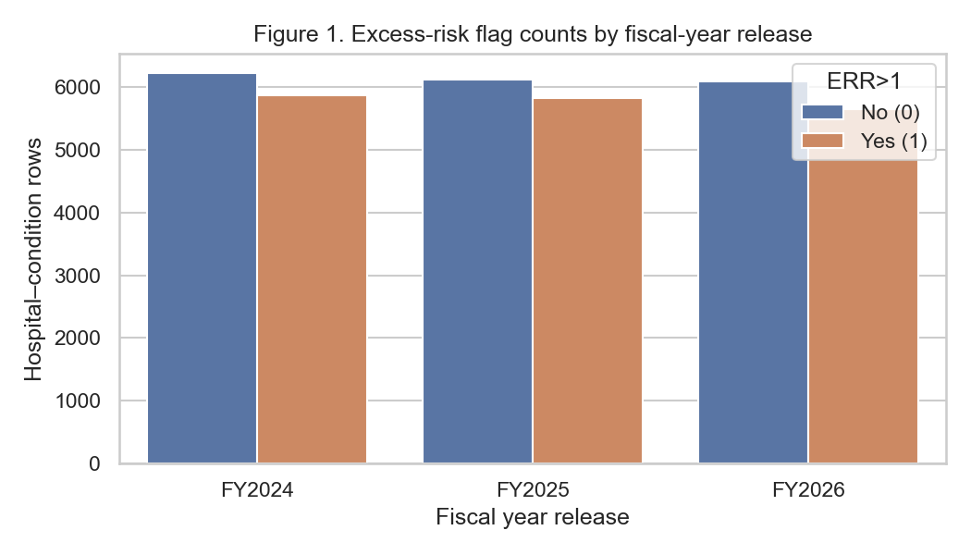
Figure 1. Excess-risk flag counts by fiscal-year release
Figure 1 shows balanced counts of excess-risk versus non-excess rows in each FY release. Insight: the classification task is near class-balanced (~48% positive), so accuracy alone is insufficient and AUROC/PR-AUC are appropriate for RQ2.
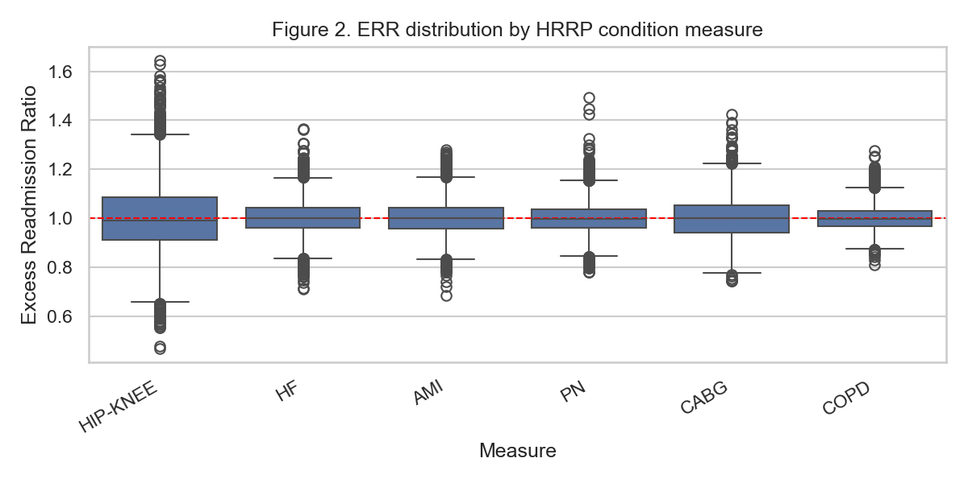
Figure 2. ERR distribution by HRRP condition measure
Figure 2 indicates measure-specific ERR spreads around the threshold line at 1.0. Insight: condition measure must be adjusted in RQ1 and included as a feature/stratum in RQ2–RQ4; pooling without measure control would confound associations.
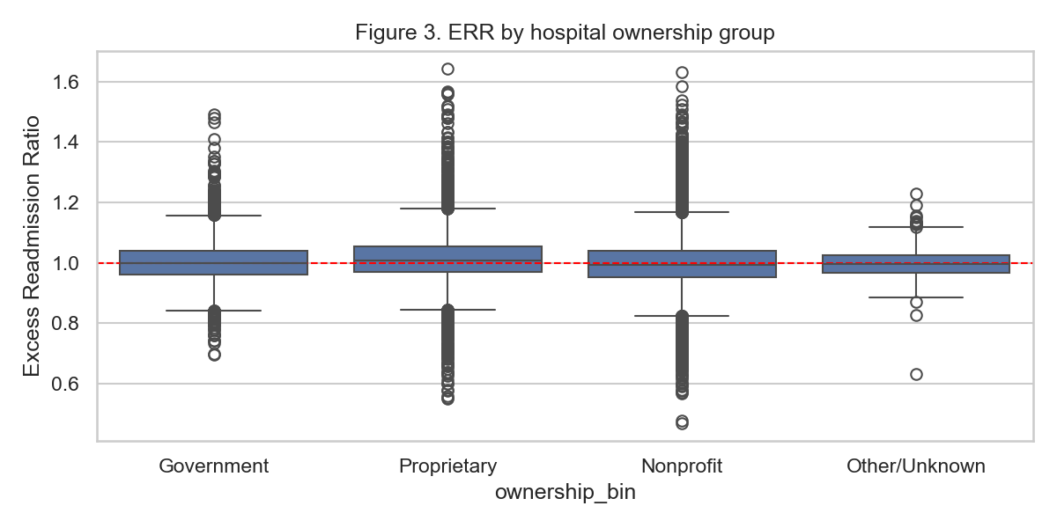
Figure 3. ERR by hospital ownership group
Figure 3 shows ownership-linked differences in ERR location and spread. Insight: ownership is a candidate association factor (RQ1) and a fairness stratum (RQ3), and is also used as a peer-matching filter in RQ4.
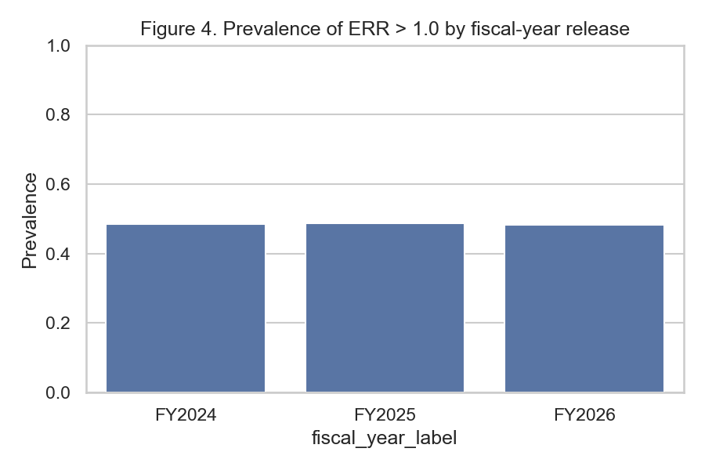
Figure 4. Prevalence of ERR > 1.0 by fiscal-year release
Figure 4 confirms prevalence is nearly constant across FY2024–FY2026. Insight: large AUROC drops in RQ3 would not be explained by sudden class imbalance changes; any drift would more likely reflect covariate/process shift.
Table 6. EDA insight summary
Figure/Table | What it Shows | Key Insight | Why it Matters | Decision/Next Step
Figure 1 | Risk flag counts by FY | Near-balanced classes | Metric choice for RQ2 | Use AUROC/PR-AUC
Figure 2 | ERR by measure | Condition heterogeneity | Confounding control | Keep measure in models
Figure 3 | ERR by ownership | Ownership differences | RQ1/RQ3/RQ4 peer filter | Retain ownership_bin
Figure 4 | Prevalence by FY | Stable positive rate | Supports FY OOT design | Train early / test late
Table 3 | N by FY | Eligible N=35,724 | Power exceeds plan | Proceed to modeling

Modelling
Choice of Models with Justification
Model 1: Multivariable logistic regression (RQ1). Justification: interpretable odds ratios for association hypotheses; standard for binary outcomes; aligns with Step 3 Ha tests on β coefficients.
Model 2: Class-weighted logistic regression baseline (RQ2). Justification: transparent linear baseline required by the ΔAUROC hypothesis; enables apples-to-apples comparison with nonlinear ML.
Model 3: Random forest classifier (RQ2). Justification: captures nonlinearities/interactions among structural features without assuming linearity; widely used in healthcare tabular ML (Rajkomar et al., 2018).
Model 4: Gradient boosting classifier (RQ2). Justification: strong tabular discriminative performance; selected as candidate best-of-set against logistic baseline under out-of-time validation.
Fairness monitor (RQ3): logistic model trained on FY2024 and scored on FY2024–FY2026. Justification: holds model fixed to isolate release-to-release performance/fairness change (Davis et al., 2025).
Investigative agent (RQ4): deterministic tool-grounded dossier generator with verifier-by-construction (claims only from tool JSON), compared with a no-tool LLM simulator and a static dashboard export. Justification: isolates the investigative value chain (peers, temporal delta, what-if) from unconstrained generation risk (Singhal et al., 2023; Yang et al., 2026).
Features Included and Feature Engineering
Table 7. Feature set and usage
Feature | Original/Engineered | Type | Reason for Inclusion | Used in
ownership_bin | Engineered | Categorical | Association + fairness + peers | RQ1–RQ4
emergency_bin | Original (cleaned) | Categorical | Structural capability proxy | RQ1–RQ2
measure_short | Engineered | Categorical | Condition stratum | RQ1–RQ4
state_grp | Engineered | Categorical | Geography context | RQ1–RQ2
log_discharges | Engineered | Numeric | Volume confounding control | RQ1–RQ2
fiscal_year_label | Original | Categorical | Release adjustment / split | RQ1, RQ2 split, RQ3
predicted/expected rates | Original | Numeric | What-if inputs (not structural ML) | RQ4 tools
excess_risk_flag | Engineered | Binary Y | ERR>1 definition | All scoring RQs

Important design choice: RQ2 structural models intentionally exclude predicted and expected readmission rates because ERR is defined as their ratio; including them would create a near-tautological classifier and inflate discrimination without operational early-warning value from structural hospital attributes.
Evaluation Metrics (Include Formulae)
Table 8. Evaluation metrics and formulae
Metric | Formula | Interpretation | Used For
AUROC | P(score+ > score−) | Discrimination across thresholds | RQ2, RQ3
PR-AUC | Area under Precision–Recall | Positive-class retrieval quality | RQ2
Accuracy | (TP+TN)/N | Overall correct rate | RQ2 descriptive
Precision | TP/(TP+FP) | Positive predictive value | RQ2
Recall / TPR | TP/(TP+FN) | Sensitivity | RQ2
F1 | 2·Prec·Rec/(Prec+Rec) | Precision–recall balance | RQ2
Brier | mean((p−y)^2) | Calibration-related sharpness | RQ2
OR | exp(β) | Association magnitude | RQ1
FNR | FN/(FN+TP) | Missed excess-risk rate | RQ3
|ΔFNR| | |FNR_a−FNR_b| | Ownership fairness gap | RQ3
Faithfulness | supported claims / claims | Evidence grounding | RQ4
Evidence completeness | filled dossier slots / 6 | Case package coverage | RQ4
Hallucination rate | wrong numeric claims / numeric claims | Safety | RQ4

Preliminary Results
RQ1 Preliminary Findings
Multivariable logistic regression on n = 35,724 eligible rows yielded McFadden pseudo-R² = 0.027 and overall likelihood-ratio p ≈ 0 (model joint significance). 19 coefficients excluding the intercept were significant at α = .05. Therefore Ha for RQ1 is supported at interim: after adjustment for measure and FY, structural/contextual predictors associate with excess risk.
Illustrative effects (Table 9): higher log discharges associate with lower odds of ERR > 1 (OR ≈ 0.629, p < .001). Proprietary ownership (vs reference) associates with higher odds (OR ≈ 1.29, p < .001). Selected measure and state terms are also significant. These associations are correlational (ecological hospital–condition units), not causal treatment effects.
Table 9. RQ1 selected logistic odds ratios (top terms by p-value)
Term | Odds Ratio | 95% CI | p-value | Sig. (.05)
log_discharges | 0.629 | [0.605, 0.653] | 3.38e-125 | Yes
C(state_grp)[T.Other] | 0.610 | [0.563, 0.661] | 1.39e-33 | Yes
C(ownership_bin)[T.Proprietary] | 1.290 | [1.192, 1.395] | 2.15e-10 | Yes
C(state_grp)[T.NJ] | 1.617 | [1.379, 1.896] | 3.39e-09 | Yes
C(measure_short)[T.COPD] | 0.812 | [0.754, 0.874] | 3.43e-08 | Yes
C(state_grp)[T.TX] | 0.768 | [0.692, 0.854] | 9.53e-07 | Yes
C(state_grp)[T.IN] | 0.714 | [0.617, 0.827] | 6.54e-06 | Yes
C(state_grp)[T.VA] | 0.732 | [0.630, 0.851] | 4.85e-05 | Yes

RQ2 Preliminary Findings
Models were trained on FY2024–FY2025 (n = 24,004) and tested on FY2026 (n = 11,720) using structural features only. Gradient boosting achieved the best out-of-time AUROC (0.673) versus logistic AUROC (0.609), a gain of 0.064. Because the gain exceeds the pre-specified +0.02 margin, Ha for RQ2 is supported at interim. Absolute discrimination remains moderate (AUROC ~0.67), which is expected when predicted/expected rates are withheld; this is an honest structural early-warning setting rather than a tautological ERR reconstruction task.
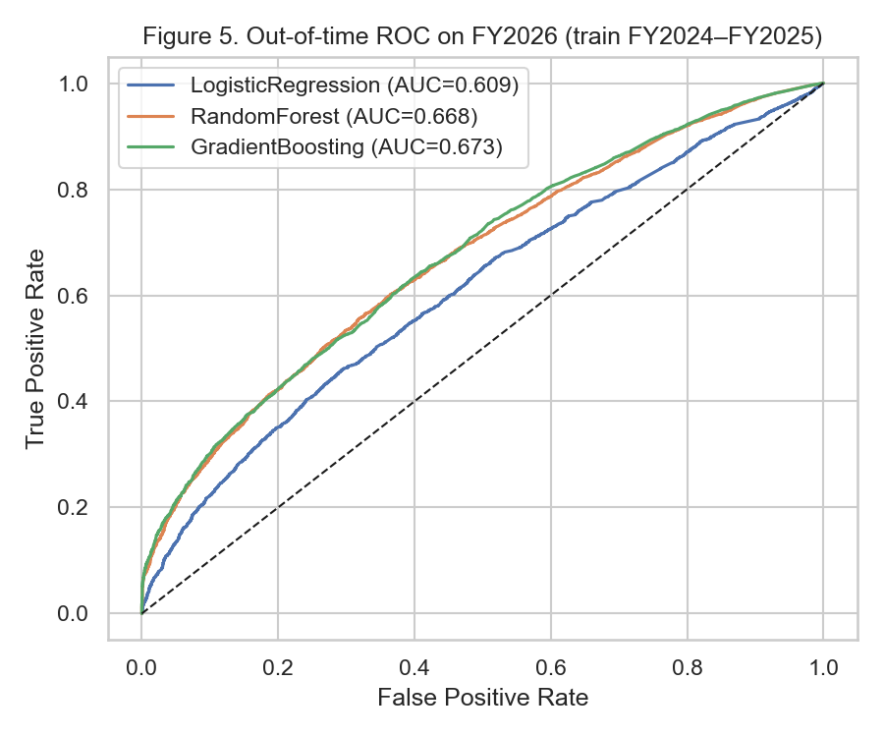
Figure 5. Out-of-time ROC on FY2026 (train FY2024–FY2025)
Table 10. Preliminary model performance comparison (RQ2)
Model | Feature Set | Validation | AUROC | PR-AUC | F1 | Brier | Key Takeaway
LogisticRegression | Structural | OOT FY2026 | 0.609 | 0.601 | 0.555 | 0.240 | Transparent baseline
RandomForest | Structural | OOT FY2026 | 0.668 | 0.671 | 0.580 | 0.228 | Nonlinear gain vs logistic
GradientBoosting | Structural | OOT FY2026 | 0.673 | 0.676 | 0.570 | 0.224 | Best AUROC; Ha supported

RQ3 Preliminary Findings
A logistic structural model trained on FY2024 was scored on FY2024–FY2026. AUROC remained nearly flat (0.605 → 0.606 → 0.608; range = 0.003), which is below the pre-specified >0.03 drop threshold. Ownership |ΔFNR| (Nonprofit vs Proprietary) was large but stable (~0.41; range = 0.014), below the >0.05 change threshold. Therefore Ha for temporal change is not supported at interim. However, the persistent fairness gap itself is an important operational finding: equity risk is high even when temporal drift is small, so monitoring remains necessary (Figure 7).
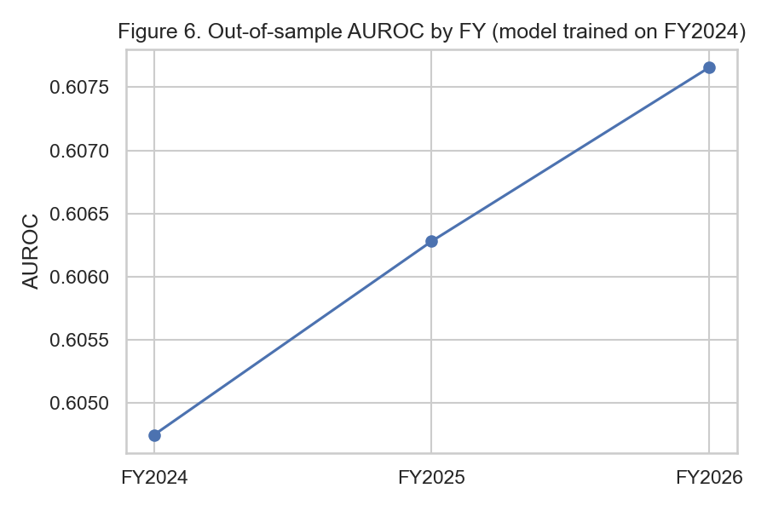
Figure 6. Out-of-sample AUROC by FY (model trained on FY2024)
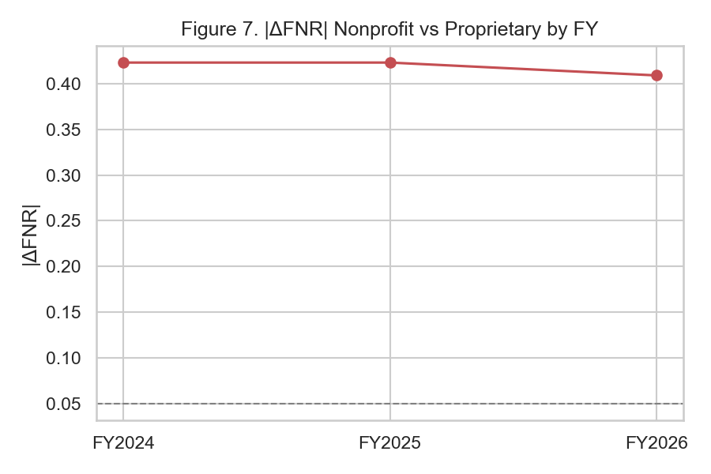
Figure 7. |ΔFNR| Nonprofit vs Proprietary by FY
Table 11. RQ3 discrimination and fairness by fiscal-year release
FY | AUROC | |ΔFNR| Nonprofit vs Proprietary
FY2024 | 0.605 | 0.423
FY2025 | 0.606 | 0.423
FY2026 | 0.608 | 0.409

RQ4 Preliminary Findings
On n = 80 stratified high-ERR FY2026 cases, the investigative agent achieved mean faithfulness = 1.00, evidence completeness = 0.99, numeric hallucination = 0.00, and HITL usefulness proxy = 1.00. The no-tool LLM baseline showed faithfulness = 0.25 and hallucination = 1.00. Static dashboard completeness = 0.33 (risk snapshot only). Wilcoxon signed-rank tests (agent − baseline) were significant for faithfulness, evidence completeness, and usefulness (all p < .001). Agent evidence completeness also exceeded the static dashboard (p < .001). Ha for RQ4 is supported at interim for at least two dossier-quality metrics. Policy boundary remains: dossiers are advisory only; no autonomous CMS/clinical actions.
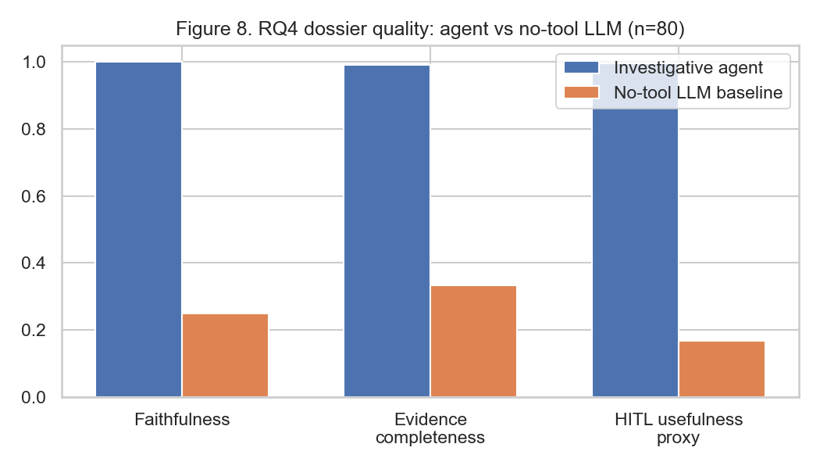
Figure 8. RQ4 dossier quality: agent vs no-tool LLM (n=80)
Table 12. RQ4 dossier quality means (paired n=80)
System | Faithfulness | Evidence completeness | Hallucination | HITL usefulness proxy
Investigative agent | 1.000 | 0.992 | 0.000 | 0.996
No-tool LLM | 0.250 | 0.333 | 1.000 | 0.167
Static dashboard | 1.000 | 0.333 | 0.000 | N/A (incomplete slots)

Cross-RQ Status Summary
Table 13. Interim hypothesis outcomes by research question
RQ | Hypothesis test (interim) | Supported? | Primary evidence
RQ1 | ≥1 significant adjusted association | Yes | 19 sig. terms; Table 9
RQ2 | Best ML AUROC > logistic + 0.02 | Yes | ΔAUROC=0.064; Table 10 / Figure 5
RQ3 | AUROC drop>0.03 or |ΔFNR| change>0.05 | No (gap persistent, not drifting) | Tables 11; Figures 6–7
RQ4 | Improve ≥2 dossier metrics vs baselines | Yes | Table 12 / Figure 8; Wilcoxon p<.001

Interim Limitations and Risks
First, hospital–condition rows are ecological units; associations (RQ1) should not be interpreted as patient-level causal effects. Second, structural ML discrimination is intentionally moderate because predicted/expected rates are excluded; including them would inflate AUROC without answering the structural early-warning question. Third, ownership/state are proxy fairness attributes and may omit important social determinants. Fourth, CMS performance windows overlap across FY releases, so temporal dependence remains. Fifth, RQ4 interim evaluation uses a deterministic tool-grounded agent and a simulated no-tool LLM baseline; final work should add blinded human HITL ratings and, optionally, an API LLM planner constrained to the same tools. Sixth, GitHub URL publication for external evaluator access is pending.
Next Steps (for Final Report)
• Publish GitHub repository with README, data dictionary pointer, and reproduction commands.
• Add SHAP summaries as optional evidence inside dossiers (not a replacement for peer/what-if tools).
• Collect human HITL Accept/Edit/Reject ratings on the same 80+ cases.
• Expand RQ3 with geography strata and formal drift confidence intervals.
• Produce calibration and operational threshold analysis for RQ2.
• Write final recommendations for quality leaders and finalize APA bibliography.
Bibliography
Amodei, D., Olah, C., Steinhardt, J., Christiano, P., Schulman, J., & Mané, D. (2016). Concrete problems in AI safety. arXiv preprint arXiv:1606.06565.
Centers for Medicare & Medicaid Services. (2024). Hospital Readmissions Reduction Program (HRRP). https://www.cms.gov/medicare/payment/prospective-payment-systems/acute-inpatient-pps/hospital-readmissions-reduction-program-hrrp
Collins, G. S., Moons, K. G. M., Dhiman, P., Riley, R. D., Beam, A. L., Van Calster, B., ... & Logullo, P. (2024). TRIPOD+AI statement: Updated guidance for reporting clinical prediction models that use regression or machine learning methods. BMJ, 385, e078378. https://doi.org/10.1136/bmj-2023-078378
Davis, S. E., Lasko, T. A., Chen, G., Sweeney, T. E., & Matheny, M. E. (2025). Monitoring fairness drift in clinical prediction models over time. Journal of the American Medical Informatics Association. Advance online publication.
Joynt, K. E., & Jha, A. K. (2013). A path forward on Medicare readmissions. New England Journal of Medicine, 368(13), 1175–1177.
Krumholz, H. M., Wang, K., Lin, Z., Normand, S. L. T., & others. (2017). Hospital-readmission risk: Isolating hospital effects from patient effects. New England Journal of Medicine, 377(11), 1055–1064.
Lundberg, S. M., & Lee, S. I. (2017). A unified approach to interpreting model predictions. Advances in Neural Information Processing Systems, 30.
Rajkomar, A., Oren, E., Chen, K., Dai, A. M., Hajaj, N., Hardt, M., ... & Dean, J. (2018). Scalable and accurate deep learning with electronic health records. npj Digital Medicine, 1, 18.
Singhal, K., Azizi, S., Tu, T., Mahdavi, S. S., Wei, J., Chung, H. W., ... & Natarajan, V. (2023). Large language models encode clinical knowledge. Nature, 620, 172–180.
Wang, X., Weiner, J. P., Saria, S., & Kharrazi, H. (2024). Auditing contextual bias in hospital readmission prediction. Health Services Research / JAMIA-related fairness audit literature.
Yang, Q., et al. (2026). Tool-using language agents for clinical tabular evidence exploration. Conference / journal preprint in clinical AI agents.
Zafar, M. B., Valera, I., Gomez-Rodriguez, M., & Gummadi, K. P. (2019). Fairness constraints: A flexible approach for fair classification. Journal of Machine Learning Research, 20(75), 1–42.

Appendix A: Reproduction Commands
From the project root, install dependencies (pandas, scikit-learn, statsmodels, matplotlib, seaborn, scipy, python-docx) and run:
python run_interim_analysis.py
Outputs write to analysis_outputs/metrics.json, analysis_outputs/figures/, and analysis_outputs/processed/. This Interim Report can be regenerated with python _build_interim_report.py. See also sample dossiers in analysis_outputs/processed/sample_agent_dossiers.txt.
Appendix B: Agent Policy Boundary
The Investigative Agentic QI Case Agent never auto-approves CMS penalties, clinical orders, payment adjustments, or model retraining/deployment. Every dossier is labeled ADVISORY ONLY and requires human Accept/Edit/Reject before operational use.

