IT3060 – HCI Lab Exercise 05
Activity 4: FitFlow System Architecture Design
Project: FitFlow – AI-Powered Fitness Tracking Application

1. Architecture Components
Layer | Technology / Component | Responsibility
Frontend | React Native | Provides the Android and iOS user interface.
Backend | Node.js + Express | Handles API requests, business logic, and service communication.
Authentication | Authentication service | Manages registration, login, and access control.
AI/ML layer | TensorFlow Lite, ML Kit, Cloud AI | Creates personalized workout plans and identifies food images.
Database layer | Application database | Stores users, workouts, nutrition, progress, and social data.
Real-time layer | Firebase services | Supports real-time social updates and notifications.
Caching layer | Cache service | Improves response time and reduces repeated database requests.
Security layer | Encryption, validation, access control | Protects personal and health-related information.

2. Architecture Diagram Description
Figure 1: FitFlow System Architecture Diagram
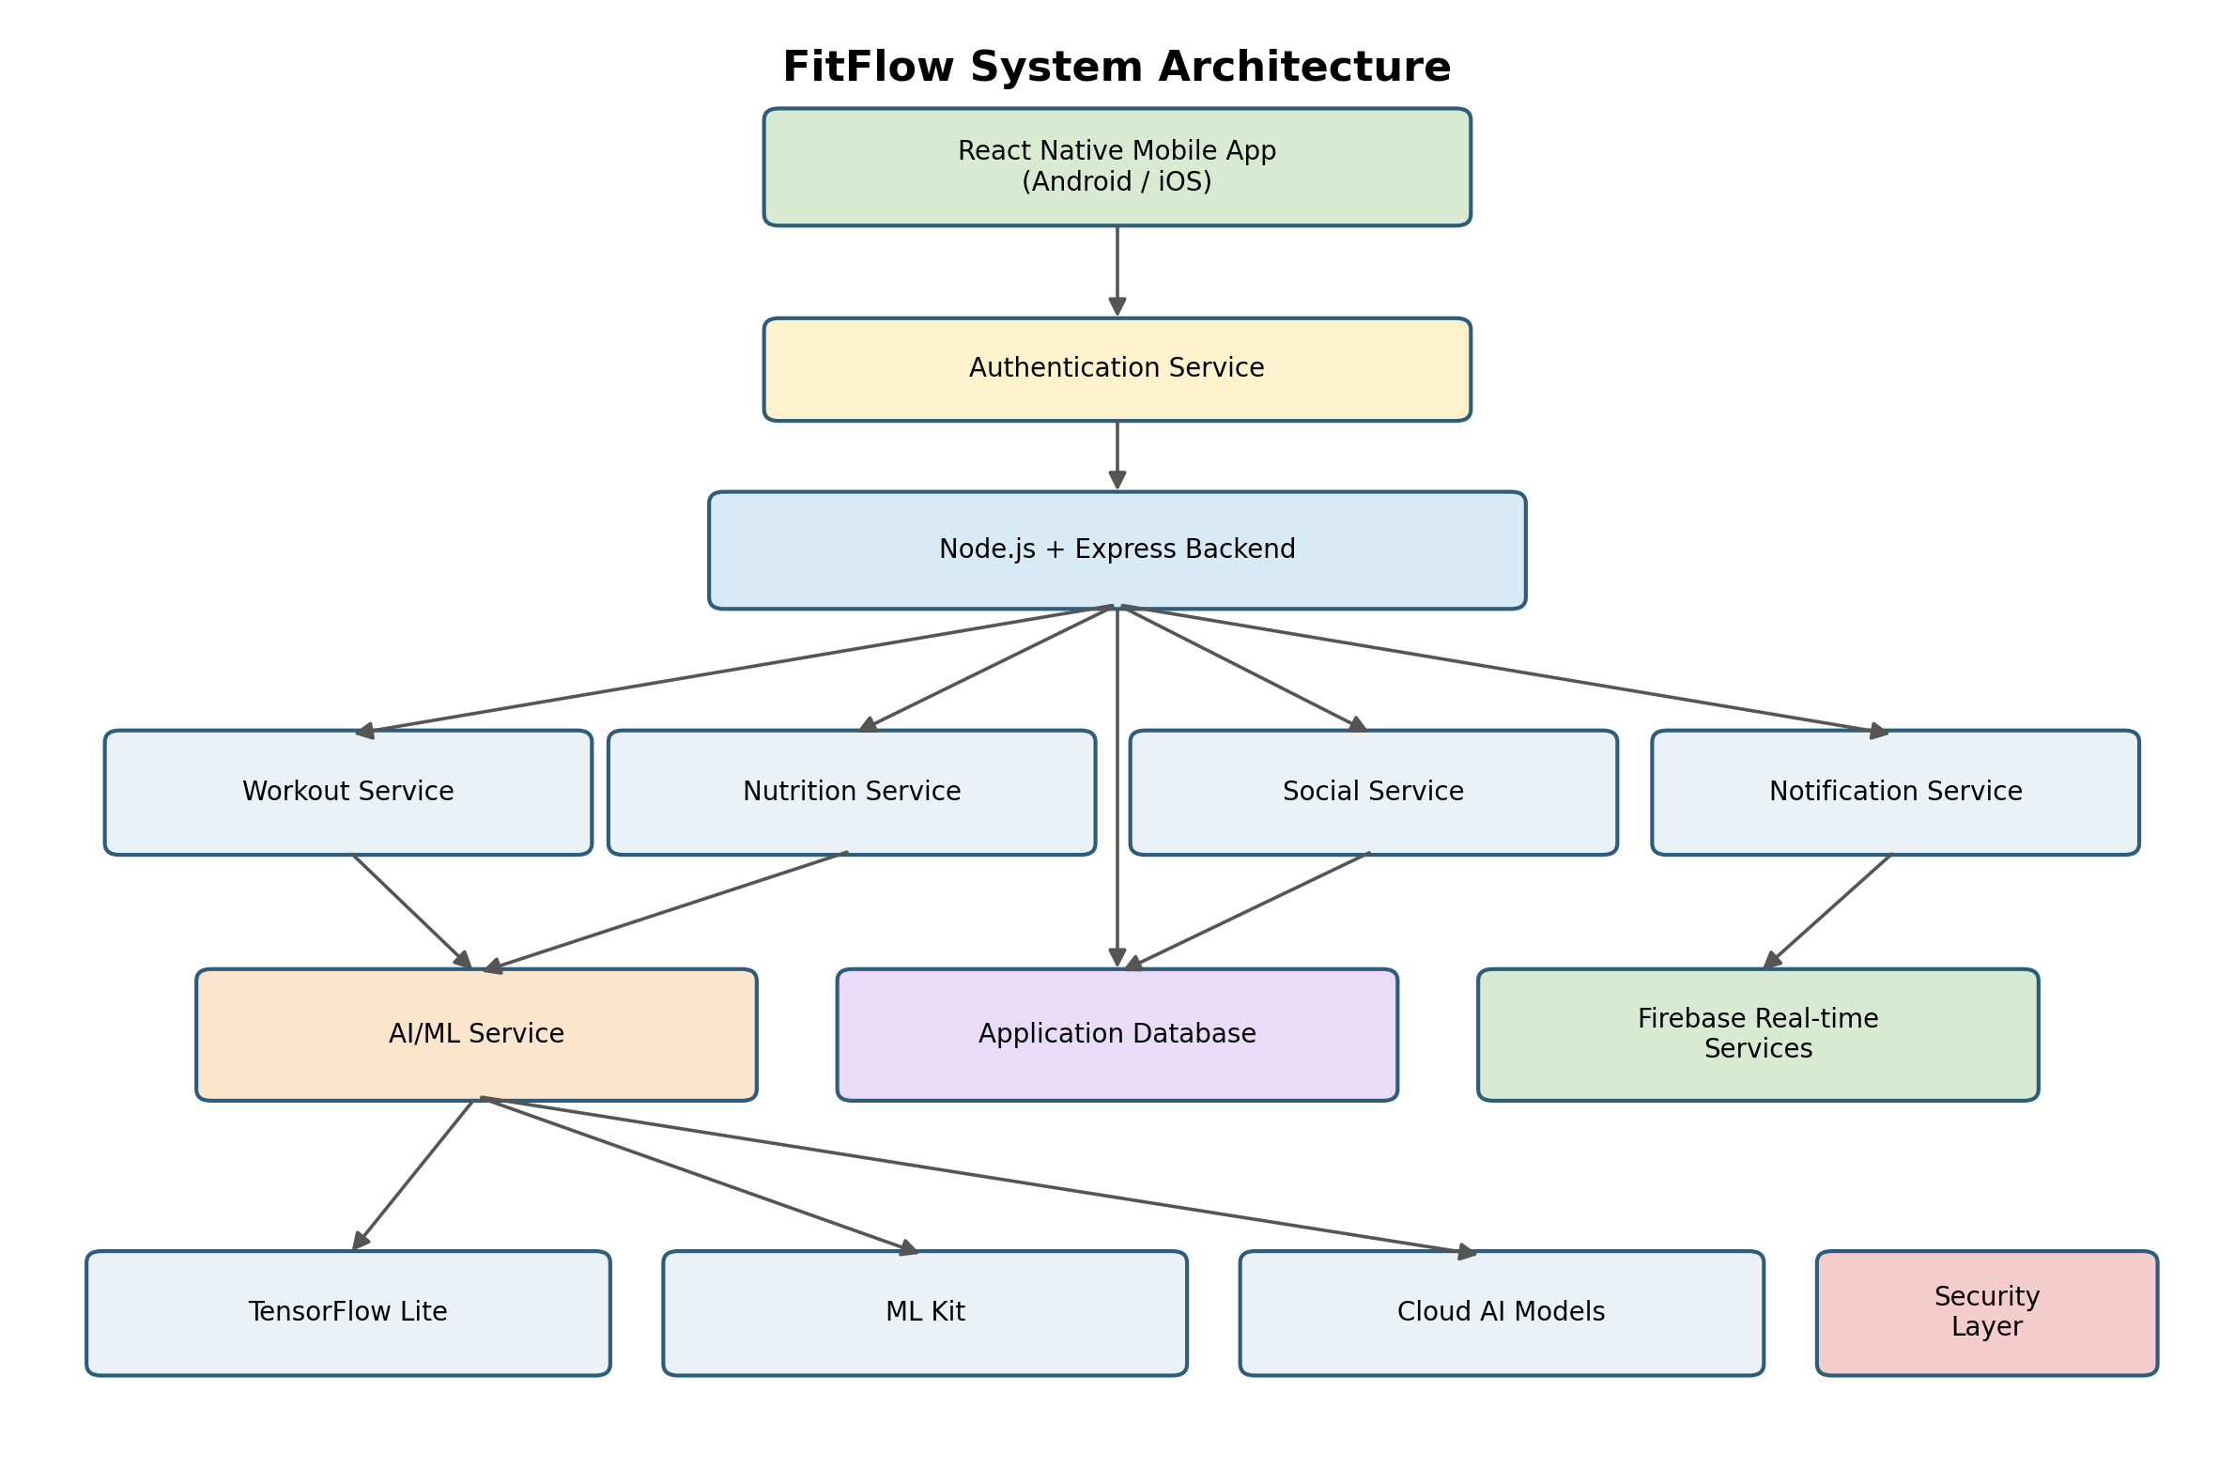
The React Native application communicates with the Node.js and Express backend through secure API requests. The backend manages user, workout, nutrition, and social services. It communicates with the database, Firebase real-time services, cache layer, and AI/ML services. The AI/ML layer uses TensorFlow Lite for on-device personalization, ML Kit for image-based nutrition recognition, and cloud AI models for advanced processing.
Text-based architecture flow:
- React Native Mobile App → Authentication Service
- React Native Mobile App → Node.js + Express Backend
- Backend → User, Workout, Nutrition, and Social Services
- Workout and Nutrition Services → AI/ML Service
- AI/ML Service → TensorFlow Lite, ML Kit, and Cloud AI Models
- Backend → Application Database
- Backend → Firebase Real-time Services → Social Updates and Notifications
- Backend → Cache Layer
- Security Layer protects authentication, APIs, databases, and real-time services

3. Data Flow Examples

3.1 Personalized Workout Plan
User enters fitness goals → App sends request → Backend processes request → AI service generates plan → Plan is stored → Plan is displayed.

3.2 Nutrition Tracking
User captures food image → ML Kit/AI identifies food → Nutrition information is calculated → Record is stored → User views nutrition details.

3.3 Social Community
User creates post or joins challenge → Backend validates request → Data is stored → Firebase sends real-time update → Other users receive notification.

4. Security and Scalability
Security measures:
- Use secure authentication and authorization.
- Validate all user inputs.
- Encrypt sensitive data during transmission.
- Apply role-based access control.
- Protect private social groups and health-related information.
- Minimize unnecessary transmission of personal data.
Scalability measures:
- Separate AI services from the main backend.
- Use caching for frequently requested information.
- Use Firebase for real-time communication and notifications.
- Use scalable database services.
- Deploy and monitor services independently.

5. Architecture Decision Record
Decision: Use a layered architecture with React Native, Node.js with Express, Firebase real-time services, and separate AI/ML services.
Reason: This structure supports cross-platform development, fast implementation, real-time social interaction, AI-based personalization, and future scalability.
Advantages: Shared mobile codebase, clear separation of responsibilities, easier maintenance, independent AI service development, and scalable real-time communication.
Possible challenges: Managing multiple services, protecting sensitive data, controlling cloud costs, synchronizing data, and monitoring AI performance.

