***WATER QUALITY ANALYSIS***

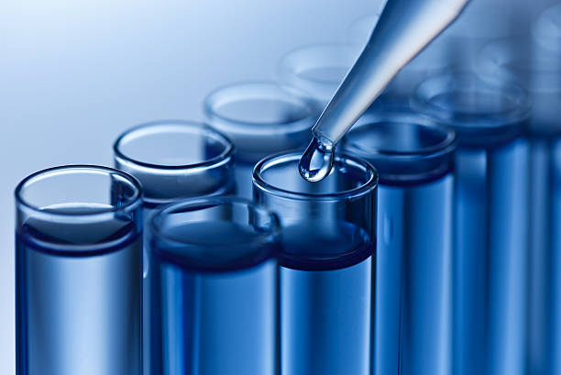

**INTRODUCTION**

Water quality analysis is a critical aspect of environmental monitoring and management. In recent years, advancements in data analytics have revolutionised the way we assess and manage water quality. This project aims to leverage data analytics techniques to gain deeper insights into water quality parameters, enabling more efficient decision-making and proactive environmental protection.

**OBJECTIVE:**

The primary objective of this project is to develop a comprehensive understanding of water quality in a specific region. By analysing various water quality parameters, such as pH, turbidity, dissolved oxygen, temperature, and pollutant levels, we seek to identify patterns, trends, and potential issues affecting water bodies.

**DATA COLLECTION:**

In the context of water quality analysis, the process of data collection involves the systematic acquisition of diverse datasets from a multitude of sources. These sources encompass an array of in-situ sensors, remote sensing technologies, manual measurements, and historical records. The aim is to procure a rich and comprehensive dataset that encapsulates the spatiotemporal dynamics of water quality parameters.

- **In-Situ Sensors:** Deployed within the aquatic ecosystem, these sensors continuously record real-time data on parameters such as pH, dissolved oxygen, temperature, and turbidity.

- **Remote Sensing:** Satellite and aerial imagery provide an invaluable macroscopic view of water bodies, enabling the assessment of parameters like watercolour, temperature anomalies, and algal blooms over large geographic areas.

- **Manual Measurements:** Laboratory and field measurements conducted by trained personnel yield precise and controlled data on a range of parameters, ensuring data accuracy.

- **Historical Records:** Archive data from past observations, research studies, and government agencies offer long-term trends and historical context.

**DATA MONITORING:**

The process of data monitoring in water quality analysis entails real-time observation and continuous quality control of incoming data streams. It involves the following technical components,real-time data essential for accurate water quality assessment and management. These technical aspects form the foundation for subsequent data analytics and modelling processes in the project.

- **Data Integration:** Diverse datasets from multiple sources are integrated and harmonised to create a unified dataset. Advanced data integration techniques, such as data fusion and interpolation, are employed.

- **Metadata Management:** Detailed metadata records are maintained to provide a context for each data point, including sensor specifications, location, and timestamp.

- **Real-time Visualisation:** Data visualisation tools and dashboards enable real-time monitoring of water quality parameters, allowing immediate response to sudden changes or anomalies.

- **Alerts and Notifications:** Automated alert systems can be set up to notify operators and stakeholders in the event of critical deviations in water quality parameters.

**DATA ANALYSIS AND VISUALISATION:**

* In the field of water quality analysis, data analysis involves applying statistical, machine learning, and spatial techniques to derive insights from collected datasets, revealing patterns and relationships in water quality parameters.
* Concurrently, data visualisation techniques, including graphical plots, heatmaps, geospatial mapping, and interactive dashboards, are employed to effectively communicate these insights to stakeholders, enabling informed decision-making and proactive environmental management.

**PREDICTIVE MODELLING:**

Predictive modelling in water quality analysis involves using statistical, machine learning, and hydrological models to forecast future water quality parameters based on historical and real-time data. This process includes selecting relevant features, training models, evaluating accuracy, and implementing the models for real-time predictions, aiding in early anomaly detection and informed environmental decision-making.

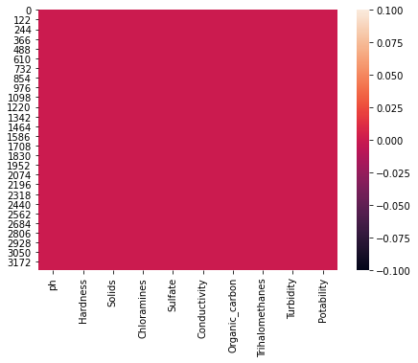

**IDENTIFYING POLLUTING SOURCE:**

* Analysing spatial and temporal trends in water quality data, conducting site inspections.
* employing tracing methods, pollution sources such as industrial discharges or agricultural runoff can be pinpointed, facilitating targeted mitigation efforts.

**PUBLIC AWARENESS AND EDUCATION:**

* It involves disseminating information about the importance of clean water, the potential risks of pollution, and ways to contribute to its preservation.
* This includes community outreach, school programs, and digital resources to inform individuals about responsible water usage, pollution prevention, and the significance of safeguarding this vital resource for current and future generations.

**CONTRIBUTORS:**

* Furthermore, risk assessment aids in understanding and quantifying potential hazards related to water contamination. Lastly, public reporting and communication convey water quality findings to stakeholders, fostering transparency and informed decision-making.
* These diverse components collectively contribute to comprehensive water quality management and protection

**CHALLENGES:**

* Challenges in a water quality analysis project may include dealing with the complexity of water systems.
* which are influenced by various natural and anthropogenic factors, leading to intricate data patterns and potential data gaps.
* Data quality and consistency issues can arise from sensor inaccuracies, limited historical records, and the need for extensive data cleaning.

**PROGRAM:**

*water quality data analytics program in python is as follows and the output is given.*

*water_quality_data =*

*{*

*'pH': [7.2, 7.4, 7.0, 7.5, 6.8],*

*'Turbidity': [5.2, 5.5, 6.0, 4.8, 5.2],*

*'Dissolved_Oxygen': [8.2, 8.5, 8.0, 7.7, 8.4],*

*'Chlorine_Level': [1.0, 0.8, 1.2, 1.5, 0.9]*

*}*

*# Calculate average values for each parameter*

*average_values = {}*

*for parameter, values in water_quality_data.items():*

*average_values[parameter] = sum(values) / len(values)*

*# Define water quality thresholds*

*pH_threshold = (6.5, 8.5)*

*turbidity_threshold = (0, 5.0)*

*dissolved_oxygen_threshold = (7.0, 9.0)*

*chlorine_threshold = (0.5, 1.5)*

*# Analyze water quality based on thresholds*

*def analyze_water_quality(parameter, value, threshold):*

*if threshold[0] <= value <= threshold[1]:*

*return "Within acceptable range"*

*else:*

*return "Outside acceptable range"*

*# Check if water quality parameters are within acceptable ranges*

*for parameter, value in average_values.items():*

*result = analyze_water_quality(parameter, value, locals()[f"{parameter}_threshold"])*

*print(f"{parameter}: {value} - {result}")*

**OUTPUT:**

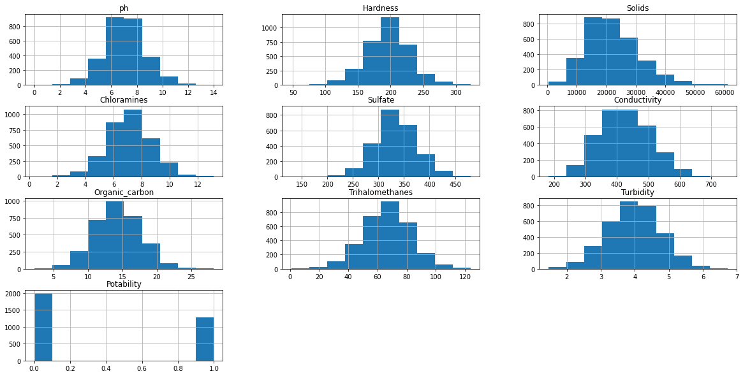

**pH Calculation:**

pH is a measure of the acidity or alkalinity of a solution.

pH is calculated using the formula:

pH = -log10([H+]).

**Dissolved Oxygen (DO) Saturation:**

DO saturation is the amount of oxygen present in water compared to the maximum amount it can hold at a given temperature.

It's calculated using Henry's Law: DO% = (Measured DO / DO at Saturation) x 100%.

**Total Dissolved Solids (TDS):**TDS is the sum of all inorganic and organic substances in a water sample.

It's calculated by evaporating a known volume of water and measuring the residue.

The formula is:

TDS (mg/L) = (Residue Weight (mg) / Volume of Water Sample (L)).

**Chlorine Dosage:**

To calculate the amount of chlorine needed to disinfect water, you'll need the chlorine demand, water volume, and desired chlorine residual.

The formula is:

Chlorine Dosage (mg/L) = (Chlorine Demand (mg/L) + Desired Residual (mg/L)) x Water Volume (L).

**BENEFITS:**

Ensuring safe drinking water.

Protecting aquatic ecosystems.

Monitoring industrial discharge.

Supporting agricultural practices.

Preventing waterborne diseases.

Compliance with environmental regulations.

Identifying contamination sources.

Safeguarding public health.

Assessing ecological health.

Preserving natural resources.

**CONCLUSION:**

In conclusion, water quality analysis plays a critical role in safeguarding human and environmental health by ensuring access to safe drinking water, protecting aquatic ecosystems, monitoring industrial discharges, supporting agriculture, and helping prevent waterborne diseases. It also aids in regulatory compliance, source identification, and resource preservation.