Model Evaluation – Fine-grained Classification

1) Learning rate = 9e-4
Weight decay =1e-9
momentum = 0.9
Epochs = 100

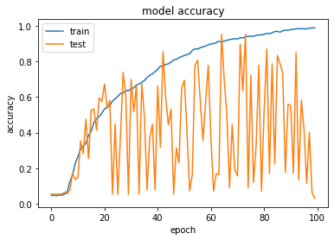

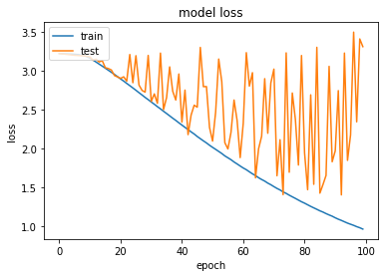

2) Learning rate = 1e-4
Weight decay =1e-9
momentum = 0.9
Epochs = 100

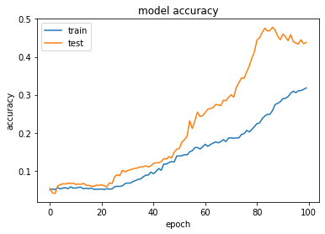

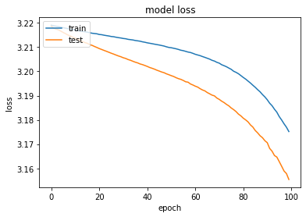

3) Learning rate = 1e-4
Weight decay =1e-9
momentum = 0.9
Epochs = 500

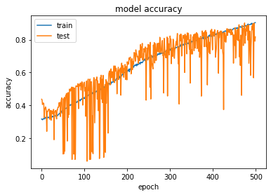

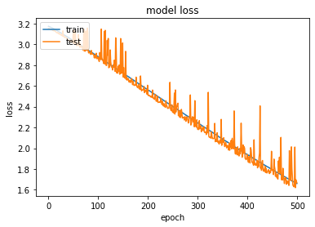

4) Learning rate = 1e-5
Weight decay =1e-9
momentum = 0.9
Epochs = 100

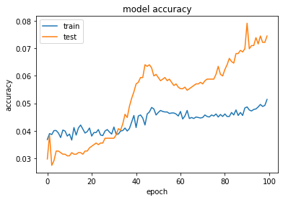

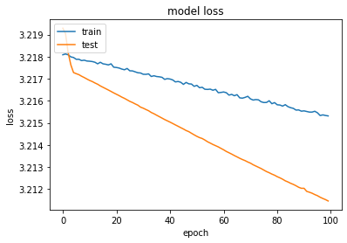

5) Learning rate = 1e-5
Weight decay =1e-9
momentum = 0.9
Epochs = 500

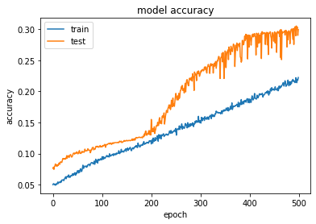
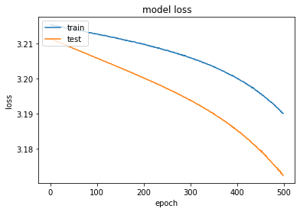

6) Learning rate = 1e-6
Weight decay =1e-9
momentum = 0.9
Epochs = 100

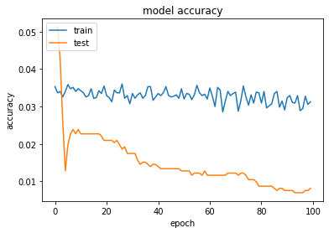
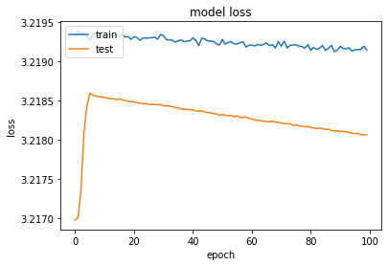

The best results were yield by using the learning rate as 1e-5. Continuing training with that hyper-parameter setting for 500 epoch.
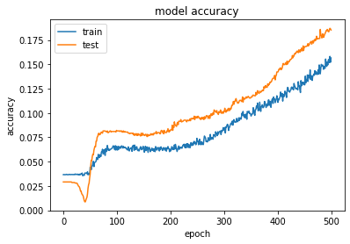
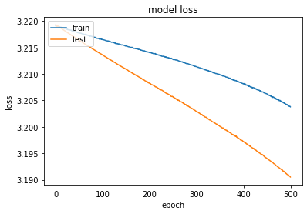

Continuing training for another 1000 epochs
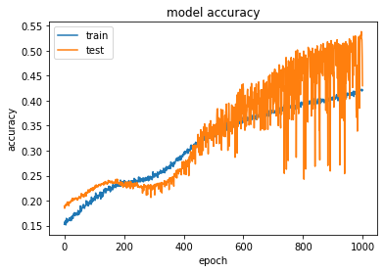
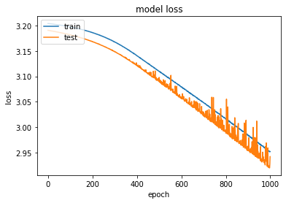

Model training shows unexpected spikes in accuracy/loss after some epochs. However, the learning is very slow. Therefore, it does not reach a satisfactory level before it gives these unexpected behaviours.

