You can use multiple **if...else…if** statements, as in the previous chapter, to perform a multiway branch. However, this is not always the best solution, especially when all of the branches depend on the value of a single variable.

Starting with JavaScript 1.2, you can use a **switch** statement which handles exactly this situation, and it does so more efficiently than repeated **if...else if** statements.

Flow Chart

The following flow chart explains a switch-case statement works.

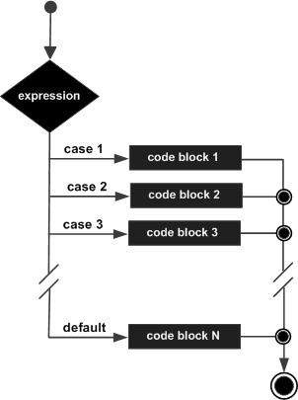

Syntax

The objective of a **switch** statement is to give an expression to evaluate and several different statements to execute based on the value of the expression. The interpreter checks each **case** against the value of the expression until a match is found. If nothing matches, a **default** condition will be used.

switch (expression) {

case condition 1: statement(s)

break;

case condition 2: statement(s)

break;

...

case condition n: statement(s)

break;

default: statement(s)

}

The **break** statements indicate the end of a particular case. If they were omitted, the interpreter would continue executing each statement in each of the following cases.

We will explain **break** statement in **Loop Control** chapter.

Example

Try the following example to implement switch-case statement.

[Live Demo](http://tpcg.io/pNWbNd)

<html>

<body>

<script type = "text/javascript">

<!--

var grade = 'A';

document.write("Entering switch block<br />");

switch (grade) {

case 'A': document.write("Good job<br />");

break;

case 'B': document.write("Pretty good<br />");

break;

case 'C': document.write("Passed<br />");

break;

case 'D': document.write("Not so good<br />");

break;

case 'F': document.write("Failed<br />");

break;

default: document.write("Unknown grade<br />")

}

document.write("Exiting switch block");

//-->

</script>

<p>Set the variable to different value and then try...</p>

</body>

</html>

Output

Entering switch block

Good job

Exiting switch block

Set the variable to different value and then try...

Break statements play a major role in switch-case statements. Try the following code that uses switch-case statement without any break statement.

[Live Demo](http://tpcg.io/ouqbd3)

<html>

<body>

<script type = "text/javascript">

<!--

var grade = 'A';

document.write("Entering switch block<br />");

switch (grade) {

case 'A': document.write("Good job<br />");

case 'B': document.write("Pretty good<br />");

case 'C': document.write("Passed<br />");

case 'D': document.write("Not so good<br />");

case 'F': document.write("Failed<br />");

default: document.write("Unknown grade<br />")

}

document.write("Exiting switch block");

//-->

</script>

<p>Set the variable to different value and then try...</p>

</body>

</html>

Output

Entering switch block

Good job

Pretty good

Passed

Not so good

Failed

Unknown grade

Exiting switch block

Set the variable to different value and then try...