**What Are Variables In Python?**

Variables and data types in python as the name suggests are the values that vary. In a programming language, a variable is a memory location where you store a value. The value that you have stored may change in the future according to the specifications.

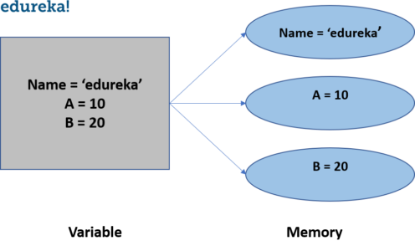

Name= ‘Camerinfolks’

Name= ‘Camerinfolks’

A Variable in python is created as soon as a value is assigned to it. It does not need any additional commands to declare a variable in python.

There are a certain rules and regulations we have to follow while writing a variable, lets take a look at the variable definition and declaration to understand how we declare a variable in python.

**Variable Definition & Declaration**

Python has no additional commands to declare a variable. As soon as the value is assigned to it, the variable is declared.

|  |  |
| --- | --- |
| 1  2 | x = 10  #variable is declared as the value 10 is assigned to it. |

There are a certain rules that we have to keep in mind while declaring a variable:

1. The variable name cannot start with a number. It can only start with a character or an underscore.
2. Variables in python are case sensitive.
3. They can only contain alpha-numeric characters and underscores.
4. No special characters are allowed.

There are several data types in python. Lets take a look at the data types in python.

Every value that we declare in python has a data type. Data types are classes and variables are the instances of these classes.

**Data Types In Python**

According to the properties they possess, there are mainly six data types in python. Although there is one more data type range which is often used while working with loops in python.

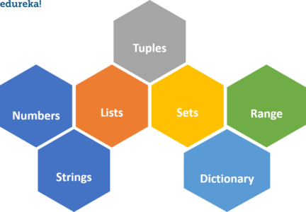

**Numerical Data Types**

Numerical data type holds numerical value. In numerical data there are 4 sub types as well. Following are the sub-types of numerical data type:

1. Integers
2. Float
3. Complex Numbers
4. Boolean

**Integers** are used to represent whole number values.

|  |  |
| --- | --- |
| 1  2  3 | x = 100  y = 124  # it will be the integer as long as the value is a whole number. |

To check the type of any variable data type, we can use the **type()** function. It will return the type of the mentioned variable data type.

**Float**data type is used to represent decimal point values.

[[](https://www.edureka.co/python-programming-certification-training)](https://www.edureka.co/python-programming-certification-training" \t "_blank)

**[Python Certification Training Course](https://www.edureka.co/python-programming-certification-training" \t "_blank)**

[Explore Curriculum](https://www.edureka.co/python-programming-certification-training" \t "_blank)

|  |  |
| --- | --- |
| 1  2 | x  = 10.25  y = 12.30 |

**Complex**numbers are used to represent imaginary values. Imaginary values are denoted with ‘j’ at the end of the number.

|  |  |
| --- | --- |
| 1 | x = 10 + 5j |

**Boolean**is used for categorical output, since the output of boolean is either true or false.

|  |  |
| --- | --- |
| 1  2  3  4  5  6 | num = 5 > 4  #num is the boolean variable  type(num)  #the output will be bool  print(num)  #this will print true. |

**Strings**

Strings in python are used to represent unicode character values. Python does not have a character data type, a single character is also considered as a string.

We denote or declare the string values inside single quotes or double quotes. To access the values in a string, we use the indexes and square brackets.

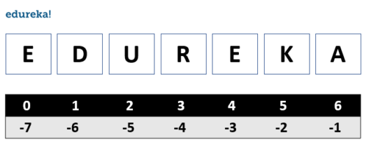

!

.

O

L

L

E

H

|  |  |
| --- | --- |
| 1  2  3 | name = 'camerinfolks'  name[2]  #this will give you the output as 'u' |

Strings are immutable in nature, which means you cannot change a string once replaced.

**Command line input for strings**

|  |  |
| --- | --- |
| 1  2 | x = input()  print( 'hello' , x) |

**Operations using strings**

|  |  |
| --- | --- |
| 1  2  3  4  5  6  7  8  9 | name = 'camerinfolks'  name.upper()  #this will make the letters to uppercase  name.lower()  #this will make the letters to lowercase  name.replace('e') = 'E'  #this will replace the letter 'e' with 'E'  name[1: 4]  #this will return the strings starting at index 1 until the index 4. |