# Arithmetic Operations on Images using OpenCV | Set-2 (Bitwise Operations on Binary Images)

* **Difficulty Level :** [Easy](https://www.geeksforgeeks.org/easy/)
* **Last Updated :** 12 Oct, 2021

Prerequisite: [Arithmetic Operations on Images | Set-1](https://www.geeksforgeeks.org/arithmetic-operations-on-images-using-opencv-set-1-addition-and-subtraction/)  
Bitwise operations are used in image manipulation and used for extracting essential parts in the image. In this article, Bitwise operations used are : 

1. **AND**
2. **OR**
3. **XOR**
4. **NOT**

Also, Bitwise operations helps in image masking. Image creation can be enabled with the help of these operations. These operations can be helpful in enhancing the properties of the input images.   
**NOTE:**The Bitwise operations should be applied on input images of same dimensions  
**Input Image 1:** 



**Input Image 2:**



### Bitwise AND operation on Image:

Bit-wise conjunction of input array elements. 

***Syntax:****cv2.bitwise_and(source1, source2, destination, mask)****Parameters:******source1:****First Input Image array(Single-channel, 8-bit or floating-point)****source2:****Second Input Image array(Single-channel, 8-bit or floating-point)****dest:****Output array (Similar to the dimensions and type of Input image array)****mask:****Operation mask, Input / output 8-bit single-channel mask*

* Python3

|  |
| --- |
| # Python program to illustrate  # arithmetic operation of  # bitwise AND of two images    # organizing imports  import cv2  import numpy as np    # path to input images are specified and  # images are loaded with imread command  img1 = cv2.imread('input1.png')  img2 = cv2.imread('input2.png')    # cv2.bitwise_and is applied over the  # image inputs with applied parameters  dest_and = cv2.bitwise_and(img2, img1, mask = None)    # the window showing output image  # with the Bitwise AND operation  # on the input images  cv2.imshow('Bitwise And', dest_and)    # De-allocate any associated memory usage  if cv2.waitKey(0) & 0xff == 27:      cv2.destroyAllWindows() |

**Output:**

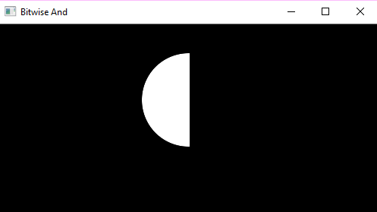

### Bitwise OR operation on Image:

Bit-wise disjunction of input array elements. 

***Syntax:****cv2.bitwise_or(source1, source2, destination, mask)****Parameters:******source1:****First Input Image array(Single-channel, 8-bit or floating-point)****source2:****Second Input Image array(Single-channel, 8-bit or floating-point)****dest:****Output array (Similar to the dimensions and type of Input image array)****mask:****Operation mask, Input / output 8-bit single-channel mask*

* Python3

|  |
| --- |
| # Python program to illustrate  # arithmetic operation of  # bitwise OR of two images    # organizing imports  import cv2  import numpy as np    # path to input images are specified and  # images are loaded with imread command  img1 = cv2.imread('input1.png')  img2 = cv2.imread('input2.png')    # cv2.bitwise_or is applied over the  # image inputs with applied parameters  dest_or = cv2.bitwise_or(img2, img1, mask = None)    # the window showing output image  # with the Bitwise OR operation  # on the input images  cv2.imshow('Bitwise OR', dest_or)    # De-allocate any associated memory usage  if cv2.waitKey(0) & 0xff == 27:      cv2.destroyAllWindows() |

**Output:**

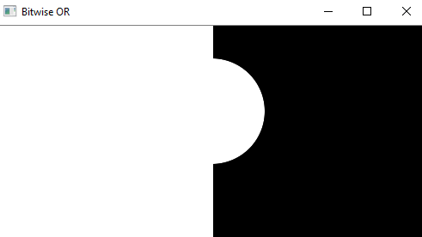

### Bitwise XOR operation on Image:

Bit-wise exclusive-OR operation on input array elements. 

***Syntax:****cv2.bitwise_xor(source1, source2, destination, mask)****Parameters:******source1:****First Input Image array(Single-channel, 8-bit or floating-point)****source2:****Second Input Image array(Single-channel, 8-bit or floating-point)****dest:****Output array (Similar to the dimensions and type of Input image array)****mask:****Operation mask, Input / output 8-bit single-channel mask*

* Python3

|  |
| --- |
| # Python program to illustrate  # arithmetic operation of  # bitwise XOR of two images    # organizing imports  import cv2  import numpy as np    # path to input images are specified and  # images are loaded with imread command  img1 = cv2.imread('input1.png')  img2 = cv2.imread('input2.png')    # cv2.bitwise_xor is applied over the  # image inputs with applied parameters  dest_xor = cv2.bitwise_xor(img1, img2, mask = None)    # the window showing output image  # with the Bitwise XOR operation  # on the input images  cv2.imshow('Bitwise XOR', dest_xor)    # De-allocate any associated memory usage  if cv2.waitKey(0) & 0xff == 27:      cv2.destroyAllWindows() |

**Output:** 

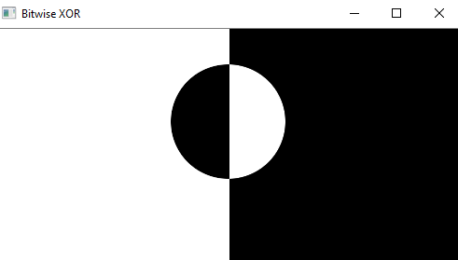

### Bitwise NOT operation on Image:

Inversion of input array elements. 

***Syntax:****cv2.bitwise_not(source, destination, mask)****Parameters:******source:****Input Image array(Single-channel, 8-bit or floating-point)****dest:****Output array (Similar to the dimensions and type of Input image array)****mask:****Operation mask, Input / output 8-bit single-channel mask*

* Python3

|  |
| --- |
| # Python program to illustrate  # arithmetic operation of  # bitwise NOT on input image    # organizing imports  import cv2  import numpy as np    # path to input images are specified and  # images are loaded with imread command  img1 = cv2.imread('input1.png')  img2 = cv2.imread('input2.png')    # cv2.bitwise_not is applied over the  # image input with applied parameters  dest_not1 = cv2.bitwise_not(img1, mask = None)  dest_not2 = cv2.bitwise_not(img2, mask = None)    # the windows showing output image  # with the Bitwise NOT operation  # on the 1st and 2nd input image  cv2.imshow('Bitwise NOT on image 1', dest_not1)  cv2.imshow('Bitwise NOT on image 2', dest_not2)    # De-allocate any associated memory usage  if cv2.waitKey(0) & 0xff == 27:      cv2.destroyAllWindows() |

**Output:**   
**Bitwise NOT on Image 1** 

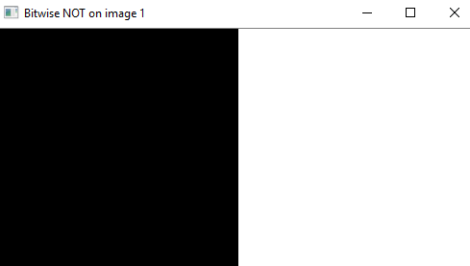

**Bitwise NOT on Image 2** 

