**Downloading and Installing OpenCV:**

OpenCV can be directly downloaded and installed with the use of pip (package manager). To install OpenCV, just go to the command-line and type the following command:

pip install opencv-python

**Beginning with the installation:**

* **Type the command in the Terminal and proceed:**  
  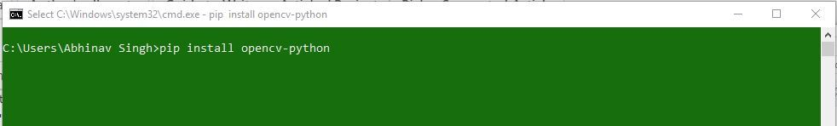
* **Collecting Information and downloading data:**  
  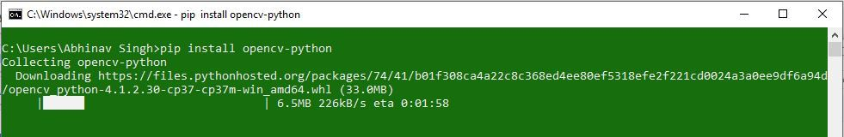
* **Installing Packages:**  
  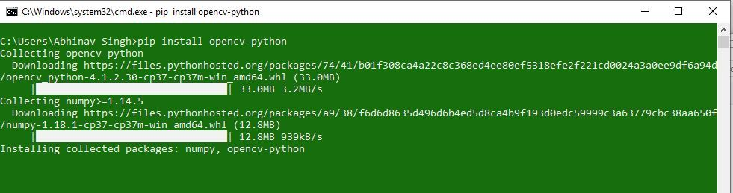
* **Finished Installation:**  
  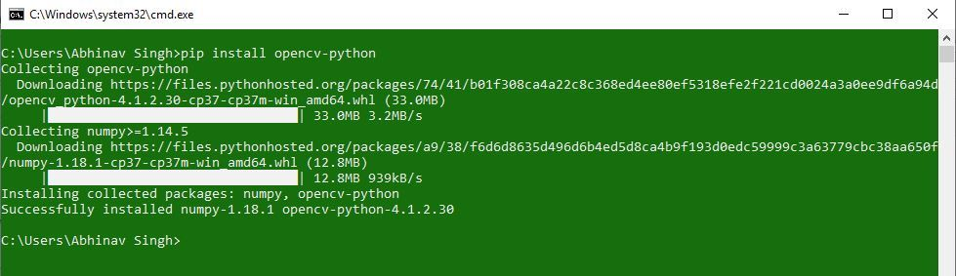

To check if OpenCV is correctly installed, just run the following commands to perform a version check:

python

>>>import cv2

>>>print(cv2.__version__)

