React Flux Concept

Flux is an application architecture that Facebook uses internally for building the client-side web application with React. It is not a library nor a framework. It is neither a library nor a framework. It is a kind of architecture that complements React as view and follows the concept of Unidirectional Data Flow model. It is useful when the project has dynamic data, and we need to keep the data updated in an effective manner. It reduces the runtime errors.

Flux applications have three major roles in dealing with data:

1. Dispatcher
2. Stores
3. Views (React components)

Here, you should not be confused with the Model-View-Controller (MVC) model. Although, Controllers exists in both, but Flux controller-views (views) found at the top of the hierarchy. It retrieves data from the stores and then passes this data down to their children. Additionally, action creators - dispatcher helper methods used to describe all changes that are possible in the application. It can be useful as a fourth part of the Flux update cycle.

Structure and Data Flow

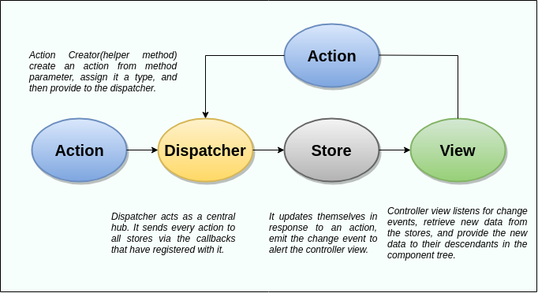

In Flux application, data flows in a single direction(unidirectional). This data flow is central to the flux pattern. The dispatcher, stores, and views are independent nodes with inputs and outputs. The actions are simple objects that contain new data and type property. Now, let us look at the various components of flux architecture one by one.

41.5M

715

History of Java

Dispatcher

It is a central hub for the React Flux application and manages all data flow of your Flux application. It is a registry of callbacks into the stores. It has no real intelligence of its own, and simply acts as a mechanism for distributing the actions to the stores. All stores register itself and provide a callback. It is a place which handled all events that modify the store. When an action creator provides a new action to the dispatcher, all stores receive that action via the callbacks in the registry.

The dispatcher's API has five methods. These are:

|  |  |  |
| --- | --- | --- |
| **SN** | **Methods** | **Descriptions** |
| 1. | register() | It is used to register a store's action handler callback. |
| 2. | unregister() | It is used to unregisters a store's callback. |
| 3. | waitFor() | It is used to wait for the specified callback to run first. |
| 4. | dispatch() | It is used to dispatches an action. |
| 5. | isDispatching() | It is used to checks if the dispatcher is currently dispatching an action. |

Stores

It primarily contains the application state and logic. It is similar to the model in a traditional MVC. It is used for maintaining a particular state within the application, updates themselves in response to an action, and emit the change event to alert the controller view.

Views

It is also called as controller-views. It is located at the top of the chain to store the logic to generate actions and receive new data from the store. It is a React component listen to change events and receives the data from the stores and re-render the application.

Actions

The dispatcher method allows us to trigger a dispatch to the store and include a payload of data, which we call an action. It is an action creator or helper methods that pass the data to the dispatcher.

Advantage of Flux

* It is a unidirectional data flow model which is easy to understand.
* It is open source and more of a design pattern than a formal framework like MVC architecture.
* The flux application is easier to maintain.
* The flux application parts are decoupled.

React Flux Vs. MVC

MVC

MVC stands for Model View Controller. It is an architectural pattern used for developing the user interface. It divides the application into three different logical components: the Model, the View, and the Controller. It is first introduced in 1976 in the Smalltalk programming language. In MVC, each component is built to handle specific development aspect of an application. It is one of the most used web development frameworks to create scalable projects.

MVC Architecture

The MVC architecture contains the three components. These are:

* **Model:** It is responsible for maintaining the behavior and data of an application.
* **View:** It is used to display the model in the user interface.
* **Controller:** It acts as an interface between the Model and the View components. It takes user input, manipulates the data(model) and causes the view to update.

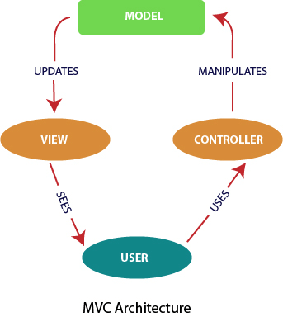

Flux

According to the official site, Flux is the application architecture that Facebook uses for building client-side web applications. It is an alternative to MVC architecture and other software design patterns for managing how data flows in the react application. It is the backbone of all React application. It is not a library nor a framework. It complements React as view and follows the concept of Unidirectional Data Flow model.

Flux Architecture has three major roles in dealing with data:

Keep Watching

1. Dispatcher
2. Stores
3. Views (React components)

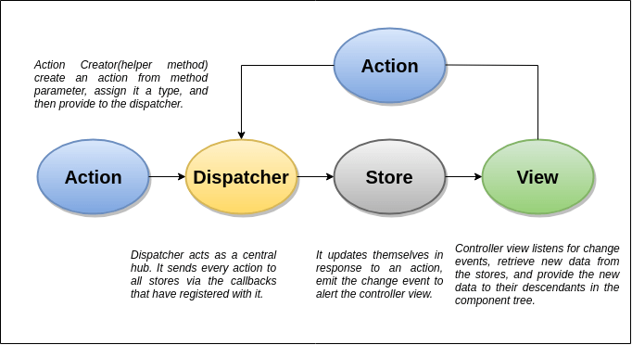

MVC Vs. Flux

|  |  |  |
| --- | --- | --- |
| **SN** | **MVC** | **FLUX** |
| **1.** | It was introduced in 1976. | It was introduced just a few years ago. |
| **2.** | It supports Bi-directional data Flow model. | It supports Uni-directional data flow model. |
| **3.** | In this, data binding is the key. | In this, events or actions are the keys. |
| **4.** | It is synchronous. | It is asynchronous. |
| **5.** | Here, controllers handle everything(logic). | Here, stores handle all logic. |
| **6.** | It is hard to debug. | It is easy to debug because it has common initiating point: Dispatcher. |
| **7.** | It is difficult to understand as the project size increases. | It is easy to understand. |
| **8.** | Its maintainability is difficult as the project scope goes huge. | Its maintainability is easy and reduces runtime errors. |
| **9.** | Testing of application is difficult. | Testing of application is easy. |
| **10.** | Scalability is complex. | It can be easily scalable. |