Here is a small example of react and Redux application. You can also try developing small apps. Sample code for increase or decrease counter is given below −

This is the root file which is responsible for the creation of store and rendering our react app component.

/src/index.js

import React from 'react'

import { render } from 'react-dom'

import { Provider } from 'react-redux'

import { createStore } from 'redux';

import reducer from '../src/reducer/index'

import App from '../src/App'

import './index.css';

const store = createStore(

reducer,

window.__REDUX_DEVTOOLS_EXTENSION__ &&

window.__REDUX_DEVTOOLS_EXTENSION__()

)

render(

<Provider store = {store}>

<App />

</Provider>, document.getElementById('root')

)

This is our root component of react. It is responsible for rendering counter container component as a child.

/src/app.js

import React, { Component } from 'react';

import './App.css';

import Counter from '../src/container/appContainer';

class App extends Component {

render() {

return (

<div className = "App">

<header className = "App-header">

<Counter/>

</header>

</div>

);

}

}

export default App;

The following is the container component which is responsible for providing Redux’s state to react component −

/container/counterContainer.js

import { connect } from 'react-redux'

import Counter from '../component/counter'

import { increment, decrement, reset } from '../actions';

const mapStateToProps = (state) => {

return {

counter: state

};

};

const mapDispatchToProps = (dispatch) => {

return {

increment: () => dispatch(increment()),

decrement: () => dispatch(decrement()),

reset: () => dispatch(reset())

};

};

export default connect(mapStateToProps, mapDispatchToProps)(Counter);

Given below is the react component responsible for view part −

/component/counter.js

import React, { Component } from 'react';

class Counter extends Component {

render() {

const {counter,increment,decrement,reset} = this.props;

return (

<div className = "App">

<div>{counter}</div>

<div>

<button onClick = {increment}>INCREMENT BY 1</button>

</div>

<div>

<button onClick = {decrement}>DECREMENT BY 1</button>

</div>

<button onClick = {reset}>RESET</button>

</div>

);

}

}

export default Counter;

The following are the action creators responsible for creating an action −

/actions/index.js

export function increment() {

return {

type: 'INCREMENT'

}

}

export function decrement() {

return {

type: 'DECREMENT'

}

}

export function reset() {

return { type: 'RESET' }

}

Below, we have shown line of code for reducer file which is responsible for updating the state in Redux.

reducer/index.js

const reducer = (state = 0, action) => {

switch (action.type) {

case 'INCREMENT': return state + 1

case 'DECREMENT': return state - 1

case 'RESET' : return 0 default: return state

}

}

export default reducer;

Initially, the app looks as follows −

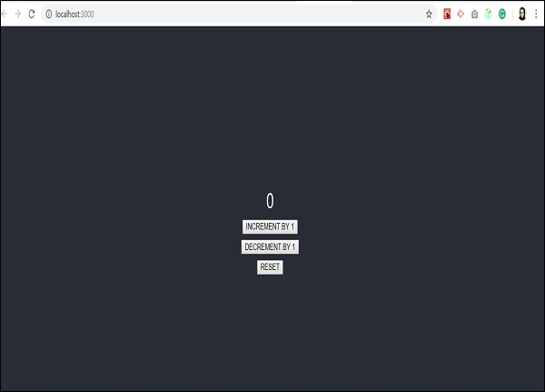

When I click increment two times, the output screen will be as shown below −

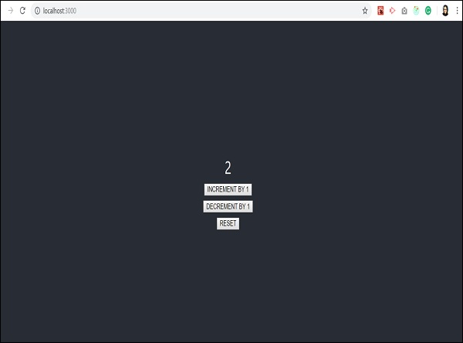

When we decrement it once, it shows the following screen −

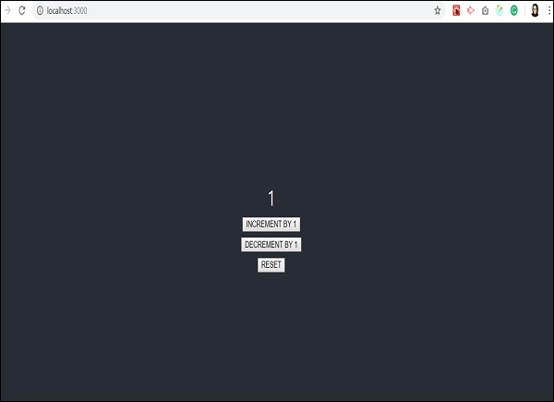

And reset will take the app back to initial state which is counter value 0. This is shown below −

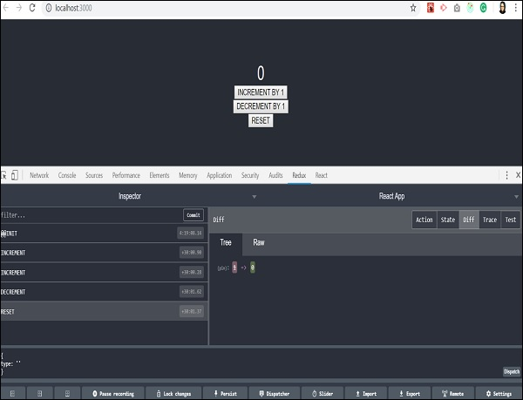

Let us understand what happens with Redux dev tools when the first increment action takes place −

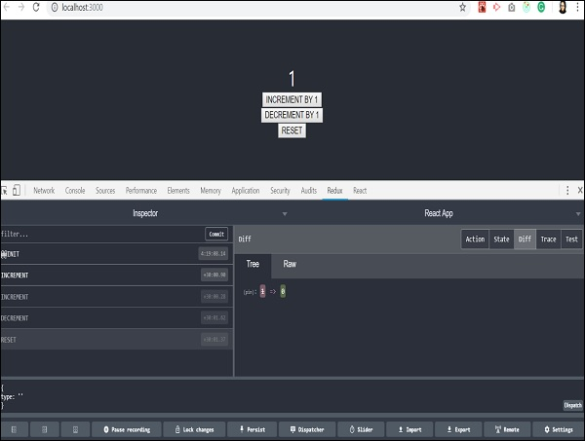

State of the app will be moved to the time when only increment action is dispatched and rest of the actions are skipped.