**Exercise 4: Functions**

**Scenario 1:** Calculate the age of customers for eligibility checks.

* + **Question:** Write a function CalculateAge that takes a customer's date of birth as input and returns their age in years.

CREATE OR REPLACE FUNCTION CalculateAge (

p_dob IN DATE

) RETURN NUMBER IS

v_age NUMBER;

BEGIN

v_age := TRUNC(MONTHS_BETWEEN(SYSDATE, p_dob) / 12);

RETURN v_age;

END;

//example use of the function CalculateAge

SELECT CalculateAge(TO_DATE('1988-05-20', 'YYYY-MM-DD')) AS Age FROM dual;

2.-- Ensure DBMS output is enabled

SET SERVEROUTPUT ON;

//function declaration

CREATE OR REPLACE FUNCTION CalculateAge (

p_dob IN DATE

) RETURN NUMBER IS

v_age NUMBER;

BEGIN

v_age := TRUNC(MONTHS_BETWEEN(SYSDATE, p_dob) / 12);

RETURN v_age;

END;

/

//the block to use the function

DECLARE

v_dob DATE := TO_DATE('1961-10-24', 'YYYY-MM-DD'); -- You can change this DOB

v_age NUMBER;

BEGIN

v_age := CalculateAge(v_dob);

DBMS_OUTPUT.PUT_LINE('Calculated age is: ' || v_age || ' years');

END;

/

OUTPUTS:

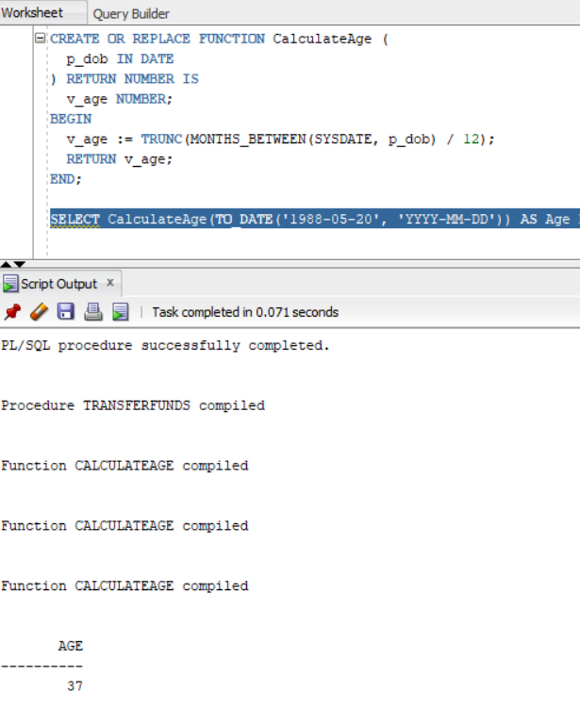

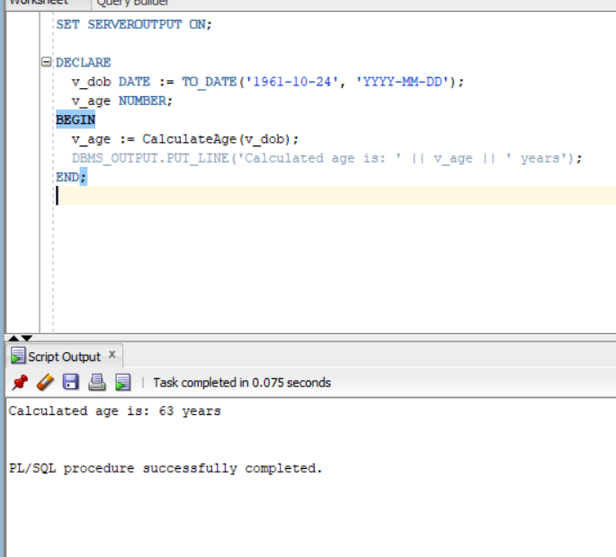

**Scenario 2:** The bank needs to compute the monthly installment for a loan.

* + **Question:** Write a function **CalculateMonthlyInstallment** that takes the loan amount, interest rate, and loan duration in years as input and returns the monthly installment amount.

CREATE OR REPLACE FUNCTION CalculateMonthlyInstallment (

p_loan_amount IN NUMBER,

p_annual_rate IN NUMBER, -- e.g., 6.5 for 6.5%

p_duration_years IN NUMBER -- loan duration in years

) RETURN NUMBER IS

v_monthly_rate NUMBER;

v_total_months NUMBER;

v_emi NUMBER;

BEGIN

v_monthly_rate := p_annual_rate / 12 / 100;

v_total_months := p_duration_years * 12;

IF v_monthly_rate = 0 THEN

v_emi := p_loan_amount / v_total_months;

ELSE

v_emi := p_loan_amount * v_monthly_rate * POWER(1 + v_monthly_rate, v_total_months)

/ (POWER(1 + v_monthly_rate, v_total_months) - 1);

END IF;

RETURN ROUND(v_emi, 2); -- Rounded to 2 decimal places

END;

/

SET SERVEROUTPUT ON;

DECLARE

v_loan_amount NUMBER := 500000;

v_interest_rate NUMBER := 7.5;

v_years NUMBER := 10;

v_monthly_emi NUMBER;

BEGIN

v_monthly_emi := CalculateMonthlyInstallment(v_loan_amount, v_interest_rate, v_years);

DBMS_OUTPUT.PUT_LINE('Monthly EMI is: ₹' || v_monthly_emi);

END;

/

OUTPUT:

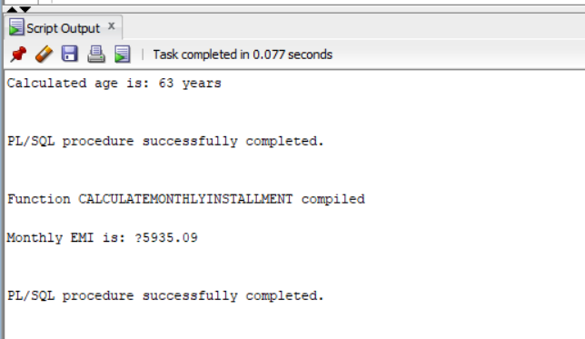

**Scenario 3:** Check if a customer has sufficient balance before making a transaction.

* + **Question:** Write a function **HasSufficientBalance** that takes an account ID and an amount as input and returns a boolean indicating whether the account has at least the specified amount.

CREATE OR REPLACE FUNCTION HasSufficientBalance (

p_account_id IN Accounts.AccountID%TYPE,

p_amount IN NUMBER

) RETURN BOOLEAN IS

v_balance Accounts.Balance%TYPE;

BEGIN

SELECT Balance

INTO v_balance

FROM Accounts

WHERE AccountID = p_account_id;

RETURN v_balance >= p_amount;

EXCEPTION

WHEN NO_DATA_FOUND THEN

RETURN FALSE; -- Account does not exist

END;

/

SET SERVEROUTPUT ON;

DECLARE

v_result BOOLEAN;

BEGIN

v_result := HasSufficientBalance(3, 2000);

IF v_result THEN

DBMS_OUTPUT.PUT_LINE('✅ Sufficient balance available.');

ELSE

DBMS_OUTPUT.PUT_LINE('❌ Insufficient balance or invalid account.');

END IF;

END;

/

OUPUT:

