# Springrest-3

Pom.xml

<?xml version="1.0" encoding="UTF-8"?>

<project xmlns="http://maven.apache.org/POM/4.0.0" xmlns:xsi="http://www.w3.org/2001/XMLSchema-instance"

xsi:schemaLocation="http://maven.apache.org/POM/4.0.0 https://maven.apache.org/xsd/maven-4.0.0.xsd">

<modelVersion>4.0.0</modelVersion>

<parent>

<groupId>org.springframework.boot</groupId>

<artifactId>spring-boot-starter-parent</artifactId>

<version>3.5.3</version>

<relativePath/> <!-- lookup parent from repository -->

</parent>

<groupId>com.cognizant</groupId>

<artifactId>spring-learn</artifactId>

<version>0.0.1-SNAPSHOT</version>

<name>spring-learn</name>

<description>Demo project for Spring Boot</description>

<url/>

<licenses>

<license/>

</licenses>

<developers>

<developer/>

</developers>

<scm>

<connection/>

<developerConnection/>

<tag/>

<url/>

</scm>

<properties>

<java.version>21</java.version>

</properties>

<dependencies>

<dependency>

<groupId>org.springframework.boot</groupId>

<artifactId>spring-boot-starter-validation</artifactId>

</dependency>

<dependency>

<groupId>org.springframework.boot</groupId>

<artifactId>spring-boot-starter-web</artifactId>

</dependency>

<dependency>

<groupId>org.springframework</groupId>

<artifactId>spring-tx</artifactId>

</dependency>

<dependency>

<groupId>org.springframework.boot</groupId>

<artifactId>spring-boot-devtools</artifactId>

<scope>runtime</scope>

<optional>true</optional>

</dependency>

<dependency>

<groupId>org.springframework.boot</groupId>

<artifactId>spring-boot-starter-test</artifactId>

<scope>test</scope>

</dependency>

<dependency>

<groupId>org.projectlombok</groupId>

<artifactId>lombok</artifactId>

<version>1.18.30</version>

<scope>provided</scope>

</dependency>

</dependencies>

<build>

<plugins>

<plugin>

<groupId>org.springframework.boot</groupId>

<artifactId>spring-boot-maven-plugin</artifactId>

</plugin>

</plugins>

</build>

</project>

**Src/test/java/com/congnizant/spring_learn/**

**SpringLearnApplicationTests.java**

package com.cognizant.spring_learn;

import org.junit.jupiter.api.Test;

import org.springframework.boot.test.context.SpringBootTest;

@SpringBootTest

class SpringLearnApplicationTests {

@Test

void contextLoads() {

}

}

**Src/main/resources/**

**Application.properties**

spring.application.name=spring_learn

server.port=8080

logging.level.com.example.spring_learn=DEBUG

logging.level.org.springframework=INFO

**employee.xml**

<?xml version="1.0" encoding="UTF-8"?>

<beans xmlns="http://www.springframework.org/schema/beans"

xmlns:xsi="http://www.w3.org/2001/XMLSchema-instance"

xsi:schemaLocation="http://www.springframework.org/schema/beans

http://www.springframework.org/schema/beans/spring-beans.xsd">

<!-- Skills -->

<bean id="skillJava" class="com.example.spring_learn.model.Skill">

<property name="id" value="1"/>

<property name="name" value="Java"/>

</bean>

<bean id="skillSpring" class="com.example.spring_learn.model.Skill">

<property name="id" value="2"/>

<property name="name" value="Spring"/>

</bean>

<!-- Departments -->

<bean id="deptIT" class="com.example.spring_learn.model.Department">

<property name="id" value="101"/>

<property name="name" value="IT"/>

</bean>

<bean id="deptHR" class="com.example.spring_learn.model.Department">

<property name="id" value="102"/>

<property name="name" value="HR"/>

</bean>

<!-- Employees -->

<bean id="emp1" class="com.example.spring_learn.model.Employee">

<property name="id" value="1"/>

<property name="name" value="Alice"/>

<property name="department" ref="deptIT"/>

<property name="skills">

<list>

<ref bean="skillJava"/>

<ref bean="skillSpring"/>

</list>

</property>

</bean>

<bean id="emp2" class="com.example.spring_learn.model.Employee">

<property name="id" value="2"/>

<property name="name" value="Bob"/>

<property name="department" ref="deptHR"/>

<property name="skills">

<list>

<ref bean="skillJava"/>

</list>

</property>

</bean>

<bean id="employeeList" class="java.util.ArrayList">

<constructor-arg>

<list>

<ref bean="emp1"/>

<ref bean="emp2"/>

</list>

</constructor-arg>

</bean>

<bean id="departmentList" class="java.util.ArrayList">

<constructor-arg>

<list>

<ref bean="deptIT"/>

<ref bean="deptHR"/>

</list>

</constructor-arg>

</bean>

</beans>

**/main/java/com/example/Spring_learn/**

**SpringLearnApplicartion.java**

package com.example.spring_learn;

import org.springframework.boot.SpringApplication;

import org.springframework.boot.autoconfigure.SpringBootApplication;

import org.springframework.context.annotation.ImportResource;

@SpringBootApplication

@ImportResource("classpath:employee.xml")

public class SpringLearnApplication {

public static void main(String[] args) {

SpringApplication.run(SpringLearnApplication.class, args);

}

}

**/controller/Department Controller.java**

package com.example.spring_learn.controller;

import com.example.spring_learn.model.Department;

import com.example.spring_learn.service.DepartmentService;

import org.springframework.beans.factory.annotation.Autowired;

import org.springframework.web.bind.annotation.*;

import java.util.List;

@RestController

public class DepartmentController {

@Autowired

private DepartmentService departmentService;

@GetMapping("/departments")

public List<Department> getAllDepartments() {

return departmentService.getAllDepartments();

}

}

**/EmployeeController.java**

package com.example.spring_learn.controller;

import com.example.spring_learn.model.Employee;

import com.example.spring_learn.service.EmployeeService;

import org.springframework.beans.factory.annotation.Autowired;

import org.springframework.web.bind.annotation.*;

import java.util.List;

@RestController

public class EmployeeController {

@Autowired

private EmployeeService employeeService;

@GetMapping("/employees")

public List<Employee> getAllEmployees() {

return employeeService.getAllEmployees();

}

}

**/dao/DepartmentDao.java**

package com.example.spring_learn.dao;

import com.example.spring_learn.model.Department;

import org.springframework.beans.factory.annotation.Autowired;

import org.springframework.beans.factory.annotation.Qualifier;

import org.springframework.stereotype.Component;

import java.util.List;

@Component

public class DepartmentDao {

private static List<Department> DEPARTMENT_LIST;

@Autowired

public DepartmentDao(@Qualifier("departmentList") List<Department> departmentList) {

DEPARTMENT_LIST = departmentList;

}

public List<Department> getAllDepartments() {

return DEPARTMENT_LIST;

}

}

**/dao/EmployeeDao.java**

package com.example.spring_learn.dao;

import com.example.spring_learn.model.Employee;

import org.springframework.beans.factory.annotation.Autowired;

import org.springframework.beans.factory.annotation.Qualifier;

import org.springframework.stereotype.Component;

import java.util.List;

@Component

public class EmployeeDao {

private static List<Employee> EMPLOYEE_LIST;

@Autowired

public EmployeeDao(@Qualifier("employeeList") List<Employee> employeeList) {

EMPLOYEE_LIST = employeeList;

}

public List<Employee> getAllEmployees() {

return EMPLOYEE_LIST;

}

}

/model/Deaprtment.java

package com.example.spring_learn.model;

public class Department {

private int id;

private String name;

// Getters and Setters

public int getId() {

return id;

}

public void setId(int id) {

this.id = id;

}

public String getName() {

return name;

}

public void setName(String name) {

this.name = name;

}

@Override

public String toString() {

return "Department{" +

"id=" + id +

", name='" + name + '\'' +

'}';

}

}

**/model/Employee.java**

**package com.example.spring_learn.model;**

import java.util.List;

public class Employee {

private int id;

private String name;

private Department department;

private List<Skill> skills;

// Getters and Setters

public int getId() {

return id;

}

public void setId(int id) {

this.id = id;

}

public String getName() {

return name;

}

public void setName(String name) {

this.name = name;

}

public Department getDepartment() {

return department;

}

public void setDepartment(Department department) {

this.department = department;

}

public List<Skill> getSkills() {

return skills;

}

public void setSkills(List<Skill> skills) {

this.skills = skills;

}

@Override

public String toString() {

return "Employee{" +

"id=" + id +

", name='" + name + '\'' +

", department=" + department +

", skills=" + skills +

'}';

}

}

**/model/skill.java**

package com.example.spring_learn.model;

public class Skill {

private int id;

private String name;

// Getters and Setters

public int getId() {

return id;

}

public void setId(int id) {

this.id = id;

}

public String getName() {

return name;

}

public void setName(String name) {

this.name = name;

}

@Override

public String toString() {

return "Skill{" +

"id=" + id +

", name='" + name + '\'' +

'}';

}

}

**/service/DepartmentService.java**

package com.example.spring_learn.service;

import com.example.spring_learn.dao.DepartmentDao;

import com.example.spring_learn.model.Department;

import org.springframework.beans.factory.annotation.Autowired;

import org.springframework.stereotype.Service;

import java.util.List;

@Service

public class DepartmentService {

@Autowired

private DepartmentDao departmentDao;

public List<Department> getAllDepartments() {

return departmentDao.getAllDepartments();

}

}

**/service/EmployeeService.java**

package com.example.spring_learn.service;

import com.example.spring_learn.dao.EmployeeDao;

import com.example.spring_learn.model.Employee;

import org.springframework.beans.factory.annotation.Autowired;

import org.springframework.stereotype.Service;

import org.springframework.transaction.annotation.Transactional;

import java.util.List;

@Service

public class EmployeeService {

@Autowired

private EmployeeDao employeeDao;

@Transactional

public List<Employee> getAllEmployees() {

return employeeDao.getAllEmployees();

}

}

**Output:**

**Employee:**

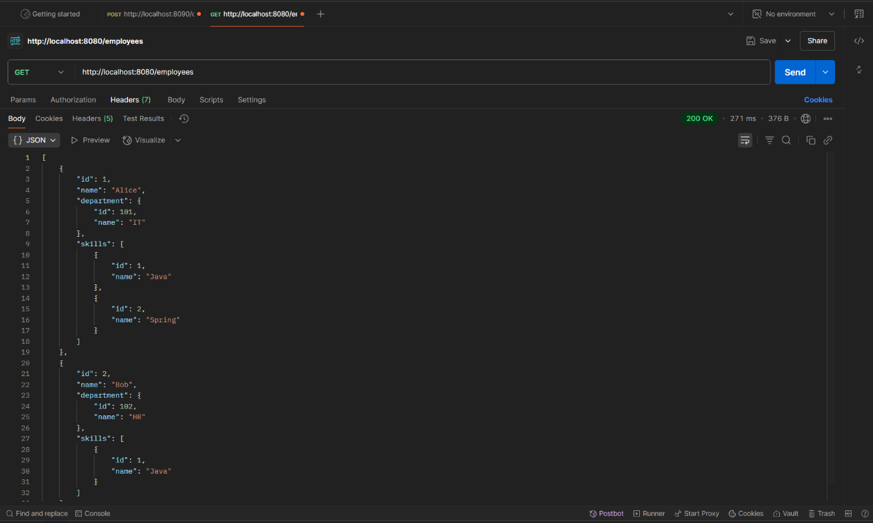

**Departement:**

