To Run JSON Server:

npm install -g json-server

cd C:\Users\Sravya\Desktop\Angular\crudjson_Api_Try\src\assets

with the above command Goto the location where the json file is

and execute the following command.

json-server --watch Employee.json

To Enable Cors:

Go to the Web API project.

Download a Nuget package for CORS. Go to NuGet Package Manager and download the following file.

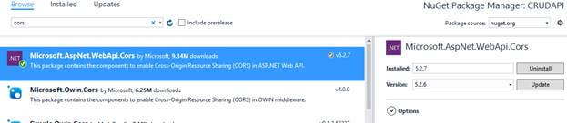

After that, go to App_Start folder in Web API project and open WebApiConfig.cs class. Here, modify the Register method with the below code.

1. Add namespace
2. using System.Web.Http.Cors;
3. **var** cors = **new** EnableCorsAttribute("*","*","*");//origins,headers,methods
4. config.EnableCors(cors);